PATTERN RECOGNITION AND CLASSIFICATION

WEEK 2 ASSIGNMENT ANSWERS

ARYA RAJIV CHALOLI

PES1201700253

1. What is the need for the Bayesian Decision Rule? What are the assumptions that we take before using this rule?

Answer:

The need of the Bayesian Decision rule arises when the probability of the error is to be minimised. One is capable of the making the most appropriate decision by following the decision rule based on the probability of occurrences, cost of errors etc.

It makes the assumption that the decision problem is posed in probabilistic terms, and that all of the relevant probability values are known.

1. What do you mean by likelihood? Give its formula. Also elaborate on the likelihood ratio.

Answer:

Likelihood is the term used to describe on how ‘likely’ is the occurrence of the event.

Formula: p(x|ωj) .

p(x|ωj) indicates the likelihood of ωj with respect to x (which means that, all other things being equal, the category ωj for which p(x|ωj) is large is more “likely” to be the true category).

1. Write both iterations of the decision rule and explain what each term is briefly.

Answer:

The first iteration involves the comparison of only the probabilities of occurrence. In this process we decide to choose ωi if

$$P\left(ωi | x\right)>P\left(ωj | x\right) for all j ≠ i.$$

where, $$P\left(ωi | x\right)= \frac{p\left(x | ωj\right)×P(ωj)}{p(x)}$$

The second iteration involves the comparison of the risks of occurrence. In this process we decide to choose ωi if

$$R\left(α1 | x\right)<R\left(α2 | x\right) for all j ≠ i.$$

Where,

$$R\left(αi | x\right)=\sum_{j=1}^{c}{ λ(αi|ωj)P(ωj|x) }$$

1. What is Bayes Risk and how can we use it to form a decision rule?

Answer:

Bayes risk is the minimum overall risk. It is denoted by R\*, and is the best performance that can be achieved.

To apply it into the decision rule: Minimize the overall risk for which one has to compute the conditional risk

$$R\left(αi | x\right)=\sum_{j=1}^{c}{ λ(αi|ωj)P(ωj|x) }$$

for i = 1, ... , a and select the action αi for which R(αi|x) is minimum.

We decide ω1 if

$$R\left(α1 | x\right)<R\left(α2 | x\right)$$

to minimise the risk and vice-versa.

1. 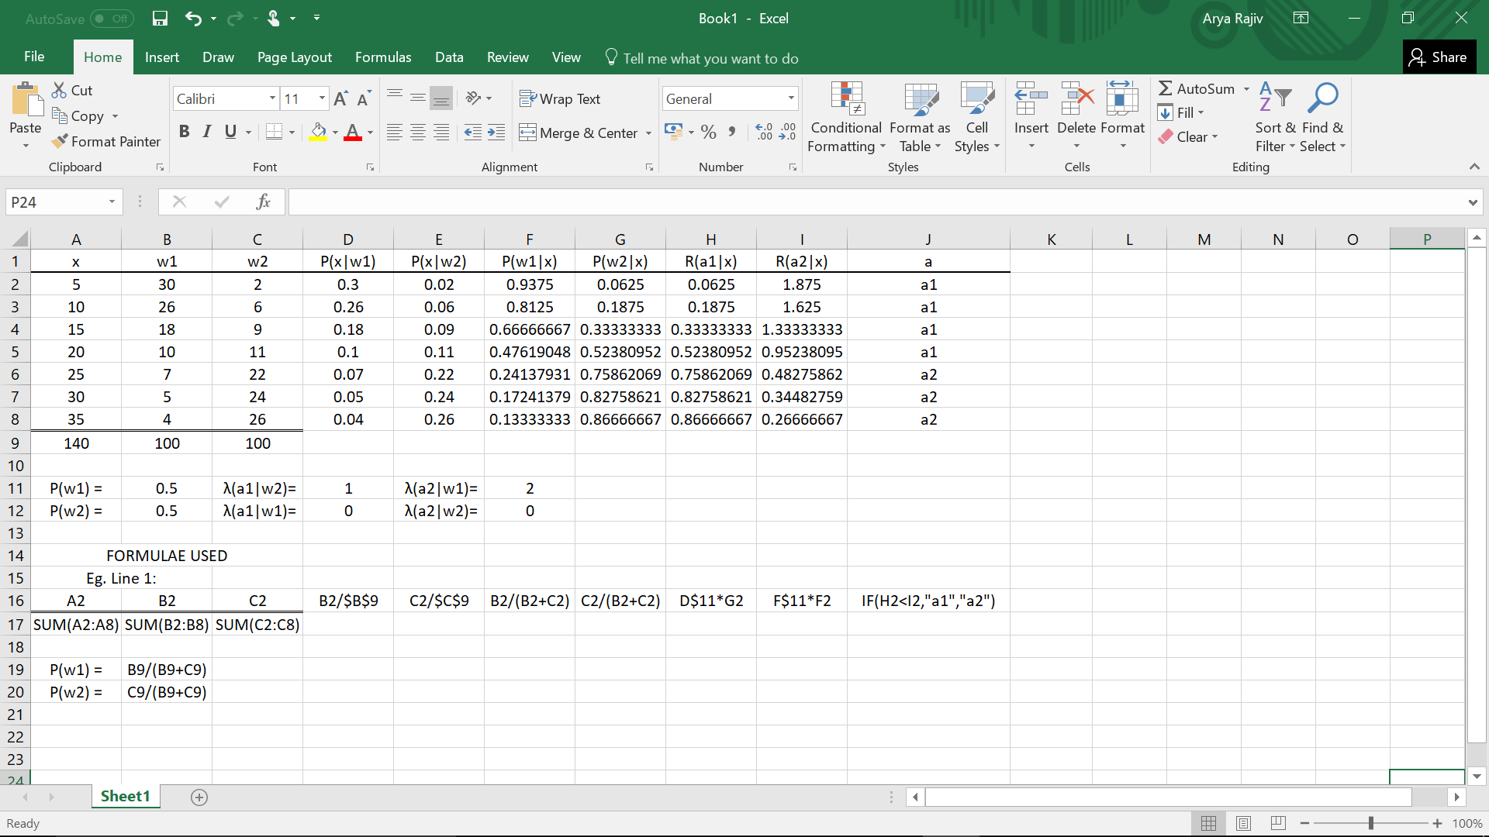Use the given data in the image to determine the actions taken for each class, cost of each action. Show the decision rules for your actions and all mathematical working with the intermediate steps in a table.

The final decision to be taken is given by the value in the column J (named a), where a1 refers to choosing metal 1 (w1) and a2 refers to choosing metal 2 (w2).