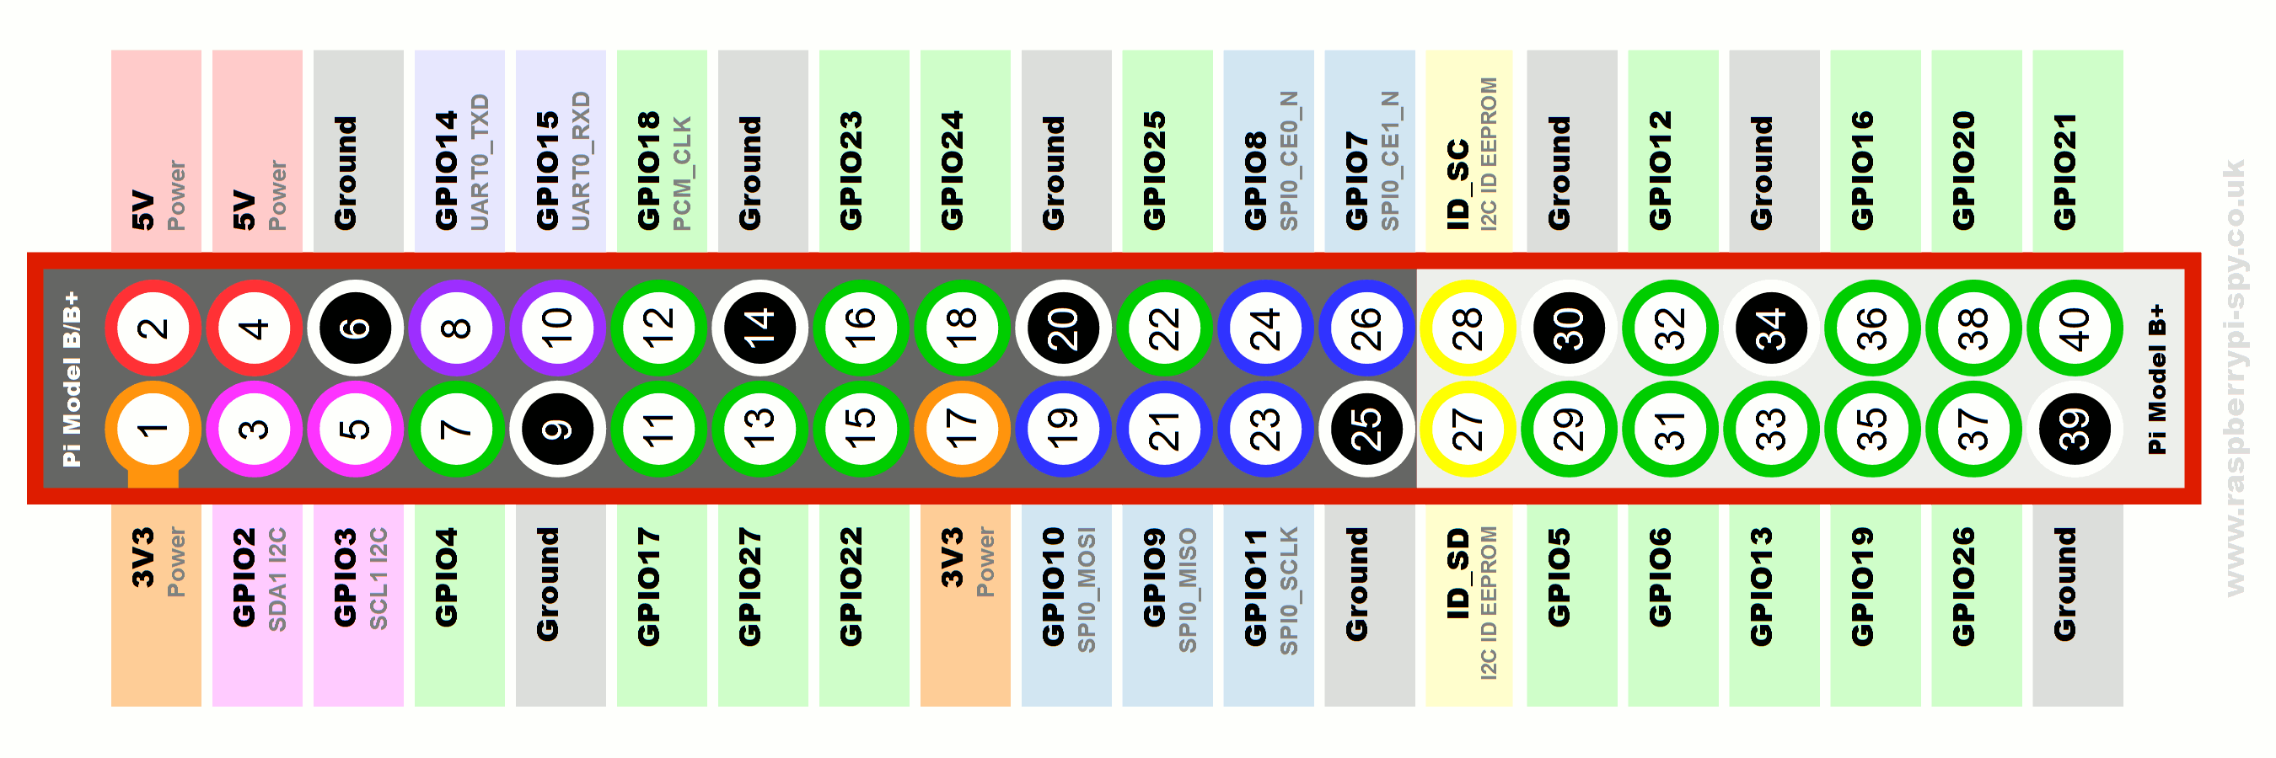

Raspberry Pi 3B

POWER BANK 1

5V

Motor 2

Motor 1

webcam

Step up (transformer)

(O/p : 12V)

(I/p : 5V)

SERVO 1 (big)

SERVO 2 (small)

H bridge