I want to make a webpage that is used to visualize job sequencing algorithms.
I want separate HTML, CSS and JavaScript codes for the same.

On the landing page, we will get the options to choose which algorithm we wish to use to sequence the jobs.
FCFS (First Come First Serve)
SJF(Shortest Job First)
SRTF(Shortest Remaining Time First)
Priority Scheduling - Non Premptive
Priority Scheduling - Premptive
Round Robin
HRRN (Highest Response Ratio First)
LJF(Longest Job First)
LRTF(Longest Remaining Time First)

Based on the option chosen, the webpage then allows us to input our values for Arrival Time and Burst Time. Use a table format to do so. If the option chosen requires other inputs (Priority Values for priority scheduling, time quantum for round robin), provide fields for the inputs, but if they are not necessary, don’t provide fields.
Make it so that to add jobs, we use a plus symbol, that adds a new empty job field to the table. Make default names of jobs as P1, P2, …, but if user wants to change, allow editing.

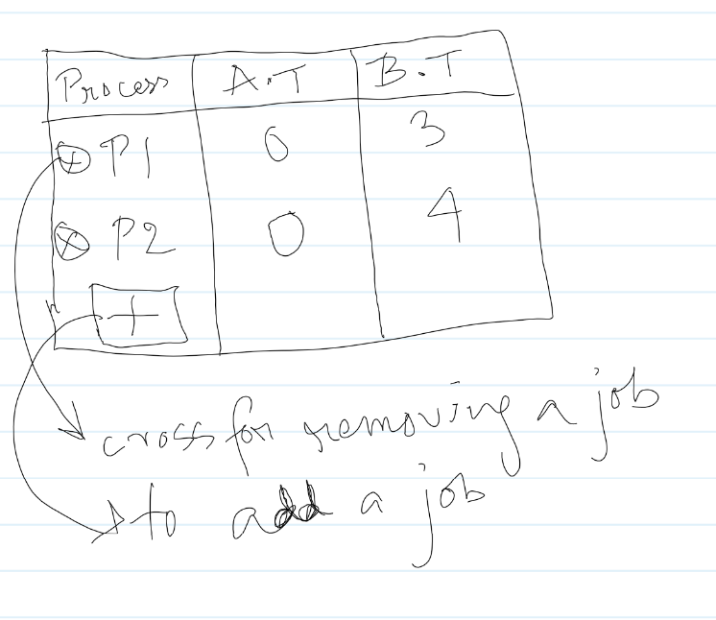

After all these changes, have a submit button. On clicking submit, the following page appears.
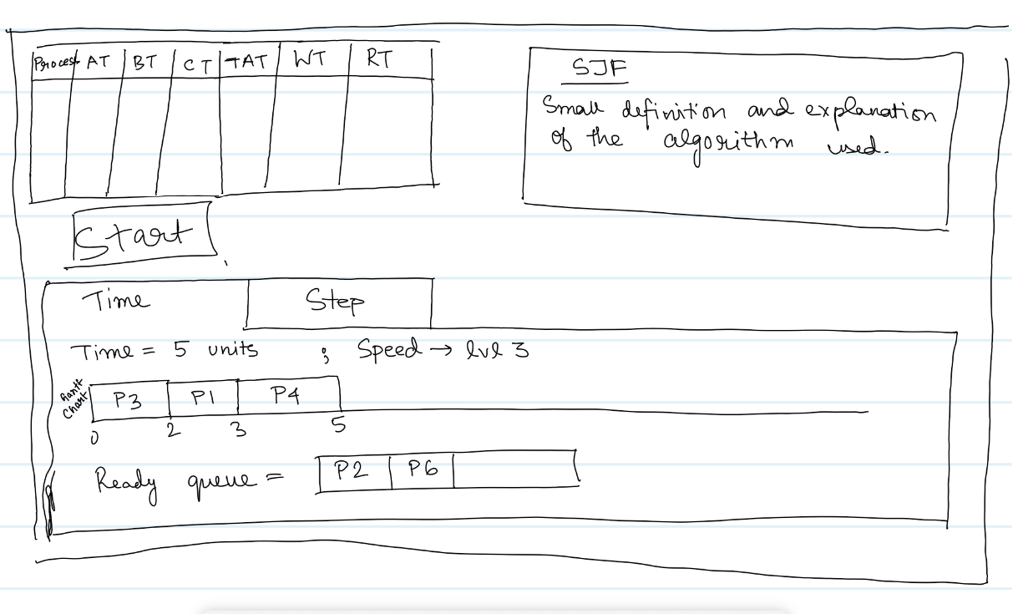

at - arrival time, bt - burst time, ct - completion time, tat = turnaround time, wt = waiting time, rt = response time.

At the press of the START button, the job sequencing process starts.

In the TIME option, the job sequencing continues automatically. The time keeps increasing and simultaneously, the job sequencing follows the time. The Gantt Chart fills up accordingly and the Ready Queue updates as the algorithm works.
There will be 5 levels of speed
Level 1: 1 unit time -> 1 second
Level 5: 5 unit time -> 1 second
When the job sequencing process ends, the START button changes to RESTART button, and on pressing, the process restarts.
Speed can be modified while the process is running.
Also make an END button, next to the START button, that automatically skips to the final result of the job sequencing process.
Color scheme: Bright Yellow, Blood Red, Sand, Navy Blue
Text Font: Lora by Cyreal, Times New Roman.

