

Digital Twin for Perishable Food Supply Chain

Under the guidance of Prof. R. B. Keskar
Ayaan Khan BT22CSE001 Arya Patil BT22CSE003 Nihaal Badam BT22CSE004 Swastik Ankulge BT22CSE013

Project: A Digital Twin for perishable food logistics, starting with oranges (extensible)

Problem: High spoilage rates in the "last mile" due to poor monitoring and inflexible routing
Our Scope: Warehouse → Retailer
Key challenges:
- Vehicle Routing/ Re-routing
- Real-time Monitoring (temp, humidity)
- Spoilage Prediction
- Dynamic Disruptions (traffic, accidents)

Concept:
- Most DTs are passive dashboards. They show you a problem (ex: "This truck is too hot").
- Our DT will be an autonomous control system. It will solve the problem.

The Loop:
- Monitor (Simulated IoT): "A truck is in a traffic jam, and its temperature is 2°C above optimal."
- Predict (ML): "At this rate, the oranges will lose 30% of their shelf life before reaching Retailer A."
- Act (RL): "Autonomously reroute the truck to Retailer B, who is closer and has immediate demand, preserving the batch's value."

Concept: We will model supply chain as a graph, a common framework for logistics DTs.

Simple Visual Diagram:
  - Nodes: Warehouse, Retailer
  - Edges: Route (connecting nodes)
  - Agent: ex-Freight (traverses the graph)
  - Entity: OrangeBatch (the asset that moves through the system)

Extensibility: This graph structure allows us to easily add new nodes (e.g., new warehouses, new freights) or agents without re-architecting the core model.

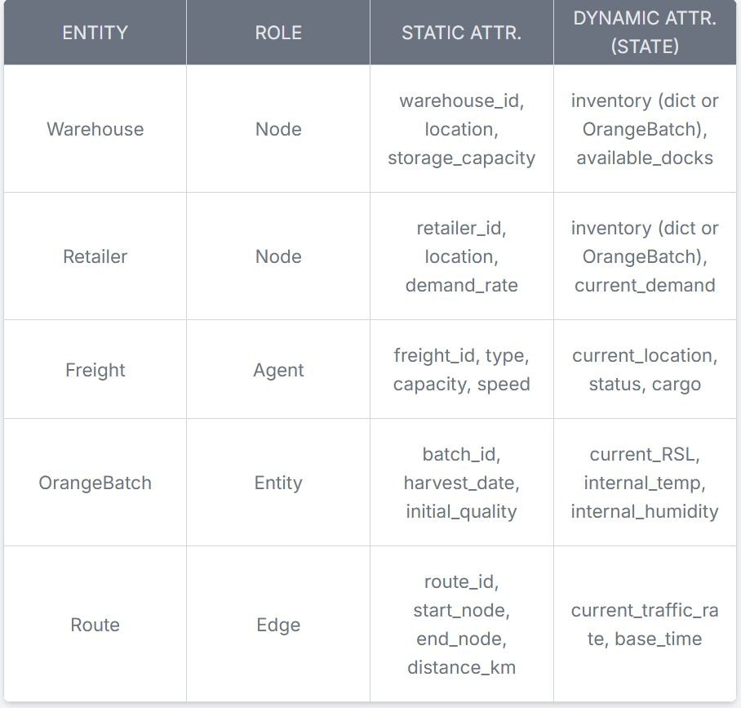
Concept: We will model the static supply chain as a graph, a common framework for logistics DTs.

Simple Visual Diagram:
  - Nodes: Warehouse, Retailer
  - Edges: Route (connecting nodes)
  - Agent: Freight (traverses the graph)
  - Entity: OrangeBatch (the asset that moves through the system)

Concept: To meet the "extensible to other foods" requirement, we need a formal way to define relationships. We will adopt the W3C SOSA (Sensor, Observation, Sample, and Actuator)
Method 1: Freight.temperature = 2.5

Method 2: SOSA
    - sosa:Sensor (thermometer)
    - sosa:madeObservation (a reading)
    - sosa:FeatureOfInterest (the OrangeBatch)

Why:
  - To add Apples, we don't change the Freight or Sensor models.
  - We simply create a new sosa:FeatureOfInterest called AppleBatch.
  - This is makes it modular.

Problem: We don't have a real-world fleet of IoT sensors
Solution: A Hybrid Data Strategy to create a realistic, accurate simulation/representation

- Bootstrapping the Data: Use public, static datasets to set the initial state of the simulation (ex: how much inventory does a warehouse start with initially, what rates does the warehouse receive oranges from the packhouses, etc.)
- Generative Pattern Data: Use public IoT datasets as a pattern for our simulation (ex: what does a real traffic jam look like? What are real truck temperature fluctuations?)
- Generative Scientific Data: Create our own high-value data (through spoilage function) using a validated scientific model

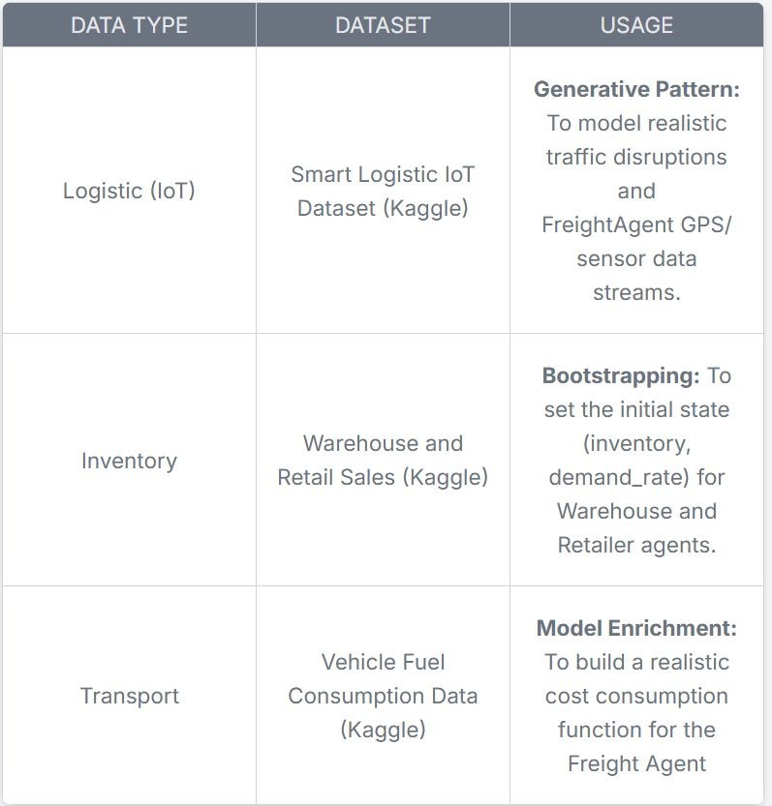
Concept: We will generate the Remaining Shelf Life (RSL) data stream based on physics
Model: Arrhenius Equation:
  - This is a validated model from food science that calculates the rate of quality degradation as a function of temperature
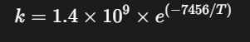
  - The specific model for sweet orange degradation is:

Implementation:
- Our simulated FreightAgent Sensor would provide a T
- Arrhenius equation gives us the net the degradation rate k
- We update the OrangeBatch.current_RSL every simulation minute (or choose a time based on system capacity)
Result: We create a high-frequency, scientifically-valid RSL data stream

Technology Stack

SimPy: Simulation Engine

  - define agents as Python classes with generator methods

MQTT: IoT Data Broker

  - Agents publish data externally to this broker
  - Ex: FreightAgent has a monitor_cargo() process that through mqtt_client.publish() a JSON payload (ex:
{'temp': 4.5, 'rsl': 98.2}) to a topic
  - MQTT over Kafka: lightweight, push-based, IoT-style

Telegraf: Data Pipeline

  - server-agent that listens to the MQTT broker and writes to the database
  - configure [[inputs.mqtt_consumer]] plugin to subscribe to iot/freight/# topics
  - configure [[outputs.influxdb_v2]] plugin to automatically write that data into InfluxDB with tags
InfluxDB: Time-Series Database (Memory)

  - Digital Twin's database.
  - InfluxDB over Prometheus: push-based system, SimPy
-> MQTT -> Telegraf push architecture
  - optimized for high-volume sensor data and event logging
Streamlit: Dashboard/Interface

  - interactive web app
  - use the InfluxDB client library to query the database
  - Ex: show me the last 1 hour of temperature for 'truck-01'
  - Streamlit over Plotly Dash: simplicity, faster prototyping for data-focused applications

Models: ML and RL System
Part 1: The Predictor (Machine Learning) Goal: Predict the RSL of an orange batch
Model: Support Vector Regression (SVR)

Why: Research specifically on 'Valencia' oranges found SVR was the most accurate model (R² score=0.884) using the exact features our simulation will generate: storage time, temperature, and humidity.
Part 2: The Decision-Maker (Reinforcement Learning) Goal: Solve the Dynamic Vehicle Routing Problem (DVRP)
Model: Deep Q-Network (DQN)

How:

    - State: DQN agent's state Ex: current location, fuel, etc
    - Action: Ex: "Go to Retailer A," "Go to Retailer B," or "Wait."
    - Reward: fast deliveries, high final RSL, heavily penalization for spoiled-batch deliveries, inefficient routing, etc.

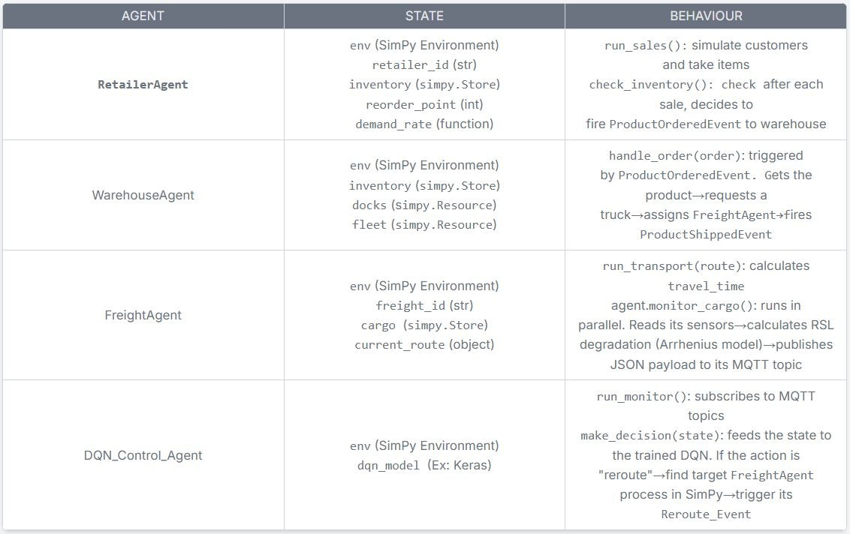
Concept: to use Agent-Based Modeling to model the Actors in our system. Agent: is a Python class with process methods that simulate behavior over time Core Agents:

Concept: Event-Driven Architecture

- Agents do not call each other directly.
- They communicate indirectly by firing and listening for Events

Example of flow:
- RetailerAgent's: low inventory → fires ProductOrderedEvent
- WarehouseAgent (listening): catch event → reserve FreightAgent → fire ProductShippedEvent
- FreightAgent: catch this→ starts its run_transport()
- SimulationEnv: fire a Disruption_Event (ex: traffic jam, accident)
- DQN_Control_Agent (listening): catch the event → check FreightAgent's cargo RSL (from the Arrhenius model) → decide if a new route is needed → fire Reroute_Event
- FreightAgent: catch Reroute_Event → changes its destination/route accordingly

- Maersk (Cold Chain Monitoring):
  - virtual refrigerated cargo assistant
  - provides real-time data and visibility for in-transit reefer (refrigerated) containers
  - prevent spoilage on a global scale
- Zomato/Swiggy (Perishable Routing):
  - Dynamic Vehicle Routing Problem (DVRP) for hot perishables
  - strict delivery window.
  - autonomously route drivers, balancing real-time traffic, weather, and variable restaurant prep times
- Amul/Agropur (The Perishable Domain):
  - Amul - India's largest dairy co-op
  - inefficient routes and lack of cold storage lead to spoilage
  - GIS to optimize collection routes
  - Agropur - a global dairy producer
  - Digital Twins to optimize their plant and engineering design

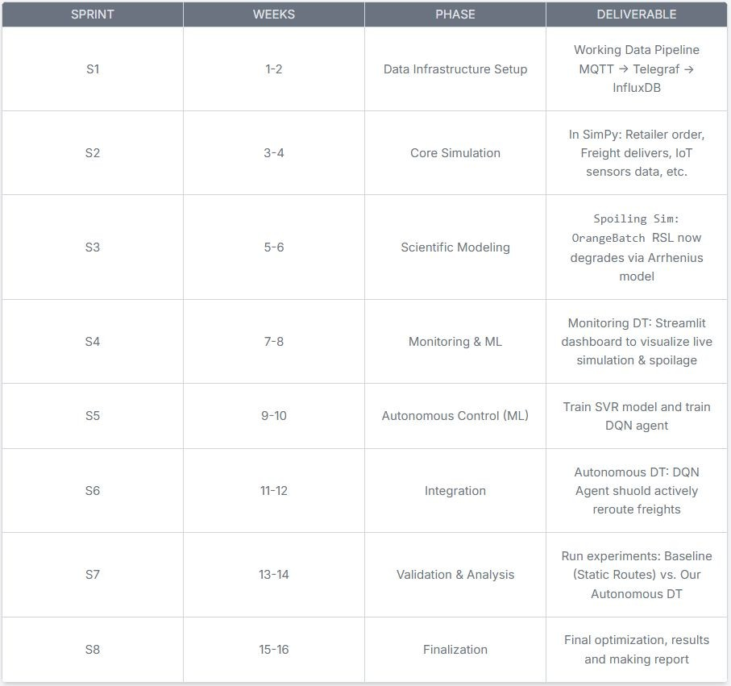
Rough Timeline

Conclusion

Conclusion:
- From Passive Monitoring to Autonomous Control: We successfully demonstrated a paradigm shift. Traditional digital twins are passive dashboards that only show you a problem (e.g., "This truck is too hot"). Our Digital Twin is an autonomous control system that solves the problem.
- Bridged the "Monitoring-to-Control" Gap: Our core contribution is the integration of a Deep Q-Network (DQN) agent. This "brain" analyzes real-time spoilage predictions and autonomously acts on them, creating a system that actively prevents spoilage, not just reports it.
- Achieved High-Fidelity, Realistic Simulation: We solved the "no real data" problem. By using a hybrid data strategy and implementing the scientific Arrhenius equation, we created a high-frequency, scientifically-valid data stream for "Remaining Shelf Life" (RSL)
- Built a Technically Feasible & Extensible Framework:
  - Feasible: Our lightweight stack (SimPy, MQTT, InfluxDB, Streamlit) proved capable of handling a complex, event-driven simulation.
  - Extensible: By using the W3C SOSA ontology, our framework is not just for oranges. We can add new products like apples or even pharmaceuticals just by defining them as a new sosa:FeatureOfInterest without re-architecting the system.

References
- [1] S. H. Ahmad, R. Rosle, M. S. A. Rani, M. S. A. Bakar, and N. I. M. Z. Abidin, "The Shelf-life Prediction of Sweet Orange Based on Its Total Soluble Solid by Using Arrhenius and Q 10 Approach," IOP Conf. Series: Materials Science and Engineering, vol. 506, no. 1, 2019, Art. no. 012061.
- [2] A. P. Moller - Maersk, "Captain Peter™," Maersk.com. Accessed: Nov. 3, 2025. [Online]. Available: https://www.maersk.com/digital-services/captain-peter
- [3] A. Shukhla and F. Qasim, "Optimizing Delivery Time and Customer Satisfaction: A Data-Driven Analysis of Zomato's Logistics Operations," ijsrem.com, 2024. Accessed: Nov. 3, 2025. [Online]. Available:
https://www.google.com/search?q=https://ijsrem.com/download/optimizing-delivery-time-and-customer-satisfaction-a-data-driven-analysis-of-zomatos-logistics-operations/
- [4] Y. Umamahesh, "Data Science Delights: How Swiggy and Zomato Revolutionize Food Delivery with Advanced Techniques," Medium, 2024. Accessed: Nov. 3, 2025. [Online]. Available:
https://www.google.com/search?q=https://medium.com/%40yenumamahesh/data-science-delights-how-swiggy-and-zomato-revolutionize-food-delivery-with-advanced-technique s-10776b6d8a43
- [5] Prevu3D, "Agropur Engineering Design Case Study," Prevu3D.com. Accessed: Nov. 3, 2025. [Online]. Available: https://www.google.com/search?q=https://prevu3d.com/case-studies/agropur-engineering-design
- [6] M. Singh, "Amul Logistics," SlideShare, 2010. Accessed: Nov. 3, 2025. [Online]. Available: https://www.google.com/search?q=https://www.slideshare.net/manpalsingh/amul-logistics-5627705
- [7] L. Wang, H. J. He, and D. Li, "Implementation of Digital Twins in the Food Supply Chain: A Review and Conceptual Framework," Foods, vol. 10, no. 5, 2021, Art. no. 936.
- [8] M.-A. Elia-Valverde et al., "Evaluation of the Storage Performance of ‘Valencia’ Oranges and Generation of Shelf-Life Prediction Models," Foods, vol. 11, no. 8, 2022, Art. no. 1157.
- [9] R. Liu, X. Yang, A. Li, H. Hu, Z. Wang, and H. Yao, "Deep reinforcement learning for the dynamic and uncertain vehicle routing problem," in Proc. Int. Conf. Autom. Plann. Sched. (ICAPS), 2020, vol. 30, pp. 638-646.
- [10] A. A. Lomonosov, N. A. Taratukhin, and D. A. Klyuchnikov, "A Theoretical Framework for Graph-based Digital Twins for Supply Chain Management and Optimization," ResearchGate, 2024. Accessed: Nov. 3, 2025. [Online]. Available:
https://www.google.com/search?q=https://www.researchgate.net/publication/377488092_A_Theoretical_Framework_for_Graph-based_Digital_Twins_for_Supply_Chain_Manageme nt_and_Optimization
- [11] "SimPy: Discrete event simulation for Python," SimPy ReadTheDocs. Accessed: Nov. 3, 2025. [Online]. Available: https://simpy.readthedocs.io/en/latest/
- [12] L. Sardois, "Handling IoT data with MQTT, Telegraf, InfluxDB and Grafana," Medium, 2019. Accessed: Nov. 3, 2025. [Online]. Available: https://www.google.com/search?q=https://medium.com/%40luciensardois/handling-iot-data-with-mqtt-telegraf-influxdb-and-grafana-769d060e20fb
- [13] W3C, "Semantic Sensor Network Ontology," W3C Recommendation, 2023. Accessed: Nov. 3, 2025. [Online]. Available: https://www.w3.org/TR/vocab-ssn/

