

AI-Powered Career and Skill-Gap Recommendation System Using Canadian Job Bank Data, O*NET Occupational Information, and CIP Educational Pathways

Group 1:
Alveera Malik
Arya Unni
Ansu Joy
Jasmine Jose
Souren Chowdhury

Course: Capstone Project (DAMO-699-1)
Program: Master of Data Analytics, University of Niagara Falls Canada
Instructor: Mehdi Mostofi

AI-Powered Career and Skill-Gap Recommendation System Using Canadian Job Bank Data, O*NET Occupational Information, and CIP Educational Pathways
Business Understanding
Career planning has become increasingly challenging for students, recent graduates, and job
seekers due to the rapid evolution of the labour market and changing industry skill
requirements. Many individuals struggle to identify career paths that match their education,
skills, interests, and long-term goals. Existing career guidance platforms and job portals
mainly rely on keyword-based matching, which often fails to consider a candidate's complete
profile, including educational background, technical skills, experience, and career aspirations.
These systems also provide limited explanations for their recommendations and rarely
identify skill gaps or suggest learning pathways.
Artificial Intelligence (AI) provides an opportunity to improve career recommendation
systems by delivering more accurate, personalized, and explainable guidance. Machine
Learning can analyze user profiles and predict suitable career paths, while Natural Language
Processing (NLP) can extract and compare skills from resumes and job descriptions.
Retrieval-Augmented Generation (RAG) enhances the reliability of Large Language Models
(LLMs) by retrieving information from trusted data sources before generating responses,
reducing inaccurate or unsupported recommendations. Together, these technologies enable
the system to recommend appropriate occupations, identify missing skills, and provide
evidence-based career advice.
Canadian labour-market data is essential to ensure that recommendations reflect current
employment opportunities and industry demand. The Government of Canada Job Bank
provides reliable information on occupations, job vacancies, wages, education requirements,
and regional labour-market trends. By integrating Job Bank data with O*NET occupational
information and the Classification of Instructional Programs (CIP), the proposed system can
connect educational programs, occupational skills, and labour-market demand. This
integration will help students and job seekers make informed career decisions while
supporting Canadian workforce needs through personalized, data-driven career
recommendations.
Project Scope
Target Users:The target users are students, graduates, and job seekers who want career
recommendations based on their skills, education, and labour market demand.
Canadian Geographic Focus:The project focuses on the Canadian labour market using
Government of Canada Job Bank data. The geographic scope is Canada-wide.
Selected Occupational Field:The project focuses on Technology and Business Analytics
occupations.
Selected Occupations:
1 Data Analyst
2 Data Scientist
3 Business Intelligence Analyst
4 Data Engineer
5 Machine Learning Engineer
6 Database Analyst
7 Database Administrator
8 Business Systems Analyst
9 Information Systems Analyst
10 Software Developer
11 Cybersecurity Analyst
12 Operations Analyst
13 Marketing Analyst
14 Financial Analyst
15 AI Specialist

Research Questions:
Main Research Question
To what extent can an integrated career recommendation system using Canadian Job Bank
labour-demand data, O*NET occupational information, and CIP educational pathways
improve career and skill-gap recommendations compared with traditional keyword-based matching?
Secondary Questions
1.Which selected occupations have the highest number of postings and vacancies in Canada?
2,How does demand for selected occupations vary by province or territory?
3.Which O*NET skills, knowledge areas, and abilities are most strongly associated with the
selected occupations?
4.Which educational programs are connected with the selected occupations through the CIP–
SOC crosswalk?
5.How accurately can the system extract skills, education, experience, certifications, and
projects from candidate resumes?
Dataset Register
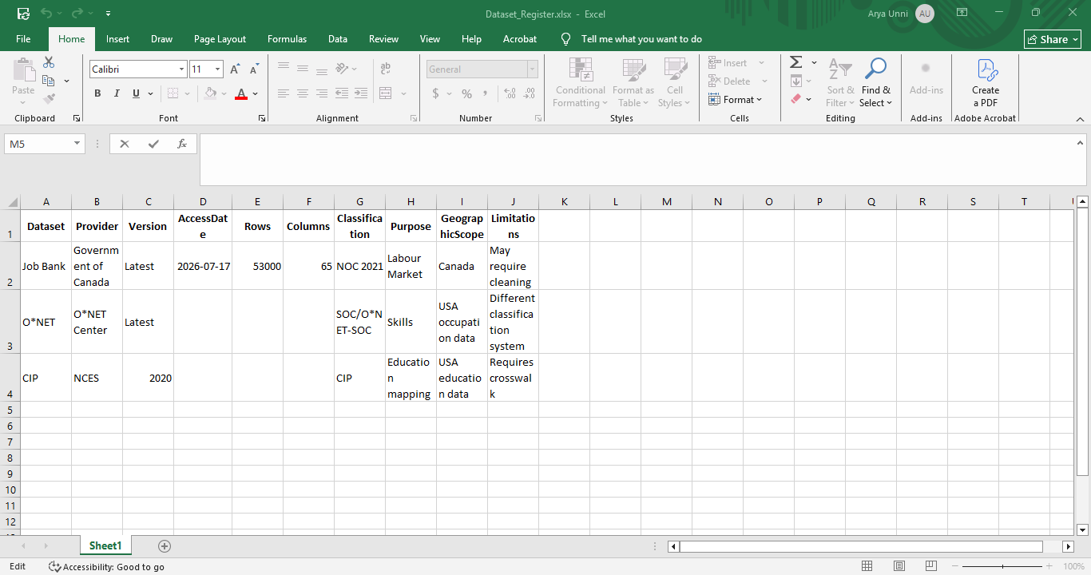
Crosswalk Files
The datasets used in this project are based on different occupational and educational
classification systems. To integrate these datasets accurately, several crosswalk files are
required. A crosswalk file provides a standardized mapping between different classification
systems, allowing information from multiple sources to be linked consistently.
NOC 2021 → NOC 2016
The Government of Canada Job Bank uses the National Occupational Classification (NOC)
2021 system, while some external datasets and mapping resources are based on NOC 2016.
The NOC 2021 to NOC 2016 crosswalk is used to convert the latest Canadian occupational
codes into the previous version, ensuring compatibility with datasets that have not yet been
updated to NOC 2021.
NOC 2016 → SOC 2018
ONET uses the Standard Occupational Classification (SOC) 2018 system rather than the
Canadian NOC classification. The NOC 2016 to SOC 2018 crosswalk is therefore required to
map Canadian occupations to their corresponding SOC codes. This mapping enables the
integration of Canadian labour-market information with detailed occupational data available
in ONET.
SOC 2018 → O*NET-SOC
Although ONET is based on the SOC 2018 classification, it uses a more detailed ONET-SOC
coding system. The SOC 2018 to ONET-SOC crosswalk is used to identify the correct ONET
occupation for each SOC code. This allows the project to retrieve occupation-specific
information such as skills, knowledge, abilities, work activities, education requirements,
tools, and technologies.
CIP 2020 → SOC 2018
The Classification of Instructional Programs (CIP) organizes educational programs, while
SOC classifies occupations. The CIP 2020 to SOC 2018 crosswalk links academic programs
to occupations that graduates commonly pursue. This relationship enables the proposed
system to connect a student's educational background with relevant occupations before
matching those occupations with required skills and current Canadian labour-market demand.
It is important to note that this crosswalk represents an educational pathway rather than a
guaranteed employment outcome.
Overall, these crosswalk files form the foundation for integrating the Government of Canada
Job Bank, O*NET, and CIP datasets into a unified framework. They enable the proposed AI-
powered career recommendation system to connect educational programs, occupational
characteristics, and Canadian labour-market information, ensuring that career
recommendations are accurate, consistent, and evidence-based.
Project Success Criteria
Metric | Target
Top 3 occupation recommendations | 80% accuracy
Skill extraction F1-score | ≥0.75
Semantic model improvement | Better than keyword matching
RAG evidence support | ≥85%

Expected System Outputs
The system is expected to:
• Recommend suitable careers.
• Predict job categories accurately.
• Identify missing technical skills.
• Recommend learning resources.
• Improve resume quality.
• Provide trustworthy AI-generated career guidance.
• Support students in making informed career decisions.

Reference
1.U.S. Department of Labor. (n.d.). ONET database*. O*NET Resource Center.
https://www.onetcenter.org/database.html
2.Government of Canada. (n.d.). Job Bank: Labour market information.
https://www.jobbank.gc.ca/
3.National Center for Education Statistics. (n.d.). Classification of Instructional Programs
(CIP). U.S. Department of Education.
https://nces.ed.gov/ipeds/cipcode/

