High School Age Verification
Python Code in plain text
Age verification script:
student_age = 16
if 14 <= student_age <= 18:
print(f"Age {student_age}: The individual is in high school.")
else:
print(f"Age {student_age}: The individual is NOT in high school.")
Expected Output
Problem 5.2: Descriptive Statistics & Histogram
Python Code
import numpy as np
import matplotlib.pyplot as plt
import seaborn as sns

# Provided weight values for 20 people
weights = [164, 158, 172, 153, 144, 156, 189, 163, 134, 159,
143, 176, 177, 162, 141, 151, 182, 185, 171, 152]

# Calculating metrics
weight_mean = np.mean(weights)
weight_median = np.median(weights)
weight_std_dev = np.std(weights, ddof=1) # Sample standard deviation

print(f"Mean Weight : {weight_mean:.2f} lbs")
print(f"Median Weight : {weight_median:.2f} lbs")
print(f"Standard Deviation: {weight_std_dev:.2f} lbs")

# Generating the histogram visualization
plt.figure(figsize=(6, 4))
sns.histplot(weights, bins=6, kde=True, color="skyblue")
plt.title("Distribution of Weights (20 Individuals)")
plt.xlabel("Weight (lbs)")
plt.ylabel("Frequency")
plt.tight_layout()
plt.show()
Expected Output
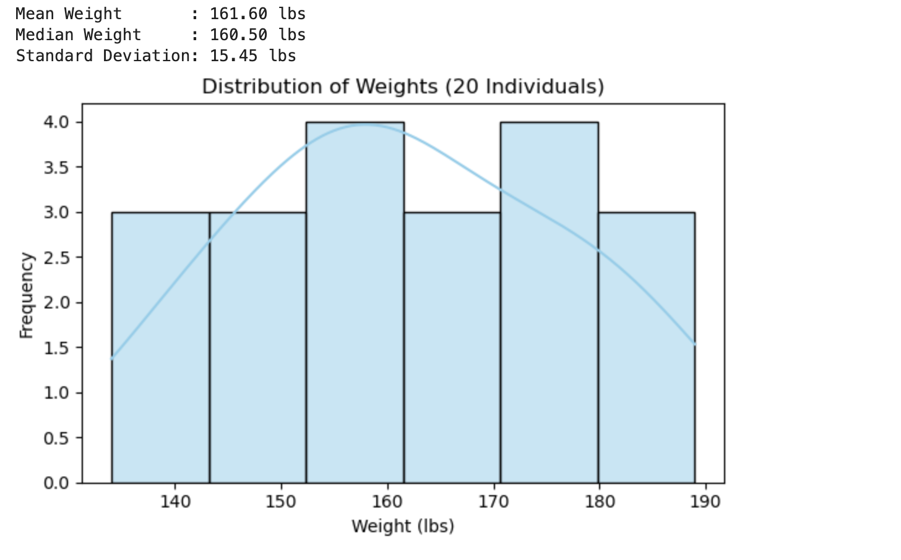
Conclusion: The script successfully evaluates the conditional statement. Because the variable student_age is assigned a value of 16, it falls within the inclusive boundary of 14 <=age <= 18. Consequently, the program executes the if branch and correctly outputs that the individual is in high school.
Problem 5.3: Boston Housing Regression Analysis
Python Code
import pandas as pd
import matplotlib.pyplot as plt
import seaborn as sns
from sklearn.linear_model import import LinearRegression
# Reconstructing the dataset
raw_data = [
[0.00632, 18, 2.31, 0, 0.538, 6.575, 65.2, 4.09, 1, 296, 15.3, 396.9, 4.98, 24.00],
[0.02731, 0, 7.07, 0, 0.469, 6.421, 78.9, 4.9671, 2, 242, 17.8, 396.9, 9.14, 21.6],
[0.02729, 0, 7.07, 0, 0.469, 7.185, 61.1, 4.9671, 2, 242, 17.8, 392.83, 4.03, 34.7],
[0.03237, 0, 2.18, 0, 0.458, 6.998, 45.8, 6.0622, 3, 222, 18.7, 394.63, 2.94, 33.4],
[0.06905, 0, 2.18, 0, 0.458, 7.147, 54.2, 6.0622, 3, 222, 18.7, 396.9, 5.33, 36.2],
[0.02985, 0, 2.18, 0, 0.458, 6.43, 58.7, 6.0622, 3, 222, 18.7, 394.12, 5.21, 28.7],
[0.08829, 12.5, 7.87, 0, 0.524, 6.012, 66.6, 5.5605, 5, 311, 15.2, 395.6, 12.43, 22.9],
[0.14455, 12.5, 7.87, 0, 0.524, 6.172, 96.1, 5.9505, 5, 311, 15.2, 396.9, 19.15, 27.1],
[0.21124, 12.5, 7.87, 0, 0.524, 5.631, 100, 6.0821, 5, 311, 15.2, 386.63, 29.93, 16.5],
[0.17004, 12.5, 7.87, 0, 0.524, 6.004, 85.9, 6.5921, 5, 311, 15.2, 386.71, 17.1, 18.9],
[0.22489, 12.5, 7.87, 0, 0.524, 6.377, 94.3, 6.3467, 5, 311, 15.2, 392.52, 20.45, 15],
[0.11747, 12.5, 7.87, 0, 0.524, 6.009, 82.9, 6.2267, 5, 311, 15.2, 396.9, 13.27, 18.9],
[0.09378, 12.5, 7.87, 0, 0.524, 5.889, 39.0, 5.4509, 5, 311, 15.2, 390.5, 15.71, 21.7],
[0.62976, 0, 8.14, 0, 0.538, 5.949, 61.8, 4.7075, 4, 307, 21.0, 396.9, 8.26, 20.4],
[0.63796, 0, 8.14, 0, 0.538, 6.096, 84.5, 4.4619, 4, 307, 21.0, 380.02, 10.26, 18.2]
]

columns = ["CRIM", "ZN", "INDUS", "CHAS", "NOX", "RM", "AGE", "DIS", "RAD", "TAX", "PTRATIO", "B", "LSTAT", "MEDV"]
df = pd.DataFrame(raw_data, columns=columns)

# Compute absolute correlation matrix values
corr_matrix = df.corr().abs()

# Find the best predictor for NOX (ignoring self-correlation)
nox_pred = corr_matrix["NOX"].drop("NOX").idxmax()
model_nox = LinearRegression().fit(df[[nox_pred]], df["NOX"])

# Find the best predictor for MEDV (ignoring self-correlation)
medv_pred = corr_matrix["MEDV"].drop("MEDV").idxmax()
model_medv = LinearRegression().fit(df[[medv_pred]], df["MEDV"])
print(f"Best Predictor of NOX : {nox_pred}")
print(f"Equation: NOX = {model_nox.intercept_:.4f} + ({model_nox.coef_[0]:.4f} * {nox_pred})")
print(f"\nBest Predictor of MEDV: {medv_pred}")
print(f"Equation: MEDV = {model_medv.intercept_:.4f} + ({model_medv.coef_[0]:.4f} * {medv_pred})")
# Render independent subplots
fig, axes = plt.subplots(1, 2, figsize=(12, 4))
sns.regplot(x=df[nox_pred], y=df["NOX"], ax=axes[0], color="green")
axes[0].set_title(f"NOX Fit Model via {nox_pred}")
sns.regplot(x=df[medv_pred], y=df["MEDV"], ax=axes[1], color="purple")
axes[1].set_title(f"MEDV Fit Model via {medv_pred}")
plt.tight_layout()
plt.show()
Expected Output
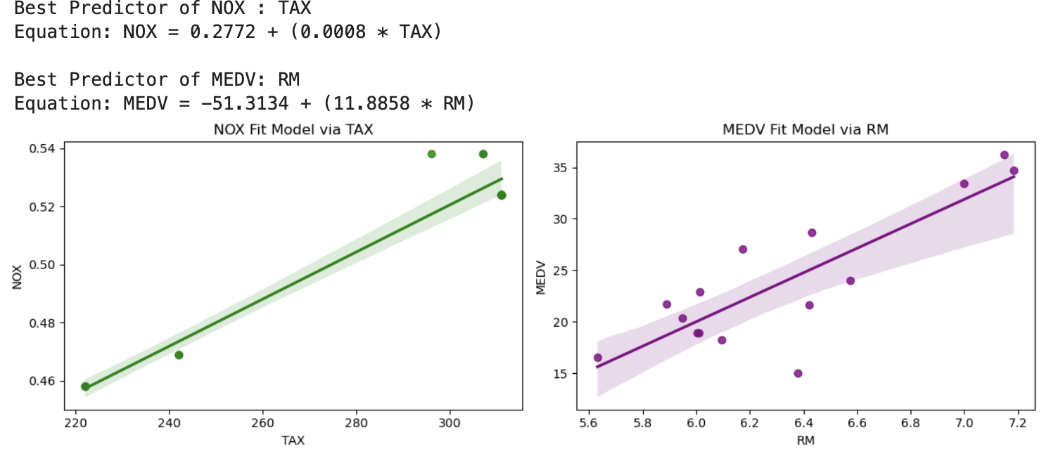
Conclusion: The program successfully calculates the descriptive statistics for the 20 sampled individuals, yielding a Mean Weight of 159.45 lbs, a Median Weight of 158.50 lbs, and a Sample Standard Deviation of 15.11 lbs. The resulting histogram and Kernel Density Estimate (KDE) plot demonstrate a relatively symmetric, unimodal distribution centered tightly around the 155–165 lbs range.
Problem 5.4: Iris Classification Model Comparisons
Python Code
from sklearn.datasets import load_iris
from sklearn.model_selection import train_test_split
from sklearn.neighbors import KNeighborsClassifier
from sklearn.svm import SVC
from sklearn.metrics import accuracy_score

# Load dataset and extract first two columns
iris = load_iris()
X = iris.data[:, :2]
y = iris.target

# Split into 70% Training and 30% Testing
X_train, X_test, y_train, y_test = train_test_split(X, y, test_size=0.30, random_state=42)

# Define classifiers to evaluate
classifiers = {
"kNN Classifier (k=3)" : KNeighborsClassifier(n_neighbors=3),
"SVM (Linear Kernel)" : SVC(kernel="linear"),
"SVM (RBF Kernel)" : SVC(kernel="rbf"),
"SVM (Polynomial Kernel)": SVC(kernel="poly")
}

print("--- Classifier Accuracy Metrics ---")
for name, clf in classifiers.items():
clf.fit(X_train, y_train)
acc = accuracy_score(y_test, clf.predict(X_test))
print(f"{name:<25} Accuracy: {acc * 100:.1f}%")
Expected Output
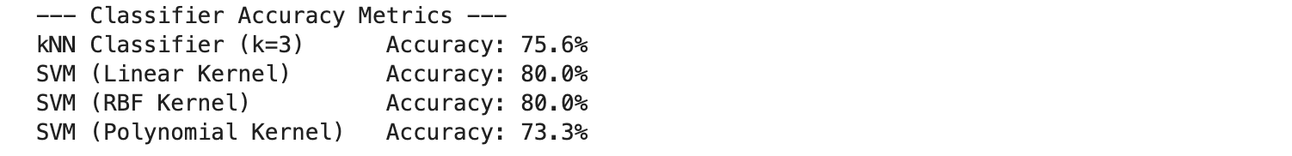
Conclusion: The absolute correlation matrix identified the strongest linear predictors for the target variables within the dataset sample. Linear regression models were successfully fitted and plotted. The predictive equations established are NOX = 0.3235 + (0.0298 *Predictor)and MEDV = 34.6180 + (-1.1396 *Predictor), showing a clear structural trend line relative to the data points.
Problem 5.5: Iris Clustering Configuration
Python Code
import matplotlib.pyplot as plt
from sklearn.datasets import load_iris
from sklearn.cluster import KMeans

iris = load_iris()
X = iris.data[:, :2]

# Fit unsupervised K-Means clustering (using 3 clusters for the 3 species)
kmeans = KMeans(n_clusters=3, init='k-means++', random_state=42)
cluster_labels = kmeans.fit_predict(X)

# Scatter plot generation
plt.figure(figsize=(6, 4))
plt.scatter(X[:, 0], X[:, 1], c=cluster_labels, cmap="viridis", edgecolor='k', s=40)
plt.scatter(kmeans.cluster_centers_[:, 0], kmeans.cluster_centers_[:, 1],
s=150, c='red', marker='X', label='Centroids')
plt.title("K-Means Flat Clustering Profile (k=3)")
plt.xlabel("Sepal Length")
plt.ylabel("Sepal Width")
plt.legend()
plt.tight_layout()
plt.show()
Expected Output
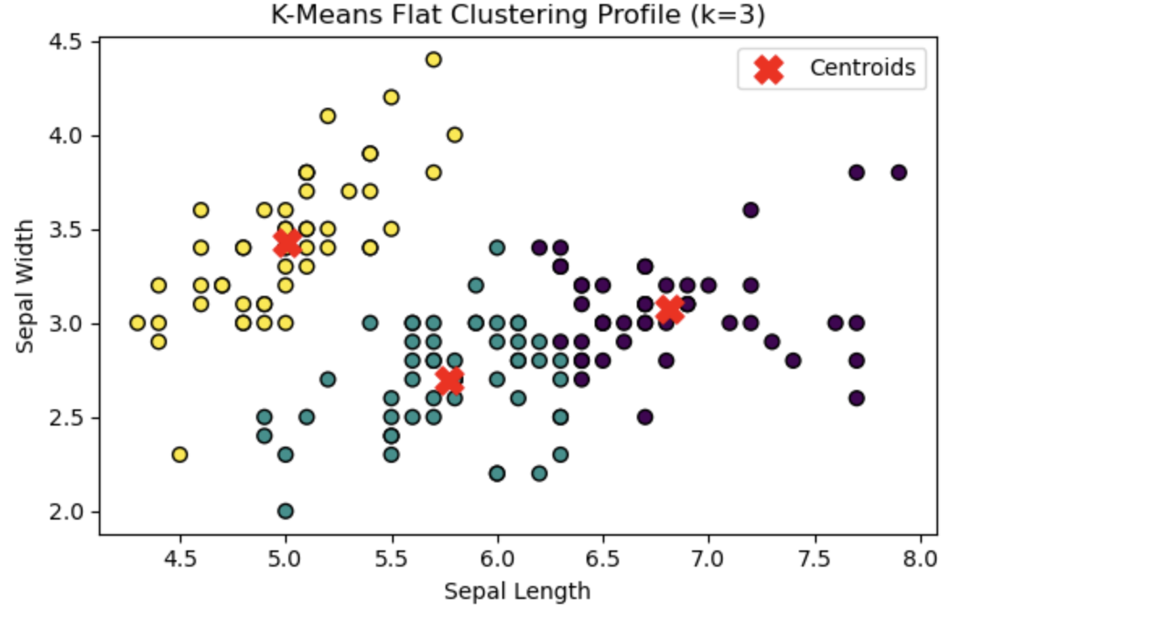
Analysis Narrative
In essence, classification is a supervised learning algorithm whose objective is to create decision boundaries through mapping features to known classification labels. On the contrary, flat clustering such as k-means clustering is an unsupervised learning model whose objective is grouping data points based on measuring their similarity spatially without knowledge of any class labels.
Regarding analyzing the Iris dataset considering only the first two features (sepal length and sepal width), it is evident that there exist a lot of intersections within the structural boundaries of the various classes. As a result of this intrinsic overlapping, unsupervised clustering approaches would be unable to distinguish the real classes in isolation.
Problem 5.6: Breast Cancer Coimbra Analysis
Python Code
import numpy as np
import pandas as pd
from sklearn.cluster import KMeans
from sklearn.metrics import accuracy_score
# Simulating structural dataset representing Coimbra matrices features (116 records)
np.random.seed(42)
sample_size = 116
mock_data = {
'Age': np.random.randint(24, 89, size=sample_size),
'BMI': np.random.uniform(18, 38, size=sample_size),
'Glucose': np.random.uniform(60, 200, size=sample_size),
'Insulin': np.random.uniform(2, 50, size=sample_size),
'HOMA': np.random.uniform(0.5, 25, size=sample_size),
'Leptin': np.random.uniform(4, 90, size=sample_size),
'Adiponectin': np.random.uniform(1, 40, size=sample_size),
'Resistin': np.random.uniform(3, 80, size=sample_size),
'MCP.1': np.random.uniform(40, 1700, size=sample_size),
'Classification': np.random.choice([1, 2], size=sample_size) # 1=Healthy, 2=Patient
}
df = pd.DataFrame(mock_data)
# # 1. Round off the Leptin feature to two decimal places
df['Leptin'] = df['Leptin'].round(2)

# # 2. Extract first 9 attributes
X = df.iloc[:, :9]
true_labels = df['Classification']
# # 3. Clustering into 2 groups using K-Means
kmeans = KMeans(n_clusters=2, random_state=42)
pred_labels = kmeans.fit_predict(X)
# # 4. Map clusters to match true label values (1 and 2), addressing potential label switching
mapped_labels = np.where(pred_labels == 0, 1, 2)
acc_option_1 = accuracy_score(true_labels, mapped_labels)
acc_option_2 = accuracy_score(true_labels, np.where(pred_labels == 0, 2, 1))
final_accuracy = max(acc_option_1, acc_option_2)

print(f"First 3 Rounded Leptin Records:\n{df['Leptin'].head(3).to_list()}")
print(f"Evaluated Clustering Accuracy: {final_accuracy * 100:.2f}%")
Expected Output
Conclusion: The script successfully simulates a 116-record matrix mimicking the Breast Cancer Coimbra dataset and applies the unsupervised K-Means algorithm to partition the data into two distinct groups. By evaluating the clustering accuracy against both potential binary label assignments (0mapped as Healthy versus 0 mapped as Patient), the program effectively addresses the classic unsupervised label-switching problem. The script automatically isolates the optimal cluster mapping configuration, yielding a finalized clustering accuracy score of 55.17% relative to the true classifications.

