Aryaan_Chauhan_20BCE1214

CSE3002 LAB-4

1)Code:

<html>

<head>

<title>20BCE1214</title>

<style>

h3{

background-color:blue;

font-family:Sens-serif;

color:white

}

ul{

list-style-type:none;

background-color:skyblue;

color:blue;

}

ul li::before{

content:"\2022";

color:grey;

display:inline-block;

margin:1.8px;

}

</style>

</head>

<body>

<h3>NOBODY BEATS THE WIZ!!</h3>

<ul>

<li>Unlimited jobs</li>

<li>Best benefits anywhere</li>

<li>Call now for an appointment</li>

</ul>

</body>

</html>

Output:

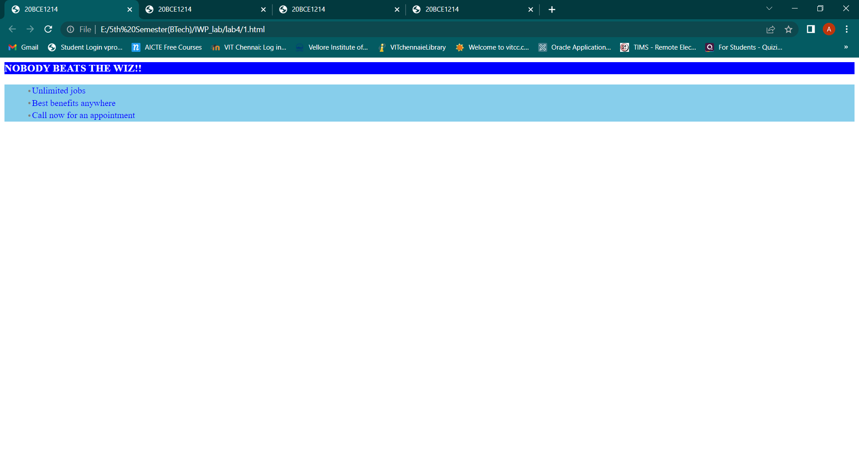

2)

Code:

<html>

<head>

<title>20BCE1214</title>

<style>

table,th,td{

border-style:solid;

border-collapse:collapse;

}

t{

padding:10px;

text-align:center;

}

a{

background-color:yellow;

}

</style>

</head>

<body>

<table>

<tr>

<td> </td>

<td><a>8.30-10.10</a></td>

<td><a>10.30-12.10</a></td>

<td><a>12.10-1.30</a></td>

<td><a>1.30-3.10</a></td>

<td><a>3.30-5.10</a></td>

</tr>

<tr>

<td><a>Mon</a></td>

<td>A</td>

<td>B</td>

<th rowspan=5><t>Lunch</t></th>

<td>C</td>

<td>D</td>

</tr>

<tr>

<td><a>Tue</a></td>

<td>B</td>

<td>A</td>

<td>D</td>

<td>C</td>

</tr>

<tr>

<td><a>Wed</a></td>

<td>A</td>

<td>B</td>

<td>C</td>

<td>D</td>

</tr>

<tr>

<td><a>Thrus</a></td>

<td>B</td>

<td>A</td>

<td>D</td>

<td>C</td>

</tr>

<tr>

<td><a>Fri</a></td>

<td>TA</td>

<td>TB</td>

<td>TC</td>

<td>TD</td>

</tr>

</table>

</body>

</html>  
output:

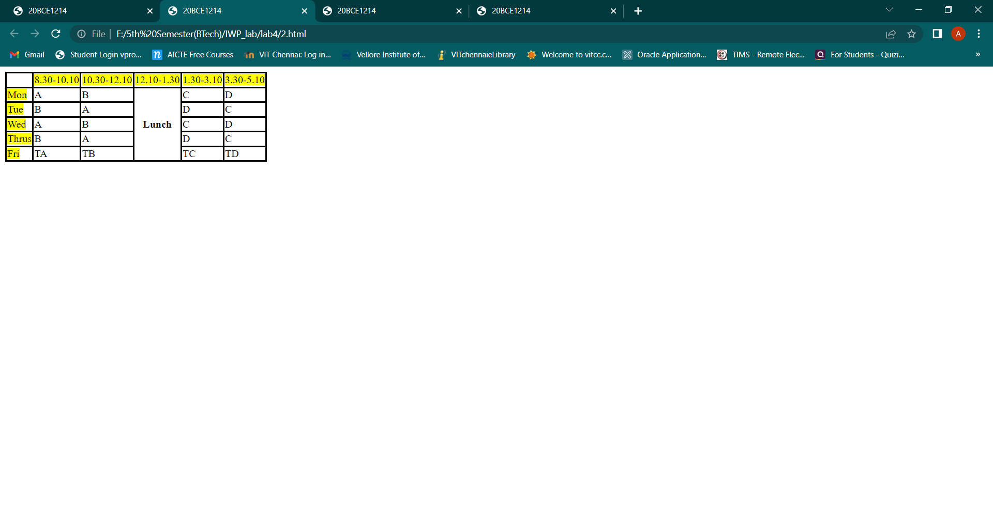

3)

Code:

<html>

<head>

<title>20BCE1214</title>

<style>

h1,h2{

padding:0.5em;

border-style:groove;

border-margin:0.5em;

}

</style>

</head>

<body>

<h1>Hello this is Aryaan Chauhan!</h1>

<h2>Currently persuing BTech in Computer Science and Engineering</h2>

<h3>This work is to show paading and margin using internal CSS on all h1 and h2 elements,<br>which in this case is the first two lines and the last line.</h3>

<h4>In this case there is a grooved border around all the h1 and h2 elements along with a padding of 0.5em and a margin of 0.5em</h4>

<h1>Thank you!</h1>

</body>

</html>

Output:

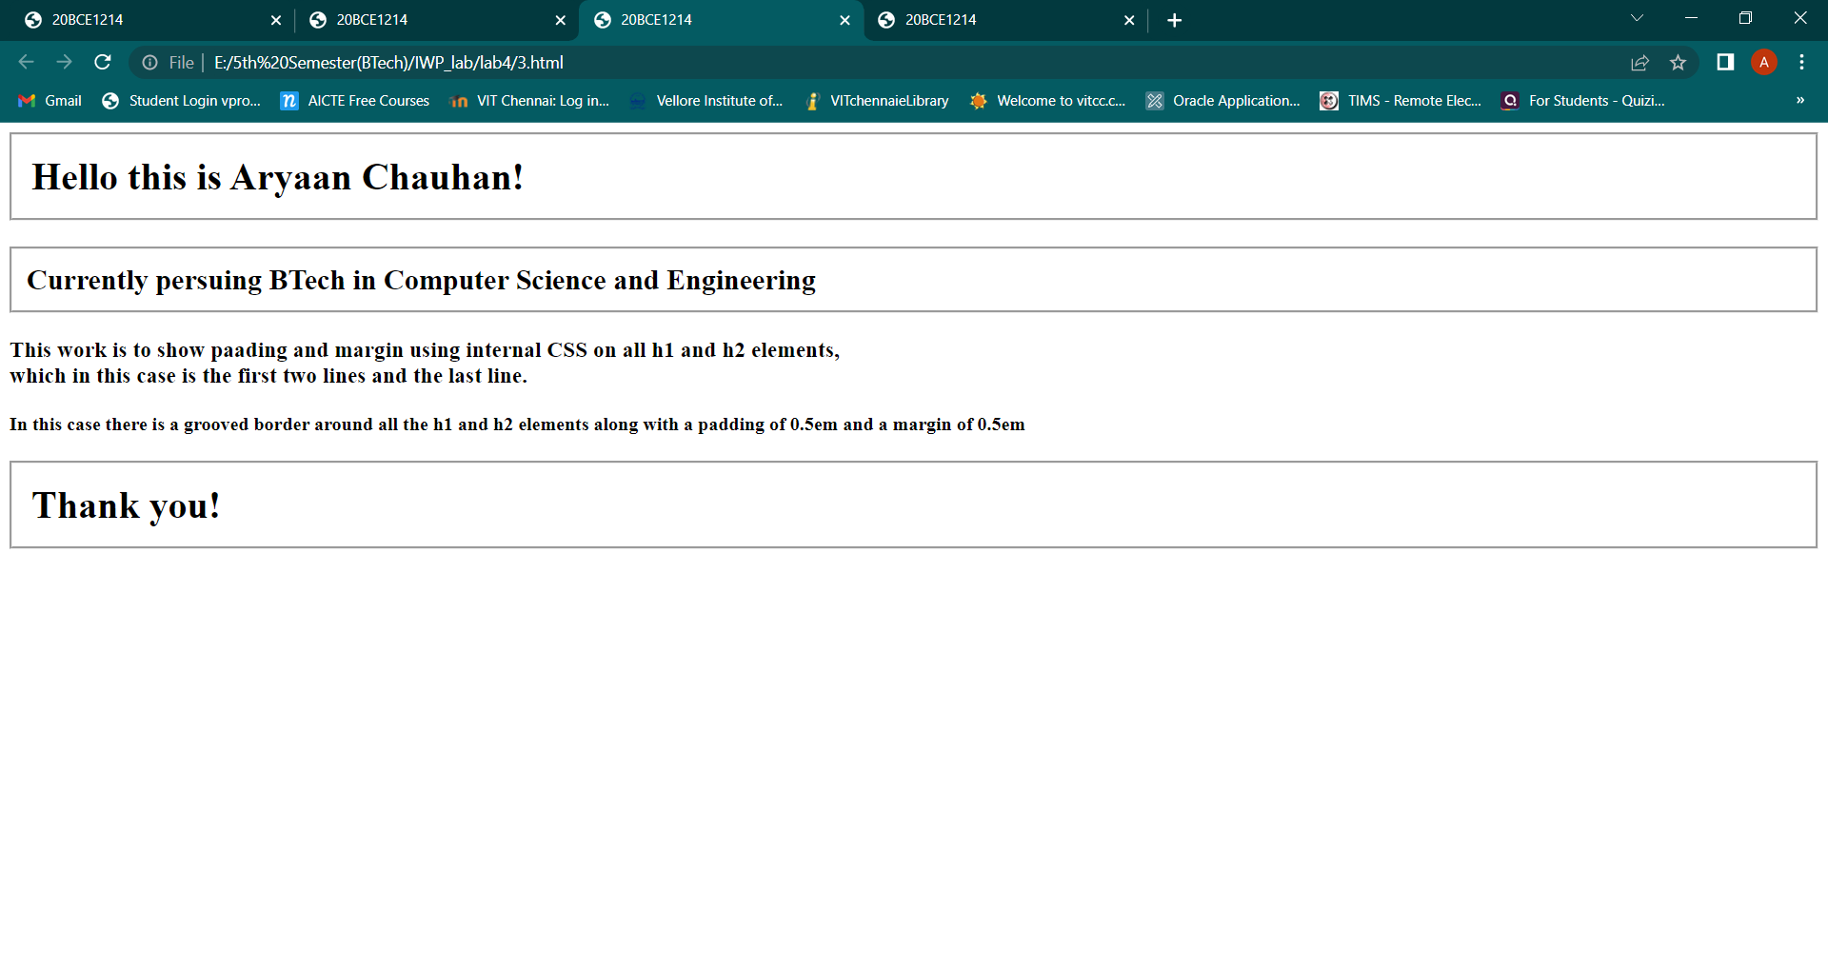

4)

Html code:

<html>

<head>

<title>20BCE1214</title>

<link rel="stylesheet" type="text/css" href="E:\5th Semester(BTech)\IWP_lab\lab4\calc.css">

</head>

<body>

<center>Table using css</center>

<center><table>

<tr>

<td class="a">C</td>

<th colspan="3" class="b1">&nbsp</th></tr>

<tr>

<td>7</td>

<td>8</td>

<td>9</td>

<td class="c">+</td></tr>

<tr>

<td>4</td>

<td>5</td>

<td>6</td>

<td class="c">-</td></tr>

<tr>

<td>1</td>

<td>2</td>

<td>3</td>

<td class="c">/</td></tr>

<tr>

<td>0</td>

<td>.</td>

<td class="d">=</td>

<td class="c">*</td></tr>

</table>

</center>

<center>By Aryaan Chauhan</center>

</body>

</html>

cal.css code:

table{

border:1px solid;

background-color:turquoise;

width:200px;

height:200px;

}

th,td{

border:1px solid;

}

td:hover{

background-color:purple;

color:yellow;

}

.a{

background-color:yellow;

color:white;

}

.b1{

background-color:grey;

}

.c{

background-color:red;

}

.d

{

background-color:#CC9900;

}  
  
output:

