20BCE1214 Aryaan Chauhan IWP LAB-9

1)

Code

The html file  
<html>

<head>

<title>Q1-lab9</title>

</head>

<body>

<form method="post", action="l9q1h.php">

<input type="text" name="data1"><br>

<input type="text" name="data2"><br>

<input type="text" name="data3"><br>

<input type="text" name="data4"><br>

<input type="text" name="data5"><br>

<input type="text" name="data6"><br>

<input type="text" name="data7"><br>

<input type="text" name="data8"><br>

<input type="text" name="data9"><br>

<input type="text" name="data10"><br>

<input type="text" name="data11"><br>

<input type="text" name="data12"><br>

<input type="text" name="data13"><br>

<input type="text" name="data14"><br>

<input type="text" name="data15"><br>

<input type="text" name="data16"><br>

<input type="text" name="data17"><br>

<input type="text" name="data18"><br>

<input type="text" name="data19"><br>

<input type="text" name="data20"><br>

<input type="submit" name="submit">

</form>

</body>

</html>

The l9q1h.php

<?php

if(isset($_POST['submit']))

{

echo "write ID, name Qualification and designation of 5 employees\n<br>";

$s1="";

$s2="";

$s3="";

$s4="";

$s5="";

$id1=$_POST['data1'];

$na1=$_POST['data2'];

$qa1=$_POST['data3'];

$de1=$_POST['data4'];

$s1=$s1.$id1." - ".$na1." - ".$qa1." - ".$de1;

echo $s1."<br>";

$id2=$_POST['data5'];

$na2=$_POST['data6'];

$qa2=$_POST['data7'];

$de2=$_POST['data8'];

$s2=$s2.$id2." - ".$na2." - ".$qa2." - ".$de2;

echo $s2."<br>";

$id3=$_POST['data9'];

$na3=$_POST['data10'];

$qa3=$_POST['data11'];

$de3=$_POST['data12'];

$s3=$s3.$id3." - ".$na3." - ".$qa3." - ".$de3;

echo $s3."<br>";

$id4=$_POST['data13'];

$na4=$_POST['data14'];

$qa4=$_POST['data15'];

$de4=$_POST['data16'];

$s4=$s4.$id4." - ".$na4." - ".$qa4." - ".$de4;

echo $s4."<br>";

$id5=$_POST['data17'];

$na5=$_POST['data18'];

$qa5=$_POST['data19'];

$de5=$_POST['data20'];

$s5=$s5.$id5." - ".$na5." - ".$qa5." - ".$de5;

echo $s5."<br>";

}

$handle=fopen('employee.txt','w');

fwrite($handle,"ID-Name-Qualification-Designation\n");

fwrite($handle,"$id1-");

fwrite($handle,"$na1-");

fwrite($handle,"$qa1-");

fwrite($handle,"$de1\n");

fwrite($handle,"$id2-");

fwrite($handle,"$na2-");

fwrite($handle,"$qa2-");

fwrite($handle,"$de2\n");

fwrite($handle,"$id3-");

fwrite($handle,"$na3-");

fwrite($handle,"$qa3-");

fwrite($handle,"$de3\n");

fwrite($handle,"$id4-");

fwrite($handle,"$na4-");

fwrite($handle,"$qa4-");

fwrite($handle,"$de4\n");

fwrite($handle,"$id5-");

fwrite($handle,"$na5-");

fwrite($handle,"$qa5-");

fwrite($handle,"$de5\n");

copy('employee.txt','copyofemployee.txt');

rename('copyofemployee.txt','copy_1.txt');

fclose($handle);

?>

Output: Consisting of command prompt, file employee.txt and copyofemployee.txt renamed to copy_1.txt and out put on web page

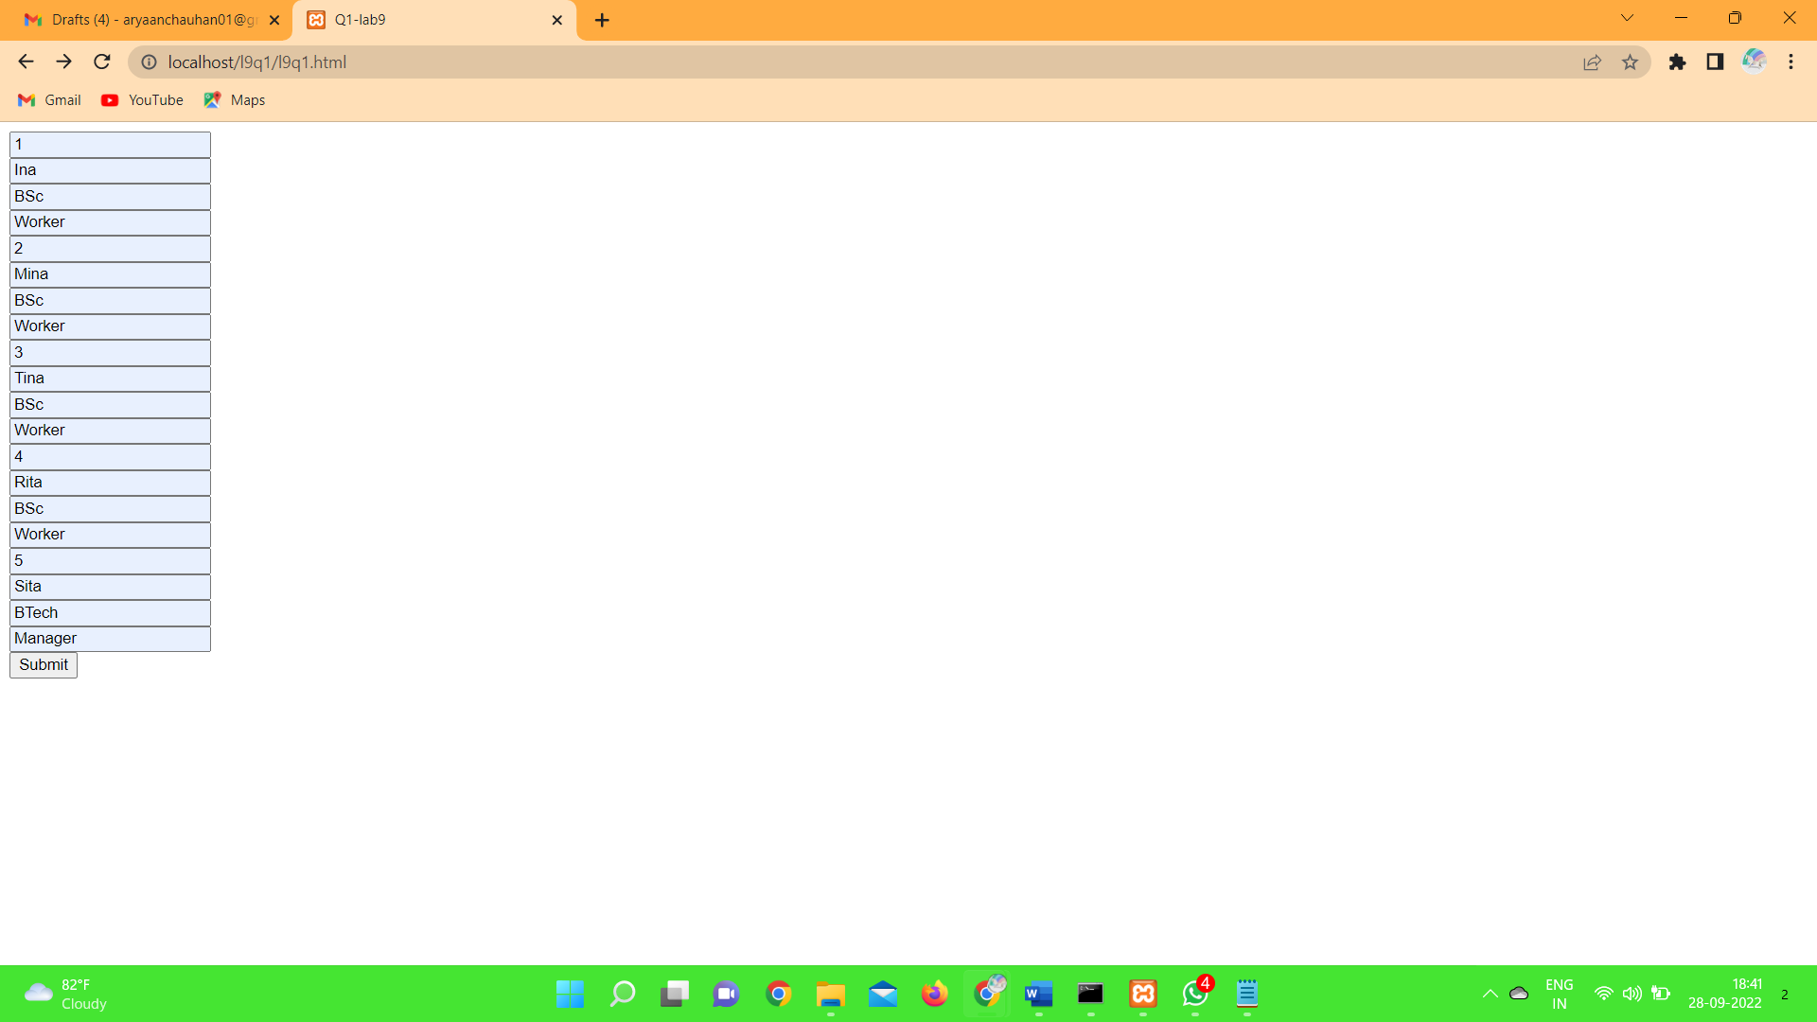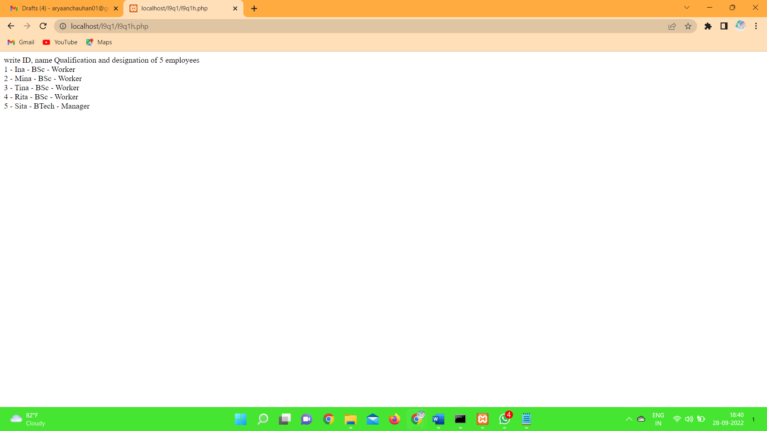

Below is the snap shot with files employee.txt and the renamed copied file copy_1.txt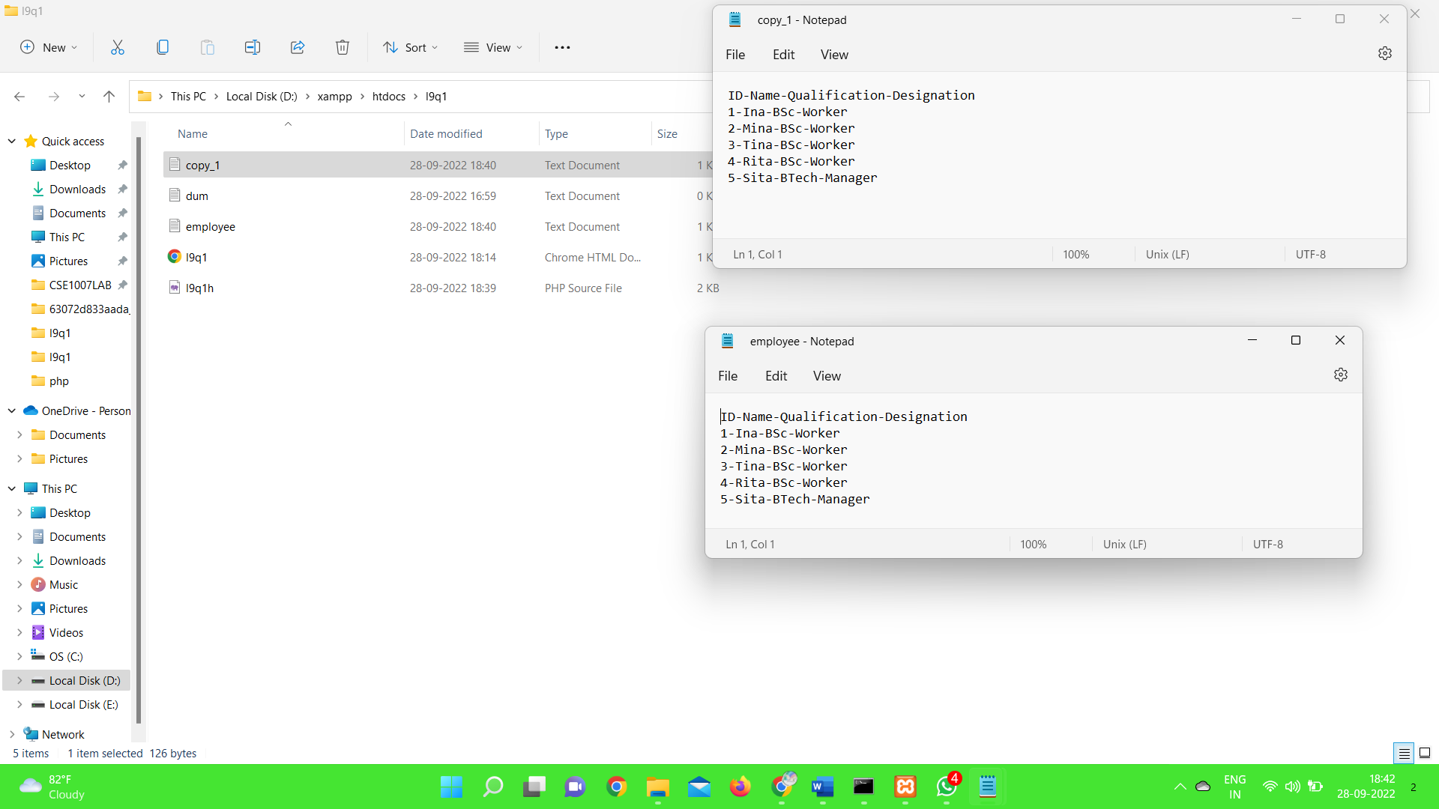

2)

Code:

Html file:

<html>

<head>

<title>Q2</title>

</head>

<body>

<form method="post", action="l9q2p.php", enctype="multipart/form-data">

<input type="text" name="data1"><br>

<input type="number" name="data2"><br>

<input type="number" name="data3"><br>

<input type="number" name="data4"><br>

<input type="file" name="filleToUpload" id="fileToUpload"><br>

<input type="submit" name="submit">

</form>

</body>

</html>

Php code:

<?php

if(isset($_POST['submit']))

{

$a=$_POST['data1'];

$b=$_POST['data2'];

$i=$_POST['data3'];

$c=$_POST['data4'];

$d1=$i*(0.3);

$d2=$c*(0.2);

$d3=sqrt($b);

$e=$d1+$d2-$d3;

echo "Extra bonus points =".$e;

$handle=fopen('data.txt','w');

fwrite($handle,$e);

$target_dir="uploads/";

$target_file=$target_dir.basename($_FILES["fileToUpload"]["name"]);

$uploadOk=1;

if(file_exists($target_file))

{

echo "sorry,file already exists";

$uploadOk=0;

}

else

{

echo "file ".htmlspecialchars(basename($_FILES["fileToUpload"]["name"]))." is uploaded.";

}

fclose($handle);

}

?>

Output:

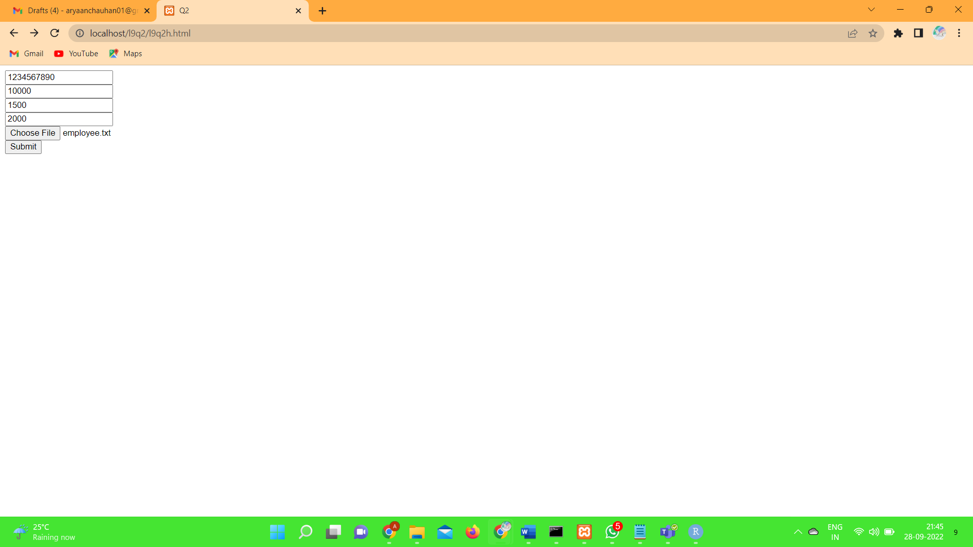

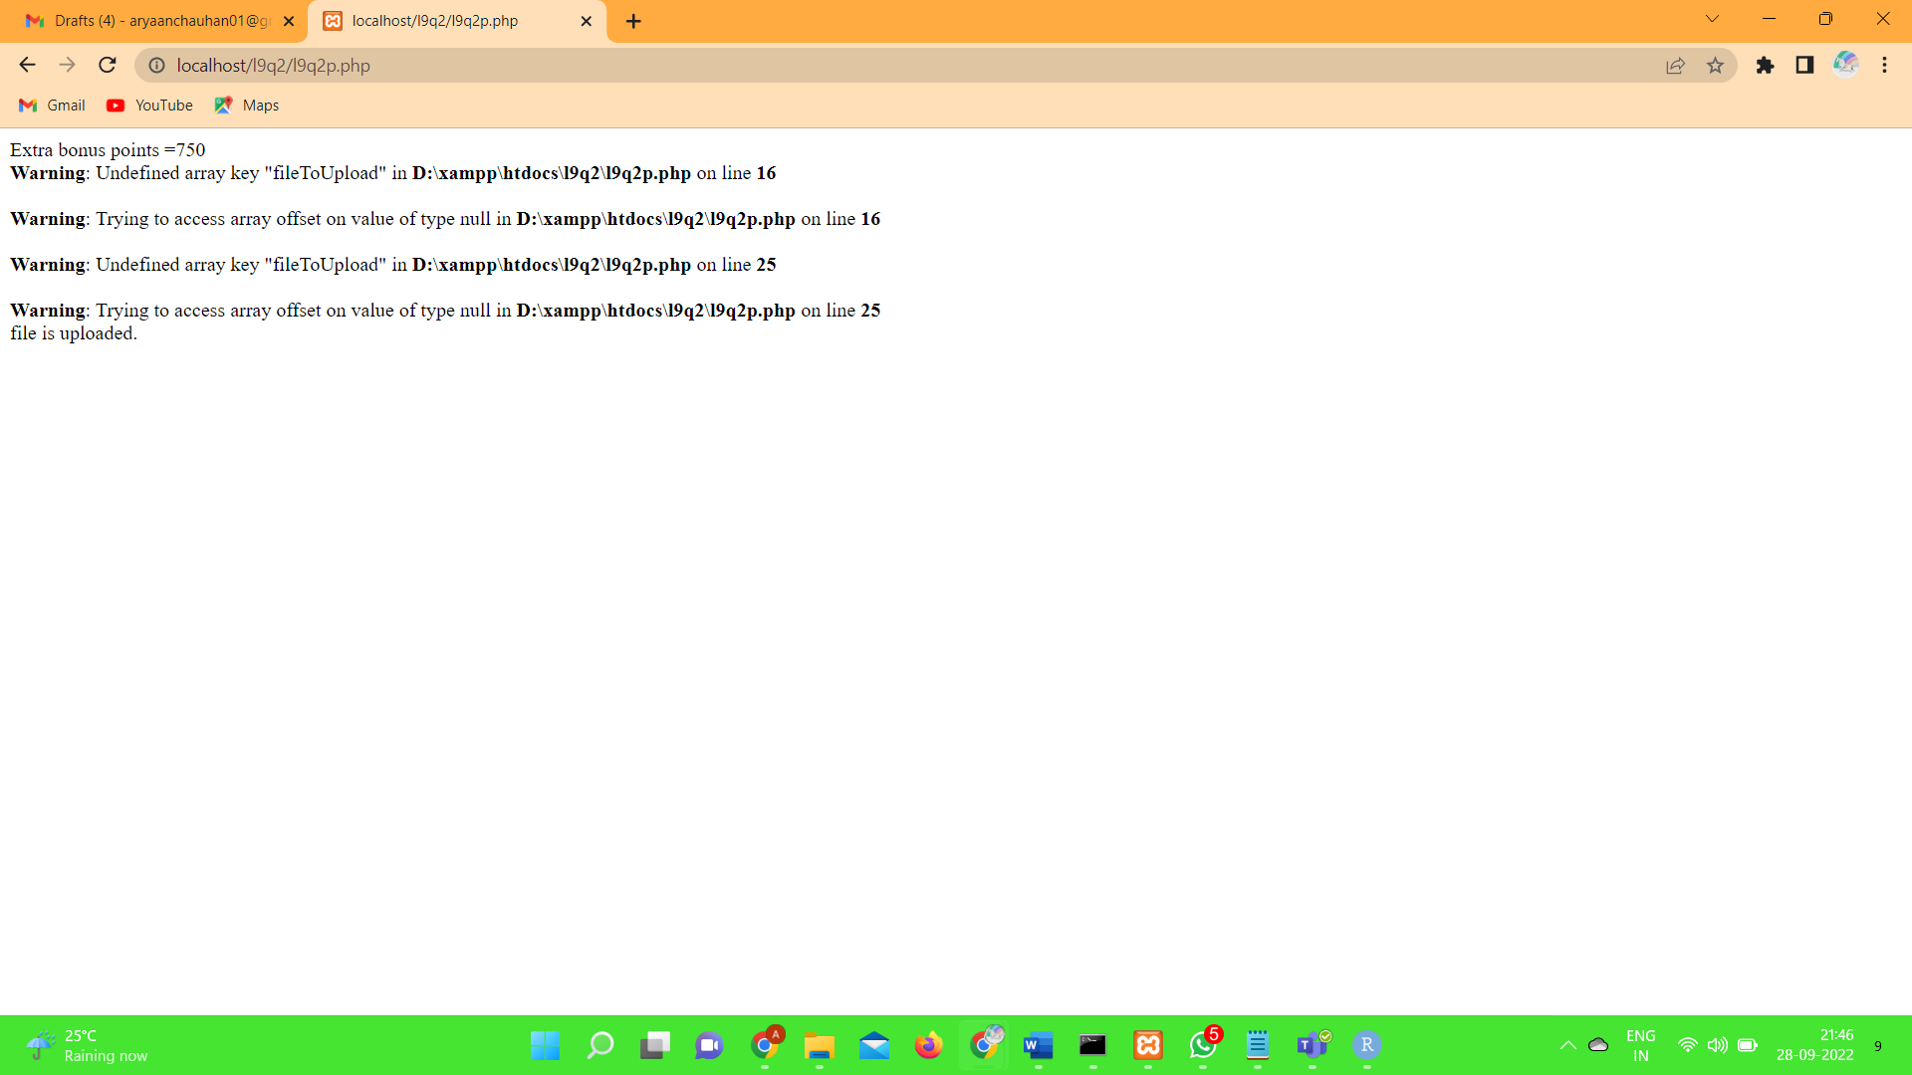

The created file is below data.txt:

