4. Practice the following with data.table by giving illustrative examples

1. with, which

with:

q1<-flights[with(flights,dep_time>530),]

View(q1)

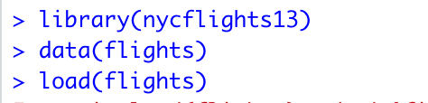

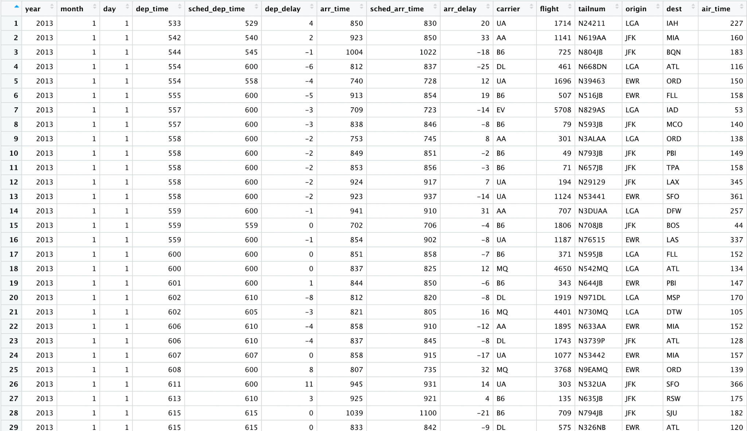

which:

q11<-flights[with(flights,month==2),]

View(q11)

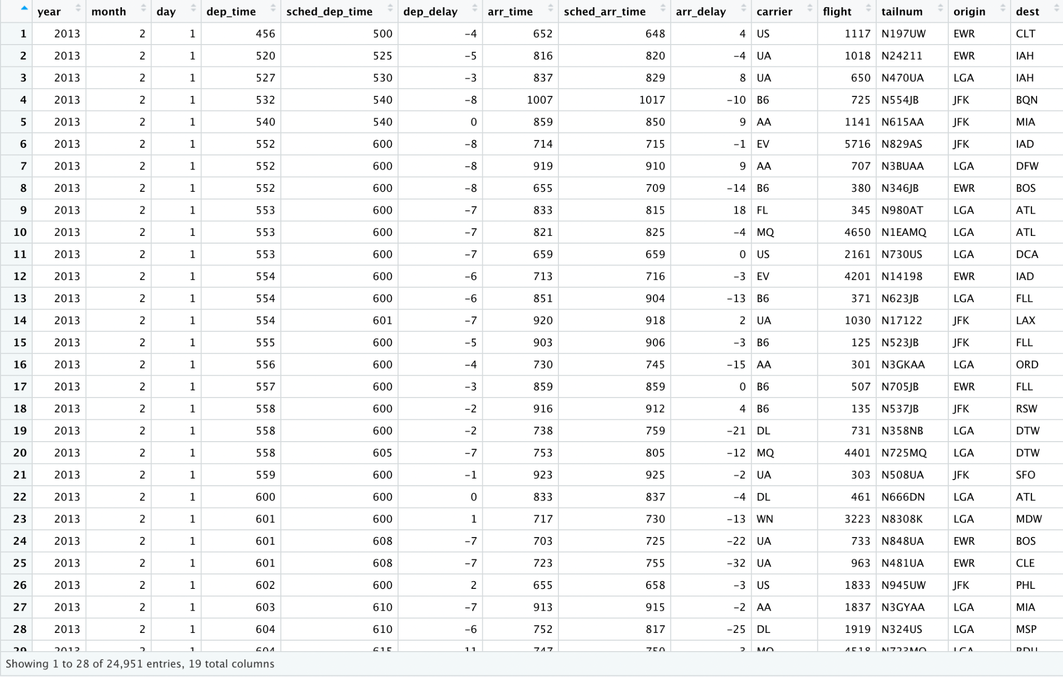

1. allow.cartesian

allow.cartesian:

require(data.table)

DT1 <- data.table(x=rep(letters[1:2], c(1e2, 1e7)), y=1L, key="x")

DT2 <- data.table(x=rep("b", 3), key="x")

dim(DT1[DT2, allow.cartesian=TRUE])

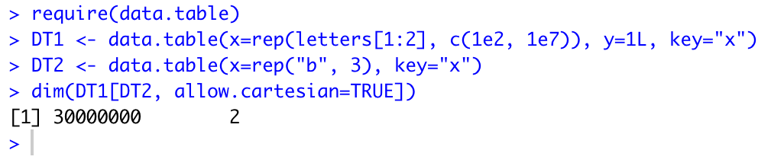

1. roll, rollends

roll:

DT <- data.table(x=rep(c("b","a","c"),each=3), y=c(1,3,6), v=1:9)

DT[.("a", 1:2), on=c("x", "y"), roll=Inf]

DT[.("a", 1:2), on=.(x, y), roll=-Inf]

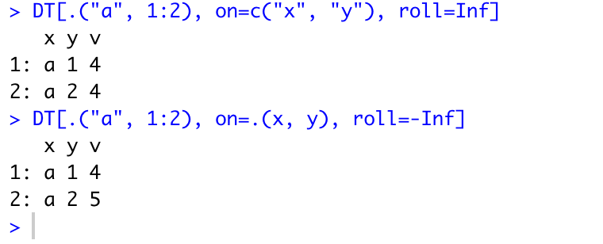

rollends:

DT[.("a", 1:2), on=c("x", "y"), roll=Inf, rollends=c(F,T)]

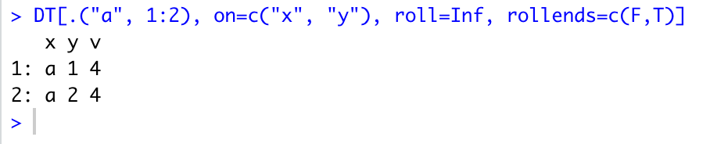

1. .SD, .SDcols

.SD

mtcars = data.table(mtcars)

mtcars[ , lapply(.SD, mean), by = cyl]

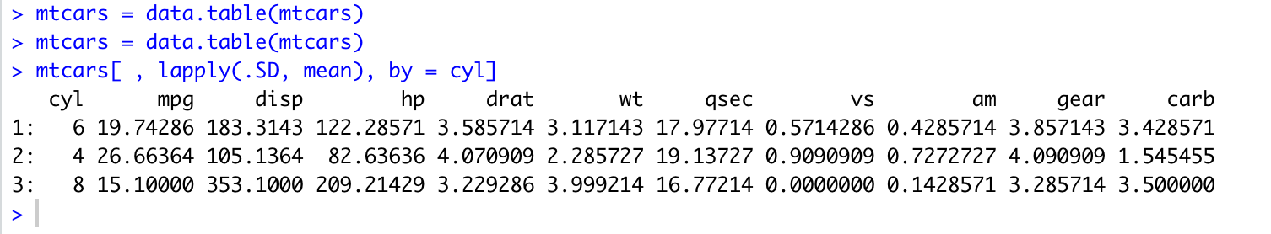

.SDcols

cols <- c("mpg", "disp", "hp", "drat", "wt", "qsec")

mtcars[ , lapply(.SD, mean), .SDcols = cols]

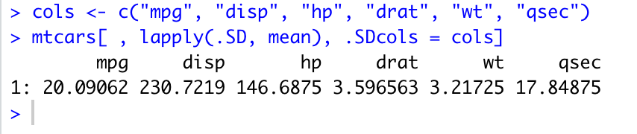

1. on, mult, nomatch

on:

DT <- data.table(x=rep(c("b","a","c"),each=3), y=c(1,3,6), v=1:9)

DT

DT["a", on="x"]

DT["a", on=.(x)]

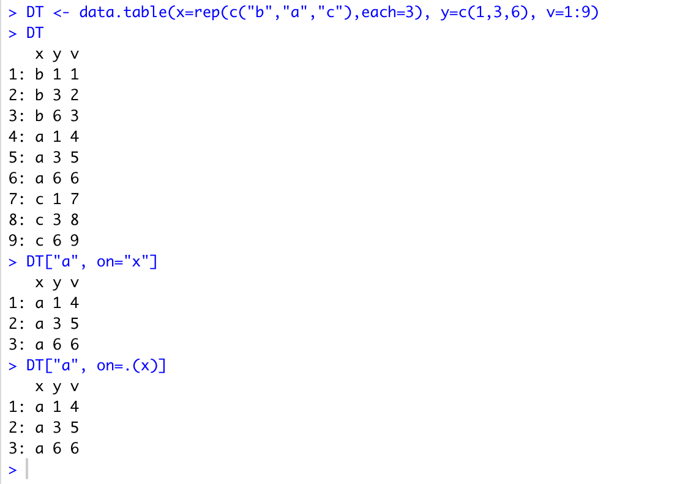

mult:

X = data.table(x=c("c","b"), v=8:7, foo=c(4,2))

DT[X, on="x", mult="first"]

DT[X, on="x", mult="last"]

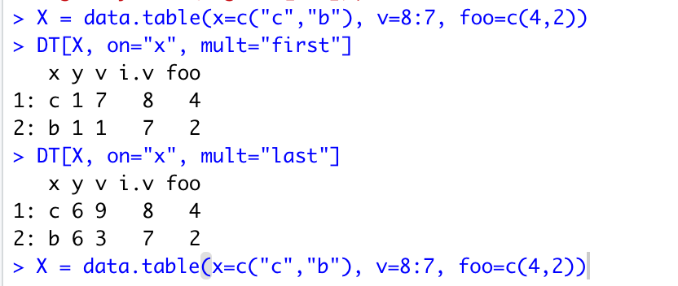

nomatch:

DT[.("b", 1:2), on=.(x, y), nomatch=NULL]