Name – Aditya Bhardwaj
Register No – 20BCE1216
Date – 27-09-2022
Lab – 8
#Use the newsurvey data obtained by cleaning ‘na’ values in survey data of MASS package to do the following:
install.packages("MASS")
library(MASS)
df <- survey
newdf <- na.omit(df)
newdf
#1. Find the range of students’ age participated in the survey.
range(newdf$Age)
#min age
mn = min(newdf$Age, na.rm=TRUE)
mn
#max age
mx = max(newdf$Age, na.rm=TRUE)
mx
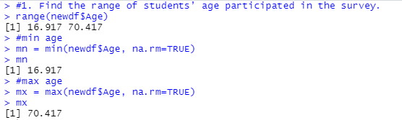
#2 Break the age range into non-overlapping sub-intervals by defining a sequence of equal distance break points of 10 by rounding the range to nearest integer.
ranges = as.data.frame(table(cut(newdf$Age,seq(mn,mx,10))))
ranges$Var1
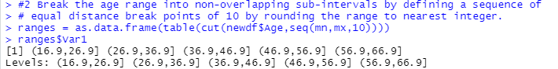

#3 Find the distribution of the age range according to the sub-intervals with cut with its right boundary opened. Display it in column form.
as.data.frame(table(cut(newdf$Age,seq(mn,mx,10))))
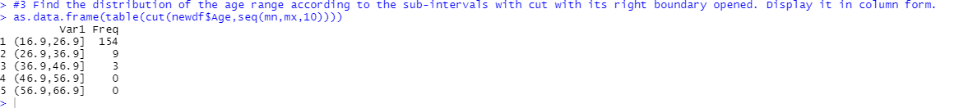

#4 Which age range of students has mostly participated in the survey.
ranges$Var1[which.max(ranges$Freq)]
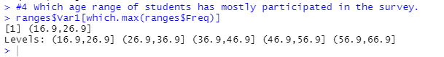

#5 Similarly, find the frequency distribution of Wr.Hnd span and display it in column format.
table(newdf$Wr.Hnd)

#6 Find the relative frequency of Wr.Hnd and display it by correcting to 3 decimal places.
round(table(newdf$Wr.Hnd)/length(newdf$Wr.Hnd), 3)
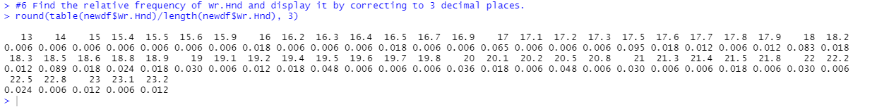

# Use the newsurvey data obtained by cleaning ‘na’ values in survey data of MASS package to do the following:
df <- newsurvey
newdf <- na.omit(df)

#Q1 Find the average age of the students participated in the survey.
mean(df$Age)


#Q2 Compute the standard deviation and variance of the height of the students participated in the survey.
sd(df$Height)
var(df$Height)

#Q3 Compute the quartile of wirte hand span.
quantile(df$Wr.Hnd)
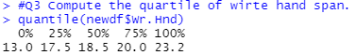

#Q4 Find the correlation between write hand span and pulse rate of the students.
cor(df$Wr.Hnd,df$Pulse)

#Q5 Find the average age of the students based on how often the student exercises.
res <- subset(df,Exer=="Freq",c(Age))
res
mean(res$Age)
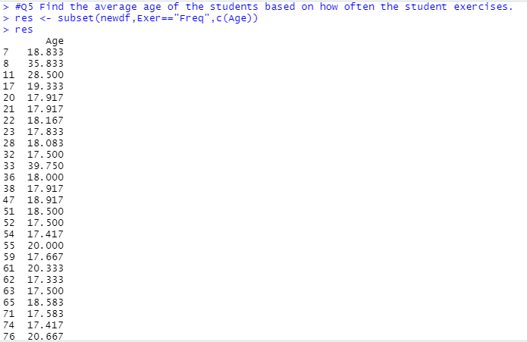
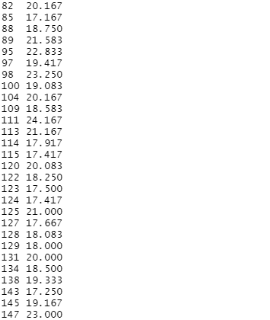
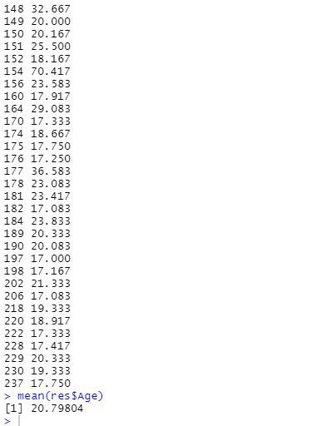

#Q6 Find the standard deviation of height of the students under different categories of span of non-writing hand.
res1 <- subset(df,NW.Hnd>=17 && NW.Hnd<20,c(Height))
res2 <- subset(df,NW.Hnd>=20,c(Height))
sd(res1$Height)
sd(res2$Height)
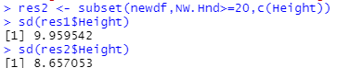

#Q7 Obtain the summary statistics of pulse rate of the students.
summary(df$Pulse)
