Name: Dhruv Bhavesh Gala
Class: BTECH – 3 Batch: A
Roll No: 16
PRN: 22UF16980CM016
Subject: Machine Learning and Soft Computing
Date: 30-09-2025

Experiment No. 11 & 12

Title: Implement Newton’s method optimization techniques.

Code for Single-variable Newton’s Method for Optimization:

import numpy as np
import matplotlib.pyplot as plt

# Define the function to optimize
def f(x):
return x**4 - 3*x**3 + 2

# First derivative
def f_prime(x):
return 4*x**3 - 9*x**2

# Second derivative
def f_double_prime(x):
return 12*x**2 - 18*x

# Newton's method for optimization
def newton_optimization(x0, tol=1e-6, max_iter=100):
x = x0
for i in range(max_iter):
f1 = f_prime(x)
f2 = f_double_prime(x)
if f2 == 0:
print("Second derivative zero. Stopping iteration.")
break
x_new = x - f1 / f2
if abs(x_new - x) < tol:
print(f"Converged in {i+1} iterations.")
return x_new
x = x_new
print("Max iterations reached.")
return x

# Initial guess
x0 = 2.0
opt_x = newton_optimization(x0)
print(f"Optimal x: {opt_x:.6f}")
print(f"Function value at optimum f(x): {f(opt_x):.6f}")

x_vals = np.linspace(0, 3, 100)
y_vals = f(x_vals)

plt.plot(x_vals, y_vals, label='f(x)')
plt.scatter(opt_x, f(opt_x), color='red', label=f'Optimal x={opt_x:.2f}')
plt.title("Newton's Method Optimization")
plt.xlabel('x')
plt.ylabel('f(x)')
plt.legend()
plt.grid(True)
plt.show()

Output:

Converged in 5 iterations.
Optimal x: 2.250000
Function value at optimum f(x): -6.542969

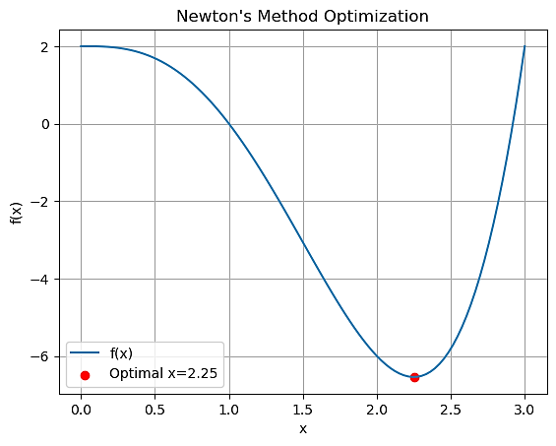

Code for Multi-variable Newton’s Method for Optimization:

import numpy as np
import matplotlib.pyplot as plt
from mpl_toolkits.mplot3d import Axes3D

# Define the function to optimize
def f_multi(X):
x, y = X
return x**2 + y**2 - x*y - 2*x - 6*y

# Gradient (first derivatives)
def grad_f(X):
x, y = X
df_dx = 2*x - y - 2
df_dy = 2*y - x - 6
return np.array([df_dx, df_dy])

# Hessian (second derivatives)
def hessian_f(X):
return np.array([[2, -1],
[-1, 2]])

# Newton's method for multi-variable optimization
def newton_multi(x0, tol=1e-6, max_iter=100):
x = np.array(x0, dtype=float)
for i in range(max_iter):
grad = grad_f(x)
H = hessian_f(x)
if np.linalg.det(H) == 0:
print("Hessian is singular. Cannot continue.")
break
x_new = x - np.linalg.inv(H).dot(grad)
if np.linalg.norm(x_new - x) < tol:
print(f"Converged in {i+1} iterations.")
return x_new
x = x_new
print("Max iterations reached.")
return x

# Initial guess
x0_multi = [0, 0]
opt_x_multi = newton_multi(x0_multi)
print(f"Optimal point: x = {opt_x_multi[0]:.6f}, y = {opt_x_multi[1]:.6f}")
print(f"Function value at optimum f(x,y): {f_multi(opt_x_multi):.6f}")

# -----------------------------
# 3D Plot of the function
# -----------------------------
x = np.linspace(-2, 5, 100)
y = np.linspace(-2, 5, 100)
X_grid, Y_grid = np.meshgrid(x, y)
Z = f_multi([X_grid, Y_grid])

fig = plt.figure(figsize=(10, 7))
ax = fig.add_subplot(111, projection='3d')
ax.plot_surface(X_grid, Y_grid, Z, cmap='viridis', alpha=0.8)
ax.scatter(opt_x_multi[0], opt_x_multi[1], f_multi(opt_x_multi), color='r', s=100, label='Optimal Point')
ax.set_xlabel('x')
ax.set_ylabel('y')
ax.set_zlabel('f(x, y)')
ax.set_title("Newton's Method Optimization (Multi-variable)")
ax.legend()
plt.show()

Output:

Converged in 2 iterations.
Optimal point: x = 3.333333, y = 4.666667
Function value at optimum f(x,y): -17.333333

