Name: Dhruv Bhavesh Gala
Class: BTECH – 3 Batch: A
Roll No: 16
PRN: 22UF16980CM016
Subject: Machine Learning and Soft Computing
Date: 14-10-2025

Experiment No. 15

Title: Explainable AI for a Classification Problem using SHAP & LIME.

Code for Classification Problem using SHAP & LIME:

# Install required packages if not installed
# !pip install shap lime scikit-learn pandas matplotlib

import pandas as pd
import numpy as np
from sklearn.datasets import load_iris
from sklearn.model_selection import train_test_split
from sklearn.ensemble import RandomForestClassifier
from sklearn.preprocessing import StandardScaler
import shap
from lime.lime_tabular import LimeTabularExplainer
import matplotlib.pyplot as plt

# Load dataset
iris = load_iris()
X = pd.DataFrame(iris.data, columns=iris.feature_names)
y = iris.target

# Split dataset
X_train, X_test, y_train, y_test = train_test_split(X, y, test_size=0.2, random_state=42)

# Standardize features
scaler = StandardScaler()
X_train_scaled = scaler.fit_transform(X_train)
X_test_scaled = scaler.transform(X_test)

# Train a classifier
model = RandomForestClassifier(n_estimators=100, random_state=42)
model.fit(X_train_scaled, y_train)

print("\n===== MODEL ACCURACY =====")
print(f"Accuracy on test data: {model.score(X_test_scaled, y_test):.4f}")
print("================================\n")

# -------------------------
# SHAP Explanation
# -------------------------
explainer = shap.TreeExplainer(model)
shap_values = explainer.shap_values(X_test_scaled)

# Summary plot
shap.summary_plot(shap_values, X_test, feature_names=iris.feature_names, plot_type="bar")

# Explain prediction for first test instance
print("SHAP values for first test instance:")
shap.initjs()
shap.summary_plot(shap_values, X_test, feature_names=iris.feature_names)

# -------------------------
# LIME Explanation
# -------------------------
explainer_lime = LimeTabularExplainer(
training_data=X_train_scaled,
feature_names=iris.feature_names,
class_names=iris.target_names,
mode='classification'
)
i = 0
exp = explainer_lime.explain_instance(X_test_scaled[i], model.predict_proba, num_features=4)
print("LIME Explanation for first test instance:")
exp.show_in_notebook(show_table=True)

Output:

===== MODEL ACCURACY =====
Accuracy on test data: 1.0000
================================

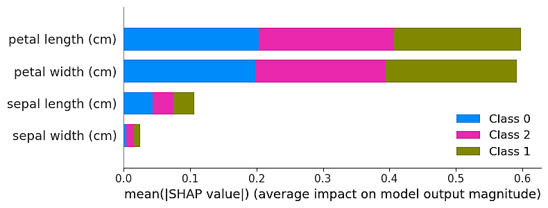

SHAP values for first test instance:

