Name: Dhruv Bhavesh Gala
Class: BTECH – 3 Batch: A
Roll No: 16
PRN: 22UF16980CM016
Subject: Machine Learning and Soft Computing
Date: 02-09-2025

Experiment No. 9

Title: To design a fuzzy set and apply various operations.

Code for Fuzzy set and its operation:

import numpy as np
import matplotlib.pyplot as plt

X = np.linspace(0, 10, 100)
A = np.maximum(0, np.minimum((5 - X) / 5, 1))
B = np.maximum(0, np.minimum((X - 5) / 5, 1))

fuzzy_union = np.maximum(A, B)
fuzzy_intersection = np.minimum(A, B)
fuzzy_complement_A = 1 - A
fuzzy_difference = np.minimum(A, 1 - B)

plt.figure(figsize=(10, 6))
plt.plot(X, A, label='Fuzzy Set A', color='blue')
plt.plot(X, B, label='Fuzzy Set B', color='orange')
plt.plot(X, fuzzy_union, '--', label='Union (A ∪ B)', color='green')
plt.plot(X, fuzzy_intersection, '--', label='Intersection (A ∩ B)', color='red')
plt.plot(X, fuzzy_complement_A, '--', label='Complement (A\')', color='purple')
plt.plot(X, fuzzy_difference, '--', label='Difference (A - B)', color='brown')
plt.title('Fuzzy Set Operations')
plt.xlabel('Universe (X)')
plt.ylabel('Membership Value')
plt.legend()
plt.grid(True)
plt.show()

def fuzzy_repr(name, X, M):
pairs = [f"({x:.1f}, {m:.2f})" for x, m in zip(X[::10], M[::10])]
return f"{name} = {{ " + ", ".join(pairs) + " }"

print("\n===== FUZZY SET REPRESENTATIONS =====\n")
print(fuzzy_repr("A", X, A))
print(fuzzy_repr("B", X, B))
print(fuzzy_repr("Union (A ∪ B)", X, fuzzy_union))
print(fuzzy_repr("Intersection (A ∩ B)", X, fuzzy_intersection))
print(fuzzy_repr("Complement (A')", X, fuzzy_complement_A))
print(fuzzy_repr("Set Difference (A - B)", X, fuzzy_difference))

Output:

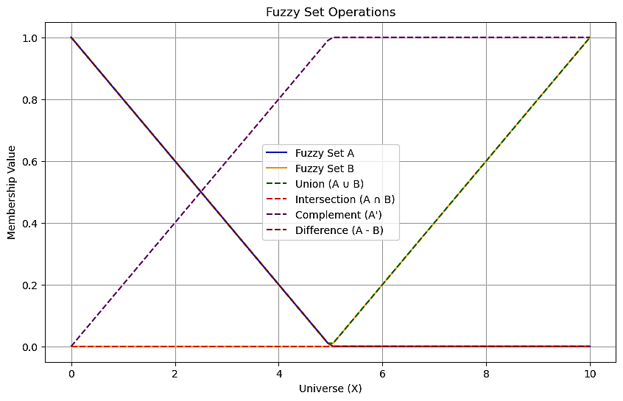
===== FUZZY SET REPRESENTATIONS =====
A = { (0.0, 1.00), (1.0, 0.80), (2.0, 0.60), (3.0, 0.39), (4.0, 0.19), (5.1, 0.00), (6.1, 0.00), (7.1, 0.00), (8.1, 0.00), (9.1, 0.00) }
B = { (0.0, 0.00), (1.0, 0.00), (2.0, 0.00), (3.0, 0.00), (4.0, 0.00), (5.1, 0.01), (6.1, 0.21), (7.1, 0.41), (8.1, 0.62), (9.1, 0.82) }
Union (A ∪ B) = { (0.0, 1.00), (1.0, 0.80), (2.0, 0.60), (3.0, 0.39), (4.0, 0.19), (5.1, 0.01), (6.1, 0.21), (7.1, 0.41), (8.1, 0.62), (9.1, 0.82) }
Intersection (A ∩ B) = { (0.0, 0.00), (1.0, 0.00), (2.0, 0.00), (3.0, 0.00), (4.0, 0.00), (5.1, 0.00), (6.1, 0.00), (7.1, 0.00), (8.1, 0.00), (9.1, 0.00) }
Complement (A') = { (0.0, 0.00), (1.0, 0.20), (2.0, 0.40), (3.0, 0.61), (4.0, 0.81), (5.1, 1.00), (6.1, 1.00), (7.1, 1.00), (8.1, 1.00), (9.1, 1.00) }
Set Difference (A - B) = { (0.0, 1.00), (1.0, 0.80), (2.0, 0.60), (3.0, 0.39), (4.0, 0.19), (5.1, 0.00), (6.1, 0.00), (7.1, 0.00), (8.1, 0.00), (9.1, 0.00) }

