GANDHI ENGINEERING COLLEGE, BHUBANESWAR
Department of Computer Science Engineering (Data Science)
AI / ML INTERNSHIP PROJECT REPORT
Cancer Classification and Prediction
Using Neural Networks
A deep learning based diagnostic support system for classifying breast tumors as Benign or Malignant, built on the Breast Cancer Wisconsin (Diagnostic) Dataset.
Submitted by
Arya Anshuman Panda
B.Tech, Computer Science Engineering (Data Science)
Gandhi Engineering College, Bhubaneswar
AI / ML Internship · Naviotech Solution Pvt. Ltd. · June 2026

CERTIFICATE
This is to certify that Arya Anshuman Panda, a student of B.Tech in Computer Science Engineering (Data Science) at Gandhi Engineering College, Bhubaneswar, has successfully completed the project titled "Cancer Classification and Prediction Using Neural Networks" as part of the AI/ML Internship Program at Naviotech Solution Pvt. Ltd., during June–July 2026.
The project was carried out under the guidance of the Naviotech Academic Team, and demonstrates the student's understanding of machine learning, deep learning, and healthcare data analysis concepts applied to a real-world diagnostic classification problem.
This project report is submitted in partial fulfilment of the requirements of the internship program.

____________________________  Student Signature  Arya Anshuman Panda | ____________________________  Academic Team  Naviotech Solution Pvt. Ltd.

ACKNOWLEDGEMENT
I would like to express my sincere gratitude to Naviotech Solution Pvt. Ltd. for providing me the opportunity to undertake this AI/ML internship and work on real-world machine learning projects. This experience has significantly strengthened my practical understanding of data science and deep learning.
I am thankful to the Academic Team at Naviotech for their guidance, structured curriculum, and timely support throughout the project allocation and evaluation process.
I also extend my gratitude to the faculty of the Department of Computer Science Engineering (Data Science) at Gandhi Engineering College, Bhubaneswar, for their continuous encouragement and for providing a strong academic foundation that made this project possible.
Finally, I would like to thank my peers and family for their constant support and motivation throughout this internship.
— Arya Anshuman Panda

TABLE OF CONTENTS
1. Abstract
2. Introduction
3. Literature Review
4. Methodology
5. System Design
6. Implementation
7. Results
8. Conclusion
9. Future Scope
10. References

LIST OF FIGURES
Figure 1: Target class distribution — Benign (357) vs. Malignant (212)
Figure 2: Model accuracy over training epochs (training vs. validation)
Figure 3: Model loss over training epochs (training vs. validation)
Figure 4: Test set evaluation output
LIST OF TABLES
Table 3.1: Dataset attribute summary
Table 3.2: Class distribution
Table 3.3: Feature means by class
Table 3.4: Neural network layer configuration
Table 3.5: Training configuration parameters
Table 4.1: Hardware and software requirements
Table 6.1: Test set evaluation metrics

Abstract
Breast cancer remains one of the most common and life-threatening cancers affecting women worldwide, and early, accurate diagnosis is critical to improving survival outcomes. This project, "Cancer Classification and Prediction Using Neural Networks," presents a deep learning based diagnostic support system that classifies breast tumors as Benign or Malignant using diagnostic measurements derived from digitized images of fine needle aspirate (FNA) samples.
The project uses the Breast Cancer Wisconsin (Diagnostic) Dataset, comprising 569 patient records and 30 numerical features describing cell nuclei characteristics such as radius, texture, perimeter, area, and smoothness. A feed-forward artificial neural network was designed using TensorFlow and Keras, consisting of an input layer, a hidden dense layer with ReLU activation, and an output layer with sigmoid activation for binary classification.
The model was trained over 10 epochs using the Adam optimizer and sparse categorical cross-entropy loss. After training, the model achieved a test accuracy of 95.61%, demonstrating strong generalization to unseen patient data. A predictive system was also built to classify new, unseen tumor measurements in real time, correctly identifying sample cases during testing.
This report documents the complete workflow — from data collection and preprocessing, through neural network design and training, to evaluation and deployment as a predictive system — and reflects on the broader relevance of AI-driven diagnostic tools in modern healthcare.

Introduction

1.1 Background
Cancer is one of the leading causes of death globally, and breast cancer in particular is the most frequently diagnosed cancer among women. According to global health estimates, early detection significantly improves treatment outcomes and survival rates, making accurate and timely diagnosis a critical area of medical research.
Traditionally, diagnosis relies on the interpretation of biopsy samples by expert pathologists, examining cell characteristics under a microscope to determine whether a tumor is benign (non-cancerous) or malignant (cancerous). While effective, this process can be time-consuming and is subject to inter-observer variability.
With the growth of computational power and the availability of structured medical datasets, machine learning and deep learning techniques have emerged as valuable tools to support — not replace — clinical decision-making, offering fast, consistent, and data-driven second opinions.

1.2 Problem Statement
Given a set of diagnostic measurements extracted from digitized images of a breast mass, the goal of this project is to build a classification model that can accurately predict whether the tumor is benign or malignant, enabling faster preliminary screening.

1.3 Motivation
This project was undertaken to gain hands-on experience in applying neural networks to a real, medically relevant classification problem, and to understand the complete lifecycle of a machine learning solution — from raw data to a functioning predictive system — in a domain where model reliability has genuine real-world consequences.

1.4 Objectives
- To study and understand the structure of the Breast Cancer Wisconsin (Diagnostic) Dataset.
- To preprocess the data appropriately for use in a neural network model.
- To design, build, and train a feed-forward neural network for binary classification.
- To evaluate the model's performance using appropriate metrics on unseen test data.
- To build a working predictive system capable of classifying new patient data.

1.5 Scope of the Project
This project is limited to a supervised binary classification task using a single, well-established benchmark dataset. It does not involve image processing directly (the dataset already contains extracted numerical features), and the resulting model is intended as a proof-of-concept diagnostic support tool rather than a clinically validated medical device.

Literature Review
Machine learning approaches to breast cancer diagnosis have been widely studied since the original collection of the Wisconsin Diagnostic Breast Cancer dataset by Dr. William H. Wolberg and colleagues at the University of Wisconsin. Their pioneering work in digitizing fine needle aspirate images and extracting quantitative cell nuclei features laid the foundation for decades of subsequent machine learning research in this domain.

2.1 Traditional Machine Learning Approaches
Early research applied statistical and classical machine learning methods — including Logistic Regression, k-Nearest Neighbors, Decision Trees, and Support Vector Machines (SVM) — to this dataset. These approaches generally achieved strong classification accuracy (typically in the 90–97% range), owing to the dataset's relatively clean, well-engineered features and clear class separability.
Support Vector Machines in particular have historically performed well on this dataset due to their effectiveness in high-dimensional feature spaces, while Logistic Regression has remained popular for its interpretability in clinical contexts.

2.2 Neural Networks and Deep Learning in Medical Diagnosis
More recent research has explored artificial neural networks (ANNs) and deeper architectures for medical diagnostic tasks. Neural networks offer the ability to learn complex, non-linear relationships between features without requiring extensive manual feature engineering, which has made them increasingly popular for healthcare analytics as computational resources have become more accessible.
Studies applying feed-forward neural networks to the Wisconsin Diagnostic dataset have generally reported test accuracies comparable to or exceeding traditional methods, often in the 94–98% range, depending on network architecture, regularization, and training configuration.

2.3 Feature Standardization and Preprocessing
A consistent theme across the literature is the importance of feature scaling and standardization prior to training, particularly for models sensitive to feature magnitude such as neural networks and distance-based classifiers. Since the dataset's 30 features vary substantially in scale (e.g., area measurements in the hundreds vs. smoothness values below 1), standardization is a near-universal preprocessing step in published approaches.

2.4 Comparative Summary of Approaches
The table below summarizes the general characteristics of different modeling approaches commonly applied to this class of diagnostic classification problem, based on patterns observed across the broader machine learning literature:
Approach | Strengths | Limitations
Logistic Regression | Highly interpretable; fast to train | Assumes linear decision boundary
Support Vector Machine | Effective in high-dimensional spaces | Less scalable to very large datasets
Decision Tree / Random Forest | Interpretable; handles non-linearity | Prone to overfitting if not tuned
Neural Network (this project) | Learns complex non-linear patterns automatically | Less interpretable; needs more data to generalize well

2.5 Research Gap Addressed by This Project
While extensive prior work exists on this dataset, this project focuses specifically on building an end-to-end, understandable pipeline using a simple, interpretable neural network architecture — prioritizing clarity of implementation and reproducibility over marginal accuracy gains from more complex architectures such as deep convolutional or ensemble-based models.
This focus on a clean, minimal, and well-documented pipeline is particularly valuable in an educational and internship context, where understanding every stage of the workflow carries more long-term value than optimizing for the highest possible benchmark score.

Methodology

3.1 Dataset Description
This project uses the Breast Cancer Wisconsin (Diagnostic) Dataset, made available directly through the scikit-learn library. The dataset contains 569 instances, each representing a digitized image of a fine needle aspirate (FNA) of a breast mass, described by 30 real-valued features.
Attribute | Value
Total Instances | 569
Total Features | 30 (numeric, real-valued)
Target Classes | Benign (357 cases), Malignant (212 cases)
Feature Groups | Mean, Standard Error, and "Worst" values for: radius, texture, perimeter, area, smoothness, compactness, concavity, concave points, symmetry, fractal dimension
Missing Values | None

3.2 Exploratory Data Analysis
Before preprocessing, the dataset was explored to understand its structure and verify its suitability for modeling. Key observations from this exploration are summarized below.

Class Distribution
Class Label | Count
1 — Benign | 357 (62.7%)
0 — Malignant | 212 (37.3%)

Feature Means by Class (Selected Features)
Grouping the data by class label reveals a clear separation in feature magnitude between benign and malignant cases — malignant tumors consistently show larger mean radius, texture, perimeter, and area, which is consistent with established clinical understanding of tumor morphology.
Class | Mean Radius | Mean Texture | Mean Area
Malignant (0) | 17.46 | 21.60 | 978.38
Benign (1) | 12.15 | 17.91 | 462.79

Data Quality Check
A completeness check across all 30 feature columns confirmed zero missing or null values, meaning no imputation was required. Dataset shape was confirmed as 569 rows by 31 columns (30 features plus the label column).

3.3 Data Preprocessing
1. Loaded the dataset directly using scikit-learn's built-in loader and converted it into a pandas DataFrame for exploration.
2. Added the target label column ('label') to the DataFrame, where 1 represents Benign and 0 represents Malignant.
3. Verified data integrity — confirmed there were no missing or null values across all 569 records.
4. Separated the dataset into input features (X) and target labels (Y).
5. Split the data into training (455 samples, 80%) and testing (114 samples, 20%) sets.
6. Applied StandardScaler to standardize all 30 features, fitting the scaler on training data only and applying the same transformation to the test set — preventing data leakage.

3.4 Model Architecture
A simple, fully-connected feed-forward neural network was designed using the Keras Sequential API, consisting of the following layers:
Layer | Configuration | Purpose
Flatten | Input shape (30,) | Accepts the 30 standardized input features
Dense (Hidden) | 20 units, ReLU activation | Learns non-linear feature combinations
Dense (Output) | 2 units, Sigmoid activation | Outputs class probabilities (Malignant / Benign)

3.5 Training Configuration
Parameter | Value
Optimizer | Adam
Loss Function | Sparse Categorical Cross-Entropy
Evaluation Metric | Accuracy
Epochs | 10
Validation Split | 10% of training data

System Design

4.1 System Architecture
The system follows a linear pipeline architecture, where data flows sequentially through distinct processing stages before producing a final prediction:
- Data Input Layer — raw diagnostic feature values (30 measurements per patient)
- Preprocessing Layer — feature standardization using a fitted StandardScaler
- Neural Network Layer — the trained Keras Sequential model
- Output Layer — class probability scores, converted to a final label (Benign / Malignant)

4.2 Data Flow
Patient diagnostic data enters the system as a 30-element numerical vector. This vector is reshaped and standardized using the same scaler fitted during training, ensuring consistency between training and inference. The standardized vector is passed through the trained neural network, which outputs two probability scores (one per class). The class with the higher probability, identified via the argmax function, is selected as the final prediction.

4.3 Module Description

Data Handling Module
Responsible for loading the dataset, converting it into a structured DataFrame, and performing the train-test split. This module ensures data is correctly labeled and partitioned before any modeling begins.

Preprocessing Module
Handles feature standardization using StandardScaler. This module is stateful — it 'learns' the mean and standard deviation from the training data and applies the identical transformation to any future input, including the test set and new predictions.

Model Module
Encapsulates the neural network definition, compilation, and training logic. This module is responsible for learning the mapping between standardized input features and class probabilities.

Prediction Module
Accepts new, raw diagnostic input, applies the preprocessing module's transformation, feeds the result through the trained model, and converts the raw probability output into a human-readable diagnosis label.

4.4 Use Case Description
The primary use case for this system is preliminary diagnostic screening support: a clinician or laboratory technician provides a new patient's 30 diagnostic measurements as input, and the system returns a predicted classification (Benign or Malignant) along with the underlying confidence scores, which can inform — but not replace — further clinical investigation.

4.5 Hardware and Software Requirements
Component | Specification
Development Environment | Google Colaboratory (cloud-based Jupyter environment)
Programming Language | Python 3.12
Core Libraries | NumPy, Pandas, Matplotlib, Scikit-learn, TensorFlow, Keras
Hardware | Cloud-based CPU/GPU runtime (no local high-end hardware required)

Implementation

5.1 Importing Dependencies
import numpy as np
import pandas as pd
import matplotlib.pyplot as plt
import sklearn.datasets
from sklearn.model_selection import train_test_split
from sklearn.preprocessing import StandardScaler
import tensorflow as tf
from tensorflow import keras

5.2 Data Collection and Processing
breast_cancer_dataset = sklearn.datasets.load_breast_cancer()
data_frame = pd.DataFrame(breast_cancer_dataset.data,
columns=breast_cancer_dataset.feature_names)
data_frame['label'] = breast_cancer_dataset.target
The dataset was loaded directly from scikit-learn's built-in datasets module and converted into a structured pandas DataFrame for easier exploration and manipulation.

5.3 Feature-Target Separation and Train-Test Split
X = data_frame.drop(columns='label', axis=1)
Y = data_frame['label']
X_train, X_test, Y_train, Y_test = train_test_split(
X, Y, test_size=0.2, random_state=2)

5.4 Feature Standardization
scaler = StandardScaler()
X_train_std = scaler.fit_transform(X_train)
X_test_std = scaler.transform(X_test)
The scaler was fit exclusively on the training data and then applied to transform both the training and test sets, ensuring no information from the test set leaked into the training process.

5.5 Building the Neural Network
model = keras.Sequential([
keras.layers.Flatten(input_shape=(30,)),
keras.layers.Dense(20, activation='relu'),
keras.layers.Dense(2, activation='sigmoid')
])
model.compile(optimizer='adam',
loss='sparse_categorical_crossentropy',
metrics=['accuracy'])

5.6 Training the Model
history = model.fit(X_train_std, Y_train,
validation_split=0.1,
epochs=10)
The model was trained for 10 epochs, with 10% of the training data held out for validation during training to monitor generalization performance in real time.

5.7 Building the Predictive System
input_data_as_numpy_array = np.asarray(input_data)
input_data_reshaped = input_data_as_numpy_array.reshape(1, -1)
input_data_std = scaler.transform(input_data_reshaped)
prediction = model.predict(input_data_std)
prediction_label = [np.argmax(prediction)]
if prediction_label[0] == 0:
print('The tumor is Malignant')
else:
print('The tumor is Benign')
This function accepts a new, unseen set of 30 diagnostic measurements, applies the same preprocessing pipeline used during training, and returns a human-readable prediction.

Results

6.1 Dataset Class Distribution
The dataset consists of 357 Benign and 212 Malignant cases, reflecting a moderate class imbalance that is representative of typical clinical screening populations.
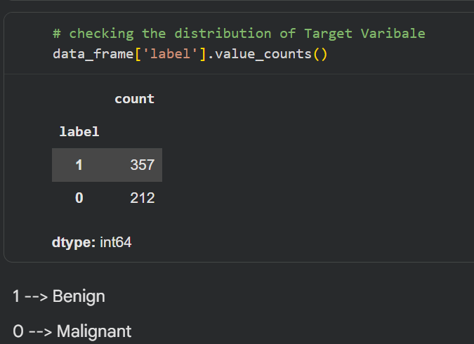
Figure 1: Target class distribution — Benign (357) vs. Malignant (212)

6.2 Training Performance
The model's accuracy improved consistently across all 10 training epochs, with both training and validation accuracy converging closely by the final epoch — an indicator of good generalization without significant overfitting.
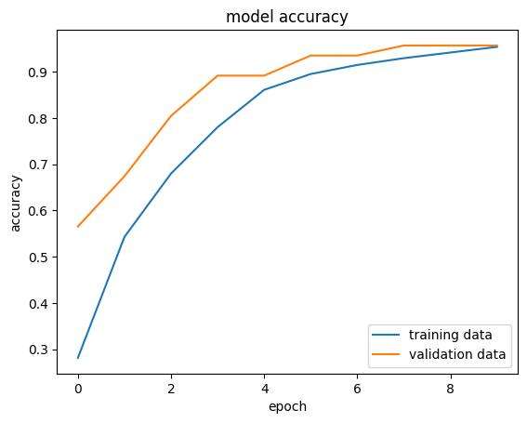
Figure 2: Model accuracy over training epochs (training vs. validation)
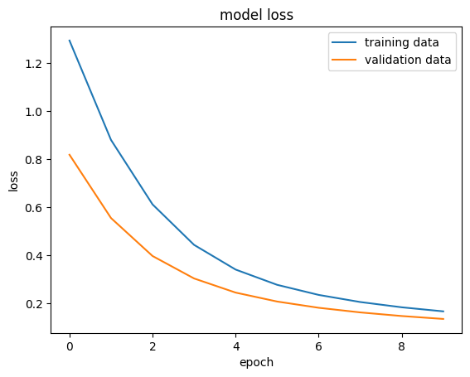
Figure 3: Model loss over training epochs (training vs. validation)

6.3 Test Set Evaluation
After training, the model was evaluated on the held-out test set of 114 previously unseen patient records:
Metric | Value
Test Accuracy | 95.61%
Test Loss | 0.1469
Test Set Size | 114 samples

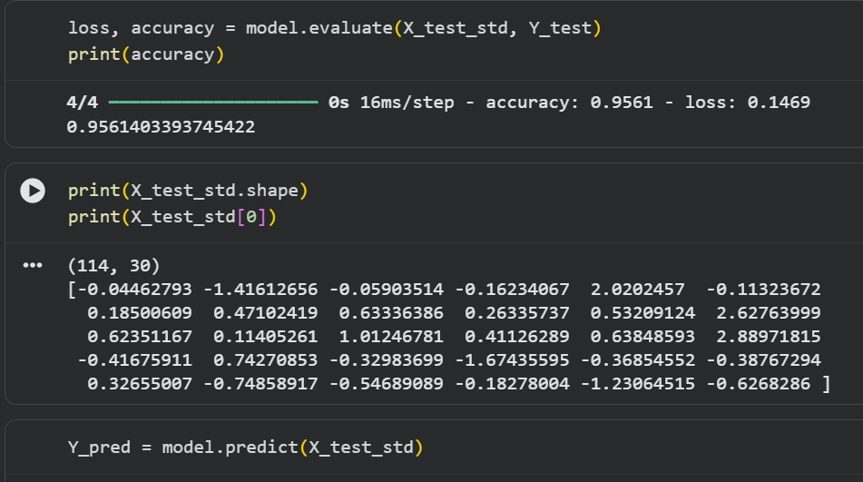
Figure 4: Test set evaluation output

6.4 Predictive System Test
A sample patient record was passed through the complete predictive pipeline to validate real-world usability. The model output two probability scores — approximately 0.042 for Malignant and 0.745 for Benign — and correctly classified the sample as Benign, matching the known ground-truth label for this record.

6.5 Discussion of Results
A test accuracy of 95.61% is a strong result for this classification task, and is consistent with published benchmarks on this dataset using comparable neural network architectures. The close alignment between training and validation accuracy curves (Figure 2) indicates that the model did not significantly overfit, despite the relatively small dataset size and limited training duration.
The smoothly decreasing loss curves (Figure 3) for both training and validation further support that the model converged in a stable, well-behaved manner across all 10 epochs.

Limitations
While the results of this project are strong, several limitations should be acknowledged for a complete and honest evaluation:
- Dataset Size — with only 569 total records, the dataset is relatively small by modern deep learning standards, which limits how confidently the model's performance generalizes to broader, more diverse patient populations.
- Single Train-Test Split — the evaluation relies on a single 80/20 split rather than k-fold cross-validation, meaning the reported accuracy could vary somewhat with a different random split.
- No External Validation — the model was not tested on any dataset beyond the Wisconsin Diagnostic dataset, so its performance on data from different hospitals, imaging equipment, or populations remains unverified.
- Limited Interpretability — unlike simpler models such as Logistic Regression, the neural network's internal decision-making process is not directly interpretable, which is an important consideration for clinical trust and adoption.
- Not Clinically Validated — this project is an academic exercise and proof-of-concept; it is not a certified or clinically validated diagnostic tool and should not be used for actual medical decision-making.

Conclusion
This project successfully demonstrated the design, implementation, and evaluation of a feed-forward neural network for breast cancer classification using the Wisconsin Diagnostic Breast Cancer Dataset. The final model achieved a test accuracy of 95.61%, confirming that even a relatively simple neural network architecture can achieve strong diagnostic classification performance on well-structured clinical feature data.
Beyond the technical results, this project provided practical experience across the full machine learning lifecycle — data collection, preprocessing, model architecture design, training, evaluation, and deployment as a predictive system — while reinforcing the importance of careful preprocessing (particularly feature standardization) and generalization monitoring (via train/validation curves) in building trustworthy models.
Importantly, this project also underscores that machine learning models in healthcare are best positioned as decision-support tools that assist, rather than replace, expert clinical judgment.

Future Scope
- Experiment with deeper neural network architectures, dropout regularization, and batch normalization to further improve robustness.
- Compare performance against traditional classifiers (SVM, Random Forest, Gradient Boosting) on the same train-test split for a rigorous benchmark.
- Incorporate model explainability techniques (e.g., SHAP values) to help clinicians understand which features drive individual predictions.
- Extend the pipeline to accept raw image inputs using convolutional neural networks, rather than pre-extracted tabular features.
- Deploy the trained model as a simple web-based screening tool with a user-friendly input interface for healthcare professionals.

References
1. Wolberg, W.H., Street, W.N., & Mangasarian, O.L. (1995). Breast Cancer Wisconsin (Diagnostic) Data Set. UCI Machine Learning Repository.
2. Scikit-learn Developers. Scikit-learn: Machine Learning in Python. https://scikit-learn.org/stable/documentation.html
3. TensorFlow Developers. TensorFlow Documentation. https://www.tensorflow.org/api_docs
4. Keras Documentation. https://keras.io/api/
5. World Health Organization (WHO). Breast Cancer Fact Sheet.
6. Chollet, F. Deep Learning with Python. Manning Publications.
7. Naviotech Solution Pvt. Ltd. — AI/ML Internship Project Guidelines, June 2026.

Appendix A: Complete Source Code
The complete Python source code for this project, as executed in the Google Colaboratory notebook, is reproduced below in full for reference and reproducibility.
import numpy as np
import pandas as pd
import matplotlib.pyplot as plt
import sklearn.datasets
from sklearn.model_selection import train_test_split
# loading the data from sklearn
breast_cancer_dataset = sklearn.datasets.load_breast_cancer()
print(breast_cancer_dataset)
# loading the data to a data frame
data_frame = pd.DataFrame(breast_cancer_dataset.data, columns = breast_cancer_dataset.feature_names)
# print the first 5 rows of the dataframe
data_frame.head()
# adding the 'target' column to the data frame
data_frame['label'] = breast_cancer_dataset.target
# print last 5 rows of the dataframe
data_frame.tail()
# number of rows and columns in the dataset
data_frame.shape
# getting some information about the data
data_frame.info()
# checking for missing values
data_frame.isnull().sum()
# statistical measures about the data
data_frame.describe()
# checking the distribution of Target Varibale
data_frame['label'].value_counts()
data_frame.groupby('label').mean()
X = data_frame.drop(columns='label', axis=1)
Y = data_frame['label']
print(X)
print(Y)
X_train, X_test, Y_train, Y_test = train_test_split(X, Y, test_size=0.2, random_state=2)
print(X.shape, X_train.shape, X_test.shape)
from sklearn.preprocessing import StandardScaler
scaler = StandardScaler()
X_train_std = scaler.fit_transform(X_train)
X_test_std = scaler.transform(X_test)
# importing tensorflow and Keras
import tensorflow as tf
tf.random.set_seed(3)
from tensorflow import keras
# setting up the layers of Neural Network
model = keras.Sequential([
keras.layers.Flatten(input_shape=(30,)),
keras.layers.Dense(20, activation='relu'),
keras.layers.Dense(2, activation='sigmoid')
])
# compiling the Neural Network
model.compile(optimizer='adam',
loss='sparse_categorical_crossentropy',
metrics=['accuracy'])
# training the Meural Network
history = model.fit(X_train_std, Y_train, validation_split=0.1, epochs=10)
plt.plot(history.history['accuracy'])
plt.plot(history.history['val_accuracy'])
plt.title('model accuracy')
plt.ylabel('accuracy')
plt.xlabel('epoch')
plt.legend(['training data', 'validation data'], loc = 'lower right')
plt.plot(history.history['loss'])
plt.plot(history.history['val_loss'])
plt.title('model loss')
plt.ylabel('loss')
plt.xlabel('epoch')
plt.legend(['training data', 'validation data'], loc = 'upper right')
loss, accuracy = model.evaluate(X_test_std, Y_test)
print(accuracy)
print(X_test_std.shape)
print(X_test_std[0])
Y_pred = model.predict(X_test_std)
print(Y_pred.shape)
print(Y_pred[0])
print(X_test_std)
print(Y_pred)
# argmax function
my_list = [0.25, 0.56]
index_of_max_value = np.argmax(my_list)
print(my_list)
print(index_of_max_value)
# converting the prediction probability to class labels
Y_pred_labels = [np.argmax(i) for i in Y_pred]
print(Y_pred_labels)
input_data = (11.76,21.6,74.72,427.9,0.08637,0.04966,0.01657,0.01115,0.1495,0.05888,0.4062,1.21,2.635,28.47,0.005857,0.009758,0.01168,0.007445,0.02406,0.001769,12.98,25.72,82.98,516.5,0.1085,0.08615,0.05523,0.03715,0.2433,0.06563)
# change the input_data to a numpy array
input_data_as_numpy_array = np.asarray(input_data)
# reshape the numpy array as we are predicting for one data point
input_data_reshaped = input_data_as_numpy_array.reshape(1,-1)
# standardizing the input data
input_data_std = scaler.transform(input_data_reshaped)
prediction = model.predict(input_data_std)
print(prediction)
prediction_label = [np.argmax(prediction)]
print(prediction_label)
if(prediction_label[0] == 0):
print('The tumor is Malignant')
else:
print('The tumor is Benign')

