Name: Arya Rohan Rachamalla
Reg no: 3122256002002
Project link: https://github.com/Aryacoding1131/ShoppingCart_Project.git

Shopping Cart Project Report

1. Project Overview
The ShoppingCart Project is a full‑stack web application designed to simulate a basic online shopping system. The platform allows users to create an account, securely log in, browse products, add items to their cart, and proceed to a dummy payment page. The application follows the MVC (Model‑View‑Controller) architecture, ensuring clean separation of concerns, maintainability, and scalability.
The backend is built using Node.js and Express.js, while MongoDB serves as the NoSQL database using Mongoose as the ORM. Password hashing is done using bcrypt, ensuring secure authentication.
The frontend is developed using HTML, CSS, Bootstrap, and JavaScript, providing responsive UI components and dynamic interactions. The application efficiently handles multiple user accounts with independent shopping carts stored in the database.

2. Project Requirements
To run the ShoppingCart application, the following tools and software are needed:
• Visual Studio Code – primary code editor for writing and managing all frontend + backend code.
• Node.js – required to run the Express server and manage package installation via npm.
• MongoDB Community Server – used as the backend database.
• Mongo Shell (mongosh) – for querying the MongoDB database through terminal.
• Internet Browser – Chrome, Firefox, Edge for testing frontend pages.
• GitHub Repository – used for hosting project files and version control.
• Required npm packages installed using `npm install`.

2.1 Wireframes / Screenshots
The application contains several user‑interface screens. Screenshots are referenced in the GitHub repository and include:

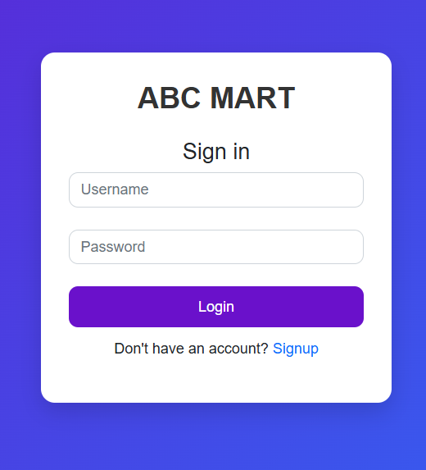
Login Page – UI with username/password fields and validation.
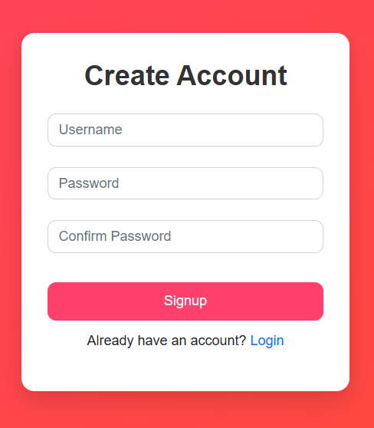
• Signup Page – includes password‑strength check and username availability check.
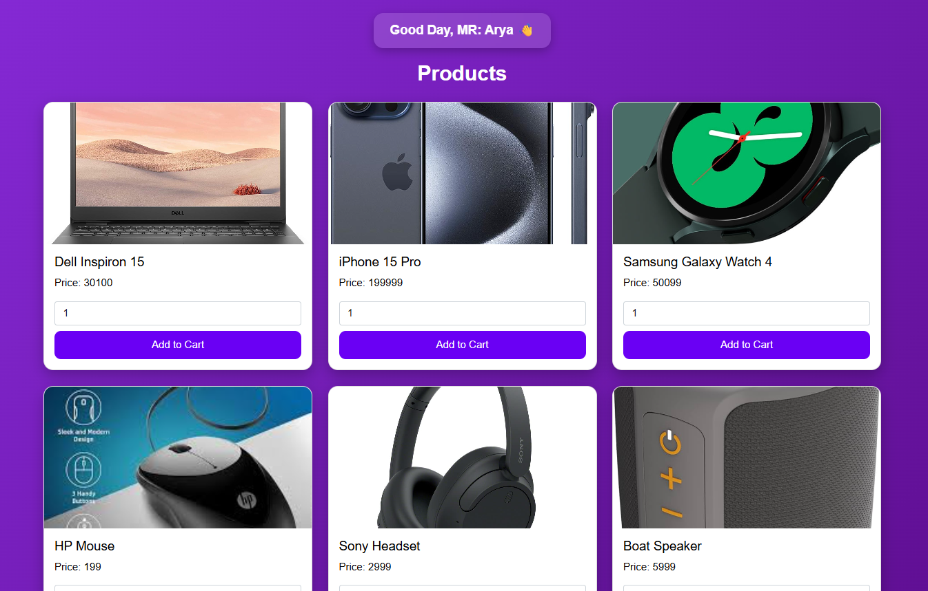
• Dashboard – displays products and personalized welcome message (e.g., 'Welcome Arya').
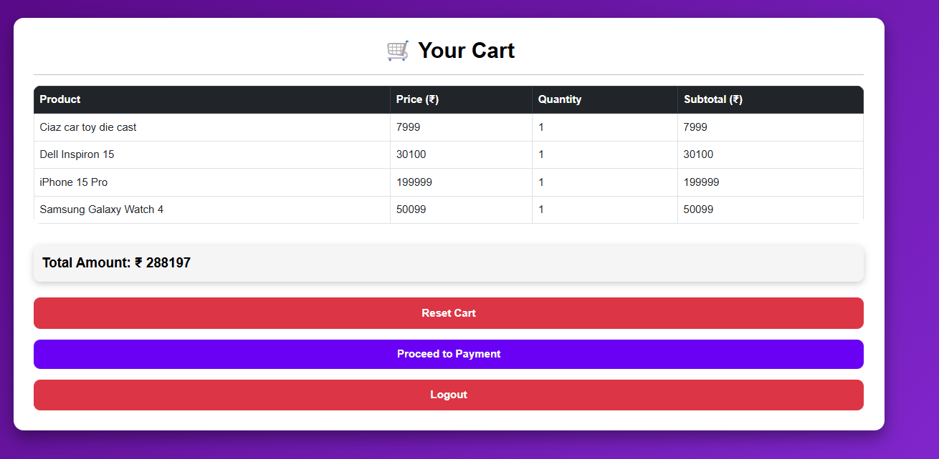
• Cart Page – displays items added to the cart and dynamically enables/disables payment button.
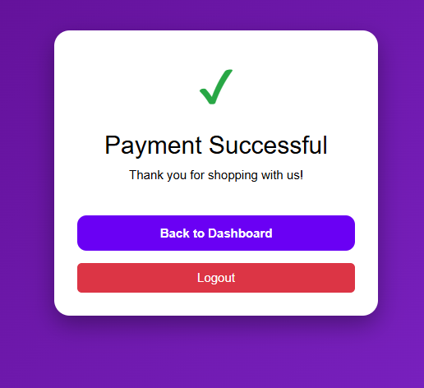
• Payment Page – dummy interface simulating payment.
These screens represent the major user interactions with the system.

2.2 Functional Requirements / Use Cases
Below are the major use cases and system functionalities:
1. User Signup
- User enters username and password.
- System verifies password strength (minimum 8 characters, special char, number, uppercase).
- bcrypt hashes the password.
- User account is stored in MongoDB.
2. User Login
- User enters credentials.
- bcrypt compares entered password with stored hashed password.
- If matched, user dashboard loads; otherwise, error message is shown.
3. Dashboard Viewing
- Personalized greeting for each logged‑in user.
- Displays list of items with ‘Add to Cart’ button.
4. Add to Cart
- User selects items to add.
- MongoDB updates the user’s item list.
- Cart total and item count dynamically update.
5. View Cart
- Displays all added items with name, price, quantity.
- Payment button activates only when cart contains at least one item.
6. Payment Page
- Dummy payment UI.
- Demonstrates end‑to‑end flow for learning purposes.
7. Database Operations
- All user and cart data stored in collections.
- Commands such as `show dbs`, `use`, `show collections`, `find().pretty()` used to verify data.

3. Technical Details

3.1 Tech Stack
• Frontend: HTML, CSS, Bootstrap, JavaScript.
• Backend: Node.js with Express.js framework.
• Database: MongoDB (NoSQL) with Mongoose ODM.
• Authentication: bcrypt hashing library.
• Architecture Style: MVC (Model‑View‑Controller).

3.2 Architecture Diagram (Description)
The project follows the MVC Architecture:
Model (Database)
View (Frontend)
Controller (Backend)

• Model Layer – Contains MongoDB schemas using Mongoose. The User model includes fields like username, hashed password, billingAmount, and an array of items.
• View Layer – Contains static HTML pages such as login.html, signup.html, dashboard.html, cart.html, payment.html. Bootstrap and JavaScript are used for UI styling and interactivity.
• Controller Layer – Handles routes such as /login, /signup, /dashboard, /add-to-cart, etc. This layer connects the frontend to the database logic.
Flow:
[Client Browser] → sends request → [Express Routes] → interacts with → [Mongoose Models] → retrieves/saves data → returns response → [Rendered HTML View]

3.3 Design Patterns Used
The following design patterns are incorporated into the system:
1. MVC Pattern
- Separates application into Model, View, Controller layers.
- Helps maintain large‑scale code and simplifies debugging.
2. Observer Pattern (implicitly through DOM Events)
- JavaScript updates UI elements based on cart changes.
3. Singleton Pattern (via Database Connection)
- Mongoose maintains a single connection instance reused throughout the application.
4. Factory Pattern (implicitly in Mongoose Models)
- Schemas act as factories for creating standardized user and item objects.
These patterns enhance the system’s modularity, maintainability, and scalability.
Appendix
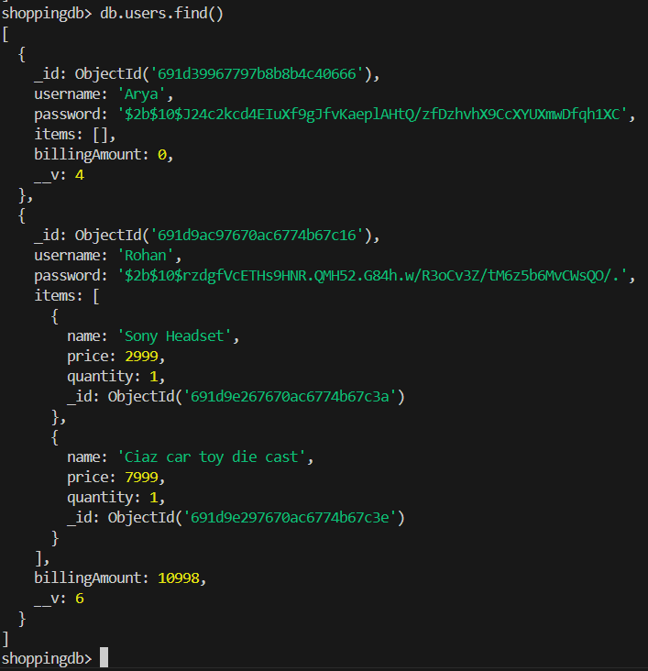
MongoDB(mongosh) – we can view the products, billing amount, username, quantity of products in cart (Username is Arya)
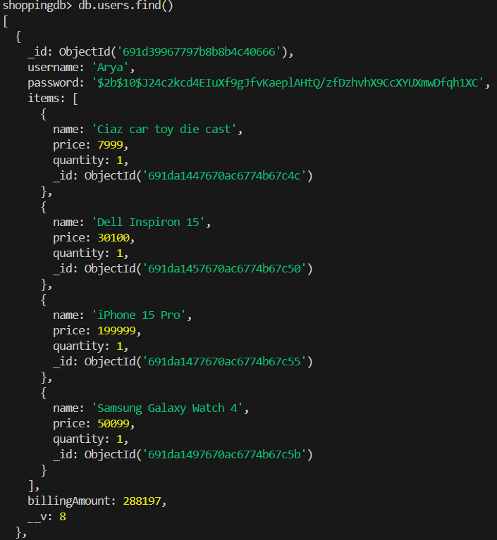
MongoDB(mongosh) – we can view the products, billing amount, username, quantity of products in cart (Username is Rohan)
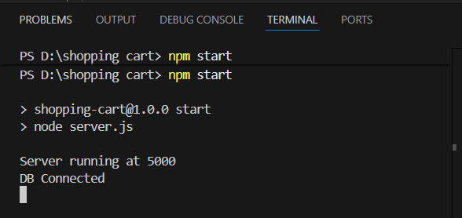
The server is running on port 5000

