Chapter | Contents | Page No.
1 | Introduction  - Project Overview  - Purpose of the Project  - Project Scope  - Project Objectives | 1-2
2 |  | 2-3
  Requirements Analysis
  2.1 Functional Requirements
  2.2 Non-Functional Requirements
  2.3 User Requirements Specification (URS)
3 | System Requirements  3.1 Hardware Requirements  3.2 Software Requirements  3.3 Supported Browsers  3.4 Development Environment and Tools | 3-4
4 | Technology Stack | 5
5 | System Design and Database Design  5.1 System Architecture  5.2 UML Design  5.3 Data Flow Modelling  5.4 Database Design | 5-15
6 | Module Design | 15
  6.1 User Authentication and Authorization
  6.2 Dashboard Module
  6.3 Functional Modules
  6.4 Administrative Module
7 | Functional Features | 16
  7.1 End-user Features
  7.2 Administrative Features
  7.3 Security Features
8 | User Interface Design  8.1 Home Page  8.2 Authentication Screens  8.3 Dashboard Interface  8.4 Module Interfaces  8.5 Administration Panel  8.6 Responsive User Interface Design | 17-20
9 | System Testing  9.1 Test Strategy  9.2 Test Cases | 20–21
10 | Security Implementation  10.1 Authentication Mechanism  10.2 Authorization and Access Control  10.3 Password Encryption and Hashing  10.4 CSRF Protection  10.5 Input Validation and Data Sanitization | 22-24
11 |  | 24
  Future Enhancements
12 | Conclusion | 25
13 | References | 25
14 | Appendices  14.1 User Interface Screenshots  14.2 User Manual (Role-Based)  14.3 Frequently Asked Questions (FAQ) | 26-29

- Introduction
1.1. Project Overview
The Diocese Project is a web-based application developed to provide a centralized digital platform for managing and presenting diocesan information. The system enables visitors to access information about priests, parishes, publications, news, events, galleries, and downloadable resources through a responsive and user-friendly website.
1.2. Purpose of the project
- Provide a centralized online platform for diocesan information.
- Enable easy access to details about priests, parishes, publications, and church activities.
- Allow administrators to manage website content efficiently through a secure backend interface.
- Improve communication between the diocese and the public.
1.3. Project scope
- Public website pages such as Home, About Diocese, Priest Directory, Parish Directory, Publications, News, Events, Gallery, and Contact page.
- Administrative features for managing priests, parishes, publications, news, events, and media content.
- Database storage for diocesan information and downloadable resources.
- Responsive design for desktop, tablet, and mobile devices.

1.4. Project objectives
- Create an informative and accessible diocesan website.
- Provide a searchable directory of priests and parishes.
- Publish news, events, announcements, and publications regularly.
- Ensure secure and efficient content management.
- Maintain a responsive and user-friendly interface.

- Requirements Analysis
2.1. Functional requirements
- Display priest profiles with details such as name, position, parish, contact information, and photograph.
- Display parish information including location, description, and contact details.
- Publish and manage downloadable publications.
- Publish news articles and announcements.
- Display upcoming events and diocesan activities.
- Provide an image gallery for church events and activities.
- Allow visitors to send inquiries through a contact form.
- Enable administrators to add, edit, and delete content.

2.2. Non-functional requirements
- The system should be responsive across different screen sizes.
- The website should load pages efficiently.
- The system should provide secure authentication for administrators.
- The application should be maintainable and scalable.
- The user interface should be easy to navigate.
2.3. User requirements specification (URS)
User | Requirements
Visitor | View diocesan information, priest profiles, parish details, publications, news, events, and gallery.
Administrator | Manage priests, parishes, publications, news, events, gallery, and contact messages.

- System Requirements
3.1. Hardware requirements
- Processor:
- RAM:
- Storage:
- Internet connection for deployment and updates
3.2. Software requirements
Component | Requirement
Programming language | Python
Framework | Django
Database | MySQL
Frontend | HTML, CSS, Bootstrap, JavaScript
IDE | Visual Studio Code

3.3. Supported Browsers
- Google Chrome
- Mozilla Firefox
3.4. Development Environment and Tools
Tool | Purpose
Visual Studio Code
  Source code editing and development
Python | Backend programming language
Django | Web application framework
SQLite | Development database
Git | Version control system
GitHub | Source code repository and collaboration
Bootstrap 5 | Responsive user interface design
HTML5 | Web page structure
CSS
  Styling and layout
JavaScript
  Client-side interactivity
Django Admin
  Content and database management
pip | Python package management

- Technology Stack

- System Workflow Diagram

User visits Diocese website

User selects a module

Request sent to Django server

Server retrieves data from database

Django renders the template

Page displayed to the user

- System Design and Database Design
5.1. System Architecture
High Level Architecture

USER
Visitors and administrators access the Diocese website through a web browser.

Django Application Server
Handles requests, business logic, authentication, and template rendering.

Database
Stores priests, parishes, publications, news, events, gallery images, spiritual organisations, and contact messages.
through a web browser.

Media Storage
Stores uploaded images and downloadable publication files.

System Workflow Diagram

User visits Diocese website
User selects a module

Request sent to Django server

Server retrieves data from database
Django renders the template

Page displayed to the user

5.2. UML Design
- Use Case Diagram

Visitor
Diocese Project System

Administrator

View priest profiles
View parish details

View organisations
Download resources
View institutions
Submit contact form
Login and manage content

- Activity diagram

User visits website

User selects a module
Data retrieved from databas

Request sent to server
Server processes request

Data retrieved from database

Page rendered and displayed

5.3. Data Flow Modelling
- Context Diagram (DFD Level 0)

Website Request Manage Content
Diocese Management System
Administrator
Visitors
Request page

Website Response Status

- Data Flow Diagram (DFD Level 1)

Visitors

Website Request
Process Request

Read Data
Database

Data
Display Web Page

Website response
Visitor

5.4. Database Design
- Conceptual Database Design (Entity Relationship Diagram)
User
user_id(PK)
username
email
password

Priest
priest_id
first_name
second_name
parish_id
address
phone
image

INSTITUTIONS
institution_id (PK)
title
description
image

organization_name

Parish
parish_id
parishname
viacrname
established_year
districtname
phone
image

OFFICE BEARER
bearer_id(PK)
name
image

organization_name

SPIRITUAL ORGANISATION
organisation_id (PK)
title
category_id (FK)
description
bearer_id (FK)

organization_name

CATEGORY LIST
category_id (PK)
organization_name

1:M 1:M

- Logical Database Design (Database Schema)

USER
Field | Type | Key
user_id | Integer | PK
username | Varchar
email | Varchar
password | Varchar

PARISH
Field | Type | Key
parish_id | Integer | PK
parishname | Varchar
vicarname | Varchar
Established_year | Integer
districtname | Varchar
phone | Integer
image | Image

PRIEST
Field | Type | Key
priest_id | Integer | PK
first_name | Varchar
second_name | Varchar
parish_id | Integer
address | Varchar
phone | Integer
image | Image

CATEGORY LIST
Field | Type | Key
category_id | Integer | PK
organization_name | Varchar

OFFICE BEAERS
Field | Type | Key
bearer_id | Integer | PK
name | Varchar
image | Image

SPIRITUAL ORGANISATION
Field | Type | Key
Organisation_id | Integer | PK
title | Varchar
category_id | Integer | FK
description | Text
bearer_id | Integer | FK

INSTITUTIONS (Schools, Colleges, Retreat Centres)
Field | Type | Key
institution_id | Integer | PK
title | Varchar
description | Varchar
image | Image

- Relational Table Design and Key Relationships

The Diocese Management System uses primary and foreign keys to establish relationships between database tables while ensuring referential integrity.
Primary Keys
Table | Primary Key
User | user_id
Parish | parish_id
Priest | priest_id
Spiritual Organisation | organisation_id
Institution | institution_id

Foreign Keys
Child Table | Foreign Key | Parent Table
Spiritual Organisation | category_id , bearer_id | Category, Office Bearers

6. Module Design
- User authentication and authorization: Django authentication system is used for secure login and role-based access control.
- Dashboard module: Provides quick access to manage priests, parishes, publications, news, events, gallery, and contact messages.
- Functional modules: Home, Priest Directory, Parish Directory, Publications, News, Events, Gallery, and Contact modules.
- Administrative module: Allows administrators to add, edit, delete, and organize diocesan content.
7. Functional Features
- End-user features
- View priest profiles.
- View parish information.
- Browse and download publications.
- Read news and announcements.
- View events and activities.
- Browse image galleries.
- Submit inquiries through the contact form.

- Administrative features
- Manage priests and positions.
- Manage parish information.
- Upload and manage publications.
- Publish and update news articles.
- Manage events and gallery images.
- View and respond to contact messages.
- Security features
- Secure admin login.
- Password hashing.
- Input validation and sanitization.
- Restricted access to administrative functions.
8. User Interface Design
The user interface (UI) of the Diocese website is designed to provide easy navigation, clear presentation of information, and an attractive visual appearance. The interface ensures that visitors and administrators can interact with the system efficiently on both desktop and mobile devices.

Home Page
  - The Home Page serves as the main entry point of the Diocese website. It provides visitors with an overview of the diocese and quick access to important sections.
  - Displays the Diocese logo, navigation menu, and welcome section.
  - Provides links to Home, About Diocese, Priest Directory, Parishes, and Contact.
  - Uses a visually appealing layout with images, banners, and highlighted content.
  - Helps visitors quickly access important information about the Diocese.

Authentication Screens (Login / Registration)
The Authentication Screens allow authorized users to securely access the system.
- Login screen: Enables administrators or authorized users to enter their username and password.
- Includes input fields, validation messages, and secure authentication mechanisms.
- Ensures that only authorized users can access restricted areas of the website.

Dashboard Interface
The Dashboard Interface provides administrators with a centralized view of the website’s management features.
- Displays summary information such as details of the priests, parishes, media, contact messages etc.
- Provides quick access to content management modules.
- Uses cards, menus, and tables to present information in an organized manner.
- Improves efficiency by allowing administrators to monitor and manage website activities from one screen.
Module Interfaces
The Module Interfaces are designed for managing different sections of the Diocese website.
Module
  Interface Function
Priest Module
  Add, edit, view, and delete priest details.
Parish Module | Manage parish information and related details.
Spiritual Organisations Module | Create, update, and publish spiritual organisations.
Downloads Module
  Upload, manage, and provide downloadable documents such as kalpana, prayer books, guideline etc
Institution Module | Manage information about diocesan institutions, including institution name, description, address, contact details, and images.
Media Module | Upload and organize images related to diocesan activities.
Contact Module | View and manage messages submitted by visitors.

Administration Panel
The Administration Panel is the backend interface used by administrators to manage website content and system operations.
- Provides secure access to authorized administrators.
- Allows management of priests, parishes, news, events, publications, gallery items, and contact messages.
- Includes features for adding, editing, deleting, and updating records.
- Uses forms, tables, search options, and action buttons to simplify administrative tasks.
- Ensures data consistency and efficient content management.
Responsive User Interface Design
The Diocese website follows a responsive user interface design, ensuring that the website adapts to different screen sizes and devices.
- Layouts automatically adjust for desktop, tablet, and mobile screens.
- Navigation menus become mobile-friendly on smaller devices.
- Images and content resize appropriately to maintain readability.
- Buttons and form fields remain easy to use on touch-screen devices.
- Provides a consistent and accessible user experience across all devices.
9. System Testing
System testing is the process of evaluating the complete Diocese website to verify that all modules function according to the specified requirements. The testing process ensures that the website is reliable, secure, user-friendly, and performs correctly under normal operating conditions.

Test Strategy
The test strategy defines the overall approach used to test the Diocese website.
- Functional testing: Verifies that all features such as login, priest directory, parish information, news, events, and contact forms work correctly.
- Integration testing: Ensures that different modules interact properly with the database and the Django application.
- Usability testing: Evaluates whether the website is easy to navigate and understand for visitors and administrators.
- Responsive testing: Checks whether the website displays correctly on desktop, tablet, and mobile devices.
- Security testing: Verifies that authentication and authorization mechanisms protect restricted areas of the website.
- Performance testing: Assesses page loading speed and system responsiveness under normal usage conditions.

Test Cases
Test cases are prepared to verify the functionality of individual modules of the Diocese website.
Test Case ID | Module | Test Scenario | Expected Result
TC-01 | Login |  | User should be redirected to the dashboard.
  Enter valid username and password.
TC-02 |  | Enter invalid username or password. | Error message should be displayed.
  Login
TC-03 |  | Add a new priest record. | Priest record should be saved in the database.
  Priest Module
TC-04 |  | Update parish information. | Updated parish details should be displayed correctly.
  Parish Module
TC-05 | Kalpana Module | Download kalpana | Downloaded message should be displayed
TC-06 |  | Add a new event. | Event details should be displayed on the events page.
  Event Module
TC-07 | Contact Form | Submit a contact message. | Message should be stored in the database and confirmation should be shown.
TC-08
  Responsive Design
  Open the website on a mobile device.
  Layout should adjust properly and remain usable.

10. Security Implementation
Security is an essential aspect of the Diocese website as it protects sensitive information, prevents unauthorized access, and ensures the integrity of the system. The website is developed using the Django framework, which provides built-in security features to safeguard user data and application resources.

10.1. Authentication Mechanism
The authentication mechanism verifies the identity of users before allowing access to protected resources.
- Users log in using a valid username and password.
- Django's built-in authentication system is used.
- Invalid login attempts display appropriate error messages.
- Only authenticated administrators can access the administration panel.
- Anonymous visitors can only access public pages.
10.2. Authorization and Access Control
Authorization determines what actions an authenticated user is allowed to perform.
- Role-based access control is implemented.
- Only administrators can:
- Add priest information
- Edit parish details
- Manage events
- Upload publications
- Manage media
- Visitors have read-only access to public information.
- Unauthorized users cannot access the Django admin panel.
10.3. Password Encryption and Hashing
Passwords are never stored as plain text.
- Django automatically hashes passwords before storing them in the database.
- Password verification is performed by comparing hashes instead of plain passwords.
- Strong password policies can be enforced.
- Passwords remain protected even if the database is compromised.

10.4. CSRF Protection
Cross-Site Request Forgery (CSRF) protection prevents unauthorized websites from submitting requests on behalf of authenticated users.
- Django generates a unique CSRF token for every form.
- Every POST request includes the CSRF token.
- Requests without a valid token are automatically rejected.
- Prevents malicious websites from performing unauthorized actions.

10.5. Input Validation and Data Sanitization
Input validation ensures that only valid and safe data is accepted by the application.
- Required fields are validated before submission.
- Invalid email addresses are rejected.
- Form data is checked using Django Forms.
- SQL Injection is prevented through Django ORM.
- Uploaded files are validated before storage.
11. Future Enhancements
- Mobile Application.
- Online Event Registration.
- SMS and Email Notifications.
- Multilingual Support.
- Live Streaming Integration.

12. Conclusion
The Diocese Website Management System was successfully developed to provide a secure, user-friendly, and efficient platform for managing diocesan information and services. Built using Django, Python, HTML, CSS, Bootstrap, and SQLite/MySQL, the system enables users to access important information such as priest directories, parish details, news, events, publications, galleries, and contact information, while allowing administrators to manage website content through a secure admin panel. The system was thoroughly tested to ensure its functionality, security, and responsiveness across different devices. Overall, it reduces manual work, improves information accessibility, enhances communication within the Diocese, and provides a solid foundation for future enhancements such as online sacrament booking, digital donations, multilingual support, and mobile applications.

13.References
- Django Documentation: https://docs.djangoproject.com/
- React Documentation: https://reactjs.org/docs/getting-started.html

14. Appendices
14.1. User Interface Screenshots
Home Page
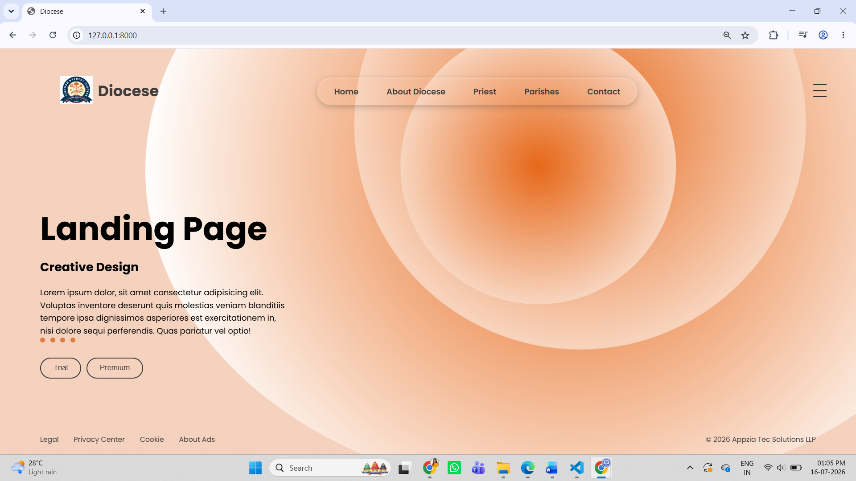
Priest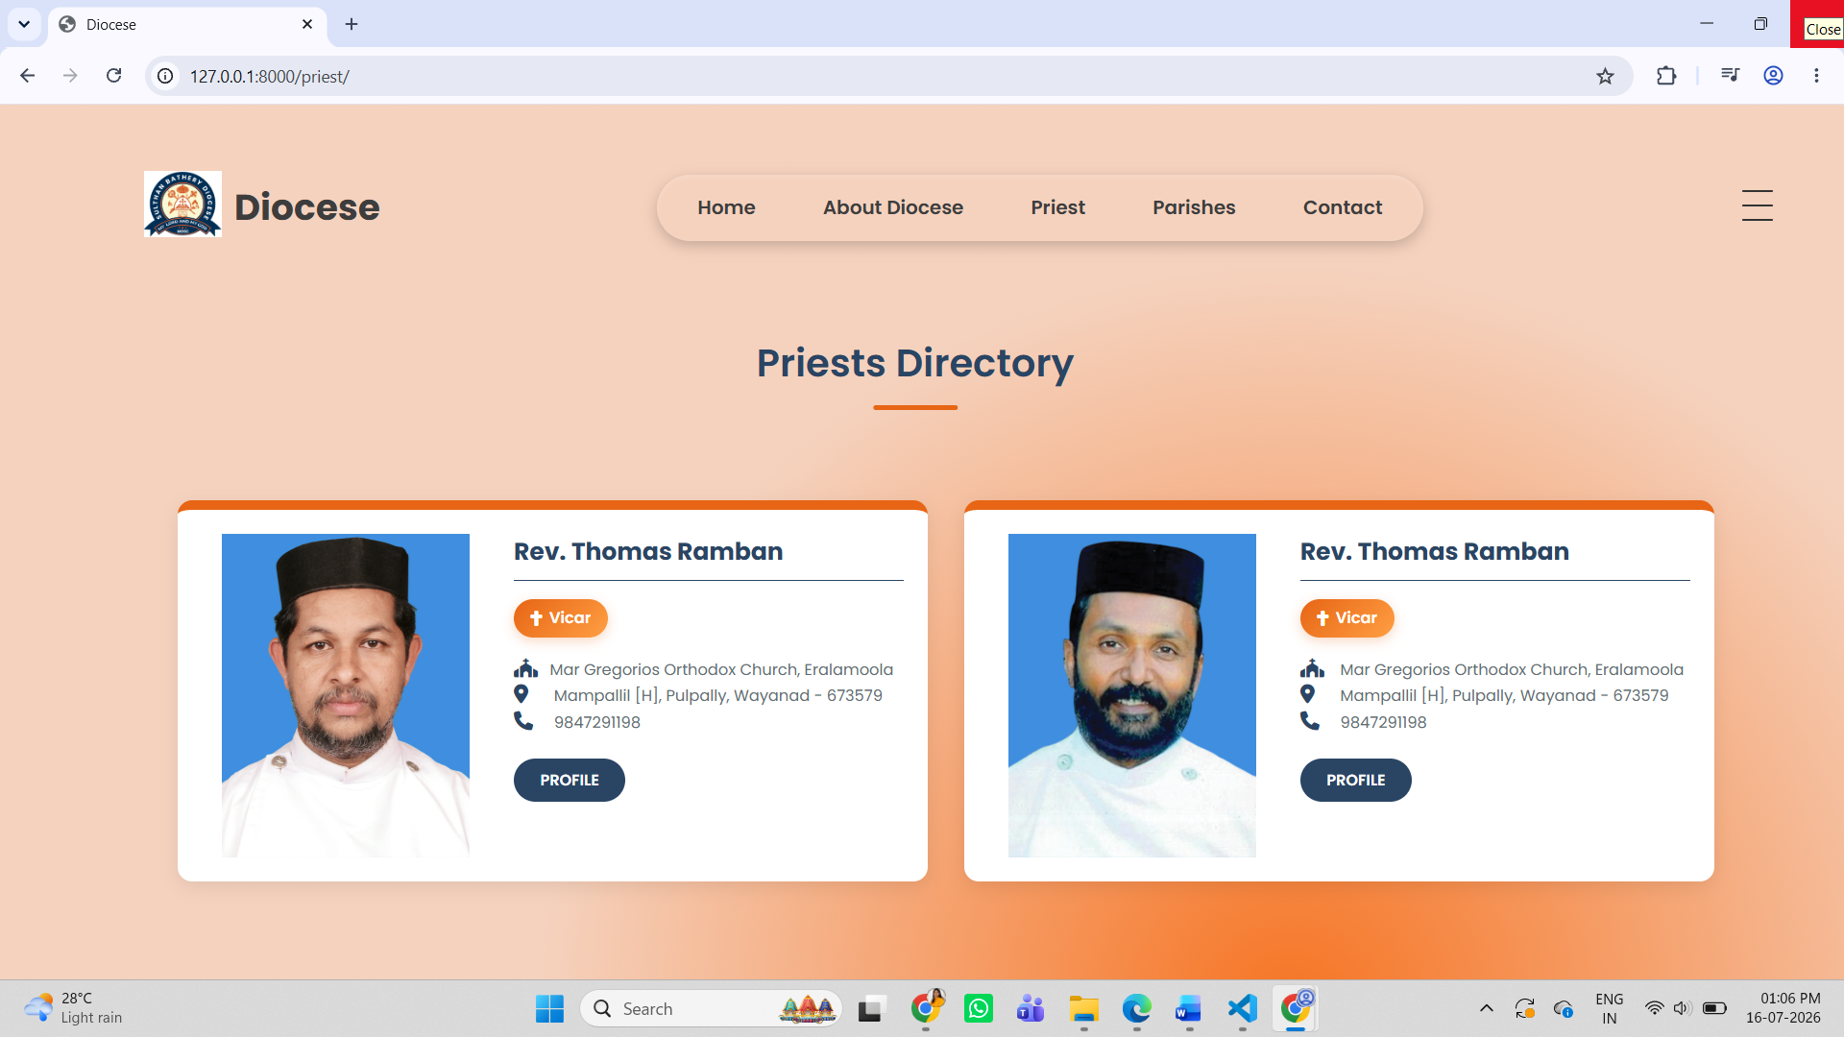
Parish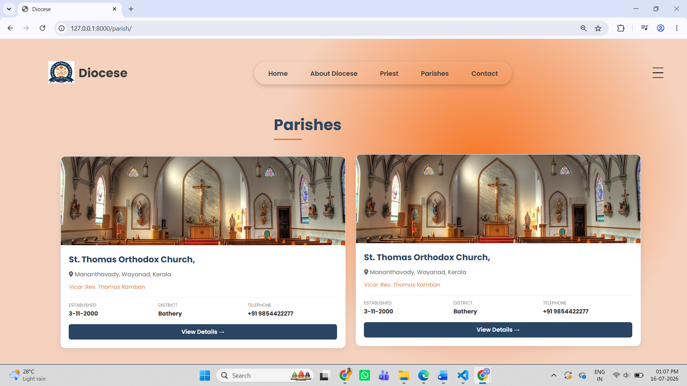

14.2. User Manual (Role-Based)
Administrator
- Log in using administrator credentials.
- Add, edit, and delete priest records.
- Manage parish information.
- Publish news and events.
- Upload publications and gallery images.
- Manage contact messages.
- Log out securely after completing administrative tasks.
User
- Browse the website.
- View priest and parish information.
- Read news and events.
- Access publications and downloads.
- View galleries.
- Submit prayer request through the contact form.

14.3. Frequently Asked Questions (FAQ)
Q1. Who can manage the website content?
Only authorized administrators can manage website content.
Q2. Can visitors view priest and parish information?
Yes. Visitors can access publicly available information without logging in.
Q3. Which technologies were used to develop the system?
The system was developed using Django, Python, HTML, CSS, Bootstrap, JavaScript, and SQLite/MySQL.

