**Defect Report – 1**

**Title** : 'see all' text link on top of the laughter activities list is not working

**Bug ID** : DF2343

**Platform** : Laptop - Windows 11 – Chrome Browser

**Version** : 131.0.6778.69

**URL** : <https://in.bookmyshow.com/explore/activities-mumbai>

**Environment** : Testing Environment

**Steps To Reproduce :**

1. Open the Application URL <https://in.bookmyshow.com/explore/home/bengaluru>

in any supported Browser  
2.Click on see all text link3.Click on 'see all' on top of the laughter activities list

**Expected** : User should navigated to laughter activities page

**Actual** : 1.User is not navigated to laughter activities page   
 2.'Sorry for bug ging' message is displaying to the user

**Priority** : P2

**Severity** :Minor

**Screenshort** :

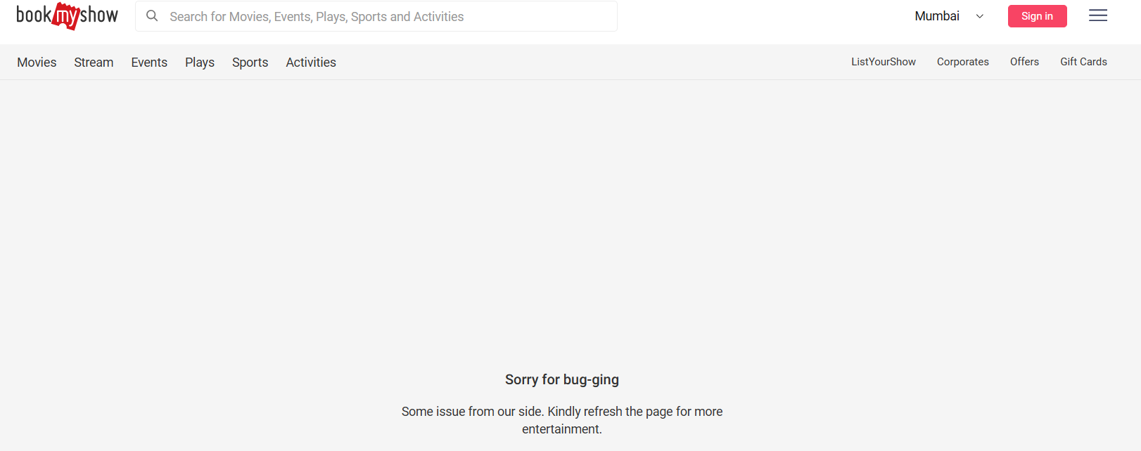

**Assigned to:**

Developer Name : @XXXXX