TUGAS PRAKTIKUM AlGORITMA PEMROGRAMAN

PEKAN 7

DISUSUN OLEH: ARYAHIYAHUL FIKRA 2511532026

DOSEN PENGAMPU: Dr.WAHYUDI, S.T, M.T
ASISTEN PRAKTIKUM: RAHMAD DWIRIZKI


DEPARTEMEN INFORMATIKA
FAKULTAS TEKNOLOGI INFORMASI PROGRAM STUDI INFORMATIKA UNIVERSITAS ANDALAS
2025
PSUEDOCODE

CLASS Akun
PRIVATE username : String
PRIVATE password : String
PRIVATE email : String
PRIVATE pinAngka : Integer
METHOD setUsername(u : String)
username ← u
END METHOD

METHOD setPassword(p : String)
password ← p
END METHOD

METHOD setEmail(e : String)
email ← e
END METHOD

METHOD setPinAngka(pin : Integer)
pinAngka ← pin
END METHOD

METHOD getUsername() : String
RETURN username
END METHOD

METHOD getEmail() : String
RETURN email
END METHOD

METHOD getPinAngka() : Integer
RETURN pinAngka
END METHOD

METHOD isPasswordValid() : Boolean
IF length(password) ≥ 8 THEN
RETURN true
ELSE
RETURN false
END IF
END METHOD

METHOD isEmailValid() : Boolean
IF email contains "@" AND email contains "." THEN
RETURN true
ELSE
RETURN false
END IF
END METHOD
END CLASS

PROGRAM Registrasi
DECLARE akunBaru AS Akun
CREATE akunBaru
DISPLAY "Masukkan Username: "
INPUT username
CALL akunBaru.setUsername(username)

DISPLAY "Masukkan Password: "
INPUT password
CALL akunBaru.setPassword(password)

DISPLAY "Masukkan Email: "
INPUT email
CALL akunBaru.setEmail(email)

DISPLAY "Masukkan PIN Angka: "
INPUT pin
CALL akunBaru.setPinAngka(pin)

DISPLAY "=== HASIL VALIDASI ==="

IF akunBaru.isPasswordValid() = false THEN
DISPLAY "Password tidak valid (minimal 8 karakter)"
END IF

IF akunBaru.isEmailValid() = false THEN
DISPLAY "Email tidak valid (harus ada @ dan .)"
END IF

IF akunBaru.isPasswordValid() AND akunBaru.isEmailValid() THEN
DISPLAY "Registrasi Berhasil!"
DISPLAY "Username: ", akunBaru.getUsername()
DISPLAY "Email: ", akunBaru.getEmail()
DISPLAY "PIN: ", akunBaru.getPinAngka()
ELSE
DISPLAY "Registrasi Gagal"
END IF
END PROGRAM
PROGRAM JAVA

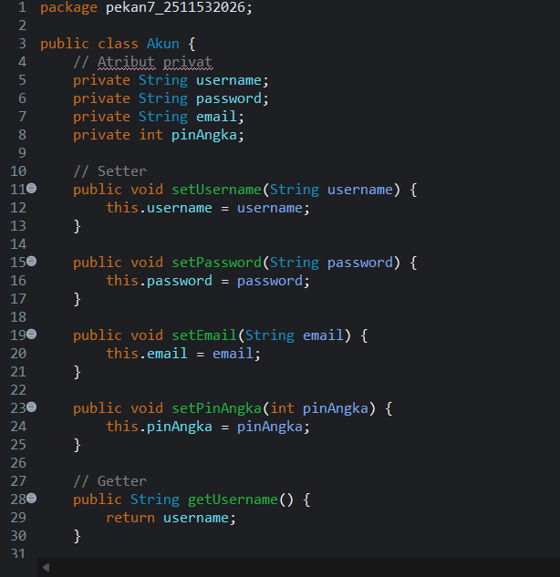

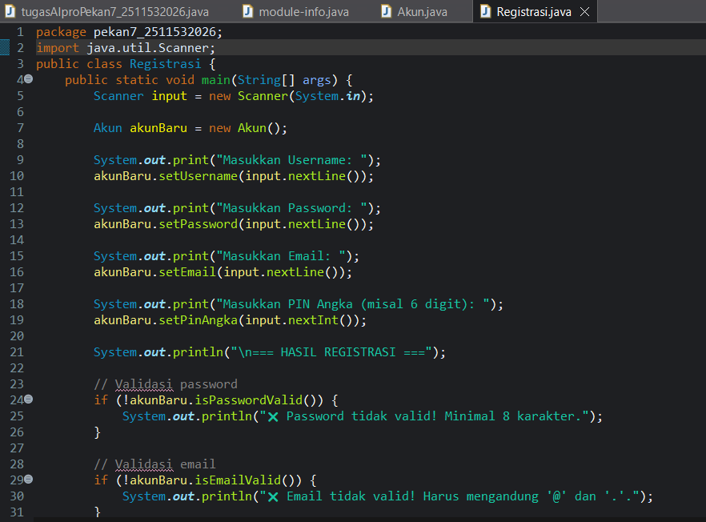

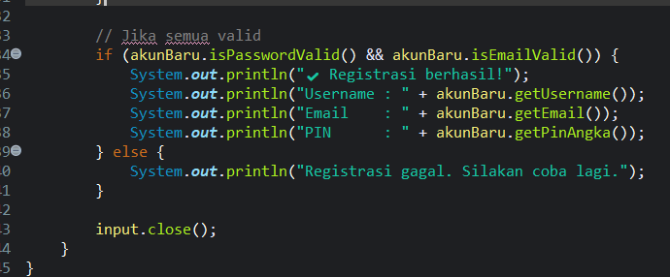

OUTPUT
