**INDEX**

**CONTENTS PAGE**

1. Abstract 3
2. Problem Statement 4
3. Problem Description 4
4. Purpose 5
5. Scope of the Project 6
6. Requirement Analysis 7

* Functional Requirements 7
* Non-Functional Requirements 7

1. System Requirements 8

* Software Requirements 8
* Hardware Requirements 8

1. System Design 9

* Use case Diagram 10
* Class Diagram 11
* Sequence Diagram 12
* Data flow 13

1. Testing 15
2. Snap shots 16
3. Conclusion 19
4. References 20

**ABSTRACT**

The NER-based Text Summarizer is an advanced natural language processing (NLP) system designed to automatically identify and extract named entities from unstructured text data, including individuals, organizations, locations, dates, and more. Leveraging state-of-the-art Named Entity Recognition (NER) technology, the system processes input text to identify relevant entities and synthesizes this information into concise and coherent summaries. By integrating NER functionality with text summarization algorithms, the system offers a seamless solution for efficiently distilling key information from large volumes of textual content. The abstract nature of the system lies in its ability to automate the extraction and summarization process, empowering users to quickly grasp the essential content of input text without extensive manual effort.

**PROBLEM STATEMENT**

Text Summarization using NER model

**PROBLEM DESCRIPTION**

This project tackles the challenge of efficiently extracting essential information from vast unstructured text data. By combining Named Entity Recognition (NER) technology with text summarization algorithms, it aims to automatically identify and extract key entities like people, organizations, and dates from diverse text sources. Through harnessing natural language processing (NLP) techniques, the system synthesizes these entities into concise summaries, alleviating the need for extensive manual efforts and facilitating quick comprehension of input text across various domains, from news articles to social media posts.

**PURPOSE**

The purpose of our project is to address this challenge by developing an advanced solution utilizing Named Entity Recognition (NER) technology coupled with a text summarization algorithm. By harnessing the power of natural language processing (NLP) techniques, our goal is to create a robust system capable of automatically identifying and extracting named entities such as people, organizations, locations, dates, and more from unstructured text. Furthermore, we aim to synthesize these identified entities into concise and coherent summaries, enabling users to quickly grasp the core content of the input text without the need for extensive reading.

**SCOPE OF PROJECT**

* **NER Model Development:** Designing and training a NER model for accurate identification of named entities in unstructured text.
* **Text Summarization Integration:** Integrating the NER model with a text summarization algorithm for generating concise summaries.
* **Evaluation and Optimization:** Rigorous evaluation of model performance and iterative optimization for improved accuracy.
* **Scalability and Deployment:** Ensuring scalability to handle large text volumes and exploring deployment options for accessibility.
* **Documentation and UI:** Providing comprehensive documentation and developing an intuitive user interface for seamless interaction.

**REQUIREMENT ANALYSIS**

Software requirement is a functional or non-functional need to be implemented in the system. Functional means providing a particular service to the user.

Software requirement can also be a non-functional, it can be a performance requirement.

The following are the functional and non-functional requirements of

**Text Summarization using NER model**

**Functional Requirements:**

* Entity Type Customization
* Sentence Segmentation
* Contextual Understanding
* Proper Noun Handling
* Abstractive Summarization
* Summarization Quality Metrics

**Non-Functional Requirements:**

* Performance
* Security
* Availability
* Reliability
* Serviceability
* Maintainability
* Regulatory
* Manageability
* Usability

**System Requirements**

System requirements are the required specifications a device must have in order to use certain [hardware](https://techterms.com/definition/hardware) or [software](https://techterms.com/definition/software).

**Software Requirements:**

**Windows:**10 or newer

**Backend:** Python

**Frontend:** HTML, CSS

## Hardware Requirements:

**Processor (CPU):** Dual-core processor or higher

**RAM:** 4GB or more

**Storage:** Minimum 20GB of free disk space

**Internet Connection:** Broadband connection for seamless online access and data transfer

**Graphics Card:** Basic graphics capabilities for a smoother user interface experience

**Display:** Monitor with a resolution of 1280x720 pixels or higher

**SYSTEM DESIGN**

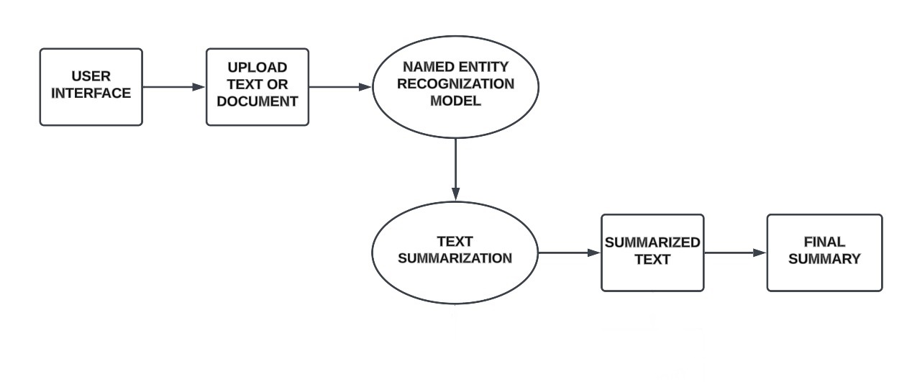

System Architecture

Following are the system designs for the mentioned project:

* Use case Diagram
* Class Diagram
* Sequence Diagram
* Data Flow Diagram

**USE CASE DIAGRAM:**

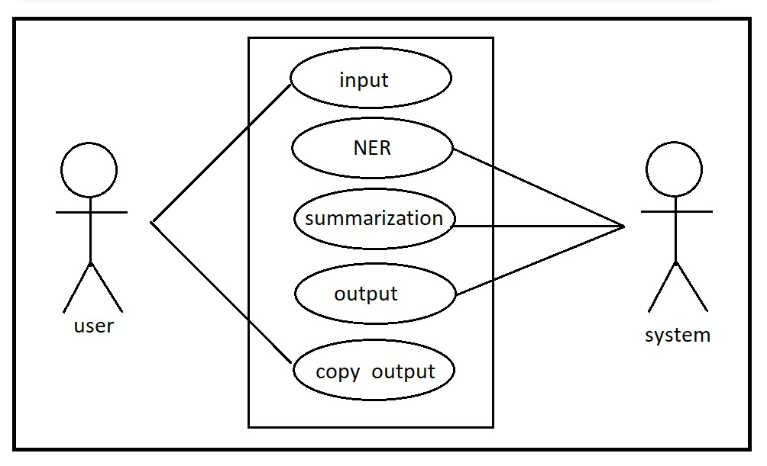

**CLASS DIAGRAM**

**SEQUENCE DIAGRAM:**

**Data Flow Diagram**

**Level 0 :**

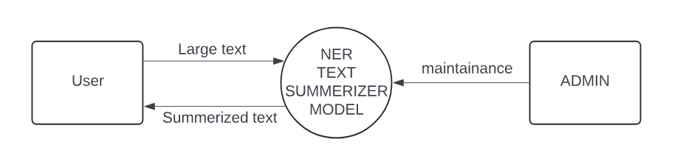

**Level 1 :**

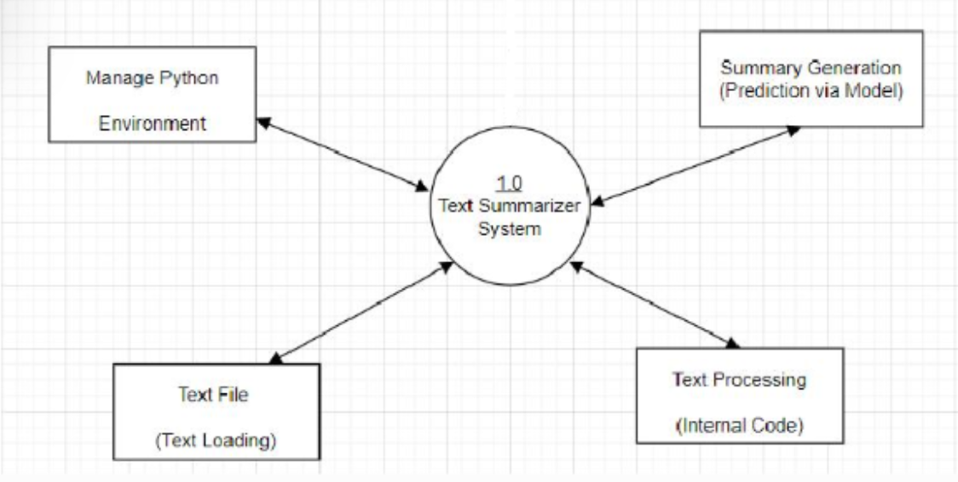

**CONCLUSION**

**REFERENCES**

[**www.w3school.com**](http://www.w3school.com)

[**www.freecodecamp.com**](http://www.geeksforgeeks.org)

**CONCLUSION**