ECG Image-to-Signal Reconstruction
Complete Project Pipeline Report

Deep Learning-Based ECG Digitization using
Hybrid CNN + Transformer Architecture

Framework: PyTorch 2.6.0 | GPU: NVIDIA RTX 3050 6GB | Dataset: PTB-XL

Table of Contents
1. Project Objective
2. Data Source — PTB-XL Dataset
3. Data Generation Pipeline (ecg_pipeline.py)
3.1 Signal Loading
3.2 Signal Preprocessing
3.3 ECG Image Generation
3.4 Batch Processing
4. Dataset & Data Loading
5. Model Architecture — ECGImageToSignalModelV3
5.1 CNN Encoder (ResNet18)
5.2 Transformer Bridge
5.3 Conv1d Decoder
6. Loss Function — StableLossWithWarmup
7. Training Strategy
8. Training Progression
9. Problems Diagnosed & Fixed
10. Final Evaluation Results
11. Output Files
12. Pipeline Flow Diagram

1. Project Objective
The goal of this project is ECG digitization: given a printed/rendered ECG image (the paper-style plot with standard clinical grid), reconstruct the underlying 1-D electrical signal as a numerical time series. This enables converting legacy paper ECG records into machine-readable digital signals for downstream clinical analysis, automated diagnosis, and electronic health record integration.
The system takes a 1968×472 pixel ECG image as input and outputs a 1000-sample digital signal representing 10 seconds of Lead I ECG recording at 100 Hz sampling rate.

2. Data Source — PTB-XL Dataset
The PTB-XL dataset (version 1.0.3) is a large, publicly available electrocardiography dataset published on PhysioNet. It is one of the largest freely accessible clinical ECG datasets available for research.
Property | Value
Dataset Name | PTB-XL v1.0.3
Source | PhysioNet (physionet.org)
Total Records | 21,799 twelve-lead ECG recordings
Patients | ~18,885 patients (ages 2–95)
Recording Duration | 10 seconds per record
Storage Format | WFDB format (.hea header + .dat binary)
Available Sampling Rates | 100 Hz (records100/) and 500 Hz (records500/)
Used Sampling Rate | 100 Hz → 1000 samples per 10-second recording
Metadata File | ptbxl_database.csv — demographics, SCP diagnostic codes, quality annotations
Lead Used | Lead I (single-lead extraction)

The dataset includes diagnostic labels using the SCP-ECG standard, covering normal ECGs as well as various cardiac conditions including myocardial infarction, conduction disturbances, and hypertrophy patterns. For this project, the diagnostic labels are not used — only the raw ECG waveforms are needed for the image-to-signal reconstruction task.

3. Data Generation Pipeline (ecg_pipeline.py)
The data generation pipeline converts raw WFDB ECG records into paired (image, signal) training samples. This is implemented in ecg_pipeline.py (341 lines) and consists of four stages.

3.1 Signal Loading
Raw ECG signals are loaded from the PTB-XL dataset using the WFDB (WaveForm DataBase) Python library. The wfdb.rdrecord() function reads the .hea header file (containing metadata like sampling frequency, number of channels, and calibration) and the .dat binary file (containing the actual signal samples).
From each 12-lead recording, only Lead I (index 0) is extracted. Lead I represents the potential difference between the right arm and left arm electrodes and is the most commonly used single lead for basic ECG analysis. This produces a 1000-sample float array representing 10 seconds of cardiac activity at 100 Hz.

3.2 Signal Preprocessing — Bandpass Filtering
The raw ECG signal undergoes bandpass filtering to remove noise while preserving clinically relevant waveform features:
Parameter | Value | Purpose
Filter Type | 4th-order Butterworth | Maximally flat passband response
Low Cutoff | 0.5 Hz | Removes baseline wander (respiratory artifacts, electrode drift)
High Cutoff | 40 Hz | Removes high-frequency noise (muscle artifacts, powerline interference)
Implementation | scipy.signal.filtfilt() | Zero-phase filtering (no time delay introduced)

The filtered signal is saved as a NumPy .npy file (float32, 1000 samples) in the output/signals/ directory. The zero-phase filtering via filtfilt() applies the filter forward and backward, ensuring no phase distortion is introduced — critical for preserving the temporal alignment of ECG waveform components (P wave, QRS complex, T wave).

3.3 ECG Image Generation
Each filtered signal is rendered as a clinical-standard ECG plot image that mimics the appearance of real printed ECG paper:
Parameter | Value
Image Dimensions | 1968 × 472 pixels (RGBA PNG)
Paper Speed | 25 mm/s (standard clinical setting)
Amplitude Scale | 10 mm/mV (standard clinical setting)
Minor Grid | Light red lines at 1mm intervals
Major Grid | Darker red lines at 5mm intervals
Background | White
Signal Trace | Black line plotted on the grid
Rendering Library | Matplotlib

The image generation closely replicates the standard clinical ECG paper format. The red grid lines on a white background with the black signal trace provide the visual structure that the neural network must learn to parse. Images are saved as RGBA PNG files in the output/images/ directory.

3.4 Batch Processing
All 21,799 PTB-XL records are processed using Python's multiprocessing.Pool for parallel execution. Each record goes through the complete pipeline: load WFDB → bandpass filter → render ECG image → save both image (.png) and signal (.npy). The process_single_record() function handles one record end-to-end, and the main() function orchestrates the parallel batch processing across all available CPU cores.

4. Dataset & Data Loading
The ECGImageSignalDataset class (defined in ecg_image_to_signal_trainer.py) handles pairing each ECG image with its corresponding signal and preparing them for the model.

Image Preprocessing
Step | Operation | Details
1 | Resize | 224 × 448 pixels (preserves ~1:2 aspect ratio of original 1968×472)
2 | ToTensor | Convert PIL image to PyTorch tensor, scale pixel values to [0, 1]
3 | Normalize | ImageNet mean=[0.485, 0.456, 0.406], std=[0.229, 0.224, 0.225]

CRITICAL: No data augmentation is applied. Early experiments used 8 simultaneous aggressive transforms (rotation, perspective warp, blur, brightness/contrast changes, JPEG compression, random erasing) that completely destroyed the waveform structure the model needed to learn. Removing all augmentation was one of the key fixes that enabled successful training.

Signal Preprocessing
Each 1000-sample signal is z-normalized: (signal - mean) / (std + 1e-8). This maps all signals to zero mean and unit variance, ensuring the model does not need to learn different amplitude scales for different patients. The epsilon (1e-8) prevents division by zero for rare flat-line recordings.

Dataset Split
Split | Samples | Percentage
Training | 17,439 | 80%
Validation | 4,360 | 20%
Total | 21,799 | 100%

Random seed = 42 ensures reproducible splits across runs.

5. Model Architecture — ECGImageToSignalModelV3
The model uses a three-stage hybrid architecture with approximately 12.5 million parameters. It combines the spatial feature extraction strength of CNNs with the global context modeling capability of Transformers, followed by a temporal decoder that generates the output signal.

5.1 Stage 1: CNN Encoder (ResNet18 Backbone)
Property | Detail
Architecture | ResNet18 (without avgpool and fc layers)
Initialization | Pretrained on ImageNet (transfer learning)
Frozen Layers | Stem (first conv + batch norm) — preserves low-level edge/texture features
Input Shape | (B, 3, 224, 448) — batch of RGB images
Output Shape | (B, 512, 7, 14) — 512-channel feature maps
Spatial Tokens | 7 × 14 = 98 tokens (preserves the wide temporal layout of ECG images)
Downsampling Factor | 32× in both spatial dimensions

Using a pretrained ResNet18 backbone provides strong initial feature extraction capabilities from ImageNet pretraining. The stem layers (first convolutional layer + batch normalization) are frozen because they detect generic low-level features (edges, textures, colors) that are useful across all image domains. The deeper layers are fine-tuned at a lower learning rate to adapt to ECG-specific features.

5.2 Stage 2: Transformer Bridge
Property | Detail
Input | 98 spatial tokens × 512 dimensions
Linear Projection | 512 → 256 dimensions (reduces computation)
Positional Encoding | Learnable positional embeddings (dynamic, interpolated)
Transformer Blocks | 2 × LightweightTransformerBlock
Attention Heads | 4 per block
Normalization | Pre-LayerNorm (more stable training than Post-LN)
MLP Ratio | 2.0 (hidden dim = 512)
Activation | GELU
Dropout | 0.1
Output | (B, 98, 256) — contextualized token representations

The Transformer bridge captures global temporal dependencies across the entire ECG trace. While the CNN backbone has a limited receptive field, the self-attention mechanism allows each spatial position to attend to all other positions, enabling the model to understand relationships between distant waveform components (e.g., relating P waves to QRS complexes across the full 10-second recording).

5.3 Stage 3: Conv1d Decoder
The decoder progressively upsamples from 64 temporal positions to the final 1000-sample output:
Layer | Operation | Shape
Interpolate | Linear interpolation of transformer output | (B, 256, 98) → (B, 256, 64)
Channel Reduce | Conv1d + GroupNorm + ELU | (B, 256, 64) → (B, 128, 64)
ResBlock 1 | ConvTranspose1d + GroupNorm + ELU + skip | (B, 128, 64) → (B, 64, 128)
ResBlock 2 | ConvTranspose1d + GroupNorm + ELU + skip | (B, 64, 128) → (B, 32, 256)
Dropout | 5% dropout for regularization | (B, 32, 256)
ResBlock 3 | ConvTranspose1d + GroupNorm + ELU + skip | (B, 32, 256) → (B, 16, 512)
ResBlock 4 | ConvTranspose1d + GroupNorm + ELU + skip | (B, 16, 512) → (B, 8, 1024)
Head | Conv1d(8→8, k=5) + ELU + Conv1d(8→1, k=7) | (B, 8, 1024) → (B, 1, 1024)
Final Interpolate | Linear interpolation to target length | (B, 1024) → (B, 1000)

KEY DESIGN CHOICE — GroupNorm instead of BatchNorm: When the model initially predicts near-constant outputs (e.g., all zeros), BatchNorm normalizes all samples identically, causing gradient collapse. GroupNorm normalizes within groups of channels per sample, maintaining gradient flow regardless of output statistics. This was one of the critical fixes that enabled training.

6. Loss Function — StableLossWithWarmup
A composite loss function with four components, designed to avoid the trivial zero-prediction solution that plagued earlier MSE-only training:
Component | Weight | Purpose
SmoothL1 (Huber) | 1.0 | PRIMARY loss — constant gradient (±1) for large errors. Unlike MSE whose gradient vanishes near the mean, SmoothL1 maintains strong gradient signal, forcing the model away from the trivial solution of predicting zeros.
MSE | 0.5 | Secondary loss — penalizes large errors quadratically for fine-grained accuracy once the model begins learning.
Pearson Correlation | 0.3 | Shape-matching loss (1 − correlation). Measures waveform similarity independent of scale/offset. Warmed up after epoch 3.
Derivative Loss | 0.1 | SmoothL1 on signal derivatives (first differences). Preserves sharp transitions like the QRS complex. Warmed up after epoch 3.

Why SmoothL1 instead of MSE?
The signals are z-normalized (zero mean, unit variance). With MSE-only loss, predicting all zeros gives MSE ≈ 1.0 (equal to the target variance). The MSE gradient near this trivial solution is proportional to the error, which is small — so the model gets "stuck" at loss = 1.0 with no improvement. SmoothL1 (Huber loss) has a constant gradient of ±1 for errors > 1.0, providing strong learning signal that pushes the model away from the trivial solution. This was the single most important fix.

Warmup Strategy
Pearson correlation and derivative losses are warmed up after epoch 3. During the first 3 epochs, only SmoothL1 and MSE are active — this allows the model to learn basic signal shape before being penalized for fine-grained waveform matching. The warmup factor linearly increases from 0 to 1 over epochs 3–6.

7. Training Strategy
Parameter | Value | Rationale
Optimizer | AdamW | Adam with decoupled weight decay — better generalization than vanilla Adam
Weight Decay | 1e-4 | Light L2 regularization
Backbone LR | 3e-5 (0.1× base) | Slower updates for pretrained weights — avoid catastrophic forgetting
Decoder LR | 9e-4 (3× base) | Faster updates for randomly initialized layers — must escape trivial solution quickly
Base LR | 3e-4 | For projection, transformer, and normalization layers
Scheduler | OneCycleLR | Super-convergence — ramps LR up then down in one cycle for faster convergence
Warmup | 10% of total steps | Gradual LR increase to stabilize early training
Batch Size | 16 | Smaller batch = noisier gradients → helps escape local minima
Epochs | 80 | Full training run (no early stopping triggered)
Mixed Precision | FP16 forward + FP32 loss | Halves GPU memory usage, ~2× faster on tensor cores
Gradient Clipping | Max norm = 1.0 | Prevents gradient explosion during early training
Early Stopping | Patience = 20 epochs | Stops training if val_loss doesn't improve (not triggered)
Data Loading | 4 persistent workers | Parallel data loading with pinned memory and prefetching
Hardware | NVIDIA RTX 3050 6GB | Laptop GPU with CUDA 12.4
Framework | PyTorch 2.6.0 | Latest stable release with torch.compile support

Differential Learning Rate
The most important training strategy is the differential learning rate. The pretrained ResNet18 backbone already has good feature extraction capabilities from ImageNet — updating it too aggressively would destroy these features (catastrophic forgetting). Meanwhile, the randomly initialized decoder needs aggressive updates to escape the trivial zero-prediction solution. The 30× ratio between decoder LR (9e-4) and backbone LR (3e-5) balances these competing needs.

8. Training Progression
The model trained for the full 80 epochs in 2.14 hours (128 minutes). The table below shows key metrics at selected epochs:
Epoch | Val Loss | MSE | Pearson Correlation | R-peak Error (ms)
1 | 0.7694 | 0.9693 | 0.1547 | 807.5
5 | 0.5500 | 0.5724 | 0.6439 | 138.2
10 | 0.2291 | 0.2082 | 0.8879 | 131.8
20 | 0.1201 | 0.1048 | 0.9458 | 126.9
30 | 0.0883 | 0.0763 | 0.9608 | 118.1
40 | 0.0790 | 0.0679 | 0.9652 | 107.7
50 | 0.0723 | 0.0622 | 0.9683 | 101.8
60 | 0.0659 | 0.0566 | 0.9711 | 97.1
70 | 0.0647 | 0.0556 | 0.9717 | 94.7
80 (final) | 0.0639 | 0.0550 | 0.9720 | 93.0

Training dynamics: The model showed rapid initial learning (epochs 1–10), with Pearson correlation jumping from 0.15 to 0.89. The middle phase (epochs 10–40) showed steady refinement. The final phase (epochs 40–80) showed diminishing returns with the OneCycleLR scheduler annealing the learning rate toward zero. No early stopping was triggered, indicating the model continued to benefit from all 80 epochs.
Total training time: 2.14 hours (128 minutes) on NVIDIA RTX 3050 6GB.

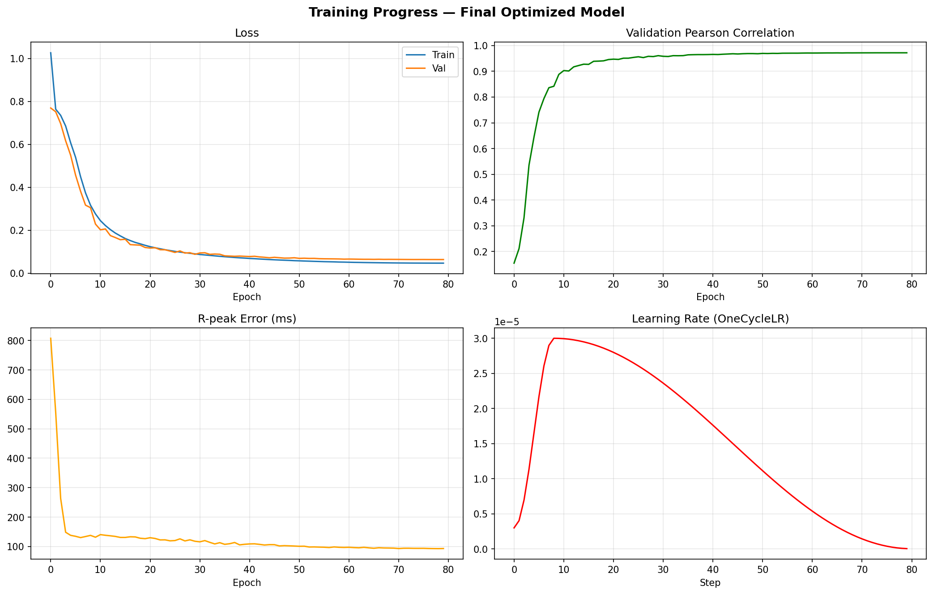
Figure 1: Training curves — Loss, Pearson Correlation, R-peak Error, and Learning Rate

9. Problems Diagnosed & Fixed
The model was initially completely non-functional: Pearson correlation ≈ 0, R-peak error = infinity, and loss stuck at 1.0 with no improvement. Five compounding issues were identified and resolved:
Issue | Problem | Fix
1. Aspect Ratio Destruction | Original 1968×472 images (4:1 ratio) were squashed to 224×224 (1:1), destroying temporal information — the horizontal time axis was compressed by 4×. | Changed image_size to (224, 448), preserving the ~1:2 aspect ratio and maintaining temporal resolution.
2. Excessive Augmentation | 8 simultaneous aggressive transforms (RandomPerspective, RandomRotation, RandomAffine, ColorJitter, GaussianBlur, RandomAdjustSharpness, Normalize, RandomErasing) obliterated waveform structure. | Removed ALL augmentation. Clean transforms only (Resize, ToTensor, Normalize).
3. MSE Loss Trivial Solution | With z-normalized targets (mean=0, std=1), predicting zeros gives MSE = 1.0 (target variance). MSE gradient vanishes near the mean → model stuck at loss = 1.0. | Switched to SmoothL1 (Huber) as primary loss — constant gradient ±1 for large errors, providing strong learning signal.
4. BatchNorm Collapse | When model output is near-constant (predicting zeros), BatchNorm normalizes all samples identically, collapsing gradients in the decoder. | Replaced BatchNorm with GroupNorm throughout the decoder. GroupNorm normalizes per-sample within channel groups, maintaining gradient flow.
5. Uniform Learning Rate | Pretrained backbone and randomly initialized decoder both at the same learning rate — backbone gets destabilized while decoder cannot learn fast enough. | Differential LR: backbone at 0.1× base (gentle fine-tuning), decoder at 3× base (aggressive escape from trivial solution).

10. Final Evaluation Results
The best model (saved at epoch 79) was evaluated on the full validation set of 4,360 samples.

10.1 Signal Reconstruction Quality
Metric | Value
Mean Pearson Correlation | 0.9720 ± 0.0362
Median Pearson Correlation | 0.9818
Mean R² (Coefficient of Determination) | 0.9451
Mean RMSE | 0.2107
Mean MAE | 0.1258
Mean SNR | 14.4 ± 5.5 dB
Val Loss (SmoothL1 composite) | 0.0639
MSE | 0.0550

10.2 Accuracy at Correlation Thresholds
The percentage of validation samples achieving at least the given Pearson correlation:
Threshold | % of Samples
Correlation ≥ 0.99 | 24.2%
Correlation ≥ 0.95 | 81.8%
Correlation ≥ 0.90 | 96.3%
Correlation ≥ 0.80 | 99.1%
Correlation ≥ 0.70 | 99.7%

96.3% of all validation samples achieve a Pearson correlation of 0.90 or higher, indicating that the vast majority of reconstructed signals closely match the ground truth waveform shape.

10.3 R-peak Detection Accuracy
R-peak detection accuracy measures how well the reconstructed signal preserves the clinically critical QRS complexes:
Tolerance Window | Accuracy
±50 ms | 59.0%
±100 ms | 76.4%
±150 ms | 85.7%

10.4 Worst / Best Case Analysis
Metric | Value
Best Pearson Correlation | 0.9990
Worst Pearson Correlation | 0.6251
Best SNR | 32.8 dB
Worst SNR | -2.1 dB
5th Percentile Pearson | 0.8989
95th Percentile Pearson | 0.9955

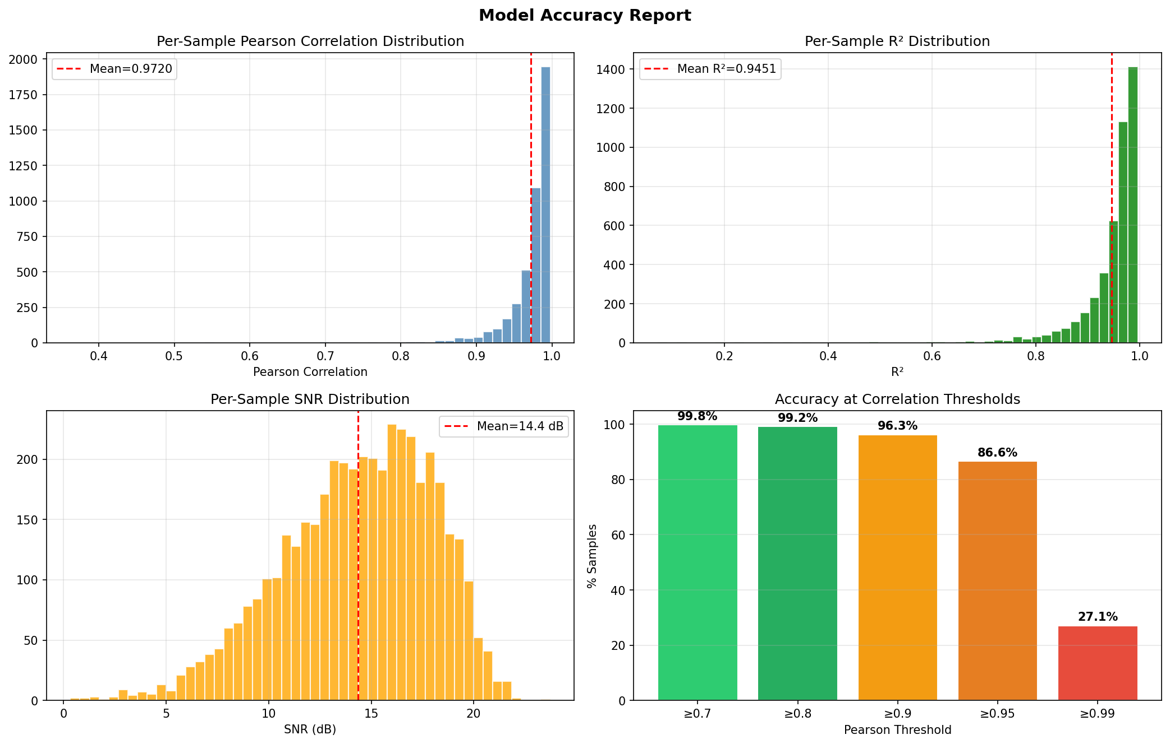
Figure 2: Accuracy report — Correlation distribution, R² distribution, SNR distribution, and threshold accuracy

11. Output Files
File/Directory | Purpose
output/images/*.png | 21,799 rendered ECG images (1968×472 RGBA)
output/signals/*_lr.npy | 21,799 filtered ECG signals (1000 samples, float32)
checkpoints_final/best_model.pth | Best trained model weights (val_loss=0.0639)
checkpoints_final/ecg_model_final.pth | Exported lightweight model for inference
checkpoints_final/latest_checkpoint.pth | Latest checkpoint with optimizer state for resuming
checkpoints_final/training_curves.png | Training loss/metrics visualization
checkpoints_final/accuracy_report.png | Comprehensive accuracy metrics visualization
checkpoints_final/epoch_*_comparison.png | Predicted vs ground truth visual comparisons at epochs 10, 20, 30, 40, 50, 60, 70, 80

12. Pipeline Flow Diagram
PTB-XL WFDB Records (21,799 × 12-lead, 100 Hz)
|
v
Lead I Extraction (single-lead)
|
v
Bandpass Filter (0.5-40 Hz, Butterworth 4th order)
|
+---> Save as .npy signal (1000 samples, float32)
|
v
ECG Image Rendering (standard clinical grid, 1968x472 PNG)
|
+---> Save as .png image
|
v
ECGImageSignalDataset (pair images <-> signals)
| - Resize to 224x448
| - ImageNet normalization
| - Z-normalize signal
|
v
ECGImageToSignalModelV3
| - ResNet18 encoder (pretrained, stem frozen)
| - Transformer bridge (2 blocks, 4 heads)
| - Conv1d decoder (GroupNorm, residual blocks)
|
v
Training (80 epochs, SmoothL1+MSE+Pearson+Derivative loss)
| - Differential LR (backbone 0.1x, decoder 3x)
| - OneCycleLR scheduler
| - Mixed precision (FP16)
| - Gradient clipping (max norm 1.0)
|
v
Best Model --> Pearson: 0.9720 | R²: 0.9451 | R-peak: 93ms

Sample Predictions (Epoch 80)
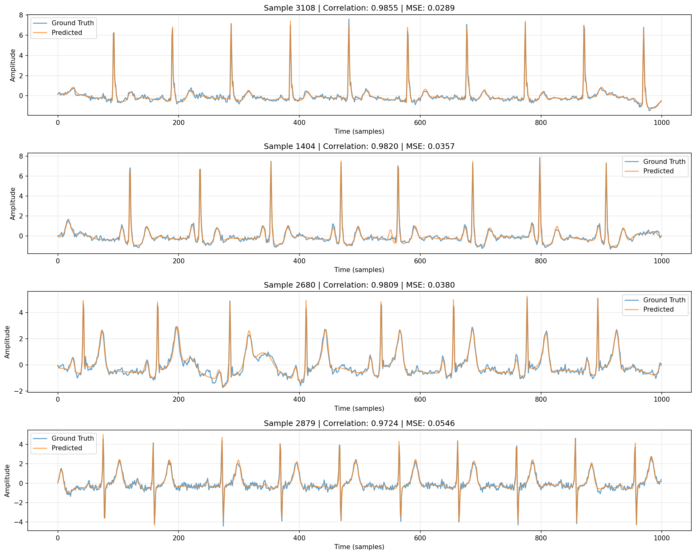
Figure 3: Predicted (orange) vs Ground Truth (blue) ECG signals at epoch 80

