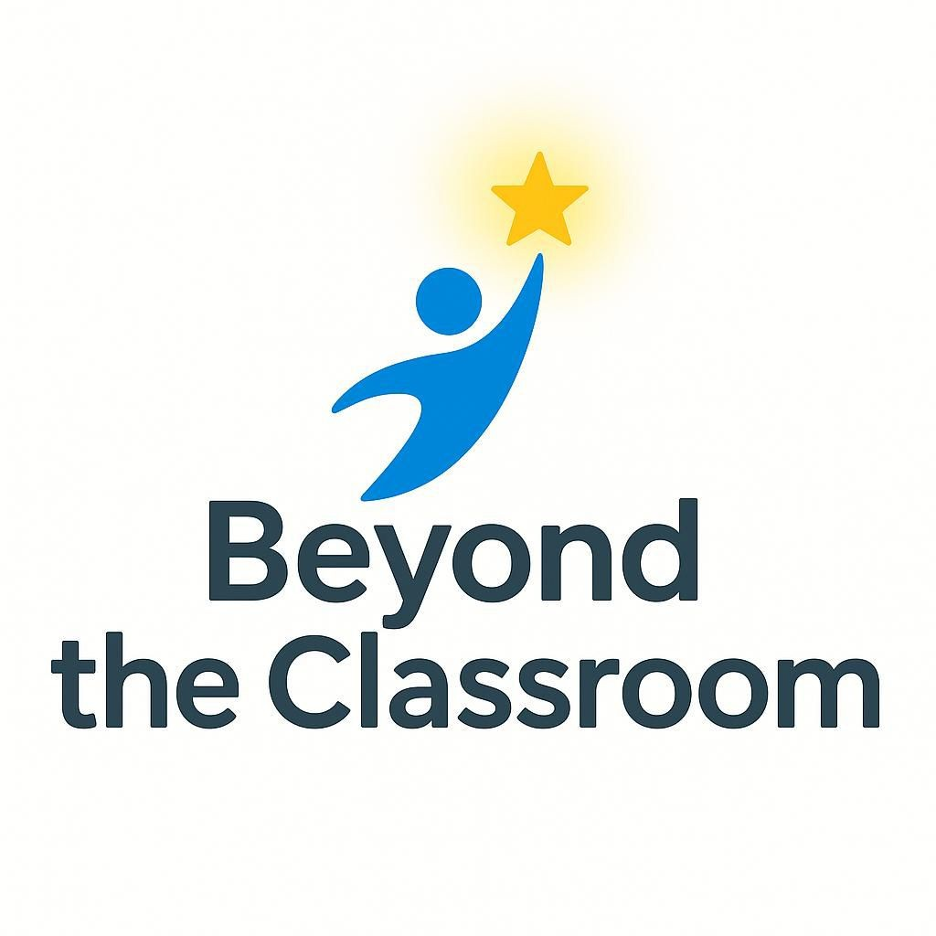
Beyond The Classroom
Empowering Students Beyond the Classroom

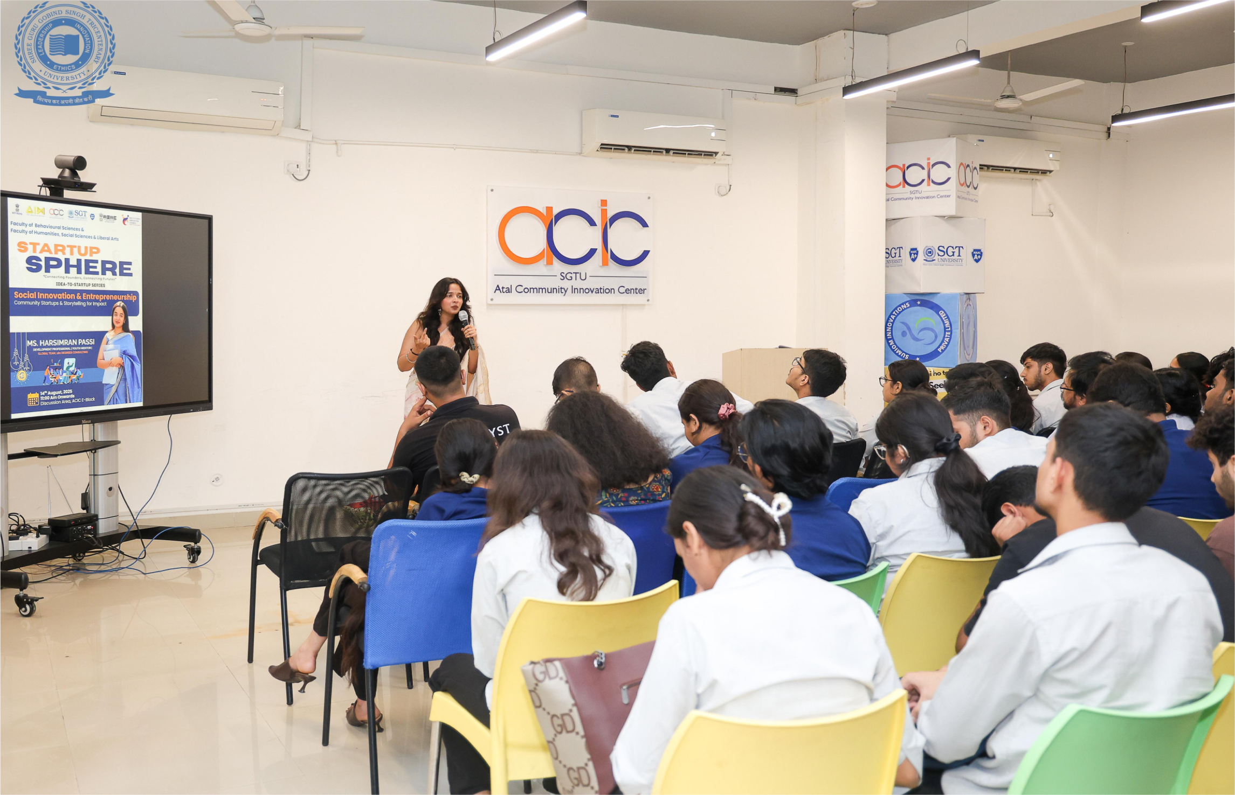

This Community -
It’s for the doers, the dreamers, and the ones who believe action speaks louder than words.
A space where ideas don’t just stay on paper — they turn into projects, movements, and real impact.


The Problem
India doesn’t have a talent gap — it has a skills gap.

- Over 80% of Indian graduates are unemployable (India Skills Report, 2024).
- Schools and colleges focus on rote learning, not real-world problem solving.
- Young people, especially women, lack access to mentors, exposure, and opportunities that align with market needs.

Education produces degree-holders. The future needs skill-holders.



Only two pages were converted.
Please Sign Up to convert the full document.

www.freepdfconvert.com/membership

