PROJECT IRL
Software Architecture, AI-Agent Council & Software Requirements Specification

Working product thesis: technology as a bridge to meaningful offline behaviour not as another engagement-maximizing destination.

Version 1.0 | 30 September 2026 Architecture baseline: India-first • mobile-first • 12–17 pilot
This document is an engineering baseline, not legal advice. Child-data, school deployment, app-store policy, and jurisdiction-specific consent flows require formal review before production launch.

Executive Summary
Project IRL is a mobile-first behavioural platform intended to help users practise real-world habits such as focus, listening, responsibility, gratitude and intentional technology use. The system deliberately avoids claiming that technology can objectively measure morality. It verifies only what can be legitimately observed, labels self-reported behaviour honestly, and uses long-term practice patterns rather than one-off “good person” scores.

Architecture decision | Selected baseline | Reason
Client | Flutter/Dart with Kotlin + Swift platform bridges | Shared product velocity while retaining native access to device-usage frameworks.
Backend | Python + FastAPI modular monolith | Small-team simplicity, typed API schemas, shared language with AI services, easy later extraction.
Primary database | PostgreSQL | Transactional integrity for consent, quest attempts, verification and reward ledger.
Realtime / cache | Redis | Rate limiting, ephemeral state, locks and event streams for MVP.
AI pattern | Constrained multi-agent council behind deterministic policy gates | LLMs advise; deterministic services own permissions, rewards, consent and safety enforcement.
Verification | Evidence classes + confidence, not “truth detection” | Reduces incentives for surveillance and overclaiming.
Deployment | Managed containers; no Kubernetes initially | Lower operational burden. Kubernetes is deferred until scale justifies it.
Privacy | Data minimisation; local aggregation; no ambient audio/camera/GPS by default | Product is aimed at minors and must avoid turning habit-building into surveillance.
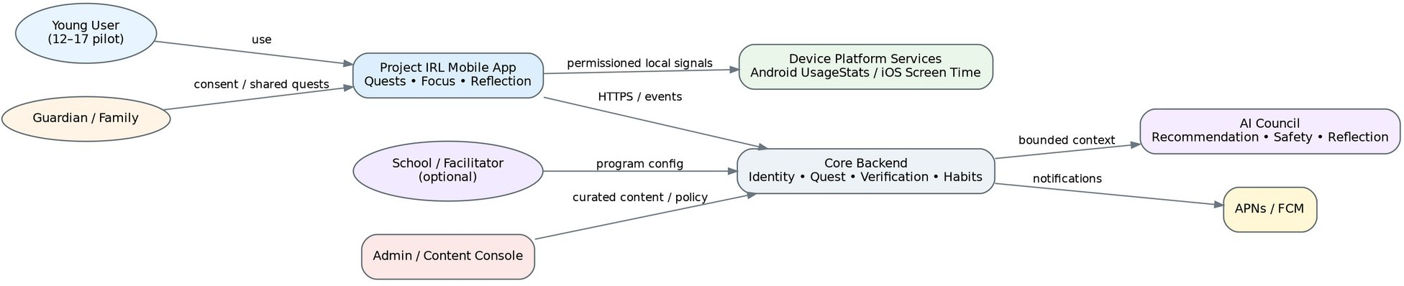

Success Definition
Figure 1 — System context and external actors

    - Increase sustained offline behaviours that continue after prompts are reduced.
    - Reduce low-value or compulsive device use without treating all screen activity as harmful.
    - Provide transparent evidence labels: device-verified, witness-confirmed, outcome-supported or self-reported.
    - Keep average in-app interaction short; a successful product can reduce its own session time.
    - Never rank children by morality, empathy, kindness or “goodness”.

Baseline Assumptions

Assumption | Baseline
Pilot audience | Users aged 12–17 with guardian involvement where required.
Launch geography | India first; architecture supports jurisdiction-specific policy packs.
Platforms | Android and iOS; web admin console later.
Quest philosophy | Real-world actions, short reflection, low-friction completion, decreasing reminders over time.
Monetisation constraint | No reward design that makes lying financially rational; XP is non-cash and non-transferable.
AI constraint | AI does not diagnose personality, detect lies, infer mental health, or

autonomously punish users.

Expert Architecture Council
The following design council represents the professional viewpoints that should be present in architecture and product reviews. These are design roles, distinct from the runtime AI agents described later.

Council member | Professional mandate | Key decision authority
Council Chair / Principal Architect | System boundaries, trade-offs, ADRs, integration contracts | Rejects premature microservices; maintains coherent domain model.
Behavioural Science Lead | Habit formation, motivation, self-determination, measurement validity | No moral scores; rewards participation and consistency, not virtue.
Child Safety & Privacy Lead | Consent, data minimisation, safeguarding, age-appropriate design | Ambient recording, facial analysis and precise location are prohibited by default.
Mobile Platform Architect | Flutter, Android/iOS capabilities, permissions, offline operation | Native functionality is isolated behind typed platform adapters.
Backend / Domain Architect | DDD, API, transactions, consistency, event boundaries | Reward and verification updates remain atomic in MVP.
AI/ML Architect | Agent orchestration, RAG, structured outputs, evaluation, model routing | LLM outputs are proposals; schemas and policy engines validate before use.
Security Architect | Threat model, secrets, auth, abuse prevention, secure SDLC | Zero-trust service identity, least privilege, immutable audit trails.
Data / Analytics Architect | Event taxonomy, warehouse path, experimentation, privacy-preserving metrics | Raw sensitive telemetry is avoided; analytics uses purpose-limited events.
QA / SRE Lead | Reliability, test strategy, observability, incident response | Safety-critical flows require deterministic tests and canary releases.
UX & Accessibility Lead | Age-appropriate UX, accessibility, anti-dark-pattern design | No shame loops, coercive streaks or hidden consent.

Council Decision Log (Architecture Decision Records)

ADR | Decision | Rationale
ADR-001 | Modular monolith first | Domain is still evolving; distributed transactions across verification/rewards would slow iteration.
ADR-002 | Cross-platform Flutter UI + native adapters | Balances delivery speed with platform-specific Screen Time / usage APIs.
ADR-003 | Evidence confidence, not lie detection | Perfect proof of offline behaviour is impossible without intrusive surveillance.
ADR-004 | No valuable rewards for self-reported quests | Prevents the reward economy from creating a rational incentive to fabricate activity.
ADR-005 | LLMs cannot directly mutate reward, consent or user restrictions | High-impact changes must pass deterministic domain services.
ADR-006 | Local aggregation of device telemetry | Server receives summaries required for the feature, not a complete behavioural exhaust by default.
ADR-007 | Quest content is curated + AI-adapted, not fully generated from scratch | Safety, consistency and educational quality need a controlled content base.
ADR-008 | Separate Digital Behaviour metrics from Human Habit practice | Objectively measured device behaviour must not be conflated with inferred character.

Target Software Architecture
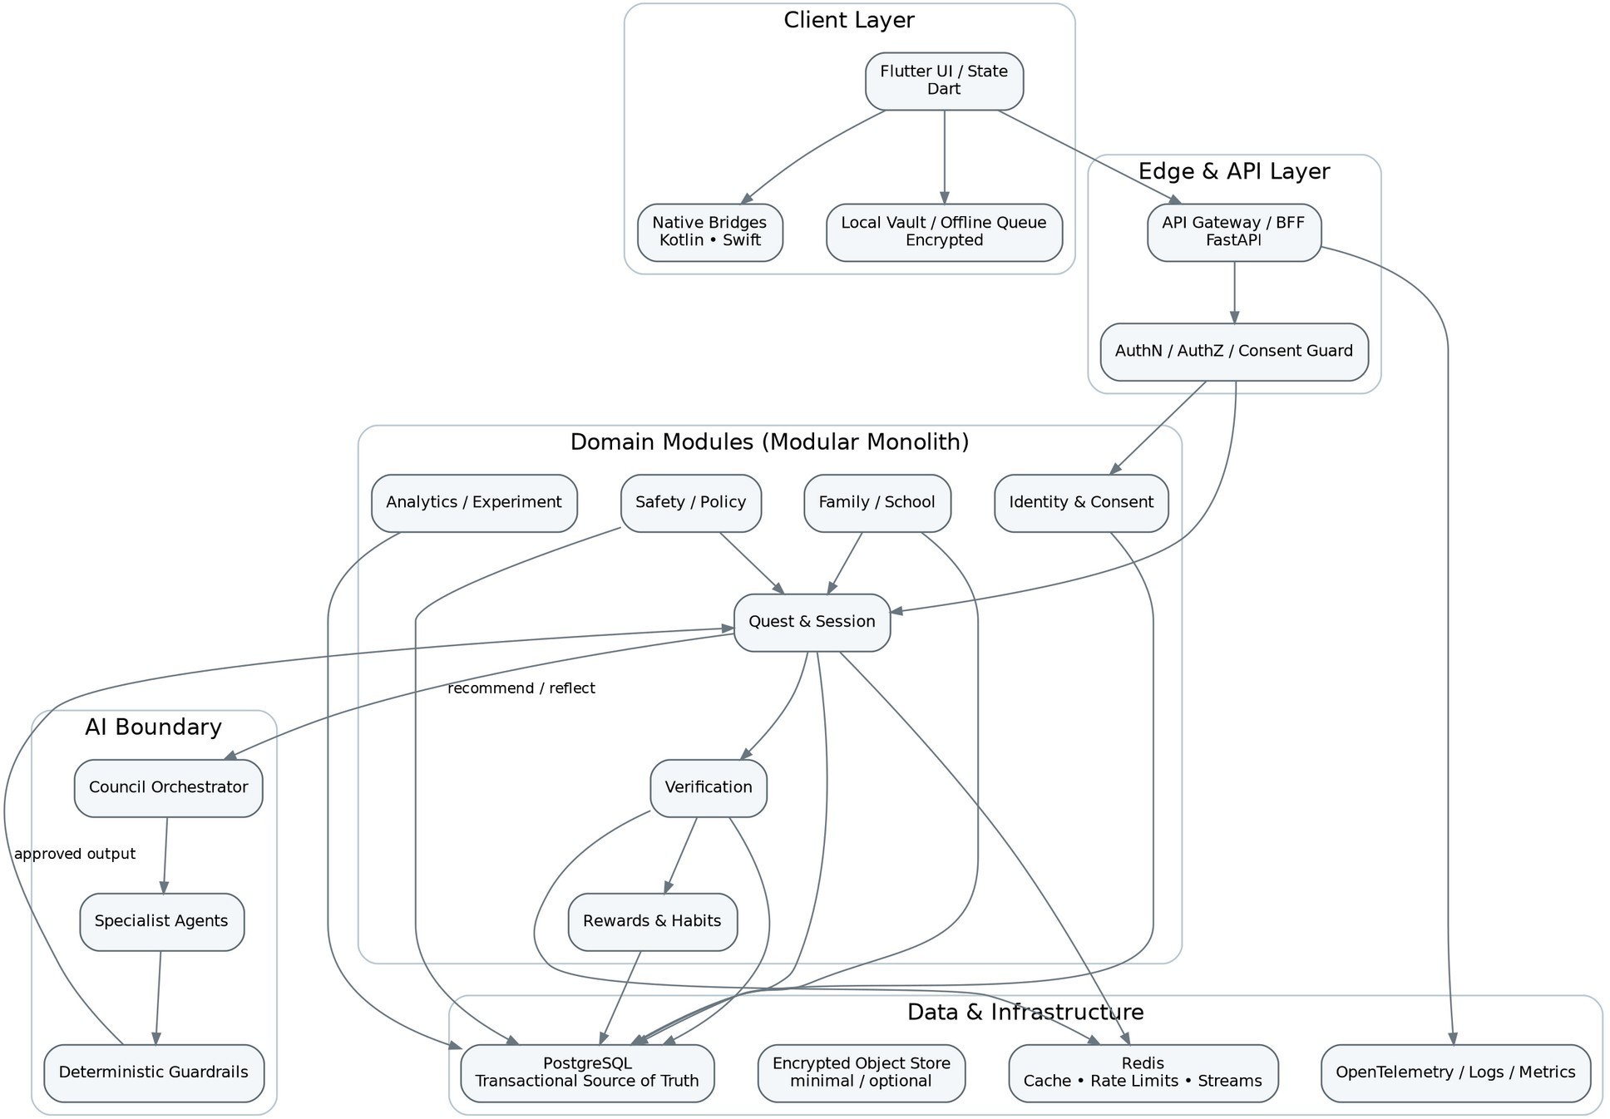

Architectural Style
Figure 2 — Layered architecture and bounded modules

Use Domain-Driven Design boundaries inside a modular monolith. Each module owns its application services, domain rules, repositories and API contracts. Cross-module calls are explicit. Events are published through an internal outbox and Redis Streams; modules can later be extracted into independent services without redesigning the entire domain.

Languages and Technology Stack

Layer | Language / technology | Use
Mobile UI | Dart + Flutter | Primary cross-platform application UI, navigation, state and local quest workflows.
Android native | Kotlin | UsageStats integration, permission adapters, device-state hooks and platform-specific secure storage integration.
iOS native | Swift | Family Controls / Device Activity / Managed Settings adapters where entitlement and consent allow.
Backend | Python 3.x + FastAPI | REST/JSON APIs, domain services, AI orchestration endpoints, background job entry points.
Admin console | TypeScript + React / Next.js | Internal content, safety policy, quest catalog, experiment and audit console.
Primary DB | PostgreSQL | Strong consistency; JSONB for structured evidence metadata; Row-Level Security where useful.
Cache / events | Redis | Caching, idempotency locks, rate limits,

 |  | session state and Streams for asynchronous jobs.
AI layer | Python | Model gateway, structured prompting, evaluation, retrieval and agent orchestration.
Infra as code | Terraform | Reproducible environments, IAM, network, database and secrets configuration.
CI/CD | GitHub Actions or equivalent | Test, SAST, dependency scanning, build, signing and deployment pipelines.
Observability | OpenTelemetry + metrics/log backend | Trace quest lifecycle, AI decisions, latency, errors and safety-policy outcomes.
Push | APNs + FCM | Time-sensitive and preference-aware reminders; no manipulative notification loops.
Android note: UsageStatsManager can provide usage/event statistics with the relevant user-granted access. It does not automatically make third-party “hard blocking” a safe or store-policy-compliant design. The MVP should verify screen/device usage and use opt-in focus mechanisms rather than relying on AccessibilityService as a blocking hack.

Module Boundaries and Internal Layers

Module | Presentation / API | Application layer | Domain layer | Infrastructure layer
Identity & Consent | Onboarding, guardian link, jurisdiction/age policy | ConsentService, GuardianLinkService, SessionPolicy | Consent aggregate, PurposeGrant, AccountState | Postgres, email/SMS provider abstraction, audit log
Profile & Goals | Values/goals, preferences, accessibility | GoalService, PreferenceService | Goal, SkillDomain, UserPreference | Postgres, encrypted local mirror
Quest | Catalog, recommendation, assignment, lifecycle | QuestAssignmentService, QuestSessionService | QuestTemplate, QuestInstance, Attempt | Postgres, Redis, AI gateway
Device Wellbeing | Usage permissions, local summaries, focus session | UsageAdapter, LocalSessionMonitor | UsageSummary, FocusSession | Kotlin/Swift platform APIs, encrypted local DB
Verification | Evidence normalization, replay checks, confidence class | VerificationService, EvidencePolicyResolver | EvidenceBundle, VerificationResult | Postgres, Redis locks, witness token service
Rewards & Habits | Activity points, streak-safe consistency, habit stages | RewardLedgerService, HabitProgressionService | LedgerEntry, HabitState | Postgres transaction/outbox
Reflection | Post-quest reflection, safe coaching | ReflectionService | Reflection, PromptTemplate | AI gateway, Postgres
Family / School | Shared challenges, guardian views, class programs | FamilyChallengeService, ProgramService | FamilyGroup, ProgramAssignment | Postgres; aggregated read models
AI Orchestration | Council routing, RAG, schema validation | CouncilOrchestrator, AgentGateway | AgentDecision, PolicyContext | LLM providers, vector index optional
Safety & Policy | Age/jurisdiction restrictions, forbidden evidence, content rules | PolicyEngine, SafetyReviewService | PolicyPack, SafetyDecision | Versioned policy store, audit
Notification | Scheduling, quiet hours, reminder decay | NotificationService | NotificationPlan | Redis/job queue, APNs/FCM
Analytics | Event taxonomy, experiments, dashboards | EventCollector, ExperimentService | ProductEvent, ExperimentAssignment | Postgres analytics schema; warehouse later
Admin | Quest authoring, policy, review, support tools | AdminApplication | ContentVersion, ReviewState | Admin DB views, audit, RBAC

Runtime AI-Agent Council
The runtime AI system is advisory and constrained. It receives the minimum context needed for a specific purpose, returns structured outputs, and cannot bypass deterministic policy, consent, verification or reward services.

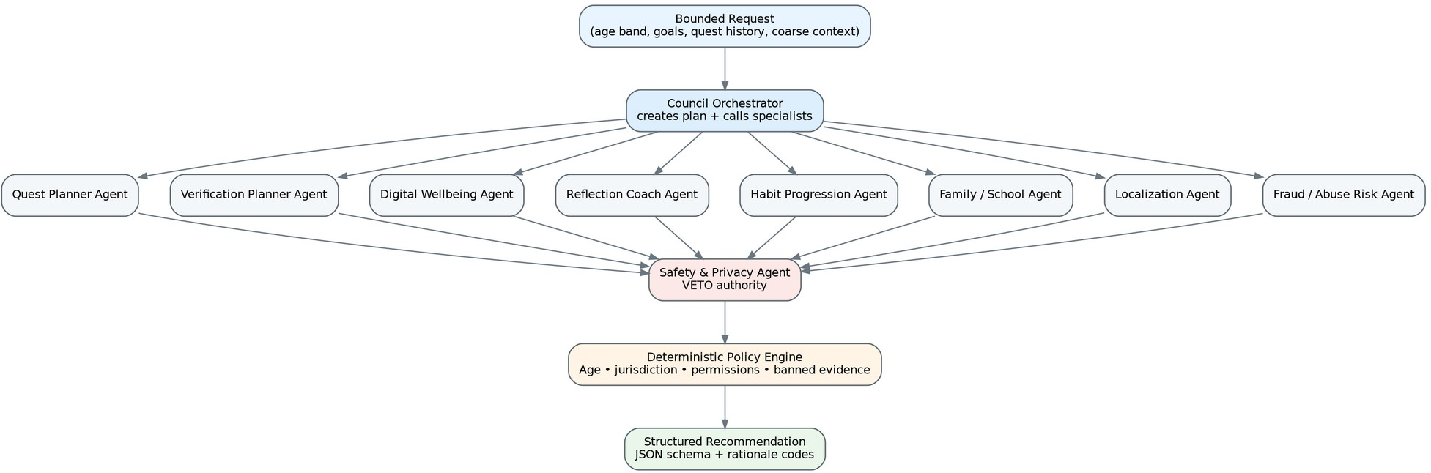

Figure 3 — Runtime AI Council with deterministic safety gate

Agent | Professional responsibility | Hard boundary
A0 Council Orchestrator | Routes a bounded task to the minimum set of specialist agents; merges structured proposals. | No unrestricted tool access; no direct DB writes; timeout and budget enforced.
A1 Quest Planner | Selects/adapts curated quests based on goals, skill domain, difficulty and recent history. | Must select from allowed template families; cannot invent risky physical tasks.
A2 Verification Planner | Chooses allowed evidence types and confidence policy for a quest. | Cannot request ambient audio, hidden recording, biometric proof or precise location unless a separately approved product flow exists.
A3 Digital Wellbeing | Interprets coarse usage summaries and suggests screen swaps / focus windows. | No clinical/addiction diagnosis; no shame language.
A4 Reflection Coach | Creates short, age-appropriate reflection prompts and summarizes structured learning. | Does not grade honesty, empathy or morality.
A5 Habit Progression | Suggests when to increase difficulty, reduce reminders or mark a habit as stable. | Final state transition is deterministic and threshold-based.
A6 Family / School | Builds cooperative challenges appropriate to context and role permissions. | No child-surveillance features; shared dashboards are aggregated.
A7 Localization & Culture | Adapts language, examples and etiquette without hardcoding one cultural norm as universal. | Protected traits and ideological assumptions are excluded from personalization.
A8 Fraud / Abuse Risk | Detects replayed witness tokens, impossible timing, device-clock anomalies and obvious reward gaming. | Produces risk signals only; cannot accuse a user of lying.
A9 Safety & Privacy | Reviews all generated/adapted content and evidence plans; has veto authority. | Fail closed when risk class or consent is ambiguous.
A10 Evaluation Agent | Runs offline rubric scoring on anonymized test cases; compares prompt/model versions. | Never evaluates production users as moral subjects; evaluates system outputs.

Agent Request Contract

Field | Example | Rule
purpose | recommend_quest | Required purpose code; determines allowed data.
age_band | 15-17 | Prefer age band rather than exact birth date in AI context.
jurisdiction_policy | IN_CHILD_V1 | Versioned policy identifier.
goals | ['focus', 'responsibility'] | Only user-selected goals.
recent_quest_summary | 3 compact records | No full chat/history dump.
device_summary | coarse metrics | No raw app-by-app telemetry unless feature and consent require it.
allowed_tools | quest_catalog_search | Explicit allow-list.
output_schema | QuestRecommendationV3 | Strict JSON schema; reject malformed responses.

Model Strategy
    - Use provider abstraction. Do not couple domain code to one model vendor.
    - Use smaller/cheaper models for classification and summarization; reserve stronger models for quest adaptation and nuanced reflection.
    - Use retrieval from a curated quest/policy knowledge base before generation.
    - Never fine-tune initially on raw child reflections; prove need and consent model first.
    - Log model version, prompt version, policy version, tool calls and decision codes — not unrestricted chain-of-thought.
    - Run red-team and age-appropriateness evaluation sets before model/prompt promotion.

Data Flow Architecture
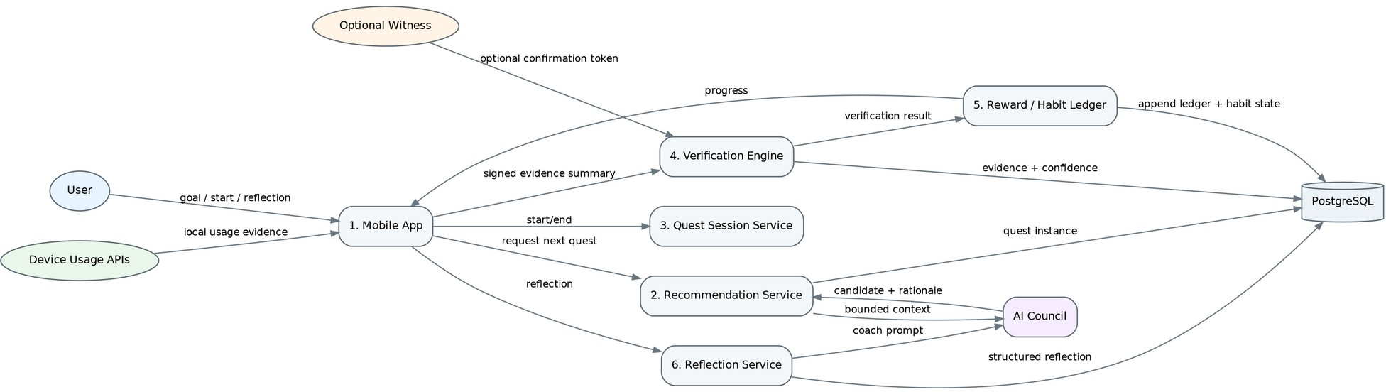
Figure 4 — Level-1 data flow for quest recommendation, execution and completion

Primary Quest Completion Flow

# | Stage | Data / rule
1 | User requests next quest | Mobile sends goal/availability/context IDs; no microphone/camera data.
2 | Recommendation | Quest service asks AI Council for ranked candidate templates; safety/policy validates output.
3 | Assignment | Server creates immutable QuestInstance containing verification policy version.
4 | Precommit | User chooses target/outcome before starting when the quest requires discipline proof-of-work.
5 | Local session | Device adapter records allowed local signals such as session timestamps and screen-interactive counts.
6 | Completion | Mobile uploads a signed evidence summary and optional structured reflection.
7 | Witness path | If optional witness confirmation is used, a short-lived one-time token is redeemed; witness identity is not required for low-risk confirmation.
8 | Verification | Engine checks evidence validity, replay, policy and produces a confidence class; it does not output “truth/lie”.
9 | Reward transaction | Reward ledger appends non-transferable activity points based on verified components; idempotency key prevents double award.
10 | Habit update | Longitudinal habit model updates practice stage using deterministic rules and verified/self-reported weighting.
11 | Reminder decay | If consistency thresholds are sustained, the system intentionally reduces reminders.

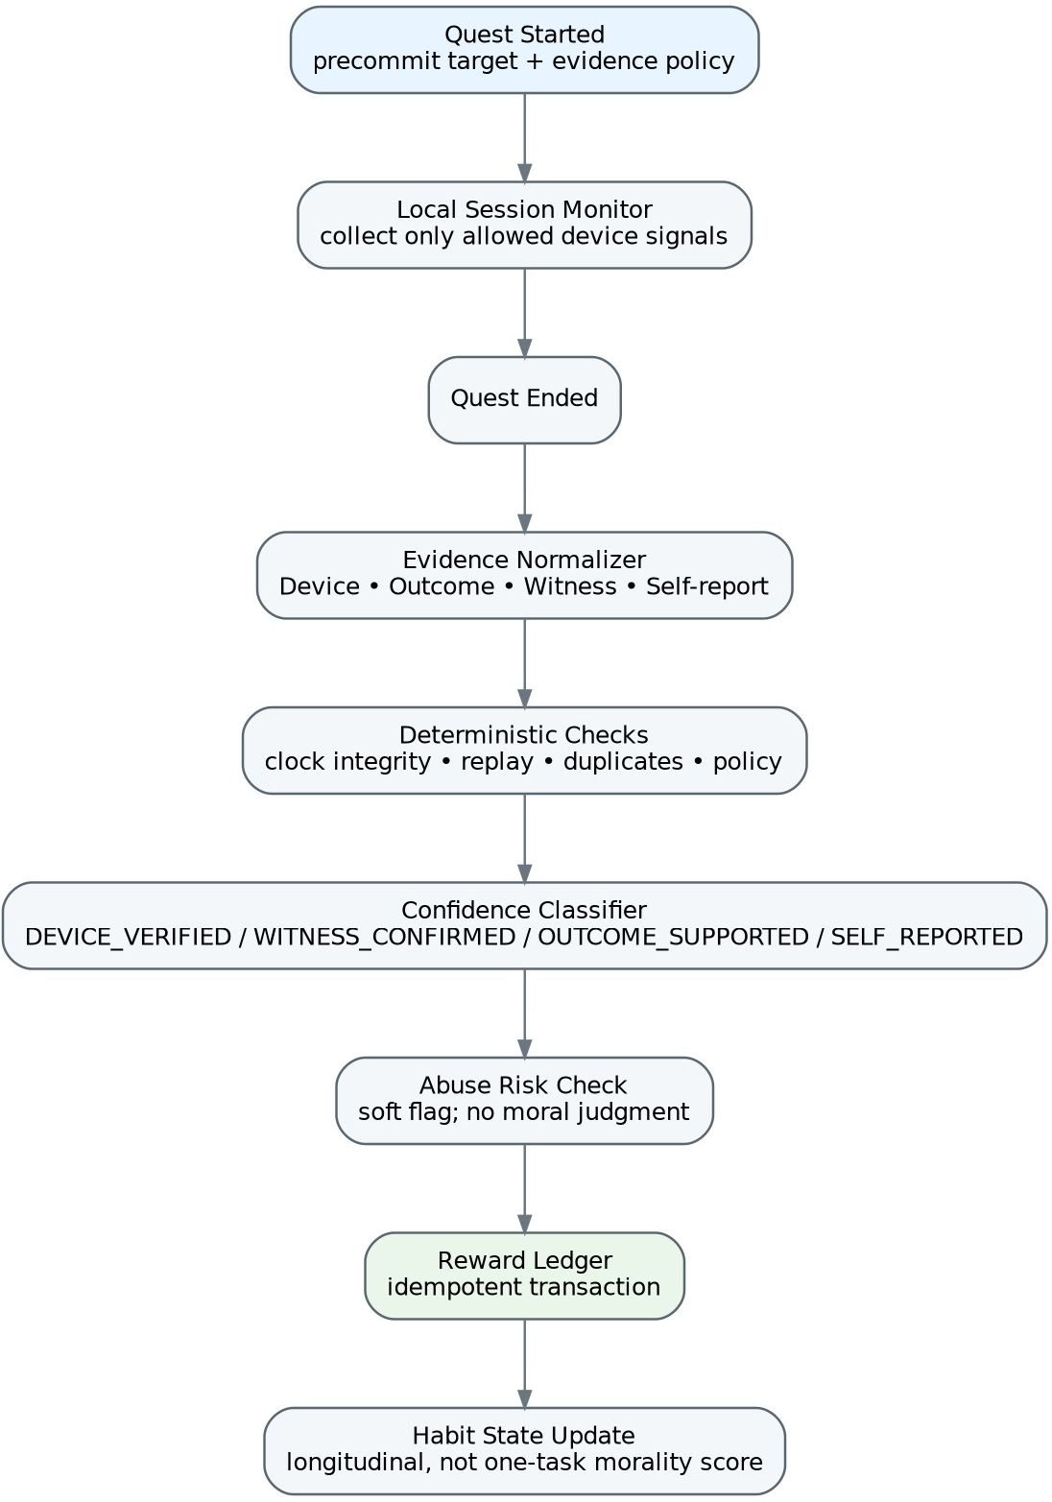

Figure 5 — Verification pipeline: evidence, policy, confidence and reward ledger

Evidence Classification

Class | What the system can claim | Examples | Reward weight guidance
DEVICE_VERIFIED | A device state or usage condition was observed under permission. | No interactive screen event during focus block; selected app threshold respected. | High for digital-behaviour component only.
WITNESS_CONFIRMED | A second party redeemed a confirmation token. | Conversation partner confirms a session occurred. | Medium; still not proof of conversation quality.
OUTCOME_SUPPORTED | A predefined output check was satisfied. | User entered answers to preselected problems; checklist target completed. | Medium-high depending on task.
SELF_REPORTED | User states behaviour occurred. | Kindness, patience, household contribution. | Low activity points; contributes to reflection history, not objective score.
UNVERIFIABLE | No legitimate verification method exists. | Internal intention, empathy, sincerity. | No “verified” label; reflection-only.

Data Architecture

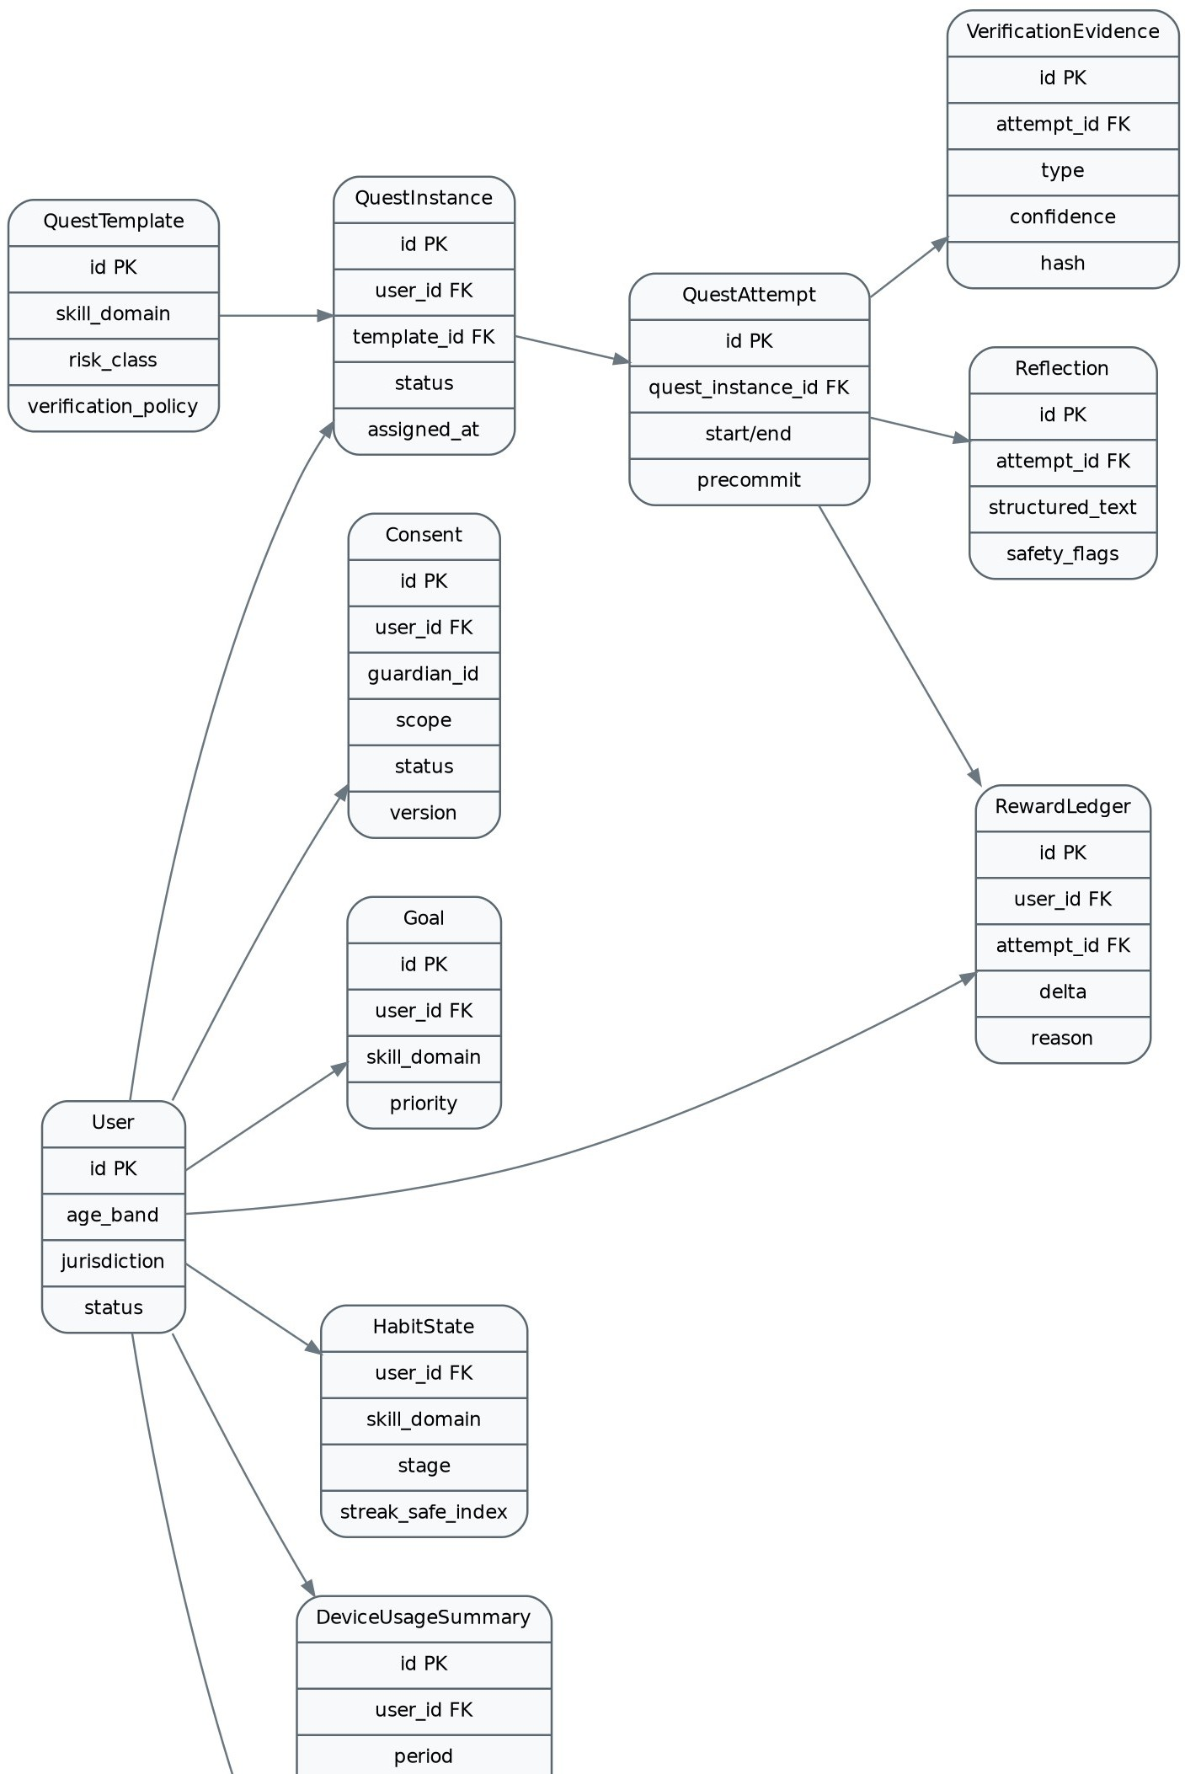

Data Classification
Figure 6 — Simplified domain entity relationship diagram

Class | Examples | Storage rule
P0 Public/curated | Quest templates, public help content | Versioned; normal backups.
P1 Account | User ID, age band, locale, guardian link | Encrypted; strict access; retention tied to account lifecycle.
P2 Behavioural | Quest attempts, habit states, device summaries | Purpose-limited; local aggregation preferred; short raw retention.
P3 Child-sensitive | Free-text reflections, support messages | Minimise, redact where possible, encrypted, restricted service roles.
P4 Prohibited by default | Ambient audio, background video, biometric analysis, precise continuous location | Do not collect in baseline architecture.

Core Tables / Aggregates

Entity | Purpose
users | Pseudonymous account, age band, locale, jurisdiction, lifecycle status.
guardians / guardian_links | Guardian account/link state and authorization relationship.
consents | Purpose, version, actor, timestamp, jurisdiction, status, withdrawal.
goals | User-selected skill goals and difficulty preferences.
quest_templates | Curated quest definition, age bounds, risk class, evidence policy, localization keys.
quest_instances | Assigned immutable quest snapshot and policy/version identifiers.
quest_attempts | Start/end, precommit target, completion state, client idempotency key.
verification_evidence | Typed evidence metadata, hashes, validation outcome; raw evidence avoided where possible.
witness_tokens | One-time hashed token, quest attempt, expiry, redemption metadata.
reflections | Structured response and optional limited free text; safety flags.
reward_ledger | Append-only point deltas with reason code and attempt id.
habit_states | Per skill domain progression stage, practice counts, reminder-decay state.
device_usage_summaries | Coarse daily/session metrics and provenance platform.
agent_decisions | Purpose, agent, model/prompt/policy versions, input-field manifest, result code.
audit_logs | Privileged/admin/domain security events.
experiment_assignments | Experiment arm and version; excludes sensitive segmentation.

Retention Baseline

Data | Suggested baseline | Notes
Raw local device events | Local only; roll into daily/session summaries | Upload only the summary required for a feature.
Device summaries | 90–180 days configurable | Longer retention only for explicit longitudinal features.
Quest attempts / reward ledger | Account life + defined post-delete accounting window | Ledger can retain de-identified integrity records if legally justified.
Free-text reflections | Default short retention or user-controlled history | Prefer structured reflections; allow deletion.
Witness tokens | Minutes/hours; delete after redemption + anti-replay window | Store hashes rather than raw tokens.
AI prompt payloads | Do not retain by default beyond | Provider-side retention must be contractually

 | operational/debug window | configured.
Audit/security logs | Security-defined retention | Segregated from product analytics.

Software Requirements Specification (SRS)
Requirements use “shall” language. Priority: M = MVP mandatory, P = post-MVP planned, O = optional/enterprise. Unless specified otherwise, each functional requirement must be testable through API, UI and/or domain-level acceptance tests.

User Roles

Role | Capabilities | Restrictions
Young user | Select goals, receive quests, run focus sessions, reflect, view personal progress. | Cannot see other users’ personal data or public morality rankings.
Guardian | Provide consent where required, join family quests, view agreed aggregate wellbeing metrics. | No access to private reflection text by default; no hidden surveillance.
Teacher/facilitator | Assign approved program themes and view aggregate class participation. | No individual “goodness” scores; minimum cohort thresholds for analytics.
Content reviewer | Create/review/publish quest content under four-eyes workflow. | Cannot alter user reward ledgers.
Support/admin | Account support, privacy requests, operational diagnostics under RBAC. | Privileged access is audited and purpose-limited.
System service | Execute jobs, notifications, verification and AI calls. | Service-to-service least privilege.

Account, Age, Consent & Privacy

ID | Pri | Requirement
FR-001 | M | The system shall create a pseudonymous user identifier independent of email/phone identifiers used for account recovery.
FR-002 | M | The onboarding flow shall determine age band and jurisdiction policy before enabling personalized behavioural features.
FR-003 | M | The system shall maintain versioned consent grants by purpose and actor.
FR-004 | M | Where guardian consent is required, the system shall block affected processing until valid guardian authorization is recorded.
FR-005 | M | The system shall allow withdrawal of optional consent and shall stop future processing for the withdrawn purpose.
FR-006 | M | The system shall provide account data export and deletion-request workflows.
FR-007 | M | The system shall expose a plain-language privacy dashboard showing collected data categories and purposes.
FR-008 | P | The system shall support configurable jurisdiction policy packs without a mobile-app release.
FR-009 | M | The system shall not collect ambient audio, continuous video, biometric identifiers, or continuous precise location in the baseline product.

Goals, Skills & Personalization

ID | Pri | Requirement
FR-010 | M | The user shall be able to select and reprioritize personal skill goals such as focus, responsibility, listening and gratitude.
FR-011 | M | The system shall distinguish user-selected goals from system-inferred recommendations.
FR-012 | M | The system shall support accessibility preferences, quiet hours and notification preferences.
FR-013 | P | The system shall allow a user to pause a skill track without losing historical progress.

Quest Catalog & Recommendation

ID | Pri | Requirement
FR-014 | M | Every quest template shall define age range, skill domain, risk class, estimated offline duration, verification policy and reflection policy.
FR-015 | M | The system shall recommend quests only from approved template families.
FR-016 | M | AI adaptation shall preserve immutable safety constraints of the source template.
FR-017 | M | The recommendation service shall avoid repeating substantially similar quests within a configurable cooldown window.
FR-018 | M | The user shall be able to skip a recommended quest without penalty.
FR-019 | M | The system shall offer a non-AI fallback recommendation path if AI services are unavailable.
FR-020 | P | The system shall support family and school-approved quest collections.

Quest Session & Device Wellbeing

ID | Pri | Requirement
FR-021 | M | The user shall explicitly start a quest session before device evidence is collected for that session.
FR-022 | M | The client shall record only evidence types permitted by the quest policy and user permissions.
FR-023 | M | For focus quests, the client shall compute device-interaction summaries locally where platform APIs permit.
FR-024 | M | The mobile client shall support offline quest execution and queue sync operations until network connectivity returns.
FR-025 | M | The system shall label a session as device-verified only when the required platform evidence is available and valid.
FR-026 | P | The user shall be able to configure selected distracting-app categories where platform capabilities permit.
FR-027 | M | Loss of a platform permission shall degrade gracefully to self-reported or unsupported evidence rather than silently claiming verification.

Verification & Anti-Gaming

ID | Pri | Requirement
FR-028 | M | The system shall classify evidence as DEVICE_VERIFIED, WITNESS_CONFIRMED, OUTCOME_SUPPORTED, SELF_REPORTED or UNVERIFIABLE.
FR-029 | M | The system shall never label a human value or internal mental state as objectively verified.
FR-030 | M | The verification engine shall detect duplicate submissions using idempotency keys and evidence hashes.
FR-031 | M | The verification engine shall detect impossible or inconsistent timing and mark the attempt for low-confidence handling.
FR-032 | M | Witness confirmations shall use single-use expiring tokens.
FR-033 | M | Witness confirmation shall not require account creation for low-risk consumer quests unless policy requires identity.
FR-034 | M | Fraud-risk signals shall affect reward eligibility only through deterministic policy rules.
FR-035 | M | The UI shall present what was verified (e.g., phone-away time) separately from what was self-reported (e.g., conversation quality).
FR-036 | P | The system shall randomly sample a minority of eligible quests for stronger non-invasive proof-of-work prompts.

Reflection & Coaching

ID | Pri | Requirement
FR-037 | M | Eligible quests shall request a short reflection after completion.
FR-038 | M | Reflection prompts shall be age-appropriate and constrained to the quest’s learning objective.
FR-039 | M | The reflection service shall not score honesty, empathy, morality, intelligence or mental health.
FR-040 | M | The user shall be able to skip optional free-text reflection and use structured answers.
FR-041 | M | Potentially unsafe free text shall be handled by a dedicated safety workflow rather than stored in general analytics.

Rewards, Habits & Motivation

ID | Pri | Requirement
FR-042 | M | Rewards shall be non-transferable and shall not have direct cash value in the baseline product.
FR-043 | M | Reward points shall be stored in an append-only ledger with reason code, attempt and idempotency key.
FR-044 | M | Self-reported evidence shall have a lower maximum reward contribution than device/outcome-supported components.
FR-045 | M | The system shall not implement leaderboards ranking users by kindness, empathy, responsibility or morality.
FR-046 | M | Habit progression shall use longitudinal practice rules and shall not be determined by a single quest.

FR-047 | M | The system shall support reminder decay when a habit shows sustained practice.
FR-048 | M | Missing a streak shall not reset all progress or trigger shame-based messaging.
FR-049 | P | Users shall be able to choose intrinsic reward themes such as mastery paths, collections or personal milestones.

Family & School Modes

ID | Pri | Requirement
FR-050 | M | Guardians shall see only data categories disclosed during linking/consent.
FR-051 | M | Private reflection text shall not be visible to guardians by default.
FR-052 | M | Family quests shall support cooperative completion without ranking family members.
FR-053 | P | School dashboards shall default to cohort aggregates and enforce a minimum cohort threshold before displaying analytics.
FR-054 | P | Teachers shall assign only administrator-approved quest collections.
FR-055 | P | A school role shall not gain access to a student’s household/device telemetry beyond the program’s declared scope.

AI Council & Content Safety

ID | Pri | Requirement
FR-056 | M | Every AI request shall include a purpose code and versioned policy context.
FR-057 | M | AI outputs shall be validated against a typed schema before reaching domain services.
FR-058 | M | The Safety & Privacy agent plus deterministic policy engine shall be able to veto generated/adapted content.
FR-059 | M | LLM agents shall not directly write reward, consent, account-state or enforcement records.
FR-060 | M | The system shall retain model, prompt, policy and output-decision metadata sufficient for audit without storing hidden chain-of-thought.
FR-061 | M | If the AI system times out, fails schema validation or violates policy, the product shall use a safe deterministic fallback.
FR-062 | M | Production AI changes shall pass offline evaluation and staged rollout before broad release.
FR-063 | P | The model gateway shall support multiple model providers to reduce lock-in and permit jurisdictional data-routing choices.

Notifications & Engagement

ID | Pri | Requirement
FR-064 | M | Notifications shall respect quiet hours, frequency caps and user/guardian preferences.
FR-065 | M | Notification copy shall not use guilt, social pressure or fabricated urgency.
FR-066 | M | The system shall reduce reminder frequency for  users demonstrating sustained independent

 |  | practice.
FR-067 | P | The user shall be able to choose reminder windows rather than only fixed system times.

Admin, Analytics & Support

ID | Pri | Requirement
FR-068 | M | Quest publishing shall require versioning and reviewer approval for medium/high-risk templates.
FR-069 | M | Admin actions affecting content, consent, user access or policy shall be audited.
FR-070 | M | Product analytics shall use documented event names, purposes and allowed properties.
FR-071 | M | Experiments shall not manipulate consent, safety warnings or privacy-protective defaults.
FR-072 | M | Support tooling shall mask sensitive fields unless a privileged break-glass workflow is invoked.
FR-073 | P | The admin console shall provide AI-output review queues and rollback to previous prompt/policy versions.

Non-Functional Requirements

ID | Category | Requirement
NFR-001 | Security | All external traffic shall use modern TLS; secrets shall be held in managed secret storage, not source code.
NFR-002 | Security | Privileged/admin access shall require MFA and role-based authorization.
NFR-003 | Privacy | Data collection shall follow purpose limitation and minimisation; raw device event history shall remain local unless explicitly required.
NFR-004 | Privacy | Deletion and consent-withdrawal workflows shall be auditable and propagate to derived stores according to documented retention rules.
NFR-005 | Reliability | Core quest start/complete APIs shall target 99.9% monthly availability after production launch.
NFR-006 | Resilience | Mobile quest execution shall tolerate temporary network loss and retry idempotently.
NFR-007 | Performance | P95 non-AI API latency shall target <400 ms under normal regional load.
NFR-008 | Performance | P95 AI-assisted recommendation latency shall target <4 s, with deterministic fallback after timeout.
NFR-009 | Scalability | Stateless API instances shall scale horizontally; asynchronous work shall be queue/stream based.
NFR-010 | Consistency | Consent, verification, reward ledger and habit transition updates that must be atomic shall occur in one database transaction in MVP.
NFR-011 | Auditability | All AI-adapted quests shall be traceable to template, model, prompt and policy versions.
NFR-012 | Explainability | The UI shall provide user-facing reason codes such as “recommended because you chose focus” rather than opaque personality inferences.
NFR-013 | Accessibility | Mobile UI shall target WCAG 2.2 AA-equivalent accessible patterns where applicable to native/mobile interfaces.
NFR-014 | Localization | All user-facing strings and quest content shall support localization keys and locale-specific review.

NFR-015 | Safety | Generated content shall fail closed when required age/risk/policy fields are absent.
NFR-016 | Observability | Each request shall carry a trace ID; quest lifecycle and agent calls shall emit structured metrics and error codes.
NFR-017 | Maintainability | Module APIs shall be typed and covered by contract tests before any module is split into a service.
NFR-018 | Portability | Cloud-specific services shall be wrapped behind infrastructure interfaces where practical; core domain logic shall be provider-neutral.
NFR-019 | Backup | Transactional database shall support encrypted automated backups and point-in-time recovery.
NFR-020 | Recovery | Initial target RPO <=15 minutes and RTO <=4 hours for core backend; tighten after pilot data.
NFR-021 | Secure SDLC | CI shall run unit/integration tests, dependency scanning, secret scanning and SAST before production deployment.
NFR-022 | AI quality | Each model/prompt release shall meet minimum pass thresholds for safety, age appropriateness, schema validity and quest relevance on a fixed evaluation set.

Critical Use Cases & Acceptance Criteria

Use case | Acceptance criterion
UC-01 Start Focus Quest | Given permission exists and the user starts a 20-minute focus quest, the client records allowed device-interaction evidence; on completion, server classifies evidence without claiming the underlying work was completed unless outcome evidence exists.
UC-02 Conversation Quest | Phone-away evidence may be DEVICE_VERIFIED; conversation occurrence may be SELF_REPORTED or WITNESS_CONFIRMED. The UI must display those separately.
UC-03 Discipline Task | User precommits an outcome before timer starts. The system checks device focus plus structured proof-of-work. Completion confidence reflects both.
UC-04 Permission Revoked | If usage permission is revoked mid-session, the attempt completes with degraded evidence and no device-verified badge.
UC-05 AI Failure | If the AI Council exceeds timeout or fails schema/safety validation, user receives a curated fallback quest; no broken screen.
UC-06 Guardian Withdrawal | When guardian consent required for a purpose is withdrawn, new processing for that purpose is blocked and downstream jobs are cancelled where feasible.
UC-07 Duplicate Completion | Two identical completion requests with same idempotency key create one ledger award only.
UC-08 Reminder Decay | After configured stable-practice criteria are met, notification cadence reduces automatically and the user can further reduce/disable it.

API and Event Contracts

Representative REST Endpoints

Method | Endpoint | Purpose
POST | /v1/onboarding/policy | Resolve age/jurisdiction policy and required consent steps.
POST | /v1/consents | Create/update a versioned purpose grant.
GET | /v1/quests/recommendation | Return next safe quest candidate.
POST | /v1/quest-instances/{id}/start | Create attempt + precommit + verification

 |  | policy snapshot.
POST | /v1/quest-attempts/{id}/evidence | Upload summarized evidence bundle; idempotent.
POST | /v1/quest-attempts/{id}/reflection | Store structured/optional free-text reflection.
POST | /v1/witness/{token}/confirm | Redeem one-time confirmation token.
POST | /v1/quest-attempts/{id}/complete | Run verification + ledger + habit update transaction.
GET | /v1/progress | Return user-facing progress and evidence labels.
GET | /v1/privacy/data-map | Return categories/purposes/retention shown in privacy dashboard.
POST | /v1/privacy/delete-request | Initiate deletion workflow.

Domain Events

Event | Minimal payload
QuestAssigned | user_id, quest_instance_id, template_version, policy_version
QuestStarted | attempt_id, client_session_id, precommit_hash
EvidenceSubmitted | attempt_id, evidence_types, client_platform, summary_hash
VerificationCompleted | attempt_id, confidence_class, component_results, risk_flags
RewardLedgerAppended | ledger_id, attempt_id, delta, reason_code
HabitStateChanged | user_id, skill_domain, old_stage, new_stage, reason_code
ConsentChanged | user_id, purpose, old_status, new_status, policy_version
AgentDecisionRecorded | decision_id, purpose, agent_set, model_versions, policy_version, result_code
NotificationPlanned | user_id, window, reason_code, decay_state

Security, Privacy and Child-Safety Architecture

Threat Model Highlights

Threat | Impact | Primary controls
Reward replay / API retry | Duplicate XP | Idempotency keys, append-only ledger, unique constraints, server-side reward calculation.
Fake witness confirmation | Gaming quests | Short expiry, one-time tokens, device/session binding where proportional, no valuable prizes.
Compromised child device | Forged local evidence | Signed session metadata where platform allows, anomaly detection, confidence degradation rather than invasive attestation everywhere.
Overprivileged guardian/school role | Privacy harm | Purpose-scoped RBAC, private reflection separation, cohort thresholds.
Prompt injection through reflection | Agent misuse | Treat reflections as untrusted data, tool allow-lists, schema validation, no direct mutation tools.
Model unsafe quest generation | Physical/social harm | Curated templates, risk classification, Safety agent + deterministic policy veto.
Admin misuse | Sensitive data access | MFA, least privilege, field masking, audited break-glass access.
Telemetry overcollection | Surveillance / legal risk | Local aggregation, event allow-list, retention schedule, data-map tests.
Provider data retention | Child-data exposure | Enterprise/API privacy terms, retention  configuration, payload minimisation, vendor

review.

Privacy-by-Design Rules
    - Exact date of birth should not be sent to AI agents; use age band and policy identifier.
    - Device usage should be aggregated locally into feature-specific summaries before upload where feasible.
    - Witness confirmation is optional and low-information; avoid storing witness identity unless a specific regulated workflow requires it.
    - Free-text reflections are sensitive; prefer structured prompts and shorter retention.
    - No advertising SDKs or cross-app behavioural advertising in a child-focused launch.
    - No hidden monitoring. Permission loss or unavailable evidence must be visible to the user.
    - Any future photo/audio feature requires a separate DPIA/threat model, consent design and purpose-specific storage/deletion plan.

Regulatory Design Hooks
The codebase should treat law/policy as versioned configuration, not scattered conditionals. The baseline architecture supports: age/jurisdiction policy resolution; purpose-scoped consent; parental/guardian authorization; data access/export/deletion; retention; audit; and vendor/data-transfer inventories. Formal legal review is required before launch.

Deployment, DevOps and Observability
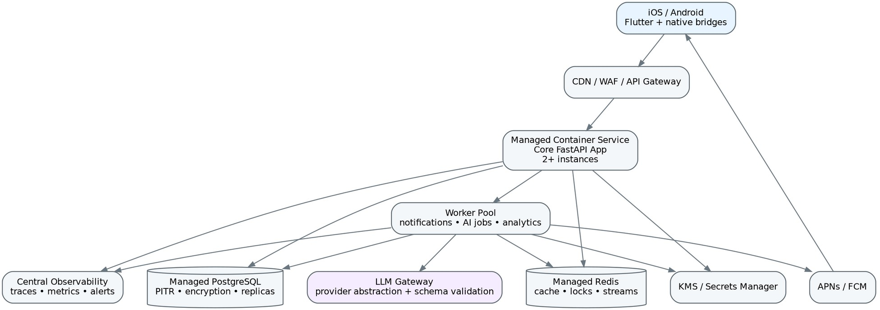
Figure 7 — Recommended deployment topology for pilot and early production

Environment Strategy

Environment | Purpose | Data rule
Local | Developer workstation / emulators | Synthetic data only.
Dev | Shared integration | Synthetic or generated test accounts.
Staging | Pre-production, release candidates, AI eval | Production-like infrastructure; no copied child production data.
Production | Live users | Strict IAM, encryption, monitored access.

Observability Metrics

Area | Metrics
API | request rate, p50/p95/p99 latency, 4xx/5xx, auth failures
Quest | assignment success, start-to-complete, skip rate, offline-sync failure
Verification | evidence-class distribution, degraded sessions, replay blocked, false-

 | positive support cases
Rewards | ledger duplicate-prevention hits, transaction failures, reconciliation mismatch
AI | latency, schema failure, safety veto rate, fallback rate, cost/request, model drift eval
Privacy | consent failures, deletion SLA, permission revocations, access audit anomalies
Product | intentional offline minutes, reminder-decay rate, sustained practice, low-value usage delta where opted in

Testing and Evaluation Strategy

Layer | Required tests
Domain unit tests | Consent transitions, reward ledger, habit progression, evidence classes, policy decisions.
Contract tests | Flutter/native bridge schemas; module APIs; AI structured output schemas.
Integration tests | Postgres transactions, Redis idempotency, witness redemption, offline sync.
Mobile device tests | Android/iOS permission flows, screen-state evidence, background/foreground transitions, clock changes.
Security tests | SAST, dependency scan, secret scan, authz matrix, API fuzzing, prompt injection tests.
AI evaluations | Age appropriateness, risk, relevance, non-manipulative tone, schema validity, cultural robustness.
Privacy tests | Data inventory diff in CI; ensure disallowed properties never enter analytics events.
Chaos/resilience | Redis/AI outage, duplicate requests, delayed events, push failure, partial network.
Usability | Can a 12–17 user understand evidence labels and privacy choices without adult technical knowledge?

AI Release Gate
    - Run fixed golden dataset for every prompt/model/policy version.
    - Zero critical safety-policy violations in release set.
    - Meet minimum schema-validity threshold (target >=99.5%).
    - Human review sample across age bands, locales and quest categories.
    - Canary release with rollback switch and comparison against deterministic fallback.
    - Never promote a model solely because engagement rises; include wellbeing/safety metrics.
- MVP → Scale Roadmap

Phase | Stage | Scope
Phase 0 — Prototype | 2–4 weeks equivalent scope | Flutter shell; 20 curated quests; local timer; manual reflection; no AI required; validate loop.
Phase 1 — MVP | Pilot | Auth/consent, goals, quest catalog, device-usage summary, verification classes, reward ledger, 1–2 AI agents behind safety gate, basic guardian flow.
Phase 2 — Controlled Pilot | Schools/families | AI Council expansion, witness tokens, reminder decay, privacy dashboard, admin review console, A/B experimentation.
Phase 3 — Production | Regional launch | SLOs, incident response, multi-provider AI,  mature data rights, threat-model closure,

 |  | external security review.
Phase 4 — Scale | Only when needed | Extract high-load modules, dedicated event/analytics platform, regional data planes, advanced model routing. Consider Kafka/Kubernetes only after measured need.

Recommended MVP Repository Structure
project-irl/
├── apps/
│ ├── mobile_flutter/
│ └── admin_web/
├── native/
│ ├── android_usage_bridge/
│ └── ios_screen_time_bridge/
├── backend/
│ ├── app/api/
│ ├── app/modules/identity/
│ ├── app/modules/quests/
│ ├── app/modules/verification/
│ ├── app/modules/rewards/
│ ├── app/modules/family/
│ ├── app/modules/policy/
│ ├── app/modules/notifications/
│ ├── app/modules/analytics/
│ └── app/ai/
├── packages/
│ ├── contracts/
│ ├── policy_schemas/
│ └── quest_content/
├── infra/terraform/
├── evals/ai/
├── tests/
└── docs/adr/

Project Risk Register

ID | Severity | Risk | Mitigation
R1 | High | Verification becomes surveillance | Keep evidence taxonomy; prohibit ambient sensors; accept self-report where needed.
R2 | High | XP causes performative/cheating behaviour | No cash value; component rewards; long-term habit progression; no morality leaderboard.
R3 | High | Parents/schools turn tool into monitoring | Role-scoped aggregate views; private reflections; explicit sharing contracts.
R4 | High | AI generates unsafe/manipulative challenge | Curated base catalog; safety veto; deterministic risk rules; offline eval.
R5 | Medium | Platform APIs differ or entitlements denied | Capability abstraction; honest degradation; no single-platform assumption.
R6 | Medium | App itself becomes another engagement loop | Short sessions; no infinite feed; reminder decay; offline-hours north-star metric.
R7 | Medium | Behavioural metrics imply scientific validity they do not have | Label practice indicators; validate instruments before making claims.
R8 | Medium | Microservice/AI complexity overwhelms team | Modular monolith; limited MVP agents; extract only measured bottlenecks.
R9 | High | Child-data compliance gaps | Data inventory, consent service,  DPIA, vendor review, legal sign-off

before launch.

Current Platform and Policy References

Reference | Why it matters | Source
Flutter architecture / platform channels | Flutter documentation: Flutter supports interoperating with platform-specific Kotlin and Swift through platform channels. | https://docs.flutter.dev/resources/architectural-overview
Android usage statistics | Android Developers: UsageStatsManager provides device usage history/statistics and relevant event stats with required usage access. | https://developer.android.com/reference/android/app/ usage/UsageStatsManager
Apple Family Controls | Apple Developer: Family Controls enables Screen Time API app extensions; Managed Settings and Device Activity provide privacy-preserving usage/restriction capabilities. | https://developer.apple.com/documentation/Xcode/ configuring-family-controls
Apple Device Activity | Apple Developer: Device Activity can monitor app/website activity with privacy-preserving APIs. | https://developer.apple.com/documentation/ DeviceActivity
PostgreSQL RLS | PostgreSQL documentation: row security policies can restrict rows visible/modifiable per role/policy. | https://www.postgresql.org/docs/current/ddl-rowsecurity.html
Redis Streams | Redis documentation: Streams provide append-only event data and consumer-group patterns. | https://redis.io/docs/latest/develop/data-types/streams/
NIST AI RMF | NIST AI Risk Management Framework and Generative AI Profile for risk-management practices. | https://www.nist.gov/itl/ai-risk-management-framework
India DPDP Act 2023 | MeitY / Gazette: the Act defines “child” as an individual under 18. | https://www.meity.gov.in/writereaddata/files/ Digital%20Personal%20Data%20Protection%20Act%2 02023.pdf
India DPDP Rules 2025 | MeitY / Gazette: notified rules include provisions for verifiable parent consent for child data and staged commencement. | https://www.meity.gov.in/documents/act-and-policies/ digital-personal-data-protection-rules-2025-gDOxUjMtQWa
COPPA guidance | FTC: child voice/audio files can be personal information and covered services may require verifiable parental consent. | https://www.ftc.gov/business-guidance/resources/ complying-coppa-frequently-asked-questions

Final Architecture Position
The product should not attempt to build a machine that proves whether a teenager was kind, disciplined or honest. It should build a trustworthy system that (1) creates opportunities to practise those behaviours, (2) verifies only legitimately observable components, (3) makes self-report explicit, (4) gradually reduces external prompting, and (5) protects young users from surveillance, coercive gamification and opaque AI decisions.
The most important engineering invariant is therefore: AI may recommend and coach; deterministic software must own consent, permissions, verification labels, rewards, safety enforcement and data lifecycle.

