SE LAB-1

NAME:ARYAMAN D K

SRN: PES1UG24AM344

Requirements Table
Problem Statement #44 — Database Query Performance Profiler | Actors: Database Administrator, Backend Lead | Lab 1: Requirements Engineering & UML Use-Case Modelling
Req ID | Type | Description | Priority | Acceptance Criteria | Rationale
FR-001 | Functional | The system shall parse Postgres/MySQL EXPLAIN plans, highlight sequential table scans on large tables, and recommend optimal index column definitions. | High | Pass: Missing composite index identified on filtered columns. Fail: Query plan with sequential scan marked optimized. | Core capability that turns raw execution plans into actionable index guidance (given in problem statement).
FR-002 | Functional | The system shall continuously ingest slow query logs from connected Postgres and MySQL instances, capturing query text, execution time, and timestamp for every entry exceeding a configurable duration threshold (e.g., 500 ms). | High | Pass: a query logged by the DB engine as exceeding the threshold appears in the profiler's log store within 60 seconds. Fail: entry missing or duplicated after one ingestion cycle. | Continuous ingestion is the data foundation that parsing, digesting, and alerting all depend on.
FR-003 | Functional | The system shall generate a weekly performance optimization digest summarizing the top 10 slowest queries of the period, their associated index recommendations, and estimated performance gain per recommendation. | Medium | Pass: a digest is generated every 7 days and lists exactly the 10 highest average-latency queries of that period with a linked recommendation. Fail: digest has missing entries or is generated more than 1 hour off schedule. | Gives DBAs and Backend Leads a periodic, digestible summary instead of requiring manual log review.
FR-004 | Functional | The system shall allow a Database Administrator to mark an index recommendation as Applied, Dismissed, or Pending Manual Action, and shall record the action with a timestamp and user ID. | High | Pass: the status change is reflected in the recommendation list and audit log within 5 seconds of the DBA's action. Fail: status is unchanged or no audit entry is created. | Tracking recommendation lifecycle avoids duplicate work and provides an audit trail for schema changes.
FR-005 | Functional | The system shall allow a Database Administrator to configure the sequential-scan row-count threshold that triggers a real-time alert (default: 100,000 rows). | Medium | Pass: after saving a new threshold, the next qualifying sequential scan above that value triggers an alert while scans below it do not. Fail: alert fires at the old threshold or fails to fire at the new one. | Databases vary in scale, so alert sensitivity must be tunable to avoid alert fatigue or missed incidents.
NFR-001 | Nonfunctional | Type: Performance & Security. Slow query log ingestion must handle up to 5,000 log records per minute without dropping entries or slowing the host database. | High | Pass: benchmarking tests confirm target latency and security standards are met under simulated peak load. | Ensures the profiler itself never becomes a performance bottleneck or attack surface on the monitored database (given in problem statement).
NFR-002 | Nonfunctional | Type: Security & Access Control. The system shall enforce role-based access control so that only Database Administrator accounts can apply/dismiss index recommendations or change alert thresholds; Backend Lead accounts have read-only access to digests and recommendations. | High | Pass: a Backend Lead account attempting to apply a recommendation via UI or API receives an authorization error and no state change occurs. Fail: the action succeeds without DBA privileges. | Prevents unauthorized or accidental schema-altering actions on production databases.

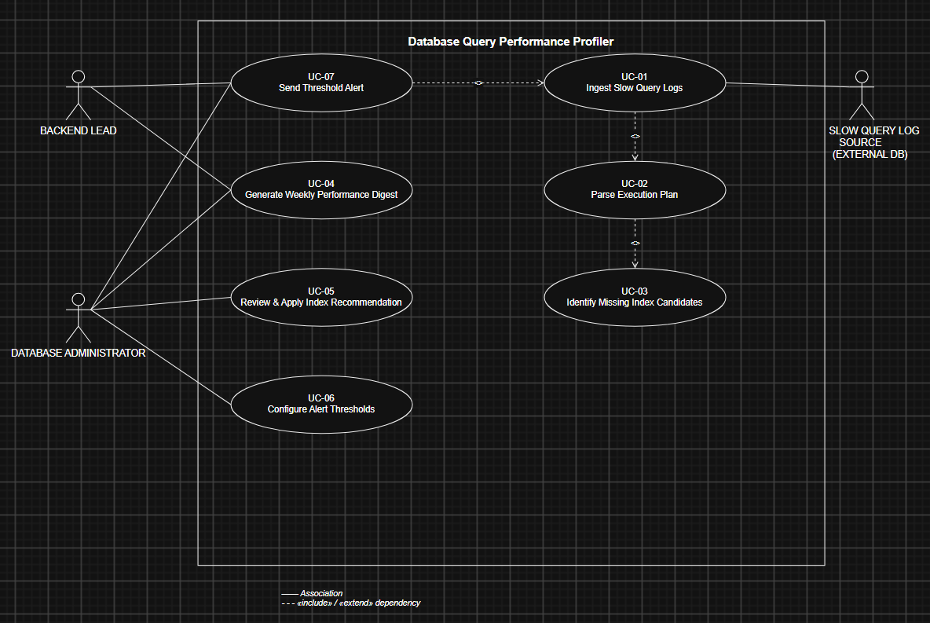

Use-Case Flow Specification
Database Query Performance Profiler — Problem Statement #44
Use Case ID / Name | UC-05: Review & Apply Index Recommendation
Primary Actor | Database Administrator (DBA)
Secondary Actors | Backend Lead (notified when a high-impact recommendation is applied)
Related Use Cases | Includes: UC-03 (Identify Missing Index Candidates) results as input. Related: UC-04 (Generate Weekly Performance Digest) surfaces the same recommendations.
Trigger | DBA opens the Index Recommendations panel to act on a pending recommendation.

Preconditions
- The Slow Query Log Profiler has ingested and parsed at least one EXPLAIN plan (UC-01, UC-02) and identified at least one missing-index candidate (UC-03) that is in "Pending" status.
- The DBA is authenticated to the Profiler dashboard with an account that holds the Database Administrator role (per NFR-002).
- The DBA has valid execute privileges on the target Postgres/MySQL instance, or the system can verify this via a stored connection credential.

Postconditions
- Success: the recommendation's status is updated to "Applied" (index created on the target database) or "Dismissed" (with a reason), and an audit log entry records the DBA's user ID, action, and timestamp.
- Failure: the recommendation remains "Pending" or is set to "Pending Manual Action", and no index is created on the target database.

Main Success Scenario
1. The DBA logs into the Query Performance Profiler dashboard.
2. The DBA navigates to the “Index Recommendations” panel.
3. The system displays the list of pending recommendations, each showing the affected table, the query pattern that triggered it, and the estimated performance gain.
4. The DBA selects a recommendation to review.
5. The system displays the full EXPLAIN plan comparison (before/after) and the proposed CREATE INDEX statement.
6. The DBA reviews the recommendation and selects “Apply”.
7. The system verifies that the DBA's account holds execute privileges on the target database.
8. The system executes the CREATE INDEX statement against the target Postgres/MySQL instance.
9. The system updates the recommendation status to “Applied” and writes an audit log entry with timestamp and user ID.
10. The system notifies the Backend Lead if the applied recommendation was flagged High priority.
11. The use case ends successfully.

Alternate Flow — 8a: Insufficient Privileges
Triggered when Step 7 finds the DBA's account lacks execute privileges on the target database.
- 8a1. The system displays an “Insufficient Privileges” error instead of executing the statement.
- 8a2. The system generates a copyable SQL script containing the CREATE INDEX statement.
- 8a3. The DBA is prompted to either run the script manually via a privileged session or request elevated access from an administrator.
- 8a4. The system sets the recommendation status to “Pending Manual Action” and logs the attempted action.
- 8a5. The use case resumes at Step 3 when the DBA returns to the recommendations list, or ends if the DBA exits.

Alternate Flow — 8b: Index Creation Fails
Triggered when Step 8's CREATE INDEX statement fails (e.g., lock timeout, disk space, duplicate index).
- 8b1. The system rolls back the failed operation and captures the database error message.
- 8b2. The system displays the error to the DBA and keeps the recommendation status as “Pending”.
- 8b3. The DBA may retry, schedule the change for a maintenance window, or dismiss the recommendation with the error noted as the reason.

