ARYAMAN MISHRA

19BCE1027

syms x1 x2 x3 y1 y2 y3

choice=input("Enter number of variables")

if choice==3

Q=input('enter the quadratic form in x1, x2 and x3')

a11=(1/2)\*diff(diff(Q,x1),x1)

a22=(1/2)\*diff(diff(Q,x2),x2)

a33=(1/2)\*diff(diff(Q,x3),x3)

a12=(1/2)\*diff(diff(Q,x1),x2)

a21=a12

a13=(1/2)\*diff(diff(Q,x1),x3)

a31=a13

a23=(1/2)\*diff(diff(Q,x2),x3)

a32=a23

A=[a11 a12 a13;a21 a22 a23;a31 a32 a33] %matrix of the quadratic form

[M D]=eig(A)

X=[x1;x2;x3];

Y=[y1;y2;y3]

disp('The canonical form is')

disp(D(1,1)\*y1^2+D(2,2)\*y2^2+D(3,3)\*y3^2)

for i=1:3

M(:,i)=[M(1,i)/sqrt(M(1,i)^2+M(2,i)^2+M(3,i)^2) M(2,i)/sqrt(M(1,i)^2+M(2,i)^2+M(3,i)^2) M(3,i)/sqrt(M(1,i)^2+M(2,i)^2+M(3,i)^2)]

end

display('The orthogonal transformation is X=MY')

X==(M\*Y)

else

Q=input('Enter the quadratic form in x1 and x2');

A=hessian(Q)/2;

[M,D]=eig(A);

X=[x1;x2];

Y=[y1;y2];

disp('The canonical form is');

disp(D(1,1)\*y1^2+D(2,2)\*y2^2)

for i=1:2

norm=sqrt(M(:,i)'\*M(:,i));

M(:,i)=M(:,i)/norm;

end

disp('The orthogonal transformation is X=MY')

X==(M\*Y)

end

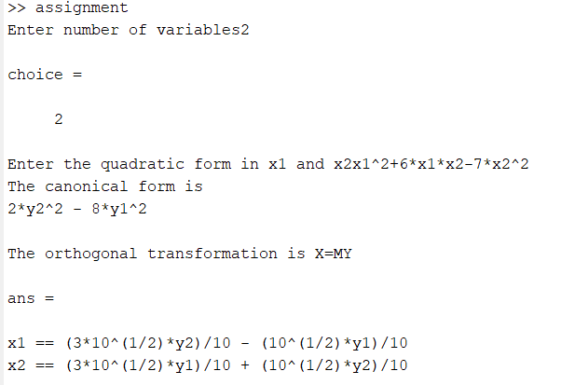

Q(x) = 3x 2 1 + 2x 2 2 + x 2 3 + 4x1x2 + 4x2x3

