1) syms x y1 y2

x = linspace(0,4\*pi,100);

if(cos(x)>sin(x))

y1=sin(x);

fplot(x,y1)

end

if(cos(x)<sin(x))

y2=sin(x);

fplot(x,y2)

end

2) 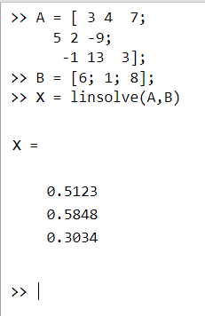

3) syms x

f = [sin(x) cos(x) exp(x)]

f =  
   
[sin(x), cos(x), exp(x)]

 W = [ f; diff(f); diff(diff(f))]

W =  
   
[ sin(x), cos(x), exp(x)]  
[ cos(x), -sin(x), exp(x)]  
[-sin(x), -cos(x), exp(x)]

det(W)

ans =  
   
- 2\*exp(x)\*cos(x)^2 - 2\*exp(x)\*sin(x)^2

subs(ans,{x},{0})

ans =  
   
-2

4) clc

clear all

syms t s Y y(t)%%%%y=y(t) is the dependent variable given in the DE%%%%Y=Y(s) is the Laplace transform of y(t)

%y=sym('y(t)')

b = input('The Coefficient of Dy = ');

c = input('The Coefficient of y = ');

nh = input('Enter the non homogenous part = ');

%eqn=a\*diff(sym('y(t)'),2)+b\*diff(sym('y(t)'),1)+c\*sym('y(t)')-nh

eqn=b\*diff(y,1)+c\*y-nh

LTY=laplace(eqn,t,s);

d = input('The initial value of y at 0 is ');

LTY=subs(LTY,{laplace(y(t),t,s),y(0)},{Y,d});

eq=collect(LTY,Y); %%%%% Y\*4+Y\*x===collect=== Y\*(4+x)

Y=simplify(solve(eq,Y));

y=simplify(ilaplace(Y,s,t))

ezplot(y)

The Coefficient of Dy =

1

The Coefficient of y =

2

Enter the non homogenous part =

5\*exp(t)

eqn(t) =  
   
2\*y(t) - 5\*exp(t) + diff(y(t), t)

The initial value of y at 0 is

7

y =  
   
(16\*exp(-2\*t))/3 + (5\*exp(t))/3

