**ARYAMAN MISHRA**

**19BCE1027**

1)

syms s t Y

a = input('The Coefficient of D2y = ');

b = input('The Coefficient of Dy = ');

c = input('The Coefficient of y = ');

nh = input('Enter the non homogenous part = ');

F = laplace(nh, t, s);

if (a==0)

d = input('The initial value of y at 0 is ');

Y1 = s*Y - d;

Sol = solve(b*Y1 + c*Y - F, Y);

else

d = input('The initial value of y at 0 is ');

e = input('The initial value of Dy at 0 is ');

Y1 = s*Y - d;

Y2 = s*Y1 - e;

Sol = solve(a*Y2+b*Y1 + c*Y - F, Y);

end

originalsol = ilaplace(Sol,s,t);

y = simplify(originalsol)

ezplot(y)

C:\Users\aryam\Downloads\MicrosoftTeams-image.png

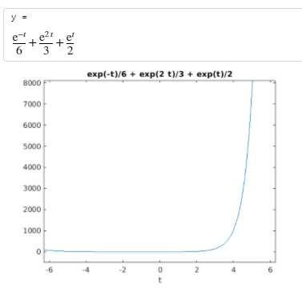

2)

clc

clear all

syms t s Y y(t)%%%%y=y(t) is the dependent variable given in the DE%%%%Y=Y(s) is the Laplace transform of y(t)

%y=sym('y(t)')

a = input('The Coefficient of D2y = ');

b = input('The Coefficient of Dy = ');

c = input('The Coefficient of y = ');

nh = input('Enter the non homogenous part = ');

%eqn=a*diff(sym('y(t)'),2)+b*diff(sym('y(t)'),1)+c*sym('y(t)')-nh

eqn=a*diff(y,2)+b*diff(y,1)+c*y-nh

LTY=laplace(eqn,t,s);

if (a==0)

d = input('The initial value of y at 0 is ');

LTY=subs(LTY,{​​​​​laplace(y(t), t, s),y(0)}​​​​​,{​​​​​Y,d}​​​​​);

else

d = input('The initial value of y at 0 is ');

e = input('The initial value of Dy at 0 is ');

LTY=subs(LTY,{​​​​​laplace(y(t), t, s),y(0),subs(diff(y),t,0)}​​​​​,{​​​​​Y,d,e}​​​​​); %%%%Dy=diff(y, t),Dy(t),Dy(0)%%%%

end

eq=collect(LTY,Y); %%%%% Y*4+Y*x===collect=== Y*(4+x)

Y=simplify(solve(eq,Y));

y=simplify(ilaplace(Y,s,t))

ezplot(y)

