**ARYAMAN MISHRA**

**19BCE1027**

1.     Using the given matrix and edges, write the R code and do the following: (25 Marks)

Matrix

|  |  |  |  |  |
| --- | --- | --- | --- | --- |
| A | B | C | D | E |
| 1 | 1 | 2 | 1 | 0 |
| 1 | 0 | 1 | 0 | 0 |
| 0 | 0 | 2 | 1 | 0 |
| 1 | 1 | 1 | 2 | 1 |
| 1 | 2 | 1 | 0 | 1 |

Edges

|  |  |
| --- | --- |
| Source | Target |
| A | B |
| A | C |
| A | D |
| A | F |
| F | A |
| B | E |
| B | C |
| D | F |
| F | B |

a.     Plot the directed graph with arrow size 0.5

b.     Plot the undirected graph

c.     Create and plot the network object using edge dataset

d.     Find number of edges, maximum and minimum degrees

e.     Plot vertex and edge customization

2.     Create an interactive dashboard using global store dataset and plot the following, (25 marks)

        a.     sum of sales for all the sub-categories. Which sub category has $1127086 sum of sales?

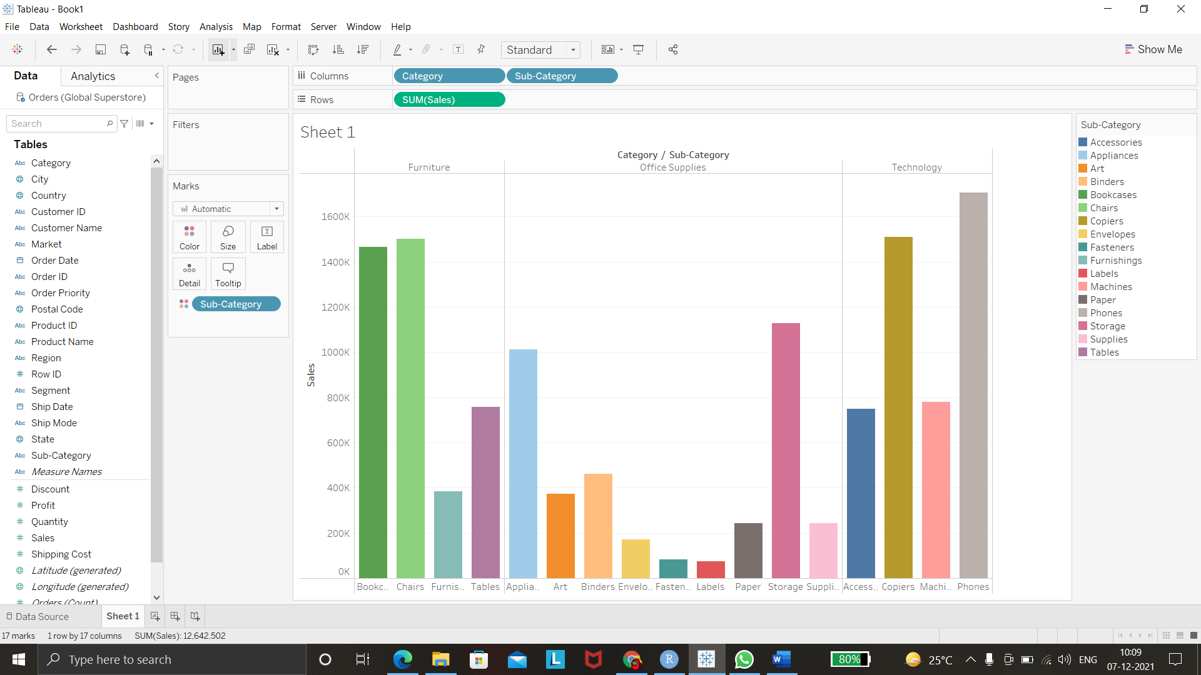

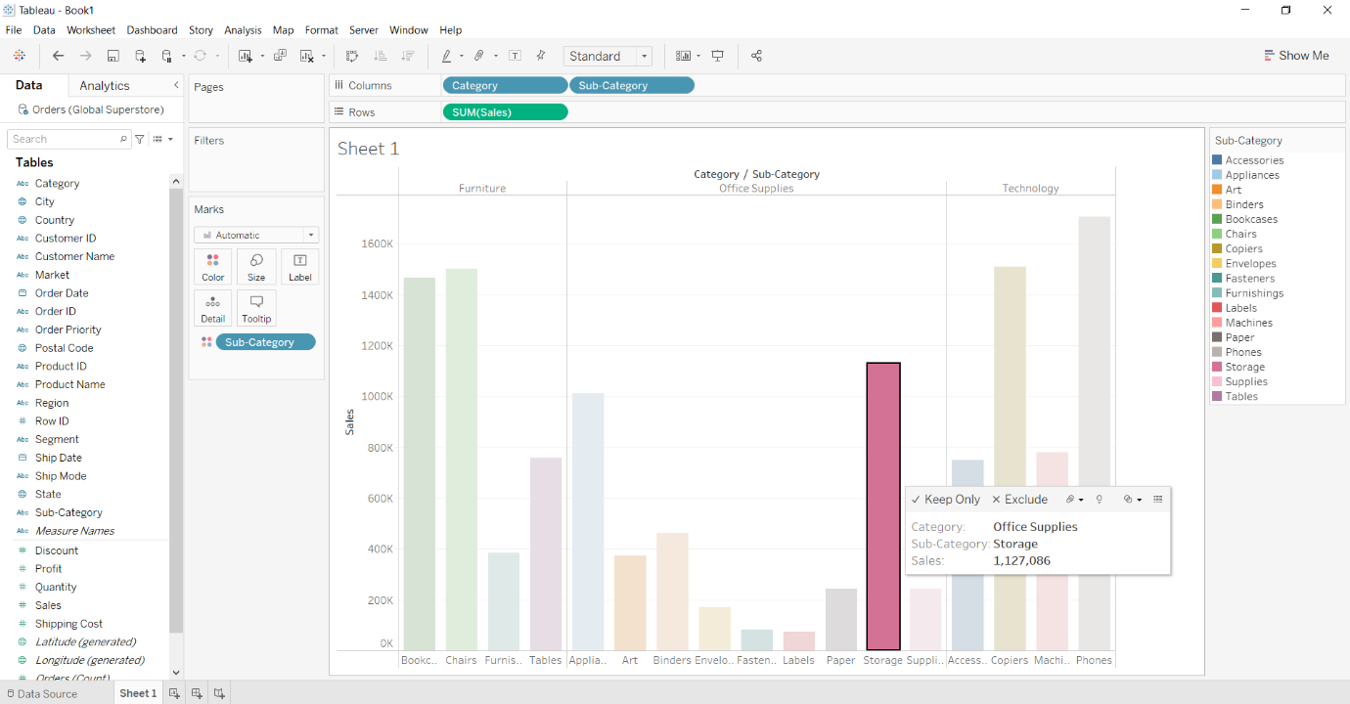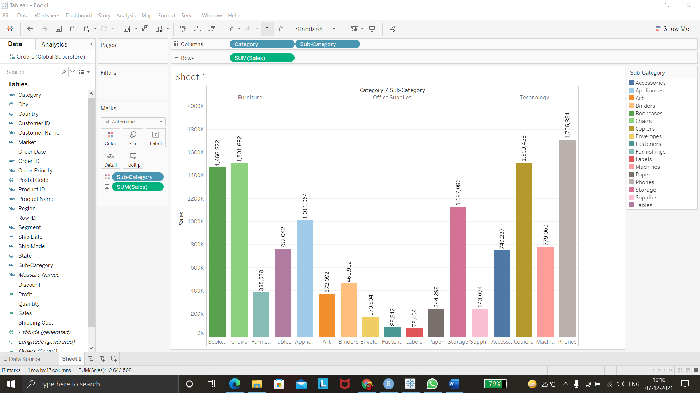

        b.     Maximum profits for all the sub-categories. Which sub category has $8,400 sum of profits?

        c.     sum of discounts for all the sub-categories

       d.     Changes in the sum of sales, profits and discounts upon selection of city.

       e.     Sum of orders for all the sub categories for the city Manaus

**Note:** Apply labels, various colors and blue border in the appropriate plots