**ARYAMAN MISHRA**

**19BCE1027**

**Launch msfconsole.**

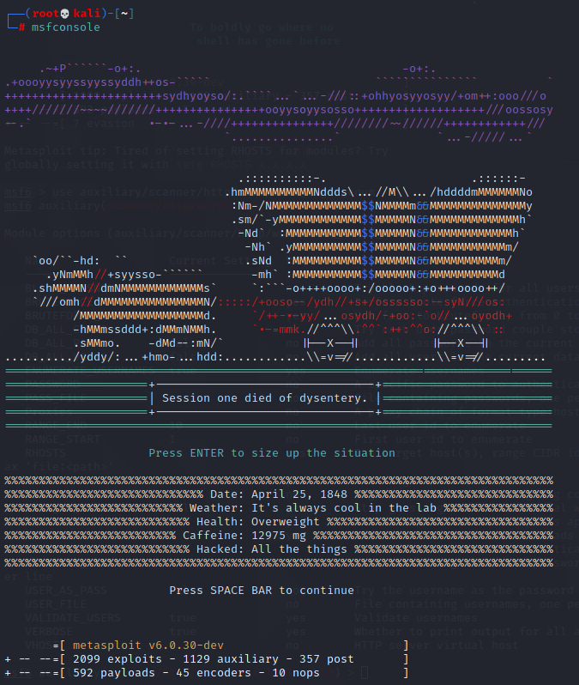

**auxiliary/scanner/http/axis_login**



**Show options**

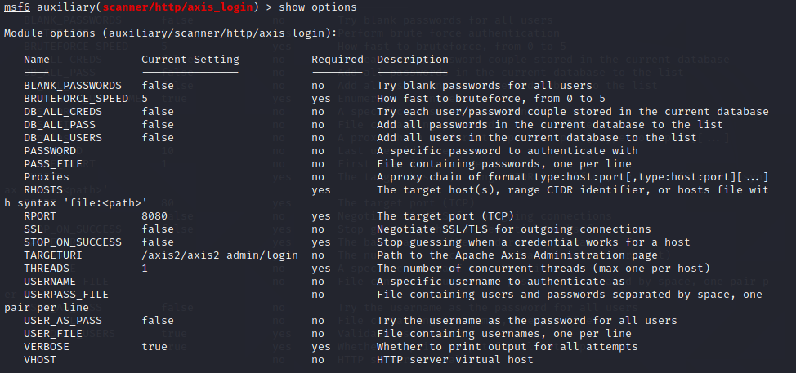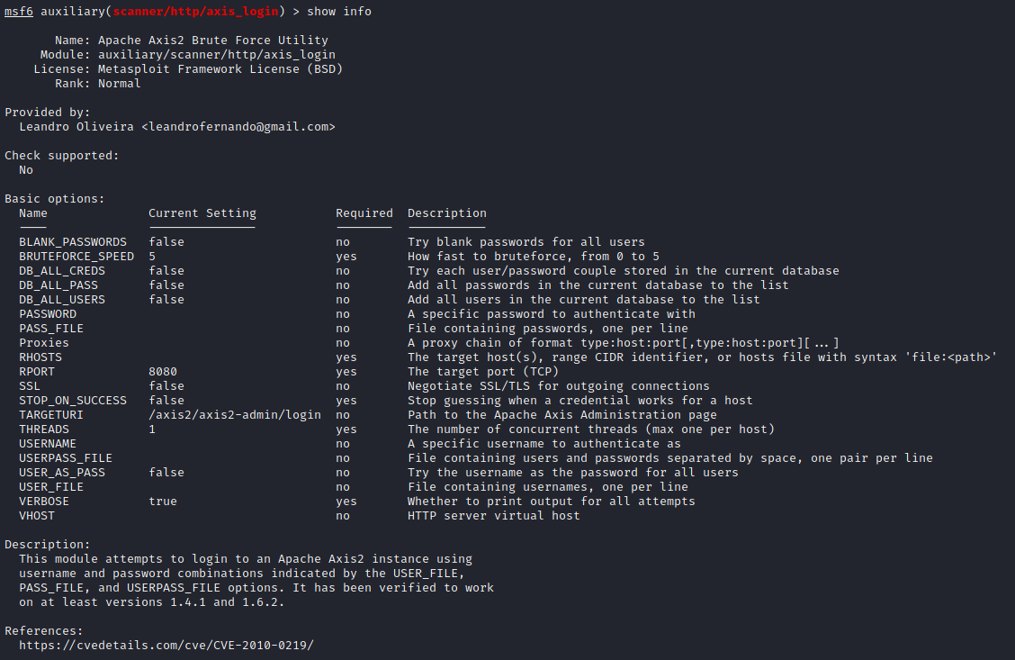

**Show evasion and info,**

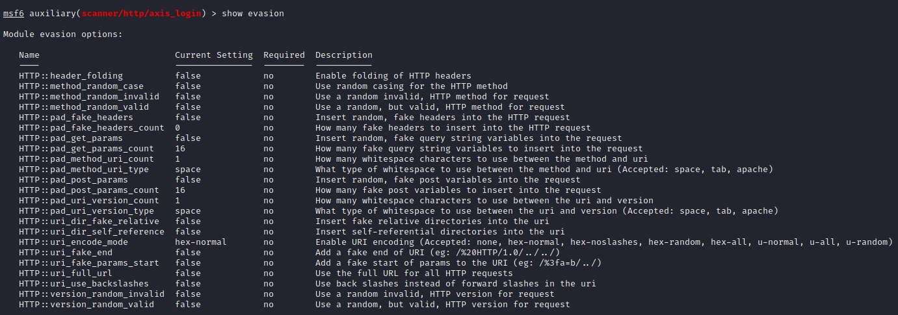 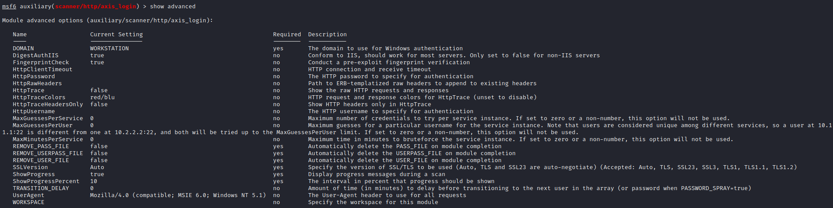

Show actions

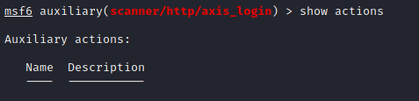

Set PASSWORD nad pw_file.



**Run the exploit.**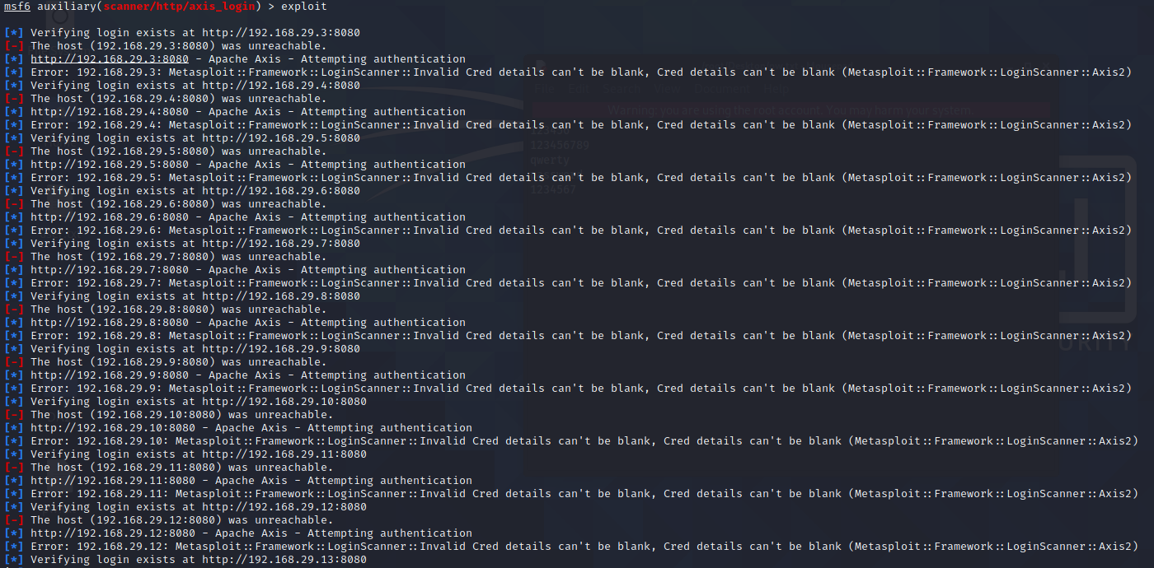

**auxiliary/scanner/http/wordpress_login_enum**

**show options**

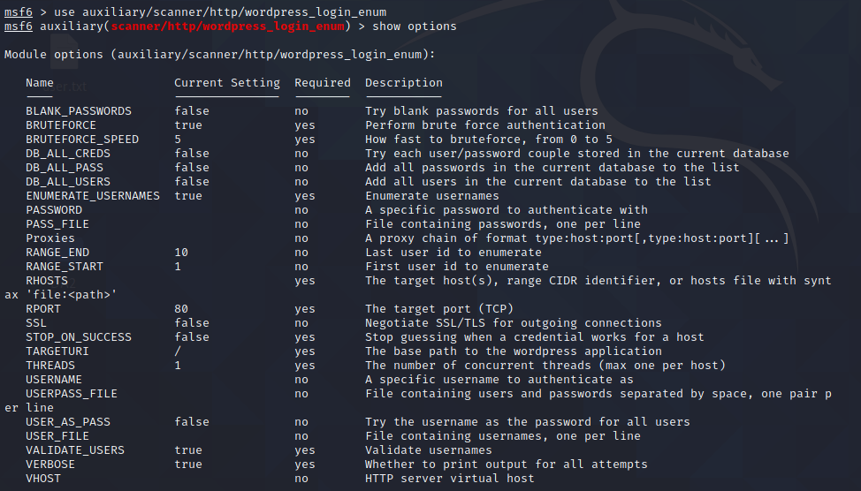

**Set URL,PASS_FILE,USER_FILE AND RHOSTS.**

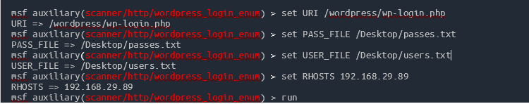

Run the exploit.

