Abstract - Road scene segmentation is a fundamental task in autonomous driving and intelligent transportation, providing critical scene understanding for navigation and safety. Recent advances in deep learning have led to the development of diverse approaches, including semantic, instance, panoptic, and video instance segmentation. In this systematic review, we analyze studies that applied these methods to road and urban scene datasets such as Cityscapes, KITTI, and BDD100K. The reviewed works are categorized into semantic methods for pixel-level road detection, instance segmentation models for lane and object-aware mapping and panoptic segmentation approaches unifying both paradigms. We summarize the algorithms applied, highlight commonly reported performance metrics, and compare their effectiveness for real-world deployment. This review provides a concise overview of the current state of road segmentation research and outlines challenges and opportunities for future advancements in robust and real-time applications.

Keywords - Deep learning, Road Segmentation, Autonomous driving, LiDar.

I.Introduction
The pursuit of fully autonomous driving represents one of the most significant technological undertakings of the 21st century, promising a future that fundamentally reimagines transportation. The vision of autonomous vehicles (AVs) extends far beyond mere convenience; it heralds a paradigm shift with profound societal implications. At its core, this vision is driven by the potential to drastically enhance road safety by mitigating the human error responsible for the vast majority of traffic accidents. Beyond safety, the widespread adoption of AVs promises to optimize traffic flow, reduce congestion and emissions, reclaim urban space currently dedicated to parking, and provide unprecedented mobility to elderly and disabled populations. This transformative potential has galvanized a global effort, with automotive manufacturers, technology corporations, and academic institutions investing immense resources into solving the complex challenges that lie between current driver-assistance systems and true, unconstrained autonomy, a task heavily reliant on advancements in machine perception.

The operation of any autonomous vehicle can be distilled into a fundamental feedback loop: Sense, Plan, and Act. The vehicle must first sense its environment to build a comprehensive and accurate model of the world around it. Based on this model, it must then plan a safe and efficient trajectory to its destination. Finally, it must act by translating this plan into precise control inputs for steering, acceleration, and braking. While each component of this loop presents formidable challenges, the "Sense" phase, or perception, is arguably the most critical, as noted by numerous studies in the field. The fidelity and reliability of the vehicle's environmental model form the bedrock upon which all subsequent planning and action are built
. An error in perception—a missed pedestrian, a misclassified lane marking, an undetected obstacle—can have immediate and catastrophic consequences. The core challenge of perception lies in interpreting the torrent of noisy, high-dimensional data from a suite of sensors and converting it into a structured, machine-readable understanding of a dynamic, unpredictable, and infinitely variable world, which is a central problem in computer vision.

To tackle this challenge, modern AVs are equipped with a diverse array of sensors, primarily high-resolution cameras (RGB) and LiDAR (Light Detection and Ranging). Cameras provide rich, dense color and texture information, making them adept at recognizing the semantic category of objects. LiDAR, in contrast, emits laser pulses to generate a sparse but geometrically precise three-dimensional (3D) point cloud of the environment, offering robust depth information and resilience to adverse lighting conditions. The complementary nature of these sensors is a cornerstone of modern perception systems, as it allows for sensor fusion strategies that leverage the strengths of one modality to overcome the weaknesses of another. However, raw sensor data alone is insufficient. The vehicle requires a granular, contextual understanding of its surroundings far exceeding simple object detection. It needs to know not just that an object is a car, but where its precise boundaries are. It needs to differentiate the drivable road surface from the sidewalk, identify lane markings, and understand the relationship between static infrastructure like buildings and dynamic agents like cyclists. This necessity for a holistic, pixel-perfect understanding has made scene segmentation the preeminent task in autonomous driving perception, a task that requires precise pixel-level predictions.

Initially, the primary goal was semantic segmentation, a task focused on assigning a class label (e.g., 'road', 'car', 'pedestrian', 'building') to every single pixel in an image or point in a 3D point cloud. Foundational approaches, such as the deep convolutional encoder-decoder architecture presented in SegNet, demonstrated that deep neural networks could achieve remarkable performance on this task. This is achieved by mapping low-resolution, semantically rich features back to the full input resolution for pixel-wise classification. However, a significant limitation of semantic segmentation quickly became apparent: it cannot distinguish between individual instances of the same object class. For an AV, knowing that a cluster of pixels represents "pedestrians" is not enough; it must recognize that this cluster is composed of three distinct individuals, each with their own potential trajectory.

This led to the development of instance segmentation, a more sophisticated task that not only classifies pixels but also groups them into distinct object instances. The seminal Mask R-CNN framework established a powerful and flexible baseline for this task. It works by extending object detectors to simultaneously predict a high-quality segmentation mask for

each detected instance. While highly effective, the sequential nature of such two-stage methods posed challenges for real-time applications. This spurred the development of fast, one-stage models that aimed to fill this gap. Methods like YOLACT broke the task into parallel subtasks of generating prototype masks and predicting per-instance mask coefficients, enabling real-time performance. Further advancements, such as SOLOv2, refined this direct, box-free approach with dynamic mask generation, pushing the boundaries of both speed and accuracy for instance-level recognition.

The pursuit of a truly comprehensive scene understanding culminated in the formulation of panoptic segmentation. This unified task elegantly combines the strengths of its predecessors by assigning both a semantic label and, where applicable, an instance ID to every pixel in the image. The result is a complete, gap-free map of the environment that simultaneously identifies all foreground objects ("things") and segments all background regions ("stuff"). Pioneering bottom-up approaches like Panoptic-DeepLab established strong and fast baselines for this task. They achieve this by predicting semantic segmentation and class-agnostic instance centers, which are then fused to generate the final panoptic output. This holistic task provides the rich, detailed environmental model necessary for complex behavioral prediction and path planning in dense urban scenarios.

This rapid progress in segmentation capability has been powered almost exclusively by the deep learning revolution. The paradigm shift occurred with the rise of Convolutional Neural Networks (CNNs), whose hierarchical architecture allows them to learn powerful and robust feature representations directly from vast amounts of data. The architectural evolution within CNNs has been relentless, with a significant focus on balancing accuracy with computational efficiency for on-board deployment. For instance, BiSeNet addressed this dilemma by designing a two-path network. This consists of a Spatial Path to preserve high-resolution spatial information and a Context Path to obtain a large receptive field, enabling real-time performance without a catastrophic drop in accuracy.

More recently, the field has witnessed another architectural sea change with the adaptation of Transformers from natural language processing to computer vision. The core self-attention mechanism of Transformers allows them to model long-range, global dependencies within an image more effectively than the inherently local receptive fields of CNNs. This has led to a new generation of state-of-the-art models. Architectures like SegFormer introduced a simple, efficient, yet powerful framework with a hierarchical Transformer encoder and a lightweight multilayer perceptron (MLP) decoder. This design achieved significantly better performance and efficiency than previous methods. The success of both paradigms has also inspired hybrid architectures that seek to combine the best of both worlds. SwinURNet, for example, integrates a CNN-based encoder to capture local semantic features with a
Swin Transformer-based decoder to model global long-range dependencies, demonstrating the power of such hybrid designs.

Bringing these advanced models into the specific context of autonomous driving requires addressing challenges unique to the domain. Processing sparse, unordered LiDAR point clouds necessitated the development of specialized architectures. PointNet was a seminal work that directly consumed raw point sets, respecting the permutation invariance of the data. To achieve real-time performance, alternative projection-based methods like SqueezeSeg were developed. These methods transform the sparse 3D point cloud into a dense 2D representation that can be efficiently processed by a compact CNN.

The clear safety imperative has also driven the development of multi-modal fusion networks that explicitly combine camera and LiDAR data. Relying on a single sensor is insufficient for achieving the required level of safety, as cameras fail in poor lighting and LiDAR can struggle with adverse weather. Modern fusion strategies leverage the power of Transformers to effectively integrate features from these disparate sensor streams. Models like CLFT and CMX explore sophisticated cross-modal attention mechanisms. These allow features from one modality to enhance and refine features from the other, creating a unified representation that is more robust and reliable than any single modality alone. Furthermore, the "domain shift" problem—where a model trained in one geographic location or weather condition fails in another—is a critical barrier to large-scale deployment. This has spurred research into domain adaptation techniques, as seen in ROAD, which proposes a reality-oriented approach to adapt segmentation models from synthetic training data to real-world urban scenes.

While numerous surveys have been published on aspects of this field, a comprehensive and systematic review that cohesively charts the parallel evolution of the segmentation task and the underlying deep learning architectures is needed. Many existing reviews focus narrowly on CNN-based semantic segmentation
or on LiDAR processing in isolation. Few have provided a unified narrative that bridges the progression from semantic to panoptic segmentation while simultaneously analyzing the pivotal architectural shift from purely convolutional networks to the recent dominance of Transformer-based models and their hybrids. Moreover, a systematic analysis of how these advancements are integrated within the multi-modal fusion frameworks essential for autonomous driving remains a critical gap in the literature.

This paper presents a systematic review of the deep learning literature for autonomous driving scene segmentation. We provide a unified perspective on the evolution of the perception task itself, from pixel-wise classification to holistic panoptic scene understanding. We systematically categorize and analyze the pivotal architectural advancements, from foundational CNNs to

state-of-the-art Transformers, and dissect the cross-modal fusion strategies that are critical for robust perception.

The contributions of our systematic review are as follows:
- We provide a structured overview of the evolution of visual perception tasks for autonomous driving, charting the progression from semantic to instance and finally to unified panoptic segmentation.
- We systematically categorize and analyze the key deep learning architectures, detailing the innovations in both CNN-based and Transformer-based models for scene understanding.
- We offer a comprehensive analysis of multi-modal fusion techniques, focusing on the synergistic integration of camera and LiDAR data to achieve robust, all-weather perception.
- We examine the critical challenges facing the field, including the demand for real-time performance, the necessity of domain adaptation, and the handling of long-tail, safety-critical scenarios.
- We conclude by discussing the primary benchmark datasets, evaluation metrics, and promising future research directions that will shape the next generation of perception systems for autonomous vehicles.

Overview of deep neural network

- CNN
Convolutional Neural Networks (CNNs) are a specialized type of deep learning architecture primarily designed for processing data with a grid-like structure, such as images. They consist of layers that apply convolutional filters (kernels) to input data to automatically extract and learn relevant features like edges, textures, and shapes. This parameter-sharing mechanism allows CNNs to efficiently detect spatial hierarchies of patterns while reducing the model complexity compared to fully connected networks.

A typical CNN is composed of convolutional layers for feature extraction, activation layers such as ReLU to introduce non-linearity, and pooling layers to downsample spatial dimensions and reduce computational load. These layers work together to transform the input through increasingly abstract representations, enabling the network to perform tasks such as image classification, object detection, and segmentation.

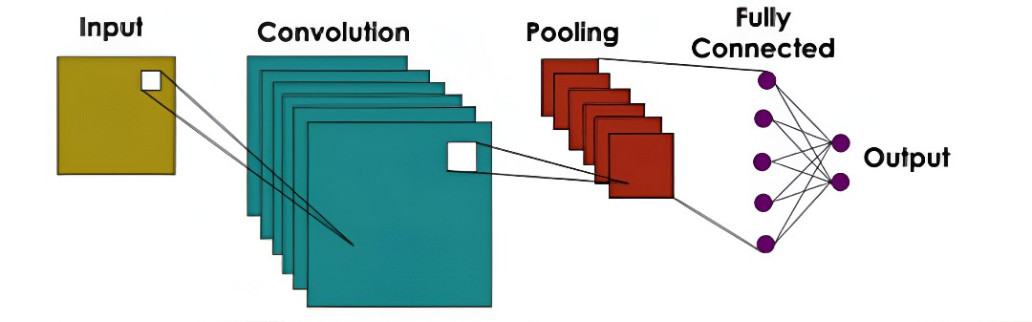

CNNs have been widely successful in computer vision applications due to their ability to learn directly from raw pixel data without manual feature engineering. By leveraging spatial locality and hierarchical features, CNNs provide strong translation invariance and robustness in visual recognition problems.

- RNN
- Encoder decoder
First introduced in 2014, the encoder–decoder architecture has since become ubiquitous in segmentation tasks, forming the
backbone of many influential models such as Segnet and Unet. In this design, the encoder compresses the input into a compact latent representation by extracting the features it considers most important for its task, while the decoder reconstructs or transforms this representation into the desired output. For image segmentation, the encoder processes the input image to capture the most relevant features, and the decoder uses these features to generate a dense segmentation mask, assigning relevant pixels to their corresponding object classes.

U-Net later enhanced this design by introducing skip connections, which directly link encoder layers with corresponding decoder layers. These connections enable the decoder to recover fine-grained spatial information lost during downsampling, thereby enabling more accurate reconstruction of the segmentation output. These have proven especially valuable in street view segmentation thanks to their ability to preserve boundaries and small structures like roads and poles.

- Transformer

While the transformer architecture was first introduced in the “Attention Is All You Need” paper in 2017 for natural language processing (NLP) tasks, they gained widespread popularity through their role as the backbone of large language models (LLMs) such as GPT and BERT. The success of LLMs in handling long-range dependencies and scaling to large datasets effectively prompted many to apply this architecture to computer vision tasks, giving rise to models such as the Vision Transformer (ViT) and SegFormer.

Transformers process input as sequences of tokens, which are vector representations of data such as words in text or image patches in vision. Via a weighted dot product operation called self attention, each token is able to weigh its relationships with every other token, enabling the model to capture both local and long-range dependencies without relying on fixed convolutional filters like more traditional models. In segmentation tasks, images are split into several patches, and self-attention helps the model relate distant regions of the scene while decoder modules reconstruct dense masks. In recent years, transformers have

become dominant in street view segmentation tasks, thanks to their ability to preserve global context while recovering fine spatial details.

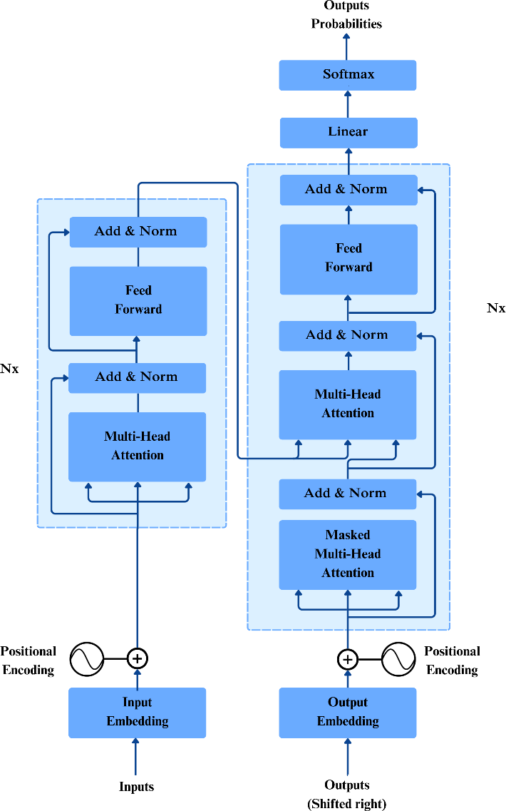

Metrics
Segmentation models in computer vision are evaluated using a combination of accuracy and efficiency metrics:

- Accuracy Metrics:
  - Intersection over Union (IoU) / Jaccard Index: Measures the overlap between predicted and ground truth segments relative to their union, widely used for semantic and instance segmentation.
  - Mean Intersection over Union (mIoU): Average IoU across all classes, reflecting overall segmentation accuracy in multi-class settings.
  - Dice Coefficient: Reflects similarity between predicted and true masks, emphasizing overlap and useful especially for small objects.
  - Pixel Accuracy: Proportion of correctly classified pixels overall, though sensitive to class imbalance.
  - Precision and Recall: Precision measures correctness of predicted segments, while recall measures completeness of ground truth detection.
  - Boundary F-measure: Evaluates how closely predicted boundaries match true object edges, important for precise segmentation.
  - Mean Average Precision (mAP): Common in instance segmentation, combining precision and recall across multiple IoU thresholds.
  - Panoptic Quality (PQ): Specifically designed for panoptic segmentation, PQ combines segmentation quality (average IoU of matched segments) and recognition quality (F1 score of matched segments), providing a unified measure for both semantic and instance segmentation tasks.
- Efficiency Metrics:
  - FLOPs (Floating Point Operations): Represents computational complexity for processing one sample; lower FLOPs indicate more efficient models.
  - FPS (Frames Per Second): Indicates inference speed, showing how many images the model processes per second.
  - Number of Parameters: Reflects model size impacting memory requirements and deployment feasibility.

Review methodology
A systematic literature review gathers and summarises the work of several research works, in accordance with the Preferred Reporting Items for Systematic Reviews and Meta-Analyses (PRISMA) guidelines. Thus, after identifying works related to our topic, we analysed and tabulated the results of these papers, drawing various conclusions. Using PRISMA methodology, we searched for full text-english-only articles relating to the use of deep learning approaches for street view image segmentation research published up to 15 May, 2025. Specifically we used the following criteria for selecting papers:-
- The papers were written in English
- The papers present models that have been applied to road scene segmentation tasks
- The papers take a deep learning approach
- The papers are published after 2015

To identify relevant papers, we searched the databases of Google Scholar, Springer and IEEE Xplore using the keyword strings “semantic”, “instance”, “panoptic”, “segmentation”, “image”, “lidar”, “Cross-modal”, “fusion”, “sensor”, “road”, “attention”, “transformer”, “driving”, “light”, “deconvolution”, “scene”, “vision”, “accurate”, “mask”, “network”, “resolution”, “detection”, “convolution”, “real time”, “3d”, “patterns”, “deep learning”, “semi supervised”, “video”, “object”, “lanes” and their permutations. Using filters like “Relevance”, “Most Popular” and “most cited by papers”, we gathered 80 papers that fit the above criteria. The final selection of papers were divided according to their ability to perform semantic, instance or panoptic segmentation, resulting in 30 papers in semantic segmentation, 20 for instance segmentation and 20 for panoptic segmentation, alongside 12 for explanations on the datasets and benchmarks commonly used for such papers.

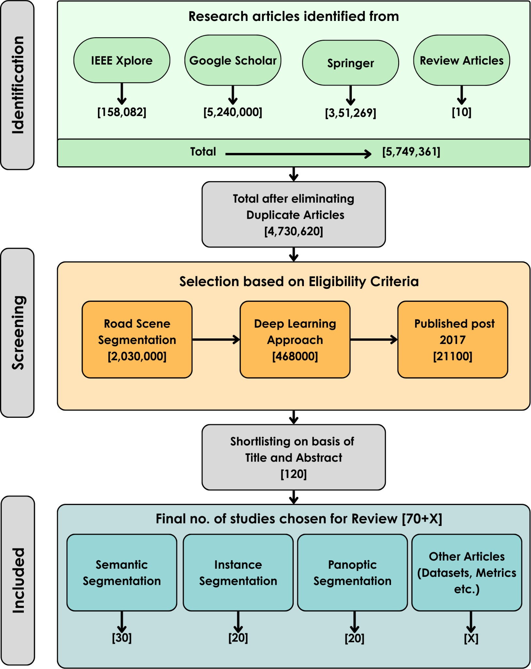

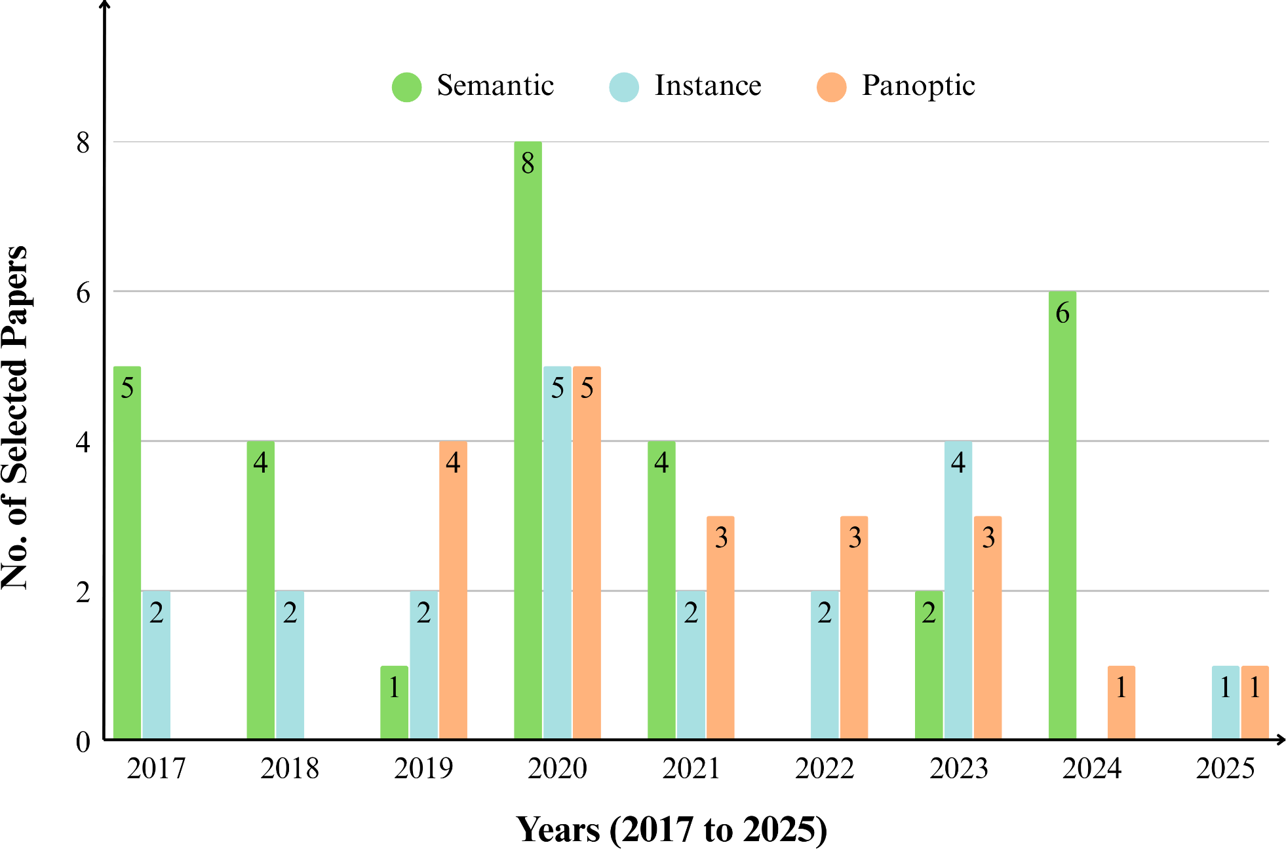
The main objective of this Systematic literature review is to view the development of road scene segmentation from 2015 to 2025 and analyse the advantages of each of the proposed architectures. The research questions used for the current systematic literature review process are

Q1 What is road scene segmentation and how is it defined in the literature on computer vision and autonomous driving?
Q2 What deep learning architectures have been applied for road scene segmentation in recent literature?
Q3 What benchmark datasets are most commonly used for training and evaluating road scene segmentation models?
Q4 What evaluation metrics (e.g., mIoU, pixel accuracy) are used in road scene segmentation, and how do different models compare in performance?
Q5 What unique contributions and advantages do different models present in advancing road scene segmentation?

- Semantic

Literature review
strategy, further enhancing the context that each pixel receives. The model is tested via PASCAL VOC and Cityscapes datasets.

Xie et al created Segformer, a transformer based approach to segmentation. It uses a lightweight mlp decoder, keeping the model simple and efficient, as well as a hierarchically structured encoder which allows the model to be resistant to changes in image resolution thanks to its avoidance of patch embeddings. Its multi-scale feature extraction takes image features from both coarse and fine levels, giving both local detail and global context. THe model used the MiT-B0 backbone for real time operation, and used MiT-B5 for non real time operation. ADE20K, Cityscapes, and COCO-Stuff datasets are used for study, using flops(Floating-Point Operation), FPS(frames per second) and miou(Mean intersection over union) for evaluation. The model achieved flops, fps and miou of

Qi et al. developed Pointnet, a neural network that directly used pointclouds, without converting them into 3d voxel grids or collections of images that other networks commonly used, thus preventing the data from becoming too voluminous. It achieves permutation invariance by applying shared MLPs to each point and aggregating features via a symmetric max-pooling operation, further enhanced by learnable spatial transformers for input and feature alignment. The model learns to summarize shapes by a sparse set of key points representing object skeletons, making it more robust in the face of noise or missing inputs.
It is tested on datasets like ModelNet40, ShapeNet, and Stanford 3D Semantic Parsing.

- Squeeze-Seg
Wu et al. proposed Squuze-Seg, which acquired a 2d representation of 3d pointcloud data via projection of the point cloud onto a spherical surface. This 2D property of the data allowed it to be manipulated by CNNs for segmentation, significantly increasing the processing speed. The output from the CNNs is further improved with the addition of CRFs(Conditional Random FIelds) which group pixels with similar coordinates and features together with the same labels, making the model more resistant to noise and outliers. KITTI and GTA were used for evaluation.

- Pyramid Scene Parsing Network
Zhao et al. made PSPNet or Pyramid Scene Parsing Network, which aims to address the need of capturing both local and global context in complex segmentation scenarios. The key innovation of PSPNet is its Pyramid Pooling Module (PPM), which aggregates contextual information at multiple scales. The PPM divides the input feature map into subregions of different sizes, applies pooling to each region to extract features, then upsamples and concatenates these features with the original feature map. This multi-scale context helps the network understand both fine details and broader scene-level information. The network uses a deep Resnet backbone that is pre-trained via the dilated network
- DenseASPP
Yang et al. created Dense ASPP, shorthand for Dense Atrous spatial Pyramid Pooling, a model designed for having increasingly dilated convolutions. Unlike traditional ASPP, which concatenates atrous convolutional features at different dilation rates but sparsely along the scale axis, DenseASPP densely connects a series of atrous convolutional layers with gradually increasing dilation rates giving each pixel information on its surrounding pixels, allowing it to capture multi scale features with ease. This model is evaluated via the cityscapes dataset

- DCN-Deeplabv3+
Peng et al. created an improvement of DeeplabV3+ christened DCN-DeeplabV3+. It offers several enhancements such as incorporation of both channel and spatial attention in its neural attention submodule, using the light mobinetV2 as a backbone instead of the heavy Xception that the original used and the use of dense ASPP+SP which is similar to not only enhances multi scale object detection but the SP(strip pooling) module also allows it to better recognise straight lines.Thanks to these, it provides a nice balance of segmentation accuracy and computational efficiency. It is evaluated using the Cityscapes and the PASCAL VOC 2012 datasets.

- BiSeNet
Yu et al. created Bisenet or Bilateral Segmentation Network, designed to address the loss of resolution and speed that U-shaped encoder-decoder architecture entailed. Its uniqueness comes from its splitting of input data into two distinct paths. The Spatial Path, stacks only three convolution layers to obtain the 1/8 feature map, which retains affluent spatial details. The context path uses a relatively lightweight backbone, Xception, with aggressive downsampling and global average pooling to rapidly capture a wide receptive field for contextual information. Then the paths are combined via a Feature Fusion Module(FFM) combining spatial and contextual information, and then improved via an Attention Refinement Module which refines features in the context path by applying global context through an attention mechanism without expensive upsampling, enabling the model to have high segmentation accuracy while having remarkable speed. The model was tested on the benchmarks of Cityscapes, CamVid, and COCO-Stuff.

- SETR
Zheng et al. created SETR, short for SEgmentation TRansformer, built as an alternative to traditional FCN encoder decoder architecture models. Instead of procedural image abstraction and reconstruction, in this model the transformer encoder processes an input image as a sequence of fixed-size image patches or patch embeddings without any spatial downsampling, enabling global context modeling at every layer through self-attention. This overcomes the limited receptive field problem intrinsic to CNNs, as transformers inherently model

long-range dependencies more effectively. These patch embeddings are then upsampled by the decoder to be assigned pixel-wise classes. This allowed it to show good results on Cityscapes, ADE20K and PASCAL Context datasets.

- Segmentero
Strudel et al. introduced Segmenter, a pure transformer model for semantic segmentation that models global context at every layer. Built upon the Vision Transformer(ViT) architecture, the image is split into a sequence of patches, which are linearly embedded and processed by a ViT encoder. For decoding the contextualized patch embeddings into class labels, the paper explores two approaches: a simple point-wise linear decoder and a more sophisticated mask transformer decoder. The mask transformer takes the encoder output and a set of learnable class embeddings as input, processing them jointly to generate class masks via a scalar product. The models leverage large-scale pre-training on ImageNet and are fine-tuned on semantic segmentation datasets.
- Swin
Wang et al. introduced SwinURNet, a hybrid transformer-CNN architecture for real-time point cloud segmentation on unstructured roads. The method first projects the 3D point cloud onto a 2D range image via spherical projection. The architecture consists of a lightweight ResNet34-based encoder to capture local semantic features and a novel Non-Square Swin Transformer (NSST) decoder designed to model global long-range dependencies and capture high-resolution transverse features suitable for the high aspect ratio of LiDAR images. A Multidimensional Information Fusion Module (MDIFM) is proposed to balance the semantic gaps between CNN feature maps and transformer attention maps, while a Multitask Loss Function (MTLF)—comprising boundary, weighted cross-entropy, and Lovász-Softmax losses—is used to guide the network in segmenting low-contrast boundaries. Evaluated on a private mining dataset as well as the public RELLIS-3D and SemanticKITTI datasets, SwinURNet demonstrated significant performance gains over compared methods with an inference speed of 8–19 FPS.

Author | Dataset | Model | Result | Uniqueness
Junyi Gu | Waymo Open and SemanticKitti | CLFT |  | fuses camera images with LiDAR projections for road segmentation, tackling class imbalance and proving robust under varied lighting and weather.
Jiaming Zhang | NYU Depth V2, SUN-RGBD,  Stanford2D3D, ScanNetV2, Cityscapes, RGB-T MFNet, RGB-P ZJU, RGB-E EventScape, RGB-L KITTI-360 | CMX |  | Robust to noise and can use diverse sensors thanks to its RGB-X segmentation framework with two streams and novel rectification and fusion modules
Jun Cen | SemanticKITTI, NuScenes | CMDFusion |  | cross-modality distillation, allowing it to create 2d representations of 3d data even beyond the camera’s FOV
Yang Zhang | SemanticKITTI, A2D2 and Paris-Lille-3D | PolarNet |  | introduces a polar grid LiDAR representation that accounts for spatial point imbalance, enabling efficient training while having lower computational cost.
Eren Erdal Aksoy | KITTI | SalsaNet | average MIOU of 79.7, | a real-time encoder–decoder network for road and vehicle segmentation using only 3D LiDAR data, featuring cross-modal label transfer and projection method analysis
Yanwei Li | Cityscapes and PASCAL VOC 2012 | Dynamic Routing | MIOU 80.7,  FLOPS 270 | a data-dependent, input-adaptive network for semantic segmentation that selects custom feature transformation paths per image, addressing scale variance and improving efficiency
Yuhui Yuan | Cityscapes, ADE20K, LIP, PASCAL Context, COCO-STUFF | OCRnet | MIOU 81.8 | enhances pixel representations by aggregating object-level contextual features, distinguishing same-class from different-class context

Mingmin Zhen | Cityscapes | IPCModule | Using RPCNet,  82.1 MIOU | a novel framework joining semantic segmentation and boundary detection, introducing pyramid context sharing, edge suppression, and a duality loss for boundary–mask consistency
Yuhua Chen | GTAV and SYNTHIA | ROAD | gtaV-85.4 IOU  for roads. miou of 35.9 after including things like bus, train, car, fence, pole, etc | improves synthetic-to-real urban scene segmentation using target-guided distillation to adapt to real styles and spatial-aware adaptation to align domains by spatial regions.
Jun Fu | PASCAL VOC 2012, CamVid,  GATECH and COCO Stuff | SDN | Camvid MIOU 92.7 | captures multi-scale context and improves localization through intra- and inter-unit connections with hierarchical supervision
Jingdong Wang | PASCAL-Context and Cityscapes | HRnet | mIoU 82.6 | maintains high-resolution features throughout the network via parallel multi-resolution streams and repeated fusion
Jun Fu | Cityscapes, PASCAL Context and COCO Stuff | DANet | miou 81.5 | models both spatial and channel dependencies through self-attention modules
Yuhui Yuan | Cityscapes, PASCAL-Context, COCO-stuff | HRFormer | miou 83.2 | extends HRNet’s multi-resolution parallel design with efficient local-window self-attention and depthwise convolutions, enabling strong multi-scale representation while keeping computation and memory costs low
Tianyi Wu | Cityscapes, CamVid | CGNet | 6 Gflops, 0.5(M)  parameters, 334 memory(M),  64.8 miou_cla,  85.7 miou_cat,  56.8 time(ms) | captures local and global context. proposes both block and network for high accuracy with minimal parameters
Ruiping Liu | Cityscapes, ACDC, NYUv2, and Pascal VOC2012 | TransKD | parameters 5.53  (M), 17.84  GFLOPS, 68.98  miou | transformer-to-transformer knowledge distillation framework for semantic segmentation, leveraging transformer-specific patch embeddings with novel CSF, PEA, GL-Mixer, and EA modules.
Hu Cao | DE20K, Cityscapes, and COCO-Stuff | SDPT | SDPT-tiny 3.6 parameters(M),  63.4 GFLOPS,  77.3 MIOU;  SDPT-small 11.9  parameters(M),  131.3 GFLOPS,  80.4 MIOU;  SDPT-large 28.5 parameters(M), 333 GFLOPS,  81.6 MIOU | hierarchical transformer encoder using Dimension-Pooling Attention (DPA) and a semantic-balanced decoder, enabling efficient  multi-scale feature generation and refined multi-level feature aggregation
Wenyu Liu | Dark Zurich, ACDC(cityscapes adverse weather) and Nighttime Driving | ACSegForm er | dark zurich miou 65.4, acdc  miou 72.7, 57.9 | pseudo label refinement, domain alignment, and masked context learning specialising in  adverse-condition semantic segmentation across

 |  |  | on nighttime dribving | multiple weather scenarios.
Vijay Badrinaraya nan | SUN RGB-D, CamVid | SegNet | 60.4 on camvid | reuses max-pooling indices for efficient upsampling, improving boundary accuracy while reducing parameters for end-to-end training.
Tobias Pohlen | Cityscapes | FRRN | 71.8 miou | Has a dual-stream ResNet-like architecture, combining a pooled low-resolution stream for recognition with a full-resolution stream for precise localization

- Instance

Ko et al. proposed Point Instance Network (PINet), an instance segmentation-based lane detection method that predicts a sparse set of key points along traffic lines and clusters them into separate lane instances using learned embeddings. The network comprises a resizing module and a predicting module built from stacked hourglass networks, each producing key point confidence, offset, and embedding outputs. Multiple hourglass modules are trained jointly with the same loss, enabling “network clipping” for computationally constrained systems without retraining, aided by knowledge distillation to retain accuracy. The loss combines confidence, offset, embedding feature similarity, and distillation terms. Evaluations on CULane and TuSimple datasets show competitive or state-of-the-art accuracy with notably low false positive rates, and robust performance under occlusion or poor visibility (e.g., “dazzle light”), with negligible performance drop in reduced-depth variants.

Neven et al. addressed lane detection as an instance segmentation problem via LaneNet, a two-branch fully convolutional network with a shared encoder and task-specific decoders: a binary segmentation branch labels lane pixels, while an embedding branch outputs per-pixel embeddings that are clustered into lane instances. This approach supports a variable number of lanes and handles lane changes effectively. A learned perspective transformation network (H-Net) predicts homography parameters conditioned on the input image, enabling reliable low-order polynomial lane fitting even with road plane changes, outperforming fixed “bird’s-eye view” transforms. On the TuSimple benchmark, LaneNet achieves high accuracy with low false positives and real-time throughput (~50 fps), delivering robust and flexible lane detection suitable for practical deployment.

Bolya et al. introduced YOLACT (You Only Look At CoefficienTs), a one-stage, real-time instance segmentation method that decomposes the task into two parallel subproblems: generation of a fixed set of prototype masks for the entire image (via a fully convolutional “Protonet” branch) and prediction of per-instance mask coefficients (via an additional head attached to the detector). Final masks are obtained as a linear combination of prototypes and corresponding coefficients, cropped to bounding box extents, enabling high mask quality without explicit feature
re-pooling. The underlying detector follows a RetinaNet-style architecture with a lightweight head, and a novel Fast NMS algorithm replaces traditional NMS to improve speed by ~12 ms with negligible mAP loss. YOLACT achieves 29.8 mAP at 33.5 FPS on COCO test-dev (ResNet-101 backbone, 550×550 resolution), with larger masks offering improved boundary fidelity, especially for large objects, and showing stable temporal behavior in videos despite being trained on static images. The design allows straightforward backbone/resolution trade-offs for speed–accuracy balance, and its direct mask generation approach avoids many of the bottlenecks present in two-stage methods.
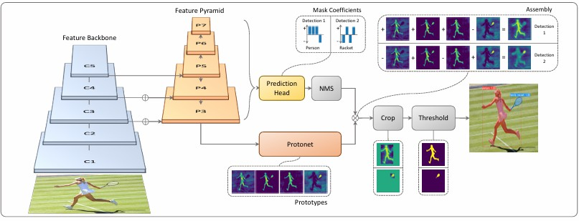

Figure X: YOLACT Architecture.

Zheng et al. proposed enhancing geometric factors in model learning and inference for object detection and instance segmentation through two key contributions: the Complete-IoU (CIoU) loss and Cluster-NMS. CIoU loss extends IoU-based regression by incorporating three geometric factors — overlap area, normalized central-point distance, and aspect ratio — to better handle challenging bounding box regression cases. This design mitigates limitations of IoU and GIoU losses, leading to faster convergence and improved localization accuracy. Cluster-NMS reformulates non-maximum suppression as an implicit clustering process of predicted boxes, enabling fully parallel GPU execution and fewer suppression iterations, with the ability to integrate geometric cues such as score penalty, central-point distance, and weighted coordinates. Experiments on instance segmentation frameworks such as YOLACT and BlendMask-RT, as well as detection models like YOLOv3, SSD, and Faster R-CNN, showed consistent gains in AP and AR without degrading inference speed; for example, CIoU loss with Cluster-NMSS+D improved both detection and segmentation precision–recall balance while maintaining real-time throughput (~28 FPS on GTX 1080Ti). These improvements were

particularly notable for large-object cases, with robustness retained across occlusions and scale variations.

He et al. introduced Mask R-CNN as a flexible extension of Faster R-CNN for object instance segmentation. The framework adds a parallel mask branch to the existing classification and bounding box regression branches, enabling simultaneous detection and high-quality pixel-wise segmentation for each object instance. Mask R-CNN resolves spatial misalignment issues of earlier approaches through the RoIAlign operation, which applies bilinear interpolation rather than quantization when pooling feature maps. This design allows simple training, rapid inference (up to 5fps), and easy generalization to tasks such as human pose estimation. Mask R-CNN achieves top results on benchmarks like MS COCO and Cityscapes, outperforming previous state-of-the-art models by providing superior mask accuracy—especially in crowded scenes with overlapping instances. Its robust architecture and general applicability have established it as a standard baseline for both academic research and real-world instance segmentation in road scenes.

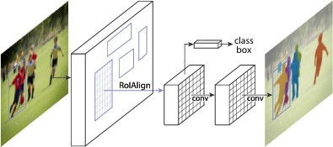

Figure X. The MaskR-CNN framework for instancesegmentation.

Wan et al. addressed challenges in road instance segmentation—particularly weaknesses in feature extraction and low accuracy for small or occluded objects—by improving the Mask R-CNN framework. The proposed method replaces the standard ResNet backbone with Res2Net, a multi-scale backbone architecture capable of extracting richer and more granular features, while integrating Feature Pyramid Networks (FPN) for multi-scale representation. Additionally, the soft non-maximum suppression (soft-NMS) algorithm is employed to mitigate missed detections in high-overlap scenarios by attenuating scores for overlapping boxes rather than removing them outright. Using the Cityscapes dataset, their modified Mask R-CNN demonstrated notable improvements: segmentation accuracy increased, especially for small and highly overlapping road objects, with AP rising up to 0.321, 0.054 higher than the original Mask R-CNN. The model was particularly effective for vehicles, pedestrians, and bicycles in complex urban environments, segmenting more occluded and small objects than baseline methods. These enhancements provide important guidance for designing efficient
instance segmentation algorithms for autonomous driving applications.

Perreault et al. introduced CenterPoly, a real-time instance segmentation method that represents objects by fixed-vertex bounding polygons rather than pixel-wise masks, striking a balance between speed and segmentation precision for road users in dense urban scenes. Built on the anchor-free CenterNet detector, CenterPoly replaces width–height regression with a polygon regression head that predicts a fixed number of vertices per object, coupled with a vertex selection policy ensuring consistent vertex semantics across instances. To resolve polygon-overlap ambiguities common in crowded road scenarios, the model incorporates a relative depth prediction head trained from weak depth order annotations, enabling correct front–back ordering of overlapping instances. Several refinements—such as elliptical Gaussian center heatmaps and center-of-gravity–based object localization—improve localization accuracy, especially for elongated objects. Implemented with an Hourglass backbone and tested on Cityscapes, KITTI, and IDD, CenterPoly achieves state-of-the-art AP among real-time methods, with particularly strong AP50 scores indicating precise coarse-level segmentation. An ablation study confirms the benefits of depth prediction, modified heatmaps, and optimal polygon vertex count (16), delivering accurate yet computationally efficient road-user segmentation suited to intelligent transportation systems.

Yang et al. proposed an improved SOLOv2 framework targeting road scene instance segmentation, enhancing small-object detection, mask edge quality, and inference speed. The method replaces the original ResNet backbone with an improved VoVNetV2 augmented by a Bottleneck Transformer (BoT) block for combining local and global feature dependencies, and Ghost Convolutions to reduce computation while preserving accuracy. The conventional Feature Pyramid Network (FPN) neck is substituted with a Feature Pyramid Grids (FPG) module, enabling multi-directional, within-scale and cross-scale feature fusion for richer high-resolution features. In the head, a Convolutional Block Attention Module (CBAM) is integrated to refine spatial and channel-wise features for more precise mask prediction. Evaluated on Cityscapes, the approach attains a mAP of 27.6%—a 4.2% gain over baseline SOLOv2—and 8.9 FPS, with notable improvements in categories rich in small instances such as person, rider, truck, motorcycle, and bicycle. Component-wise ablations confirm additive gains from each modification, demonstrating that the combined backbone, neck, and attention enhancements yield a practical, high-accuracy, single-stage instance segmentation solution for autonomous driving in complex urban environments.

Wang et al. addressed the missed detection problem in autonomous driving instance segmentation by introducing CompleteInst, an enhanced QueryInst-based architecture with parallel feature- and instance-level improvements. At the feature level, a Global Pyramid Network (GPN) augments standard FPN by adding global context modeling via GCN convolutions,

strengthening feature representation for missed instances. Additionally, a semantic branch fuses pyramid-pooled semantic features with global features in RoI space, increasing the distinction between missed objects and background. At the instance level, they replace bipartite Hungarian matching with a query-based optimal transport assignment (OTA-Query) strategy, allowing each ground truth to match multiple high-quality positive samples, enriching mask and box regression signals for hard-to-detect instances. All added modules operate in parallel within each stage, preserving QueryInst’s parallel supervision mechanism, and outperform non-parallel alternatives that degrade performance. On Cityscapes, CompleteInst improves AP from
38.9 to 40.8 and AR from 53.2 to 56.7, with gains generalizing to
COCO. The method shows significant recovery of previously missed objects in qualitative comparisons and performs better in domain shift scenarios, demonstrating its suitability for safety-critical road segmentation.

Datase ts | Models Used | Metrics/Results | Uniqueness
COC O,  Citysc apes, MVD | PANet (built on Mask R-CNN) | COCO test-dev: Mask AP up to 42.0; Object Detection AP up to 47.4; Outperforms 1Mask R-CNN | Bottom-up path augmentation for better feature flow; adaptive feature pooling; fully-connected fusion; top in COCO 2017 challenge
Citysc apes | Multi-branch ENet for semantic/instance/dep th | Cityscapes: seg. IoU 59.3% (semantic), AP 21.0%  (instance), 21 FPS | Real-time multi-task, lightweight, road-oriented; baseline for speed-focused methods
Citysc apes | SOLOv2 (modified: VoVNetV2+BoT+CB  AM+FPG+GhostCon  v) | Cityscapes: mAP 27.6% (vs SOLOv2 23.4%), FPS 8.9 (vs  7.2) | BoT for small objects, FPG neck, CBAM attention, fast; clear ablation for road scene classes
KITTI  ,  Zhi-S han | Dual-modal cam+LiDAR (DM-ISDNN) | KITTI: AP 87.1% (car);  Zhi-Shan: higher AP than Mask R-CNN/RetinaMask | Middle-stage fusion w/ weight assignment; large custom multimodal dataset; excels in poor conditions
Citysc apes | PanoNet (ICNet backbone,  position-sens. emb.) | Cityscapes: PQ 55.1, 20 FPS,  mIoU 74.6%, AP 23.1%  (instance) | One-stage panoptic (semantic+instance), position-sensitive, real-time
Citysc apes, COC O | PolyTransform (polygon-based, FPN+transformer) | Cityscapes: AP 40.1 (test), AP+3.0/Bdry+10.3 vs. init, 1st on CS LB | Refines mask polygons for geometry, transformer for boundary fit, best accuracy for instance/road

COC O,  Citysc apes, BDD1  00K | Mask Transfiner (quadtree, transformer, on top of Mask R-CNN/DETR) | Cityscapes: AP 37.9, APB (boundary) 18.0, best edge accuracy; COCO: AP 39.4â€“42.2 | Refines only incoherent regions (quadtree), high FPS/memory efficient, large boundary AP gain
Citysc apes, IDD,  synthe  tic | Poly-YOLO (YOLOv3 +  hypercolumn + polygon output) | Cityscapes: mAP (not specified); ~22 FPS, high recall on polygons, strong for instance | Polygonal instance seg. in YOLO, real-time, adjustable vertices, size-invariant, label rewrite solved
Citysc apes | PANet + Mask R-CNN,  YOLACT, SOLO, SOLOv2 | mIoU ↑ (76.3), AP ↑ (67.0)  AP vs. PolarizedCNN: 77.2% vs. 79.3% | Pseudo-polarization features; no extra hardware required
City-s cale, Space Net | RNGDet++  (Transformer w/ instance segmentation,  multi-scale feature fusion) | F1 = 78.44, APLS = 67.76  (City-scale) F1 = 82.51, APLS  = 67.73  (SpaceNet) | Multi-scale transformer; instance segmentation head; graph output
City-s cale (Sat2 Graph  ) | Sat2Graph (two-stage,  heatmap-based graph  extraction) | F1 76.26, APLS 63.14 | Graph tensor encoding; No end-to-end training;  Earlier baseline

- Panoptic

Xiong et al. solved the Panoptic Segmentation task using a Unified Panoptic Segmentation Network (UPSNet). UPSNet tackles the panoptic segmentation problem by unifying semantic and instance segmentation into a single multi-head architecture. Built on Mask R-CNN with a ResNet + Feature Pyramid Network (FPN) backbone, UPSNet adds a Panoptic Head that integrates outputs from the Semantic and Instance Heads, producing a per-pixel panoptic prediction. The design introduces a parameter-free merging strategy to resolve overlaps between thing and stuff classes. On the Cityscapes dataset, UPSNet achieves a PQ of 59.3 and an mIoU of 75.2.
Cheng et al. adopts a bottom-up approach to panoptic segmentation by extending the DeepLab model. It uses an encoder backbone with atrous convolutions for high-resolution feature maps, dual Atrous Spatial Pyramid Pooling (ASPP) modules for semantic segmentation, and a dual-decoder structure for class-agnostic instance center prediction and offset regression. This enables fast inference without an object detection stage. On the Cityscapes benchmark, Panoptic-DeepLab reports a PQ of 65.5% and mIoU of 84.2%, delivering competitive performance at near real-time speeds.

Li et al. proposes a fully convolutional approach to panoptic segmentation, representing each object or stuff region as a convolutional kernel that generates its mask directly from shared feature maps. This avoids region proposals, bounding boxes, and

non-maximum suppression, simplifying the pipeline. The kernel generator is shared for both thing and stuff classes, enabling a unified design. On Cityscapes, Panoptic FCN achieves PQ of 61.4.

Kirillov et al.'s Panoptic FPN was one of the earliest and most influential baselines for panoptic segmentation. It extends Mask R-CNN by adding a semantic segmentation branch to the existing instance segmentation pipeline. The backbone is a ResNet paired with a Feature Pyramid Network (FPN), which efficiently generates multi-scale feature maps. The instance head operates exactly as in Mask R-CNN, producing bounding boxes and instance masks for “thing” classes. The new semantic head applies a lightweight fully convolutional network on the shared FPN features to predict dense class maps for “stuff” categories. Final panoptic outputs are obtained by merging the instance and semantic predictions using a simple heuristic: instance masks take priority, while remaining pixels are filled with semantic predictions. For its simplicity, it boasts a PQ score of 58.1 and mIoU score of 75.7 when evaluated on Cityscapes.

Rohit Mohan and Abhinav Valada EfficientPS employ a shared EfficientNet backbone and a unique two-way Feature Pyramid Network (FPN) that efficiently fuses multi-scale semantic and instance features. Its innovation lies in the coherent integration of newly designed semantic and instance heads, featuring a modified Mask R-CNN for instance segmentation and a parameter-free panoptic fusion module that merges outputs from both heads to minimize discrepancies and computational overhead seen in earlier models. It yields a PQ score of 63.9 and an mIoU score of
79.3 on the Cityscapes Dataset.

D. de Geus et al. streamline the panoptic segmentation process through a dense pixel-wise classification task. Its key innovation is the elimination of computationally expensive instance mask predictions and complex merging heuristics. Instead, FPSNet assigns each pixel a class label or instance ID directly within an end-to-end framework, enabling rapid and consistent segmentation. This architectural novelty allows FPSNet to outperform prior models in speed—achieving competitive PQ scores of 55.1 on the Cityscapes benchmark.

Cheng et al. introduced Mask2Former for panoptic segmentation that can handle semantic, instance, and panoptic tasks within a single framework. Its key innovation lies in the masked attention mechanism within the transformer decoder, which restricts attention to localized foreground features, dramatically improving segmentation accuracy and efficiency for diverse objects. Mask2Former further enhances performance with a multi-scale feature pyramid, enabling precise segmentation of both large and small objects, and streamlines training and memory usage by calculating losses on randomly sampled mask points rather than
on all pixels. This unified and highly efficient approach allows Mask2Former to outperform previous specialized models while reducing the need for separate architectures for each segmentation task. On the Cityscapes dataset, it results in PQ of 66.6 and mIoU of 82.9.

Hu et al. proposed "You Only Segment Once" (YOSO), a novel real-time panoptic segmentation framework by segmenting both instance (foreground "things") and semantic (background "stuff") classes in a unified step, eliminating the need for separate, complex pipelines traditionally used for each task. Its key innovations are the feature pyramid aggregator—which speeds up multi-scale feature extraction via convolution-first aggregation—and the separable dynamic decoder that uses weight-sharing multi-head cross-attention for efficient panoptic kernel generation. These architectural advances dramatically reduce computational overhead while maintaining competitive segmentation accuracy, allowing YOSO to achieve real-time performance on major benchmarks with a streamlined, single-pass design that distinguishes it from prior methods. It has a PQ score of 59.7 on the Cityscapes Benchmark with Backbone as Resnet 50.

Sirohi et al. introduces a novel task that enriches traditional panoptic segmentation by simultaneously predicting per-pixel semantic and instance labels alongside calibrated per-pixel uncertainty estimates. Its core innovation lies in the proposed EvPSNet architecture, which uses deep evidential learning to achieve sampling-free uncertainty estimation within a shared backbone and dual semantic/instance heads. Additionally, it features a unique panoptic fusion module that exploits predicted uncertainties to refine segmentation outputs. The paper establishes new evaluation metrics, uncertainty-aware Panoptic Quality (uPQ) and panoptic Expected Calibration Error (pECE) to quantitatively measure both segmentation quality and uncertainty calibration. The EvPSNet yields PQ Score of 63.7 and uPQ Score of 51.5 on the Cityscapes Dataset.

Hong et al. uses a highly efficient approach for fast panoptic segmentation by dispensing with the traditional proposal, anchor, and mask heads used in existing models. Its key innovation is a fully convolutional, one-stage design that predicts bounding boxes and semantic categories for every pixel directly from an augmented feature pyramid. These predictions are then merged via a unique parameter-free panoptic head, streamlining the process and reducing computational and memory requirements. On the Cityscapes Benchmark, it boasts a PQ score of 61.3 and an mIoU score of 81.4.

Datasets | Model | Results | Uniqueness
Cityscapes | AUNet | PQ=59, mIoU=75.6 | attention-guided fusion between semantic and instance feature maps
Cityscapes | Weakly-and  Semi-super vised Panoptic Segmentati on | PQ=53.8, mIoU=79.8 | first to exploit pseudo-labeling at pixel level with weak labels in this context
Cityscapes | Real-Time Dense Detections | PQ=58.5, mIoU=77 | streamlined detection head with single-stage design and optimized feature pyramid for sub-50ms inference.
Cityscapes | OCFusion | PQ=59.3 | object–context fusion module combining global context encoding with object-level attention to refine boundaries.
Mapilliary Vistas | Axial-Deep Lab | PQ=33.4,  mIoU= 58.4 | factorize 2D self-attention into sequential 1D axial-attention along height and width, reducing quadratic cost.
Cityscapes VPS | VPSNet++ | PQ=58.4 | temporal warping and cross-frame feature aggregation with identity-preserving tracking heads.

NuScenes, SemanticK ITTI | DQFormer | Nuscenes PQ=73.9,  SemanticKI TTI PQ=73.1 | Dual-query design: semantic queries for class prediction + instance queries for object masks
Cityscapes | PanopticPa rtFormer++ | PQ=68.2  (Convnext Base) | Hierarchical transformer architecture jointly modeling parts, objects, and semantic regions with cross-scale relational attention.
NuScenes, SemanticK ITTI | Panoptic-P HNet | Nuscenes PQ=80.1 mIoU=80.2  ,  SemanticKI TTI PQ=61.5 mIoU=66 | Prototype-based hierarchical embeddings representing class, instance
NuScenes | LCPS | PQ=79.5, mIoU=78.9 | lightweight context prior encoding that predicts spatial priors and integrates them into convolutional backbones.

Dataset and benchmarks

MMDetection: Open MMLab Detection Toolbox and Benchmark Chen et al. introduced MMDetection, a modular, extensible PyTorch-based object detection and instance segmentation toolbox designed for both research and practical deployment. It unifies implementations of a wide range of frameworks—including SSD, RetinaNet, FCOS, Faster R-CNN, Mask R-CNN, Cascade R-CNN, and Hybrid Task Cascade—alongside numerous modules such as deformable convolutions, Soft-NMS, and mixed-precision training. The modular architecture decomposes detectors into interchangeable components, enabling flexible custom designs. MMDetection supports GPU-accelerated bounding box and mask operations for high efficiency, and includes trained weights for over 200 models. Comprehensive benchmarks and ablation studies on COCO
highlight state-of-the-art performance and reproducibility, while its open-source, actively maintained nature makes it a robust platform for reimplementing existing methods and developing new ones.

Waymo Open Dataset Sun et al. presented the Waymo Open Dataset, the largest and most geographically diverse multimodal autonomous driving dataset to date, consisting of 1,150 × 20 s scenes recorded with synchronized high-resolution cameras and multiple LiDAR sensors. It includes ~12 M 3D LiDAR and ~12 M 2D camera bounding box annotations, with consistent object IDs for tracking and a geographical split to evaluate domain generalization. The dataset spans varied urban/suburban environments (e.g., San Francisco, Phoenix, Mountain View) and conditions, achieving 15× greater geographical diversity than prior LiDAR+camera datasets. Provided baselines cover 2D/3D detection and tracking, and range image LiDAR representation

enables research beyond point clouds. Extensive experiments demonstrate domain gaps across geographies, highlighting opportunities for cross-domain learning and sensor fusion research.

Semantic Object Classes in Video: A High-Definition Ground Truth Database (CamVid) Brostow et al. introduced the CamVid database, the first high-definition driving video dataset with per-pixel semantic labels for 32 object classes, captured from a moving vehicle rather than static cameras. It provides over 10 minutes of 30 Hz video, with semantic annotations at 1 Hz (and partially at 15 Hz), along with camera calibration, pose information, and labeling metadata. Manual labels were verified by a second annotator, ensuring accuracy. The dataset supports training and quantitative evaluation for tasks such as semantic segmentation, multi-class object recognition, pedestrian detection, and label propagation. Additionally, the authors provide the InteractLabeler tool to streamline precise video annotation, promoting expansion of labeled video datasets for spatiotemporal scene understanding.

IDD: A Dataset for Exploring Problems of Autonomous Navigation in Unconstrained Environments Varma et al. proposed IDD (Indian Driving Dataset), a large-scale road scene understanding benchmark focused on unstructured driving environments where lane markings, traffic discipline, and object categories differ greatly from structured settings like Cityscapes. It contains 10,004 finely annotated images from 182 drive sequences, labeled with 34 classes organized into a novel four-level hierarchy to allow varying complexity. The dataset captures significant within-class diversity, including new categories such as “drivable fallback areas” and heterogeneous traffic participants. Experiments show state-of-the-art semantic segmentation methods trained on structured datasets perform substantially worse on IDD, highlighting its value for research in domain adaptation, few-shot learning, and behavior prediction under real-world, less-regulated conditions.

The ApolloScape Open Dataset for Autonomous Driving and Its Application Huang et al. introduced ApolloScape, a large-scale, richly annotated autonomous driving dataset designed to support multiple tasks including 3D reconstruction, self-localization, lane and scene parsing, instance segmentation, and 3D car instance understanding. It provides dense 3D point clouds, stereo videos, accurate 6DoF camera poses, per-pixel semantic and lane markings, 2D/3D car labels, and data from multiple times of day across 10 Chinese cities—exceeding existing datasets like KITTI and Cityscapes in size and label richness. A joint 2D/3D labeling pipeline reduces annotation time by 70%. The authors also propose a deep-learning-based system that fuses semantic 3D maps with GPS/IMU for simultaneous localization and segmentation in real time, demonstrating improved robustness and efficiency.

The KITTI Vision Benchmark Suite Geiger et al. presented the KITTI Vision Benchmark Suite, a set of challenging, real-world
benchmarks for stereo vision, optical flow, visual odometry/SLAM, and 3D object detection. Data was collected using a vehicle-mounted sensor suite comprising high-resolution stereo cameras, a Velodyne HDL-64E LiDAR, and a GPS/IMU-based localization system, synchronized and calibrated for precise ground truth. The suite includes 389 stereo/optical flow pairs, 39.2 km of stereo visual odometry, and over 200k 3D object annotations in complex traffic scenes. The benchmarks expose performance drops in state-of-the-art algorithms that excel on lab datasets, encouraging more robust, generalizable methods. Development kits and an online evaluation server support standardized comparison and progress tracking.

The Mapillary Vistas Dataset for Semantic Understanding of Street Scenes Neuhold et al. introduced the Mapillary Vistas Dataset, a globally diverse, large-scale street-level image collection with 25,000 high-resolution images annotated into 66 object categories and instance-specific labels for 37 classes. Images are sourced from varied devices and geographic locations across six continents, covering urban, rural, and off-road scenes under diverse weather, season, and lighting conditions. Polygon-based dense annotations emphasize fine-grained object boundaries, and a statistical QA process ensures annotation quality. The dataset is 5× larger than Cityscapes in fine annotations, providing a rich benchmark for semantic and instance segmentation aimed at advancing visual understanding for autonomous driving in heterogeneous real-world conditions. The Cityscapes Dataset for Semantic Urban Scene Understanding Cordts et al. presented Cityscapes, a large-scale benchmark for pixel- and instance-level semantic labeling of complex urban street scenes. It contains stereo video from 50 European cities, with 5,000 finely annotated images and 20,000 coarsely annotated ones across 30 classes, emphasizing high variability in scene layout and object appearance. Images are captured with automotive-grade stereo cameras, including depth from disparity, and annotations are polygon-based with strict quality control. Cityscapes exceeds prior urban datasets in size, annotation richness, and complexity, supporting research in semantic segmentation, instance segmentation, and 3D scene understanding, and enabling standardized evaluation for autonomous driving perception systems.

BDD100K: A Diverse Driving Dataset for Heterogeneous Multitask Learning Yu et al. introduced BDD100K, the largest driving video dataset to date, containing 100,000 diverse 40-second clips with annotations for 10 heterogeneous tasks: image tagging, lane detection, drivable area segmentation, object detection, semantic segmentation, instance segmentation, multi-object tracking (detection and segmentation), domain adaptation, and imitation learning. Data spans varied weather, time-of-day, geographic locations, and scene types, all sourced from driver-recorded videos. The dataset enables study of multitask learning across tasks with differing output structures, and baselines reveal the need for specialized training strategies for heterogeneous tasks. BDD100K supports robust, scalable vision

model development for real-world autonomous driving applications.

R2S100K: Road-Region Segmentation Dataset For Semi-Supervised Autonomous Driving in the Wild Butt et al. introduced R2S100K, a large-scale road-region segmentation dataset specifically designed for semi-supervised autonomous driving in unstructured roadways. The dataset comprises 100K images extracted from video sequences covering over 1000 KM of challenging roadways, with 14,000 images having fine pixel-level labeling of road regions and 86,000 unlabeled images for semi-supervised learning. Unlike existing datasets that focus on well-structured urban roads, R2S100K covers unstructured roadways containing distress, potholes, water puddles, and various road patches (earthen, gravel) common in developing countries. The authors propose an Efficient Data Sampling (EDS) based self-training framework that clusters unlabeled data based on road surface similarities and uniformly samples from clusters to address data imbalance, reducing labeling costs by 75% and training time by 79% while improving both supervised (0.71%-6.72% mIoU) and semi-supervised (0.26%-1.84% mIoU) model performance.

Caesar et al. introduced the nuScenes dataset, a large-scale multimodal benchmark for autonomous driving perception. It is the first dataset to include the full autonomous vehicle sensor suite: 6 cameras, 5 radars, and 1 lidar with complete 360° coverage, synchronized and calibrated alongside GPS/IMU localization. Data was collected in Boston and Singapore with diverse conditions, yielding 1000 scenes of 20s each, fully annotated with 3D bounding boxes for 23 classes and 8 attributes. The dataset contains 1.4M images, 390k lidar sweeps, 1.3M radar sweeps, and 1.4M 3D object boxes—7× the annotations and 100× the images of KITTI. nuScenes also provides semantic maps, scene descriptions, and supports tasks such as detection, tracking, and prediction. Novel metrics like the nuScenes Detection Score and sAMOTA reveal performance gaps in existing methods, highlighting challenges in generalization. Baselines for lidar and image-based detection are provided, along with a development kit and evaluation server to ensure standardized comparisons and community progress.

Behley et al. introduced SemanticKITTI, the first dataset providing dense, point-wise semantic labels for all sequences of the KITTI Odometry Benchmark. Built from 22 LiDAR sequences covering over 43,000 scans, it offers full 360° annotations with 28 semantic classes, including moving and non-moving traffic participants. The dataset enables three tasks: semantic segmentation of single scans, multi-scan segmentation leveraging temporal context, and semantic scene completion from LiDAR input. In total, 19 sequences with 23,201 scans are publicly labeled for training and validation, while 3 sequences with 20,351 scans are reserved for online evaluation. Ground truth was generated via efficient annotation tools, projecting scans into spherical images for labeling and then mapping back to 3D. Benchmarks show that state-of-the-art methods struggle with
moving object classes and long-tail distributions, revealing significant gaps between performance on static structures versus dynamic elements. To standardize progress, SemanticKITTI provides a development kit and evaluation server, supporting consistent comparison and fostering advancements in LiDAR-based scene understanding.

- ConclusioN
The development of safe and reliable autonomous vehicles remains a paramount goal for the technology and automotive industries, with robust environmental perception standing as its most critical pillar. In recent years, deep learning has cemented its role as the indispensable tool for tackling the complexities of visual scene understanding. Here, we have comprehensively reviewed the latest deep learning-based methods for scene segmentation in autonomous driving. We traced the evolution of the task from semantic to panoptic segmentation, analyzed the pivotal architectural shift from CNNs to Transformers, and explored the vital role of multi-modal fusion in achieving robust perception. We believe this review will serve as a valuable resource for researchers and engineers, providing a structured understanding of the field's trajectory and the current state-of-the-art. The key challenges and future directions discussed herein can help guide the development of safer and more capable perception systems for the next generation of autonomous vehicles.

