






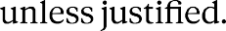
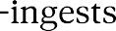



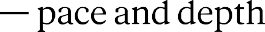

## Current state (last updated: 2026-08-04)
- Phase 1, backend setup
- Working:
- FastAPI + Uvicorn installed via uv in backend/
- GET / — static root endpoint, tested and working
- GET /documents/{document_id} — path parameter with int type
validation, tested including the 422 error case for invalid input
- Project relocated from OneDrive to C:\Doc-Vault\DocVault (avoids
OneDrive sync issues with venv/dependency folders)
- Next step: introduce Postgres + SQLAlchemy — move from placeholder
responses to actually persisting and retrieving real data

