Umm Al Qura University

College of Engineering and Computers in Al-Qunfudhah

Department of Computer Science

" Software documentation and technical writing "

PROGRAM NAME: **IHERB**

PREPARED BY:

|  |  |
| --- | --- |
| Name | ID student |
| Aryam yassin alajlani | 444010283 |
| Remas mohammed alsefri | 444006726 |

Dr. Mouna Alofi

**What Is iHerb?**

iHerb is an online store that focuses on selling health and wellness products, like vitamins, supplements, and organic foods. It's designed to make shopping for these items easy and accessible for everyone.

**The main 3 tasks that the software can do**

1. **Browse and Search:** Find products quickly using the search feature.
2. **Manage Orders:** Keep track of your orders easily.
3. **Shipping & Delivery:** Get your products delivered right to your door.

**How iHerb Helps**

iHerb makes it easy to find products that aren't available in your local stores, offers affordable prices, and guarantees high-quality, original items from trusted brands.

**What iHerb Can Do for You**

iHerb takes care of your health needs by offering a wide range of vitamins and supplements. It makes shopping super convenient since you can do it from home, saving time and effort. Plus, it helps you make smart choices with helpful information and reviews.

**Functional Requirements**

iHerb lets you easily search for products with keywords, create and manage your account (including viewing your order history), and modify items in your shopping cart before checkout. It also supports secure payments with various options and helps you track your orders, providing easy returns if needed.

**Non-Functional Requirements**

The system makes sure the website loads instantly, keeps your data safe with encryption and secure logins using your password and email or phone number, and offers a super easy, user-friendly interface that anyone can navigate.

**What Our Users Said**

We asked more than 70 people about their experience with iHerb, and here’s what we found out:

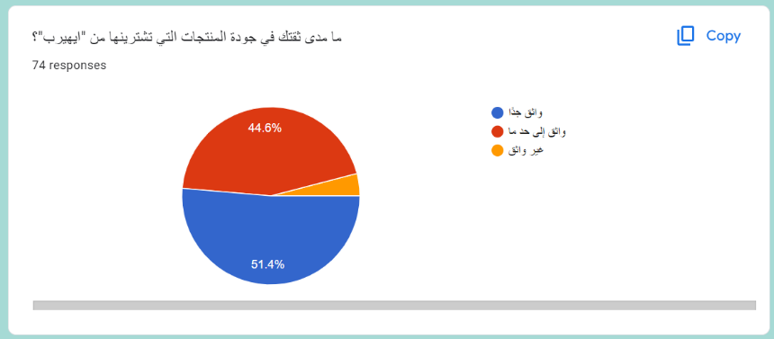

Most users trust iHerb’s products.

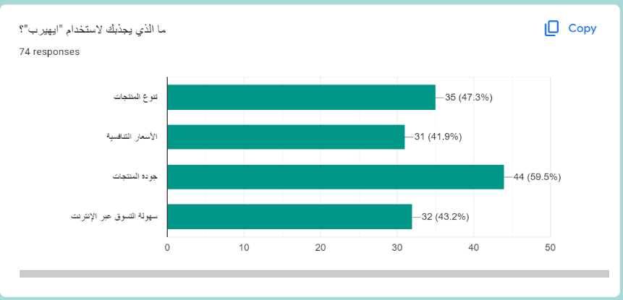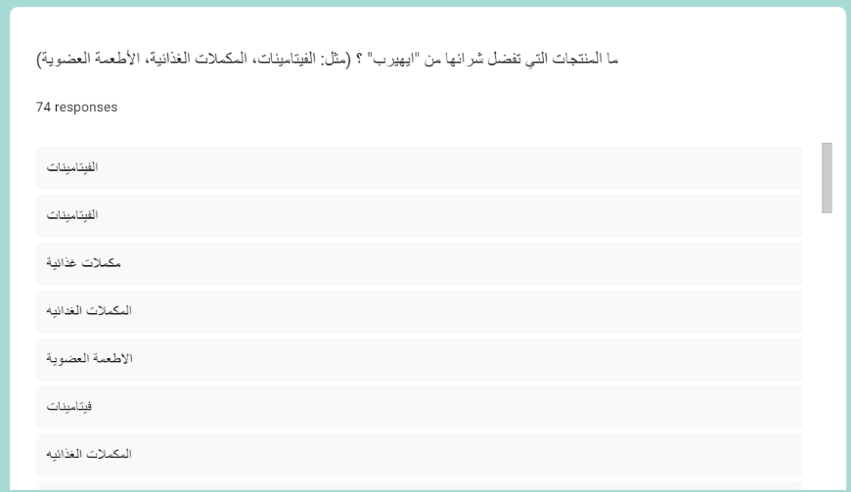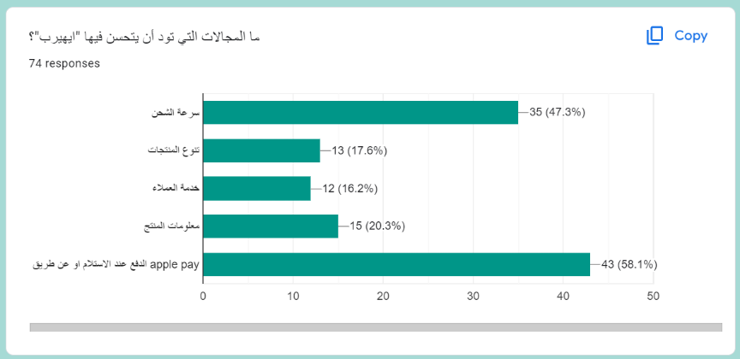

*(These results are from Saudi users.)*

Vitamins and supplements are the most popular items, but fewer people buy cosmetics. We suggest partnering with more makeup brands to improve this section.

Only 41% were drawn in by the prices, so we think offering more discounts would help.

More Payment Methods: 58% want more options for payments.

Faster Delivery: 47% wish for quicker delivery times.

**iHerb vs. Vitscoast**

We compared iHerb with Vitscoast, another health and wellness online retailer. Here’s what we found:

|  |  |  |
| --- | --- | --- |
|  | iHerb | Vitscoast |
| Product Browsing and Search | It has great search and filtering tools that help you quickly find the exact products and brands you want. | It has a friendly interface for easy browsing, though it could use more filtering options. |
| Order Management | It provides easy-to-use order tracking and management tools to make your shopping experience even better. | It offers simple order management, but it could benefit from more advanced tracking and management options. |
| Shipping and Delivery Management | It usually offers fast shipping and multiple delivery options, making it a reliable choice for getting your orders on time. | Shipping times might be a bit slower during peak seasons, and there are fewer shipping options available. |

**Summary:** While Vitscoast offers a simple shopping experience at lower prices, iHerb stands out with its wide product variety, efficient order management, and faster shipping. It’s perfect for anyone looking for a smooth and reliable online shopping experience