Heatwatch India — Project Overview
Extreme heatwave early warning and human thermal stress index for India
Prototype built for the Ministry of Earth Sciences (MoES) problem statement Extreme Heatwave Early Warning and Human Thermal Stress Index (Disaster Management theme). This document explains what the system does, why it is built the way it is, and how every part works. It describes the system as built; the design documents in docs/ (PRD, ARCHITECTURE, PIPELINE, TECH_STACK) record the original plan.
Not an official IMD warning. Heatwatch is a decision-support prototype and is not affiliated with or endorsed by MoES or IMD.

Contents
1. At a glance
2. The problem
3. What we built, mapped to the requirements
4. Architecture
5. One forecast cycle, step by step
6. Data sources
7. Thermal stress indices
8. Alert logic
9. AI and machine learning
10. Decision support
11. Historical replays
12. API reference
13. Database
14. Code map
15. Run, test and extend
16. Safety and honesty principles
17. Limitations and future scope
18. Glossary

1. At a glance
Heatwatch turns an open 7-day weather forecast into heat warnings that reflect what the human body feels, and gives district officers the tools to act on them: advisories in local languages, officer approval, CAP export, and resource allocation to the most exposed wards.
Fact | Value
Districts monitored | 81 (Census 2011 boundaries) across 19 states and union territories
Thermal stress indices | 3 — UTCI, estimated WBGT, Heat Index
Forecast | ECMWF IFS 0.25° via Open-Meteo, 7 days, hourly, refreshed every 6 hours
Climate normals | 1991–2020 daily normals per district (ERA5 reanalysis)
Alert tracks | 2 — IMD heat-wave criteria and human thermal stress; the higher is issued
Staleness gate | Alerts are blocked if forecast data are older than 12 hours or fail quality checks
Ward-level exposure | 539 wards in Ahmedabad (48), New Delhi/NCT (290) and Chennai (201)
Historical replays | 4 real heatwaves (2015, 2019, 2024 ×2) run through the live code
Machine learning | LightGBM Tmax bias correction per climate zone, leave-one-year-out evaluated
Languages | English and Hindi templates; Gujarati, Tamil, Telugu, Marathi, Bengali, Odia via LLM translation
Automated tests | 76 backend tests (unit and PostGIS integration)

2. The problem
India's heatwaves are becoming more frequent and intense. Official heat-wave declarations are based on air temperature: how hot it is, and how far above normal. But the danger to people depends on more than air temperature. Humid air slows sweat evaporation, sunshine adds radiant heat, and still air removes less heat from the skin. A humid coastal day at 38 °C can stress the body more than a dry inland day at 42 °C.
The problem statement asks for four things:
- Data ingestion — temperature, humidity, wind and solar radiation from open weather APIs or historical datasets.
- Thermal stress indexing — standard bioclimatic indices such as WBGT, Heat Index or UTCI.
- Early warning — predictive AI/ML mapping or forecasting that issues alerts or maps of zones prone to critical heat exposure.
- Decision support — an interactive GIS platform for civic authorities to orchestrate response workflows, resource allocation and advisory dispatch.

3. What we built, mapped to the requirements
Requirement | How Heatwatch meets it | Where
Data ingestion | Hourly temperature, relative humidity, surface pressure, 10 m wind, shortwave and direct radiation from the ECMWF IFS forecast; 30 years of ERA5 daily Tmax/Tmin for normals; ERA5 hourly history for replays | backend/pipeline/s1_fetch.py, climatology.py, replay.py
Thermal stress indices | UTCI, estimated WBGT (Liljegren) and Heat Index computed at the hottest hour of each IST day | backend/indices/
Early warning + AI/ML | Two alert tracks (IMD criteria against 1991–2020 normals; UTCI human-stress scale with hot nights), max-of-tracks, full reasoning trace; LightGBM bias correction of forecast Tmax; historical replays of real heatwaves | backend/app/alerts.py, backend/pipeline/operational.py, backend/models/
Decision-support GIS | MapLibre dashboard: alert and index layers, 7-day selector, district ranking, ward exposure map, advisories with officer approval, CAP 1.2, simulated SMS/email dispatch, ward resource allocation, task board, audit log, question box | frontend/src/, backend/app/main.py

4. Architecture
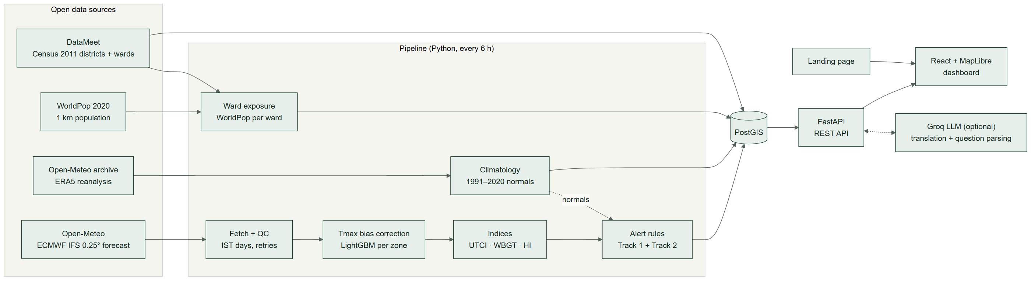

Components
Component | Technology | Role
Pipeline | Python 3.13, pythermalcomfort 4.6.0, thermofeel 2.3.0, LightGBM, rioxarray | Fetches data, runs QC, computes indices and alerts, loads normals and ward exposure
Database | PostgreSQL 17 + PostGIS 3.5 | Districts, forecasts, indices, alerts, normals, wards, advisories, tasks, audit log
API | FastAPI | 25 endpoints for the dashboard and integrations (section 12)
Dashboard | React 19, TypeScript, Vite, MapLibre GL | Map, charts, operations workflow
Landing page | Static HTML (Tailwind CDN) | Project introduction, links into dashboard and replays
LLM (optional) | Groq, llama-3.3-70b-versatile | Translates approved advisories; parses dashboard questions

Deployment (Docker Compose)
Service | What it runs
postgres | PostGIS database
backend | FastAPI on port 8000
pipeline | One pipeline cycle at start-up
scheduler | Repeats the pipeline about every 6 hours
frontend | Dashboard and landing page on port 5173

5. One forecast cycle, step by step
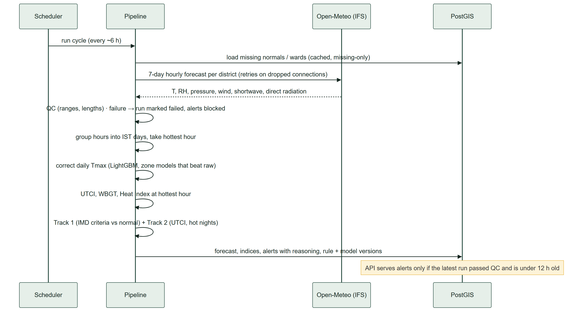
Key behaviours:
- Idempotent and traceable. Each run has an ID (open-meteo-YYYYMMDDTHHMMSSZ). Raw responses and a SHA-256 manifest are stored under data/raw/open-meteo/<run_id>/.
- Local days. Hourly values are grouped by IST calendar day; each day's indices use the hottest hour.
- Fail safe. Any fetch or QC failure writes a failed run. The dashboard then shows ALERTS BLOCKED rather than stale levels.
- Retries. Dropped connections, rate limits (HTTP 429) and server errors are retried with back-off; other errors fail the run.

6. Data sources
Source | Used for | Licence
Open-Meteo forecast API, model ecmwf_ifs025 | Live 7-day hourly forecast | Open-Meteo terms (non-commercial free tier); ECMWF open data CC BY 4.0
Open-Meteo historical archive (ERA5) | 1991–2020 normals, historical replays, bias-correction target | CC BY 4.0 (Copernicus ERA5)
Open-Meteo historical forecast API (IFS) | 2024–2025 forecast history for training | As above
WorldPop 2020 India 1 km population | Ward population exposure | CC BY 4.0
DataMeet Census 2011 district boundaries | District polygons | CC BY 2.5 India
DataMeet municipal ward boundaries | Ahmedabad, Delhi, Chennai wards | CC BY-SA 2.5 India

All sources are pinned in config (config/boundary_source.json, config/vulnerability_source.json) with commit hashes or checksums. Expensive-to-rebuild caches are committed to the repository: data/raw/climatology/ (30-year normals), data/raw/bias_training/, data/replay/ and data/models/.

Coverage
81 districts: 63 plains, 12 hills, 6 coastal (zones used by IMD criteria).
State / UT | Districts
Uttar Pradesh | 10
Madhya Pradesh, Maharashtra | 7 each
Delhi, Tamil Nadu | 6 each
Arunachal Pradesh, Assam, Jammu and Kashmir, Jharkhand, Punjab, Rajasthan | 5 each
Andhra Pradesh | 4
Bihar, Gujarat, Ladakh, Odisha | 2 each
Himachal Pradesh, Telangana, West Bengal | 1 each

7. Thermal stress indices
Index | What it measures | Implementation | Inputs | Notes
UTCI — Universal Thermal Climate Index | "Feels-like" temperature from a model of human heat balance | pythermalcomfort.utci (v4.6.0) | Air temperature, mean radiant temperature, wind, humidity | Shade estimate: mean radiant temperature is set to air temperature because the forecast lacks the full radiation budget. Primary index.
WBGT (estimated) — Wet Bulb Globe Temperature | Heat stress for work and exercise; used by occupational and sports guidelines | thermofeel.calculate_wbgt_liljegren (v2.3.0) | Temperature, humidity, pressure, wind, shortwave radiation, direct fraction, solar zenith (NOAA equations) | Estimated, not measured: real WBGT needs a globe thermometer.
Heat Index | Apparent temperature from temperature and humidity (NOAA) | pythermalcomfort.heat_index_rothfusz | Temperature, humidity | Undefined below 27 °C (stored as null).

Each index has reference-value and monotonicity tests (raising humidity at fixed temperature must not reduce heat stress) in backend/tests/.

8. Alert logic
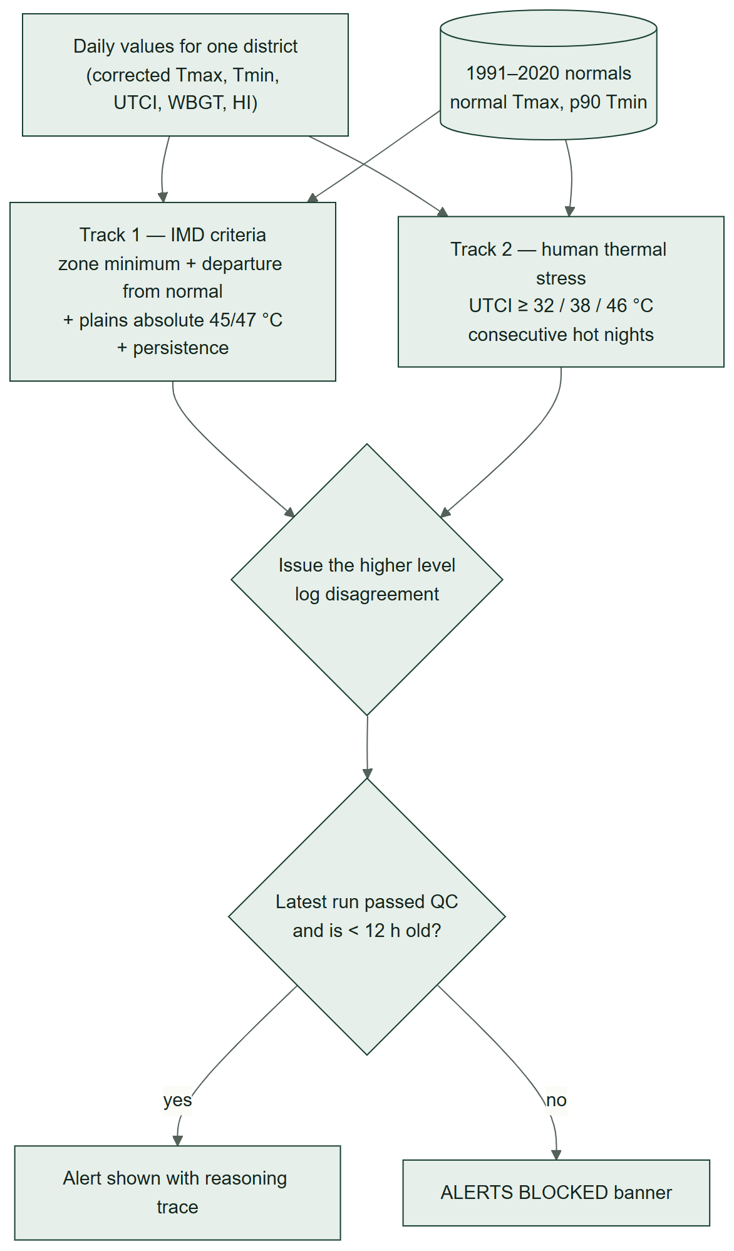

Track 1 — IMD heat-wave criteria
Rules are versioned in config/alert_rules.yaml (version imd-track1-2026-09-28), taken from IMD's heat-wave criteria.
Rule | Value
Zone minimum Tmax before any heat wave | Plains 40 °C, coastal 37 °C, hills 30 °C
Heat wave | Departure from normal ≥ 4.5 °C
Severe heat wave | Departure > 6.4 °C
Plains absolute rule | ≥ 45 °C heat wave, ≥ 47 °C severe
Colours from persistence | Yellow: 2 consecutive heat-wave days. Orange: 4 heat-wave days or 2 severe. Red: 3 severe days or more than 6 hot days.

The normal for a day is the mean ERA5 Tmax within ±7 days across 1991–2020. Persistence looks ahead through the forecast (early warning); a hot day also keeps the hot spell it belongs to, so the last days of a spell are not reset to green.

Track 2 — human thermal stress
Rule | Value
UTCI (UTCI assessment scale) | ≥ 32 °C yellow (strong stress), ≥ 38 °C orange (very strong), ≥ 46 °C red (extreme)
Hot nights | Consecutive days with Tmin ≥ the 1991–2020 90th-percentile Tmin: 2 → yellow, 3 → orange
Estimated WBGT | Shown in the reasoning; does not escalate on its own

Track 2 thresholds are labelled unvalidated_assumption in config. They follow the published UTCI scale but have not been calibrated against Indian health outcomes.

Combining and safety
- The issued level is the higher of the two tracks. Disagreement is recorded.
- Every alert stores its reasoning trace, rule version, forecast model and run ID.
- No LLM is involved in choosing a level.

Worked example (real data)
Bhubaneswar, 28 May 2024, from the ERA5 replay:
Measure | Value
Maximum temperature | 37.9 °C, +1.2 °C above the 1991–2020 normal
Track 1 (IMD criteria) | Green — well short of a heat wave
Relative humidity at the hottest hour | 58%
Estimated WBGT | 35.5 °C
UTCI | 40.5 °C (very strong heat stress)
Heat Index | 53.2 °C
Track 2 (human stress) | Orange
Issued | Orange

On the same day, inland districts such as Banda reached 48.6 °C under dry heat. The two cities show why both tracks are needed.

9. AI and machine learning

Tmax bias correction (LightGBM)
Forecast models have systematic errors that vary by region and season, and the normals come from ERA5. To compare a forecast with its normal fairly, forecast Tmax is corrected into the ERA5 frame.
Aspect | Detail
Model | LightGBM L1 residual regression, one model per climate zone (backend/models/bias_correction.py)
Raw input | ECMWF IFS 0.25° historical forecasts (first forecast day) via Open-Meteo
Target | ERA5 daily Tmax
Features | Raw Tmax, day-of-year (sine and cosine), latitude
Period | 2024–2025 (the period for which IFS history is available)
Evaluation | Leave-one-year-out: train on one year, test on the other
Adoption rule | A zone's model is used only if its held-out error beats the raw forecast by more than 0.05 °C

Held-out results (from data/models/bias_model_card.json):
Zone | Held-out day pairs | Raw forecast MAE | Corrected MAE | Used
coastal | 2,792 | 0.77 °C | 0.55 °C | yes
hills | 698 | 0.72 °C | 0.67 °C | yes
plains | 16,752 | 0.63 °C | 0.52 °C | yes

Trained on 20,242 forecast/ERA5 day pairs from the original 29 districts; the hills model came from one hills district (Shimla). Retraining with all 81 districts is in progress; the dashboard's AI bias correction panel always shows the current model card.
Only Tmax (and therefore Track 1) is corrected; indices use the raw hourly forecast. An early training run showed zero error because, without an explicit model, the historical-forecast service silently returned ERA5 itself. That run was discarded, and training now refuses to run if most forecast values equal the target.
The repository also contains a tested event classifier with isotonic calibration and SHAP explanations (backend/models/classifier.py). It is not used operationally because no labelled historical event dataset is available to evaluate its skill (POD, FAR, CSI, Brier).

LLM assistance (Groq, optional)
Use | What the LLM does | What it never does
Regional-language advisories | Translates the approved English advisory into the state's language | Change the alert level, numbers or meaning; drafts still need officer approval
Question box | Maps a question to an intent and district as JSON | Produce numbers: answers come from the database

Without GROQ_API_KEY, English/Hindi templates and keyword parsing are used and everything else works.

10. Decision support
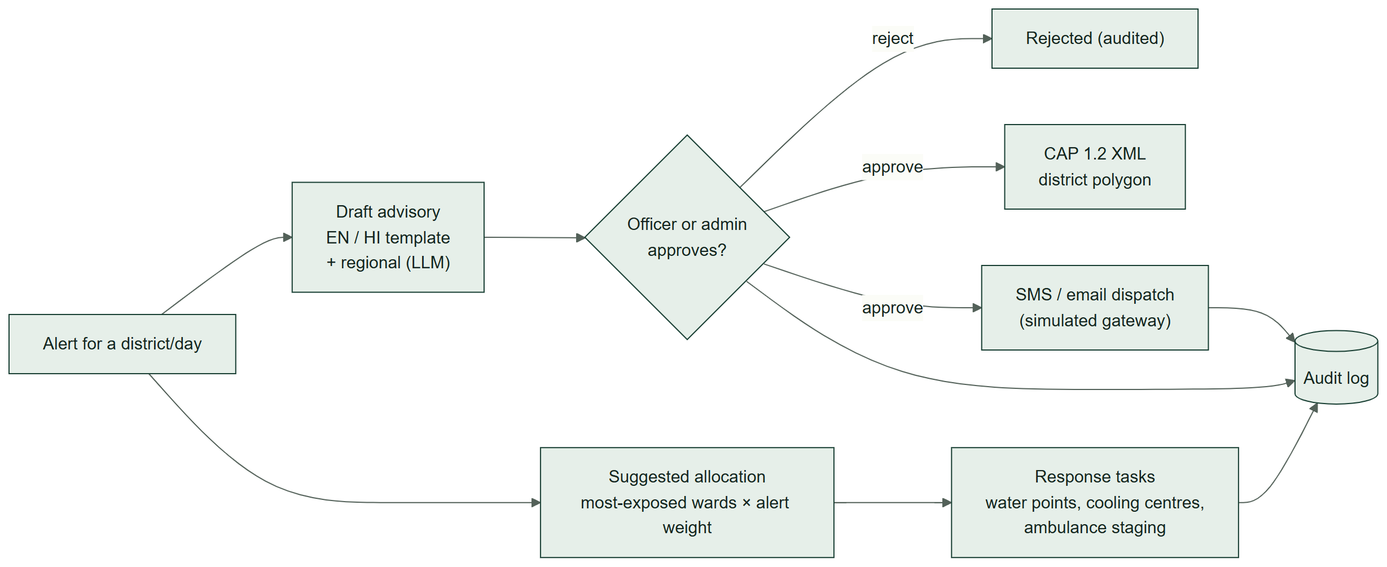

Dashboard tour
Area | What it shows / does
Status banner | Data freshness, run ID, counts of districts per level; ALERTS BLOCKED when data are stale or failed QC; HISTORICAL REPLAY in replay mode
Map | Districts coloured by alert level, UTCI, WBGT, Heat Index, or Tmax departure from normal; hover for values; ward population layer for Ahmedabad, Delhi and Chennai
Day selector | Seven forecast days; recolours map and panels
District ranking | Worst level then highest UTCI; top 12 with search across all districts
District panel | Tmax with departure, UTCI, WBGT, Heat Index; 7-day chart against the normal; Track 1 vs Track 2; full reasoning trace
Advisories | Draft English/Hindi (templates) and regional language (LLM); approve/reject as the acting user; CAP export; simulated SMS/email
Resources & tasks | Suggested water points, cooling centres and ambulance staging for the most exposed wards, editable; task board with status
Audit log | Every approval, dispatch and task change with user and time
AI bias correction | Held-out model results
Question box | e.g. "Which districts are at highest risk today?"

Resource suggestions use planning ratios — one water point per 25,000 people, one cooling centre per 50,000, one ambulance staging point per 100,000 — scaled by alert level (yellow ×0.5, orange ×1, red ×1.5). These are placeholders for state Heat Action Plan norms; officers edit quantities before creating tasks.
Roles: viewer, officer, admin. Only officers and admins can approve advisories. Identity is chosen in the UI (no authentication yet).

11. Historical replays
A replay fetches ERA5 hourly data for a past 7-day period and runs it through exactly the same QC, index and alert code as the live forecast. It shows how the system would have classified a real event. Results are cached so replays work offline.
Scenario | Dates | Red districts per day (of 81) | Hottest Tmax in replay
North & Central India heatwave | 26 May – 1 Jun 2024 | 20, 20, 21, 19, 14, 16, 8 | 48.6 °C, Banda, 28 May
East coast humid heat | 26 Apr – 2 May 2024 | 2, 2, 2, 2, 2, 1, 1 | 44.7 °C, Jamshedpur, 30 Apr
Bihar humid heatwave | 13 – 19 Jun 2019 | 1, 1, 2, 1, 1, 0, 0 | 44.7 °C, Gaya, 15 Jun
Andhra Pradesh & Telangana heatwave | 20 – 26 May 2015 | 0, 0, 1, 1, 0, 2, 0 | 45.5 °C, Vijayawada, 22 May

ERA5 is a ~25 km reanalysis that smooths extremes, so replay peaks run a few degrees below station records. A replay shows the rules applied to what happened, not how a forecast issued at the time would have performed.

12. API reference
Base URL http://localhost:8000. Interactive docs at /docs.
Method | Path | Purpose
GET | /health | Liveness
GET | /districts | District polygons (GeoJSON)
GET | /overview | All districts × days: level, tracks, Tmax, departure, indices (one call for the map)
GET | /forecast/{district_id} | Daily forecast with normal Tmax and departure
GET | /indices/{district_id} | Daily UTCI, WBGT, Heat Index
GET | /alerts/{district_id} | Daily alerts with reasoning; empty and blocked when data are stale or failed QC
GET | /vulnerability/{district_id} | Wards ranked by population, with geometry
GET | /allocation/{district_id} | Suggested resources for the most exposed wards
GET / POST | /advisories/{district_id} | List / draft template advisories (en, hi)
POST | /advisories/{district_id}/regional | Regional-language draft (LLM translation)
PATCH | /advisories/{advisory_id}/approve | Approve or reject (officer/admin)
GET | /advisories/{advisory_id}/cap | CAP 1.2 XML for an approved advisory
POST | /advisories/{advisory_id}/dispatch/sms, /dispatch/email | Simulated dispatch
GET / POST | /tasks/{district_id} | List / create response tasks
PATCH / DELETE | /tasks/{task_id} | Update / delete a task
GET | /users, /audit-log | Users and roles; audit trail
POST | /query | Question box
GET | /replay/scenarios, /replay/{scenario_id} | Historical replays
GET | /model-card | Bias-correction evaluation

13. Database
Table | Contents
districts | Id, name, state, climate zone, forecast point, boundary (MultiPolygon)
model_runs | One row per forecast cycle: source, times, checksum, QC pass/fail, failure reason
forecast_daily | Daily Tmax, Tmin, humidity, wind per district, date and run
thermal_indices | Daily UTCI, WBGT, Heat Index
alerts | Level, Track 1, Track 2, disagreement, reasoning, rule and model versions
baseline_predictions | Raw-forecast IMD baseline for evaluation
climatology_daily | Normal Tmax, p90 Tmax, p90 Tmin per district and day of year
vulnerability_wards | Ward polygons and population estimates
advisory_drafts | Advisory text, language, status, approver
users | Viewer / officer / admin
response_tasks | Task type, ward, quantity, priority, status
audit_log | Who did what, when, before and after

14. Code map
heatwave-ews/
backend/
app/ FastAPI app (main.py), alert rules (alerts.py), advisories, question box, LLM client, repository
pipeline/ s1_fetch (forecast), operational (QC, indices, alerts), climatology, replay, vulnerability
indices/ utci, wbgt_est, heat_index, composite (HTSI, not yet used operationally)
models/ bias_correction, train_bias, classifier, evaluate, baselines
tests/ 76 tests
frontend/
src/ main.tsx (app), MapView, DistrictPanel, OpsPanel, api.ts
landing.html landing page
config/ districts, boundaries, alert rules, advisory templates, replay scenarios, sources
data/ caches (committed: raw/climatology, raw/bias_training, replay, models)
scripts/ build_landing_map.py
docs/ this overview, PRD, architecture, pipeline, limitations, progress, demo script

15. Run, test and extend
cp .env.example .env # optional: GROQ_API_KEY
docker compose up --build # database, API :8000, dashboard :5173, pipeline, scheduler
make test # backend tests against a separate heatwave_test database
docker compose run --rm backend python -m pipeline.replay # precompute replays
docker compose run --rm backend python -m models.train_bias # retrain bias correction

- Dashboard: http://localhost:5173 · Landing page: http://localhost:5173/landing.html · API docs: http://localhost:8000/docs
- Adding districts: add entries (id, name, state, forecast point, climate zone, Census 2011 codes) to config/districts.yaml, regenerate config/pilot_districts.geojson from the pinned Census 2011 shapefile, then run the pipeline (normals load for missing districts only), recompute replays, retrain, and run python scripts/build_landing_map.py.

16. Safety and honesty principles
- The alert decision path is deterministic and auditable; an LLM never chooses an alert level.
- Stale or failed data block alerts, with a visible banner and data age.
- When the tracks disagree, the higher level is issued and the disagreement is logged.
- Every alert stores its model versions, rule version, run ID and reasoning.
- Nothing is dispatched without officer or admin approval.
- No data, benchmarks or citations are fabricated. Model results are reported only from held-out evaluation, and a model is used only where it beats the raw forecast.
- Limitations are recorded as they are found (docs/LIMITATIONS.md).

17. Limitations and future scope
Main limitations (full list in docs/LIMITATIONS.md):
- UTCI is a shade estimate and WBGT is estimated, not measured.
- Each district is represented by one forecast point; small neighbouring districts (for example in Delhi) share a forecast grid cell.
- Normals come from ERA5 reanalysis, which smooths extremes; they differ from IMD station normals.
- Track 2 thresholds and resource planning ratios are unvalidated assumptions.
- Climate zones for each district were assigned by the team, not by IMD.
- The Tmax correction is trained on two years and on the first forecast day only.
- There is no authentication; dispatch gateways are simulated.
- Boundaries are Census 2011 (community-maintained), not current official boundaries.
Future scope:
- All-India coverage (641 Census 2011 districts): normals from a single Copernicus ERA5 download with district-average statistics instead of point values.
- Event classifier with calibrated probabilities once a labelled historical dataset is available.
- Authentication, real SMS and email gateways, integration with state Heat Action Plans.
- Urban heat island and land-surface temperature layers; nowcasting for the next 0–6 hours.

18. Glossary
Term | Meaning
UTCI | Universal Thermal Climate Index: equivalent temperature from a model of human heat balance
WBGT | Wet Bulb Globe Temperature: heat-stress index combining humidity, radiation and wind
Heat Index | NOAA apparent temperature from air temperature and humidity
ERA5 | ECMWF's global reanalysis: a consistent reconstruction of past weather
ECMWF IFS | The European Centre's Integrated Forecasting System (0.25° open data)
Normal | Long-term average for a calendar day (here 1991–2020, ±7 days)
Departure | Forecast Tmax minus the normal Tmax
p90 Tmin | 90th percentile of daily minimum temperature — a "hot night" threshold
CAP | Common Alerting Protocol, an international standard format for emergency alerts
MAE | Mean absolute error
Leave-one-year-out | Evaluation that trains on all years but one and tests on the held-out year
POD / FAR / CSI / Brier | Probability of detection, false alarm ratio, critical success index, Brier score — standard skill scores for rare events
IST | Indian Standard Time (UTC+5:30)

