1. Create an array of 10 elements and print them using the for each loop.

**package** ust.test.com;

**public** **class** ArryForEach {

**public** **static** **void** main(String[] args)

{

**int**[] arr= {1,2,3,4,5,6,7,8,9,0};

**for**(**int** number:arr) {

System.***out***.println(number);

}

}

}

OUTPUT

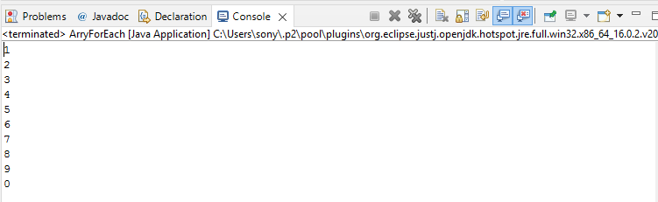

1. Take the number input from the console and add all the positive numbers. (not to consider the negative number if entered)

OUTPUT

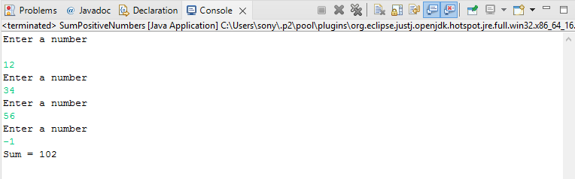

**package** ust.test.com;

**import** java.util.Scanner;

**public** **class** SumPositiveNumbers {

**public** **static** **void** main(String[] args) {

**int** sum = 0;

Scanner input = **new** Scanner(System.***in***);

System.***out***.println("Enter a number");

**int** number = input.nextInt();

**while** (number >= 0) {

sum += number;

System.***out***.println("Enter a number");

number = input.nextInt();

}

System.***out***.println("Sum = " + sum);

input.close();

}

}

1. Create a labeled break and write a simple logic and execute the program.

**package** ust.test.com;

**public** **class** SBA1_LabeledBreak {

**public** **static** **void** main(String[] args)

{

first:

**for**(**int** i=1;i<10;i++) {

second:

**for**(**int** j=1;j<5;j++) {

System.***out***.println("i= " +i+";j= "+j);

**if**(i==2)

**break** first;

}

}

}

}

OUTPUT

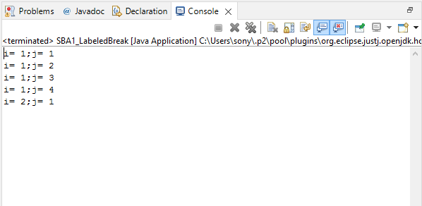

1. Do the addition of around 10 even numbers, but use the continue statement in the logic.

**package** ust.test.com;

**import** java.util.Scanner;

**public** **class** SBA1_Continue {

**public** **static** **void** main(String[] args)

{

**int** sum=0,i=0;

Scanner input = **new** Scanner(System.***in***);

System.***out***.println("Enter the limit");

**int** number=input.nextInt();

**for**(i=1;i<(2*number);i++)

{

**if**(i%2==0)

sum=sum+i;

**else**

**continue**;

}

System.***out***.println("The sum of first " + number + " even numbers are "+ sum);

}

}

OUTPUT

