1. Write a program to reverse the String (use char[] or String built in method)

**package** ust.test.com;

**import** java.io.*;

**import** java.util.Scanner;

**public** **class** Reverse_String {

**public** **static** **void** main (String[] args) {

String str= "JAVA", nstr="";

**char** ch;

System.***out***.print("Original word: ");

System.***out***.println("JAVA"); //Example word

**for** (**int** i=0; i<str.length(); i++)

{

ch= str.charAt(i); //extracts each character

nstr= ch+nstr; //adds each character in front of the existing string

}

System.***out***.println("Reversed word: "+ nstr);

}

}

OUTPUT

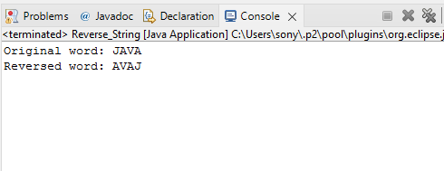

1. Write programs to depict the usage of contains(), length(), replace(), concat(), equals()

**Contains**

**package** ust.test.com;

**public** **class** LengthEx {

**public** **static** **void** main(String args[]){

String s1="javatpoint";

String s2="python";

System.***out***.println("string length is: "+s1.length());//10 is the length of javatpoint string

System.***out***.println("string length is: "+s2.length());//6 is the length of python string

}}

OUTPUT

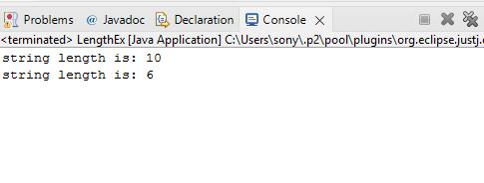

\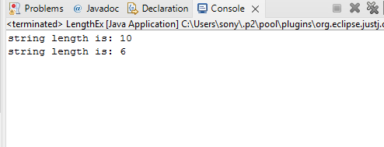

**package** ust.test.com;

**public** **class** ContainsEx {

**public** **static** **void** main(String[] args)

{

String name="My name is Aryamol";

System.***out***.println(name.contains("is"));

System.***out***.println(name.contains("Arya"));

System.***out***.println(name.contains("hii"));

}

}

Output

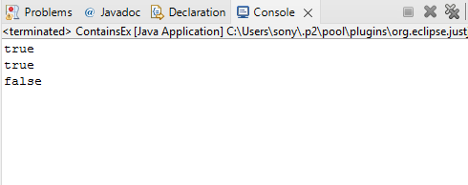

**LENGTH()**

**CONCAT()**

**package** ust.test.com;

**public** **class** EqualsEx {

**public** **static** **void** main(String[] args)

{

String s1="Java";

String s2="Java";

String s3="JAVA";

String s4="Python";

System.***out***.println(s1.equals(s2));

System.***out***.println(s1.equals(s3));

System.***out***.println(s1.equals(s4));

}

}

OUTPUT

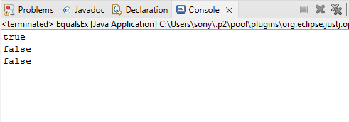

1. **class** TestStringConcatenation3{
2. **public** **static** **void** main(String args[]){
3. String s1="Sachin ";
4. String s2="Tendulkar";
5. String s3=s1.concat(s2);
6. System.out.println(s3);
7. }
8. }

OUTPUT

