Customer satisfaction towards **KSEB** service

in special reference to vaikom taluk

50 responses

[Publish analytics](https://docs.google.com/forms/d/1wGH9G3N5fVnvztAGXJ3oXlrP4khNTsT4I_IiuegV_6A/edit#start%3Dpublishanalytics)



# Name

50 responses

Adarsh SB Aswathy Ashokan Indumol P S

Anjana P S Aryamol M S

Ashly Remanan Mike

Ananthan

Sreelakshmi Rajan ALFIN JOHN

Lakshmi Akhila

Raseela Rasheed Aswath ks

Kalidas

Anjana Aswin Krishnedu Nikhil

Harikrishnan CR

Jeevamol k sam Adithyan s babu ANJU.K.A



Akhil Sivadas

Vishnu shaji Anjali

Arjun Abhirami Abhijith Abindev Midhun Nandu Akhil KR Jesein raj Amal shaji Aravind Aswin as Anupriya Ajithkumar Abhirami ps Sudheesh Gigi

Adhi Sindhu Baby Manoj Akshay Ajmal Appu Veena v

Anith Joseph Saji

2.Place

50 responses

Copy

10.0

7.5

9 (18.4%)

5.0

4 (8.2%)

5 (10.2%)

2.5 2 (24((.214%.(14)%.12)%(4) .1%)

2 (4.1

1 (2%) 1 (2%1)(12%(12)%(12)%(12)(%12)%(12)%(2)%1)(12%(12)%(12)%(12)%(12)(%12)%(2)%1)(12((%12)%(2)%1)(12((%2)%)

0.0

Arayanka…

…

THALAY…

Vadayar

Enadi



Kattikku…

Neerpara

Thalayol…

Vech…

# 3.Gender

51 responses

Copy

41.2%

Male Female

Prefer not to say

58.8%

# Age

51 responses

Copy

Below 20

20-30

30 above

11.8%

70.6%

17.6%

# Occupation

48 responses

Copy

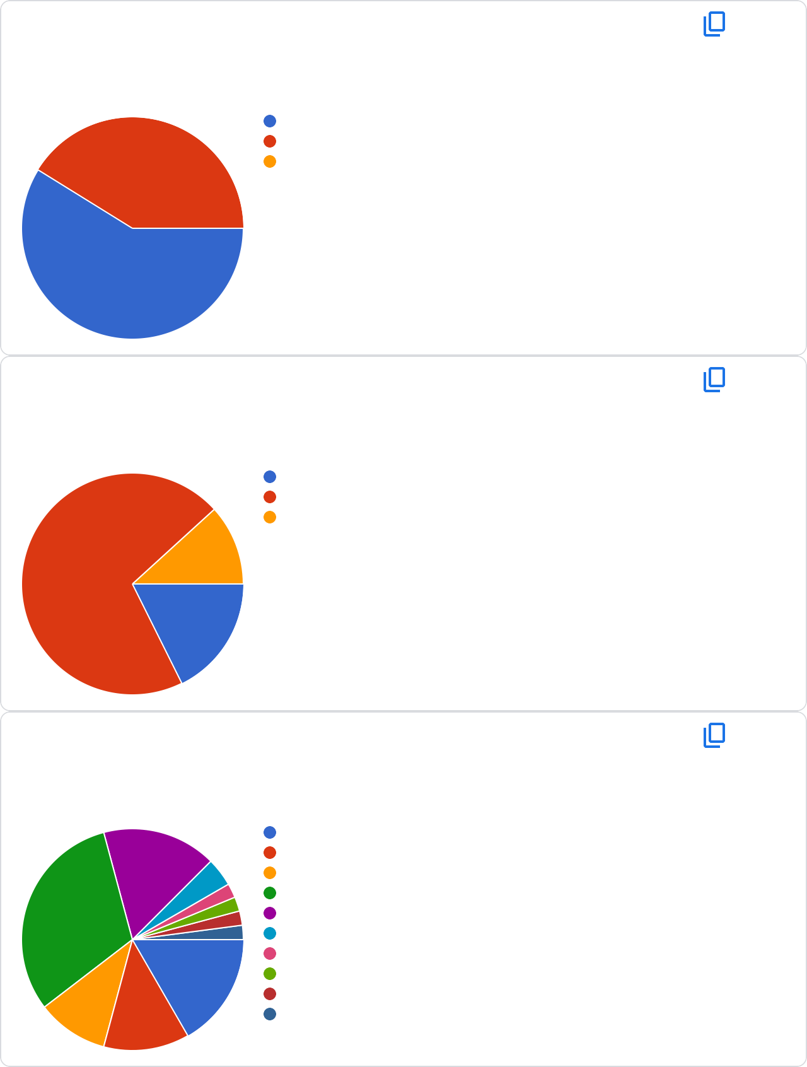

31.2%

10.4%

16.7%

12.5%

16.7%

Salaried

Professional Business Student

Studying Students Education student Driving

# Monthly income

47 responses

Copy

61.7%

Salaried

Professional Business Others

10.6%

8.5%

19.1%

# Do you turn off Or un plug large equipment ( like printer, television, computer.. Etc) at the end of the day

51 responses

Copy

Never

Sometimes

Often

Always

Rarely

4 (7.8%)

4 (7.8%)

11 (21.6%)

15 (29.4%)

17 (33.3%)

0 10 20

# What are the different types of lighting do you have

51 responses

Copy

Standard Fulerocent tubes

Compact ﬂuorescent

lamps

Normal light

bulb

Dont know

8 (15.7%)

8 (15.7%)

29 (56.9%)

8 (15.7%)

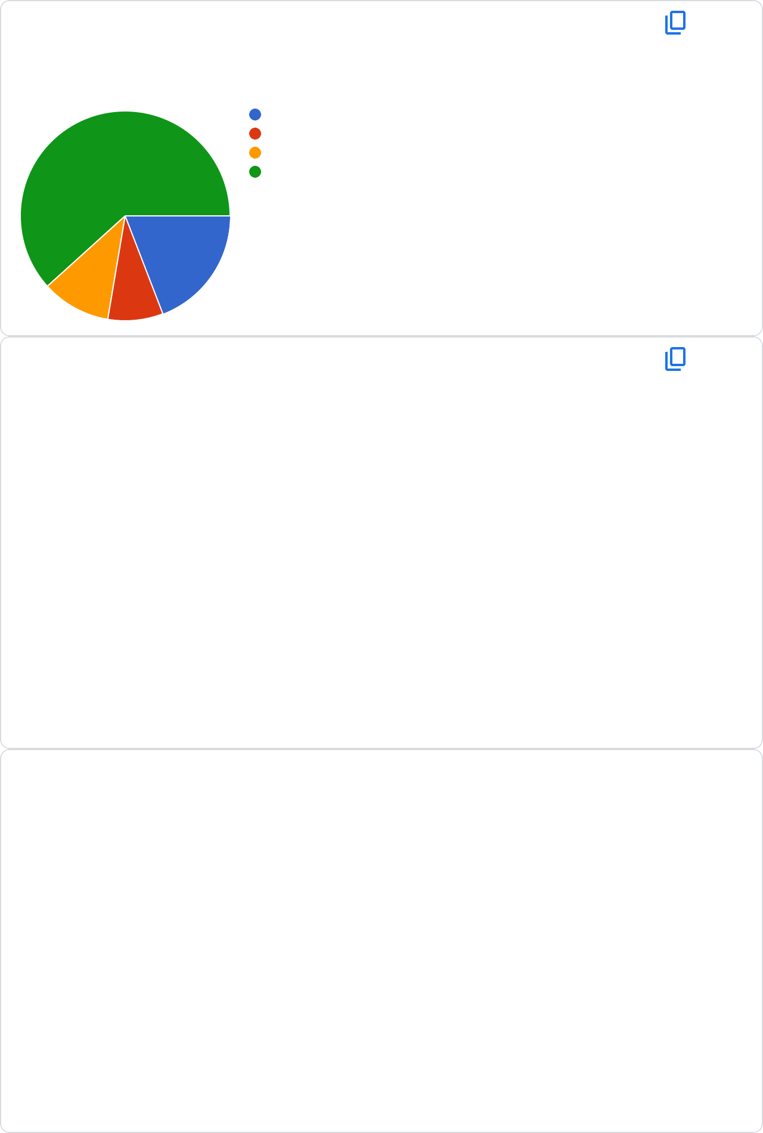

0 20 40

# How much is electricity bill for a month?

50 responses

Below 200

|  |  |  |  |  |  |
| --- | --- | --- | --- | --- | --- |
| 2 (4%)  5 (1 | 0%) |  | | 22 (44%  22 (44% | )  ) |
|  | | |  |
|  |
|  |  |  | |
|  | | |  |
|  |
|  |  |  |

201- 400

401-800

800 above

0 20 40

Copy

1. How much money could you spend of energy- efficient improvements in next year or so?

49 responses

Copy

No ﬁxed amount allocated for improvements

Maximum amount

of...............

11 (22.4%)

38 (77.

0 20 40

# Do you know current pricing slab for electricity bill?

49 responses

Copy

28.6%

Yes No

Maybe

55.1%



16.3%



12. Do you know the star rating on electrical appliances, and what are the

importance of it

49 responses

Copy

Yes

25

No

18 (36.7%)

Option 3

6 (12.2%)

0

20

40

13.do you ever clea your vaccum of your refrigerator?

47 responses

Copy

Monthly

19 (40.

Yearly

8 (17%)

Never

14 (29.8%)

What's it

6 (12.8%)

0

10

20

(51%)



14. Do you agree that we should use solar system instead of inverter or

generator to save electricity?

50 responses

Copy

Yes, of course

37 (74%

No, it cost too

much

9 (18%)

Waste of time

5 (10%)

0

20

40

15. How is your relationship with the employer?

50 responses

Copy

Good

Satisﬁed

18 (36%)

Not satisfying

4 (8%)

0

20

40

28 (56%)



16. Which is the main sourse of electricity?

50 responses

Copy

Water

Air

5 (10%)

Other 2 (4%)

0

50

100

17. Power cut duration

49 responses

Copy

1hr

37 (75.5

2hr

8 (16.3%)

2hr above

6 (12.2%)

0

20

40

48 (96%)

This content is neither created nor endorsed by Google. R [eport Abuse](https://docs.google.com/forms/d/1wGH9G3N5fVnvztAGXJ3oXlrP4khNTsT4I_IiuegV_6A/reportabuse) - T [erms of Service](https://policies.google.com/terms) - P [rivacy Policy](https://policies.google.com/privacy)

[Forms](https://www.google.com/forms/about/?utm_source=product&utm_medium=forms_logo&utm_campaign=forms)