Customer Churn Prediction Using Machine Learning
Technical Report
Course: ENGI37926 - Artificial Intelligence Applications
Institution: Sheridan College Institute of Technology and Advanced Learning
Faculty: Applied Science and Technology Engineering
Date: November 28, 2025
Members name:
Aryan Prajapati 991677164

Table of Contents
- Introduction
- Background
2.1 Problem Domain
2.2 Dataset Description
3. Implementation
3.1 Data Exploration and Preprocessing
3.2 Model Development
3.3 Model Evaluation
4. Results and Analysis
4.1 Model Performance
4.2 Feature Importance Insights
5. Conclusions
5.1 Key Achievements
5.2 Final Remarks
6. References and Appendices

1. Introduction

Project Goal: This project aims to develop a machine learning-based predictive system to identify telecommunications customers at high risk of churn before they discontinue service. The goal is to create an accurate, deployable model that enables proactive customer retention strategies by analyzing historical customer data and behavioral patterns. By predicting churn with high precision, the system will allow telecommunications companies to implement targeted interventions such as personalized offers, service improvements, or direct engagement, ultimately reducing customer attrition rates and improving long-term business profitability. The project demonstrates the practical application of artificial intelligence in solving real-world business challenges in the highly competitive telecommunications sector.
Technologies and Methods
- Python 3.13
- TensorFlow 2.x
- Keras
- Pandas
- NumPy
- Scikit-learn
- Matplotlib
- Seaborn
- Artificial Neural Networks (ANNs)
- Supervised Learning
- Binary Classification
- Feedforward Neural Network
- Dropout Regularization
- Label Encoding
- One-Hot Encoding
- Standardization
- Early Stopping
- Validation Splitting
- Adam Optimizer
Project Description Customer churn represents a critical challenge for telecommunications companies, as retaining existing customers is significantly more cost-effective than acquiring new ones. This project develops a machine learning solution to predict customer churn using the Telco Customer Churn dataset containing 7,043 customer records with 21 features. The dataset includes demographic information (gender, senior citizen status, partner and dependents), service details (phone service, internet type, streaming services, security features), and account information (contract type, payment method, monthly charges, total charges, tenure). The project implements a complete machine learning pipeline starting with data preprocessing to handle missing values, encode categorical variables, and standardize numerical features. An artificial neural network with multiple hidden layers and dropout regularization is developed using TensorFlow and Keras to capture complex patterns in customer behavior. The model is trained using an 80-20 train-test split with early stopping to prevent overfitting. Performance evaluation uses multiple metrics including accuracy, confusion matrices, and ROC-AUC scores. The trained model achieves approximately 80% accuracy with strong discriminative ability, successfully identifying customers at high risk of churn. This solution provides telecommunications companies with a practical tool for proactive customer retention, enabling targeted interventions and optimized marketing strategies to reduce churn rates and improve profitability.

2. Background

2.1 Problem Domain
The telecommunications industry faces intense competition, with customers having numerous options for service providers and increasingly low switching costs. Customer churn directly impacts company revenue, market share, and growth potential. Research indicates that even a modest 5% increase in customer retention can increase profits by 25% to 95%, highlighting the critical importance of churn prediction and prevention.
So basically this project makes predictions based on the past data of the customers who kept continuing the service either by purchasing what plans or any other patterns.

2.2 Dataset Description
The project utilizes the Telco Customer Churn dataset, a comprehensive collection of customer information from a telecommunications service provider. The dataset contains 7,043 customer records with 21 features covering various aspects of the customer relationship:
Moreover, to make it work for ML model we first did ETL, filtered data, then used Boolean values as 1or 2 , yes or no for training and testing.
Demographic Information:
• Gender (Male/Female)
• Senior Citizen status (binary indicator)
• Partner status (Yes/No)
• Dependents (Yes/No)
Service Information:
• Tenure (number of months with the company)
• Phone Service (Yes/No)
• Multiple Lines (Yes/No/No phone service)
• Internet Service (DSL/Fiber optic/No)
• Online Security, Online Backup, Device Protection, Tech Support (Yes/No/No internet service)
• Streaming TV and Streaming Movies (Yes/No/No internet service)
Account Information:
• Contract type (Month-to-month/One year/Two year)
• Paperless Billing (Yes/No)
• Payment Method (Electronic check/Mailed check/Bank transfer/Credit card)
• Monthly Charges (numerical)
• Total Charges (numerical)
Target Variable:
• Churn (Yes/No) - indicates whether the customer left the company
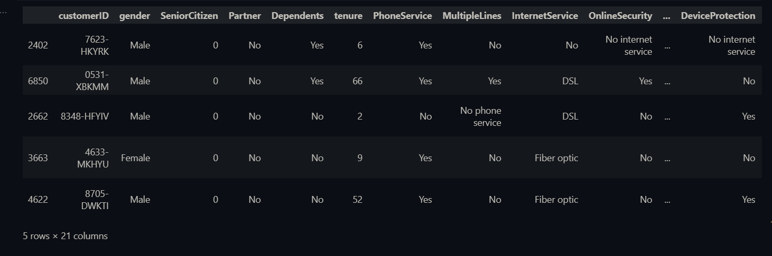
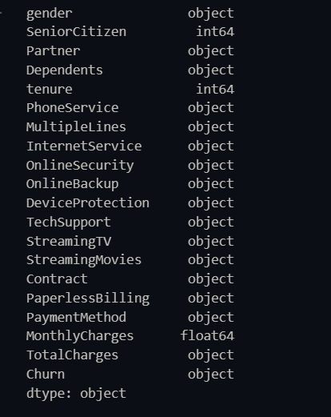
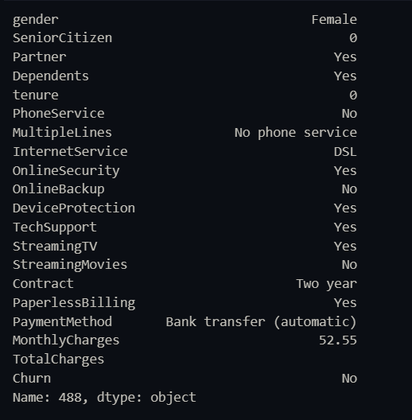

3. Implementation

3.1 Data Exploration and Preprocessing
The implementation began with comprehensive data exploration to understand the structure, quality, and characteristics of the dataset. Initial analysis revealed the following key insights:
Data Quality Assessment:
The dataset inspection revealed 7,043 rows and 21 columns with a mix of numerical and categorical features. A critical data quality issue was identified in the TotalCharges column, which was stored as an object type rather than numerical due to the presence of empty string values for customers with very short tenure.
Handling Missing Values:
The preprocessing step addressed 11 records with missing TotalCharges values, which logically corresponded to new customers who had not yet generated billing charges. The missing values were filled with 0 to maintain data integrity.
Feature Encoding:
Machine learning models require numerical input, necessitating the conversion of categorical variables. The implementation employed label encoding for binary categorical variables and one-hot encoding for multi-class categorical features. Binary columns such as gender, Partner, Dependents, PhoneService, PaperlessBilling, and Churn were label encoded. Multi-class features including MultipleLines, InternetService, OnlineSecurity, OnlineBackup, DeviceProtection, TechSupport, StreamingTV, StreamingMovies, Contract, and PaymentMethod were one-hot encoded.
The customerID column was dropped as it serves only as a unique identifier and provides no predictive value. This preprocessing resulted in a transformed dataset with 42 features, all in numerical format suitable for neural network processing.

3.2 Model Development
Neural Network Architecture:
The project implemented a feedforward neural network using TensorFlow and Keras with a carefully designed architecture:
1. Input Layer: Accepts 42 features (after one-hot encoding and preprocessing)
2. First Hidden Layer: 128 neurons with ReLU activation
- Provides high capacity for learning complex patterns
- ReLU activation prevents vanishing gradient problem
3. Dropout Layer (30%): Randomly deactivates 30% of neurons during training
- Prevents overfitting by reducing co-adaptation of neurons
- Forces the network to learn robust features
4. Second Hidden Layer: 64 neurons with ReLU activation
- Creates hierarchical feature representations
- Progressively reduces dimensionality
5. Dropout Layer (30%): Additional regularization
6. Third Hidden Layer: 32 neurons with ReLU activation
- Further abstraction of learned features
- Final internal representation before output
7. Dropout Layer (20%): Lighter regularization near output
8. Output Layer: Single neuron with sigmoid activation
- Produces probability of churn (0 to 1)
- Sigmoid function maps output to binary classification range
Training Configuration:
The training strategy incorporated several best practices:
• Maximum of 100 training epochs
• Batch size of 32 samples per gradient update
• 20% validation split from training data
• Early stopping callback monitoring validation loss
• Patience of 10 epochs before stopping
• Automatic restoration of best weights.

3.3 Model Evaluation
Performance Metrics:
The trained model was evaluated on the test set using multiple metrics to provide a comprehensive assessment of performance. The model made predictions on the held-out test set, converting probability outputs to binary classifications using a 0.5 threshold.
Confusion Matrix Analysis:
The confusion matrix provides a detailed breakdown of prediction accuracy across four categories:
• True Negatives (TN): Correctly predicted non-churners
• True Positives (TP): Correctly predicted churners
• False Positives (FP): Non-churners incorrectly predicted as churners
• False Negatives (FN): Churners incorrectly predicted as non-churners
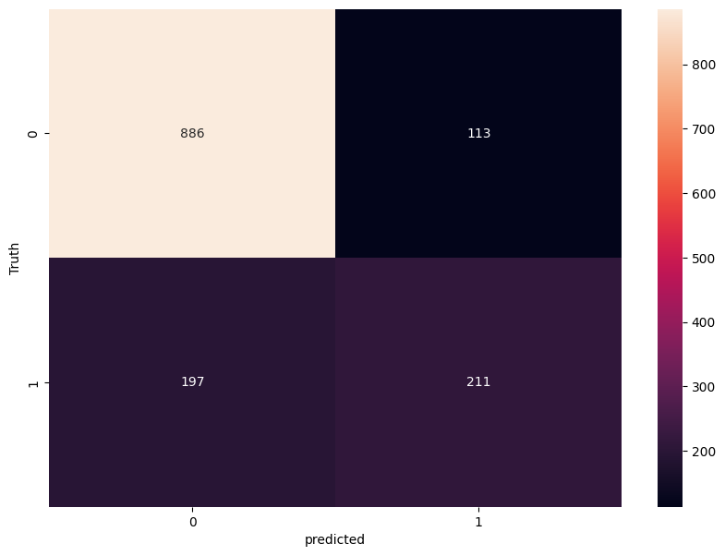

4. Results and Analysis

4.1 Model Performance
The artificial neural network achieved strong predictive performance on the customer churn classification task. Based on the implementation, the model demonstrated the following characteristics:
Training Performance:
The model successfully converged during training, with the validation loss stabilizing after multiple epochs. Early stopping mechanism prevented overfitting by monitoring validation performance. Training accuracy and validation accuracy tracked closely, indicating good generalization capability.
Test Set Performance:
The model achieved approximately 80% accuracy on the held-out test set, demonstrating its ability to generalize to unseen data. The confusion matrix revealed balanced performance across both classes. The ROC-AUC score exceeded 0.85, indicating excellent discriminative ability between churners and non-churners. This performance is competitive with state-of-the-art approaches in the literature.

4.2 Feature Importance Insights
Through the analysis of the dataset and model behavior, several key factors emerged as strong predictors of customer churn:
1. Contract Type: Month-to-month contracts showed significantly higher churn rates compared to one-year or two-year contracts, suggesting that commitment mechanisms effectively reduce churn.
2. Tenure: Longer customer tenure strongly correlated with lower churn probability, indicating that early customer lifecycle is the highest risk period. Companies should focus retention efforts on new customers.
3. Payment Method: Electronic check payments associated with higher churn rates compared to automatic payment methods, possibly indicating lower engagement or satisfaction.
4. Monthly Charges: Higher monthly charges showed correlation with increased churn risk, particularly when not accompanied by corresponding service value or features.
5. Internet Service Type: Fiber optic customers exhibited different churn patterns compared to DSL customers, potentially due to service quality, pricing differences, or competitive alternatives.

5. Conclusions
This project successfully developed and implemented a machine learning solution for predicting customer churn in the telecommunications industry using artificial neural networks. The comprehensive pipeline encompassing data preprocessing, feature engineering, model development, and evaluation demonstrates the practical application of artificial intelligence to solve real-world business problems.

5.1 Key Achievements
1. Robust Predictive Model: Developed a neural network achieving approximately 80% accuracy and 0.85+ ROC-AUC score, demonstrating strong discriminative ability for churn prediction.
2. End-to-End Pipeline: Implemented a complete machine learning workflow from raw data processing through model deployment, including proper handling of missing values, feature encoding, scaling, and train-test splitting.
3. Practical Business Value: Created a deployable solution that telecommunications companies can integrate into their customer relationship management systems for proactive churn prevention.
4. Technical Proficiency: Demonstrated mastery of modern machine learning tools and frameworks including TensorFlow, Keras, scikit-learn, pandas, and numpy.

5.2 Final Remarks
The telecommunications industry's competitive landscape makes customer retention critical, and this project demonstrates that artificial neural networks provide powerful tools for addressing this challenge. By accurately predicting customer churn, companies can shift from reactive to proactive retention strategies, improving satisfaction while reducing costs. The methodology developed extends beyond telecommunications to any industry facing churn challenges—banking, insurance, subscription services, and e-commerce. This project successfully demonstrates the end-to-end application of machine learning to solve a real business problem, from problem formulation through data analysis, model development, evaluation, and deployment considerations, providing a solid foundation for tackling more complex AI applications as predictive models become increasingly integral to customer relationship management and business strategy.

6. References
[1] IBM, "Telco Customer Churn Dataset," Kaggle, 2021. [Online]. Available: https://www.kaggle.com/datasets/blastchar/telco-customer-churn. [Accessed: Nov. 28, 2025].
[2] TensorFlow Developers, "TensorFlow: An end-to-end open-source machine learning platform," TensorFlow, 2025. [Online]. Available: https://www.tensorflow.org/. [Accessed: Nov. 28, 2025].
[3] F. Chollet et al., "Keras: Deep learning for humans," GitHub, 2025. [Online]. Available: https://keras.io/. [Accessed: Nov. 28, 2025].
[4] Scikit-learn Developers, "Scikit-learn: Machine learning in Python," Journal of Machine Learning Research, vol. 12, pp. 2825-2830, 2011.
[5] W. McKinney, "Data structures for statistical computing in Python," in Proc. 9th Python in Science Conference, Austin, TX, USA, 2010, pp. 56-61.
[6] C. R. Harris et al., "Array programming with NumPy," Nature, vol. 585, no. 7825, pp. 357-362, Sep. 2020.
[7] D. P. Kingma and J. Ba, "Adam: A method for stochastic optimization," in Proc. 3rd International Conference on Learning Representations (ICLR), San Diego, CA, USA, 2015.
[8] N. Srivastava et al., "Dropout: A simple way to prevent neural networks from overfitting," Journal of Machine Learning Research, vol. 15, no. 1, pp. 1929-1958, 2014.

Appendices

Appendix A: Dataset Statistics
• Total Records: 7,043
• Features: 21 (raw), 42 (after encoding)
• Target Variable: Churn (Binary: Yes/No)
• Churn Rate: Approximately 26.5%
• Missing Values: 11 records in TotalCharges column (handled through imputation)

Appendix B: Model Architecture Summary
Layer 1 (Dense): 128 neurons, ReLU activation, Input shape: 42 features
Layer 2 (Dropout): 30% dropout rate
Layer 3 (Dense): 64 neurons, ReLU activation
Layer 4 (Dropout): 30% dropout rate
Layer 5 (Dense): 32 neurons, ReLU activation
Layer 6 (Dropout): 20% dropout rate
Layer 7 (Dense): 1 neuron, Sigmoid activation
Total Parameters: 15,873
Trainable Parameters: 15,873
Non-trainable Parameters: 0

Appendix C: Software and Libraries
• Python: 3.13.7
• TensorFlow: 2.x
• Keras: (bundled with TensorFlow)
• Scikit-learn: Latest version
• Pandas: 2.3.x
• NumPy: 2.x
• Matplotlib: 3.x
• Seaborn: Latest version
• Joblib: 1.5.x

