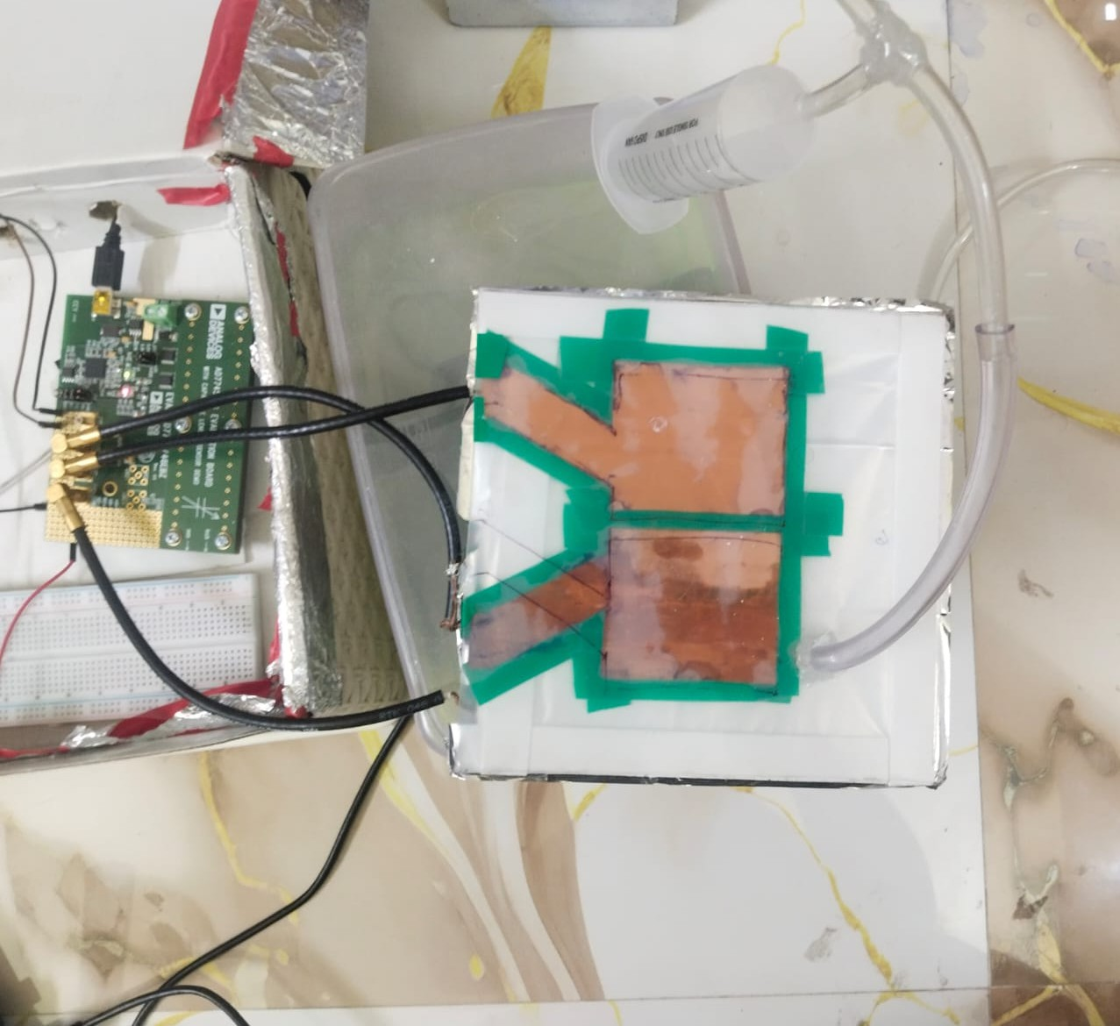
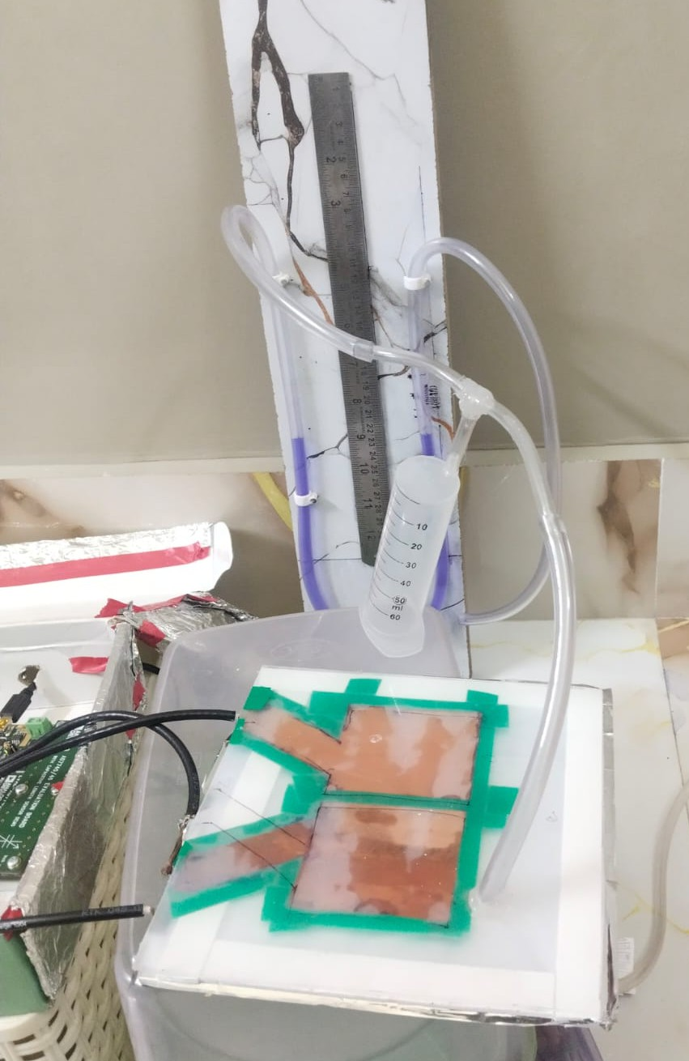
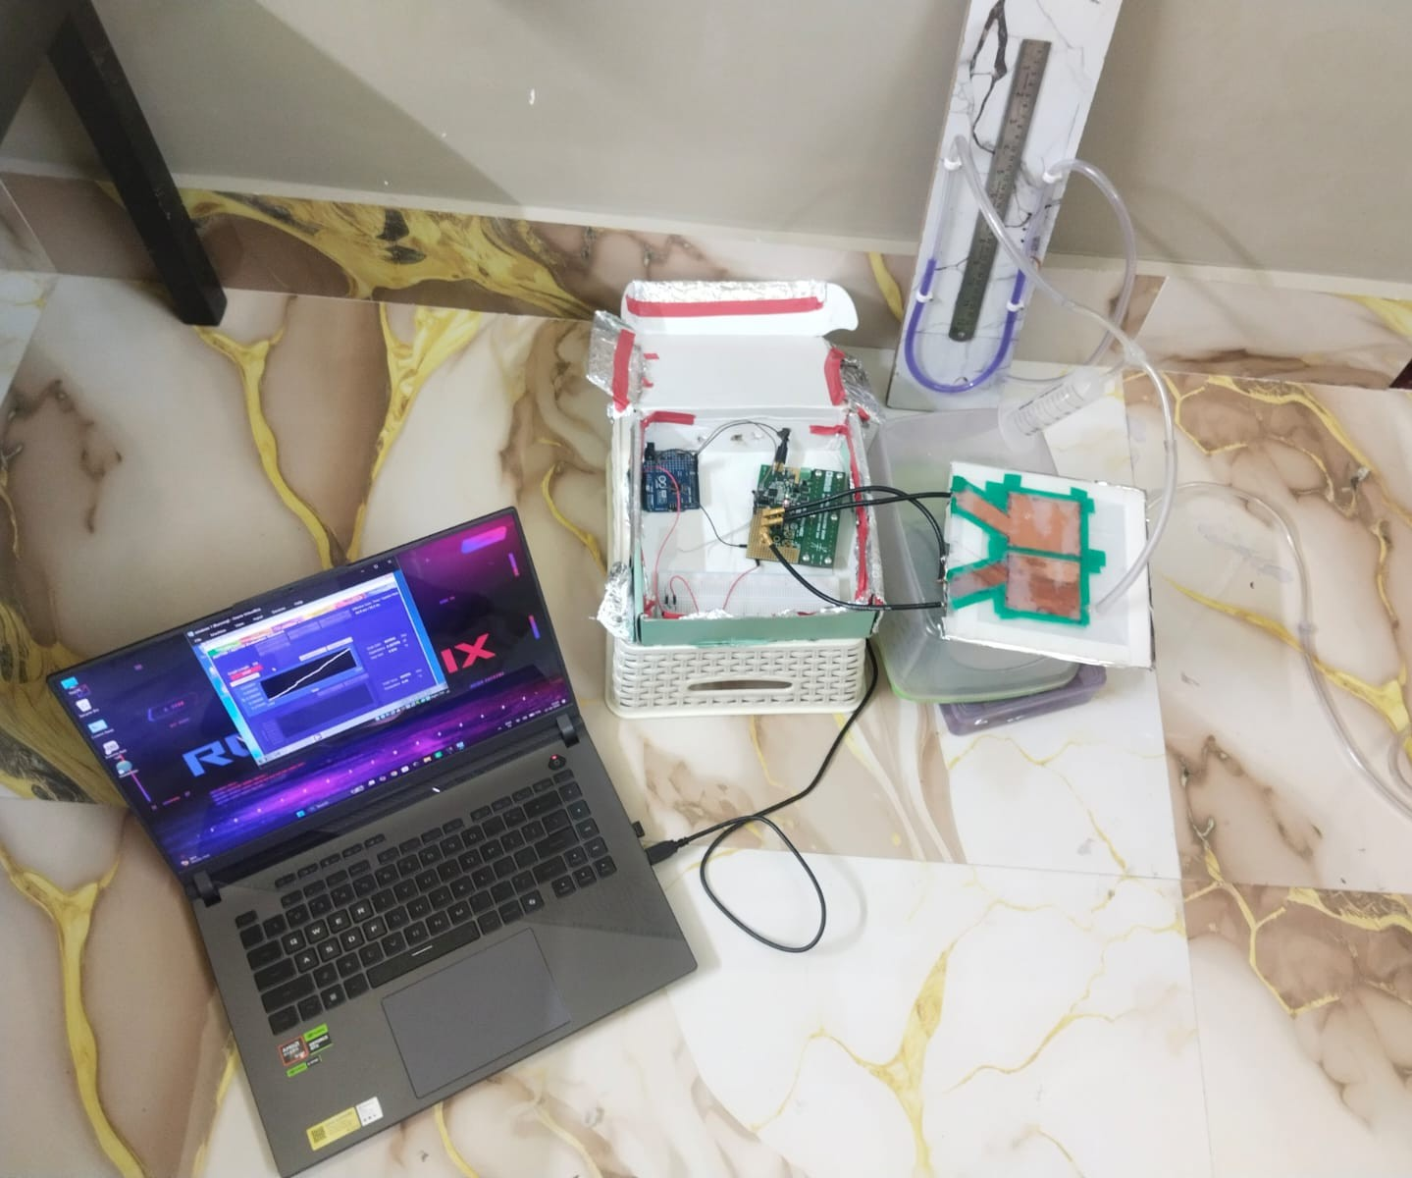

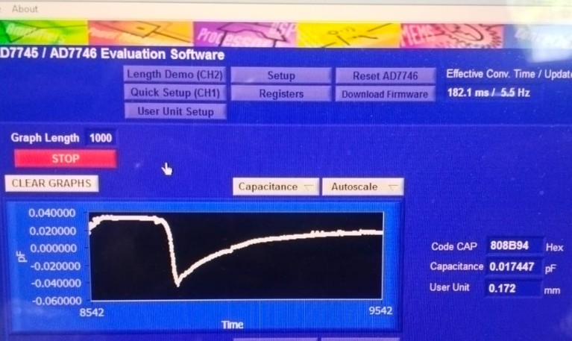
Calibration of a Low-Cost Differential-Capacitive Infrasonic Micro-barometer

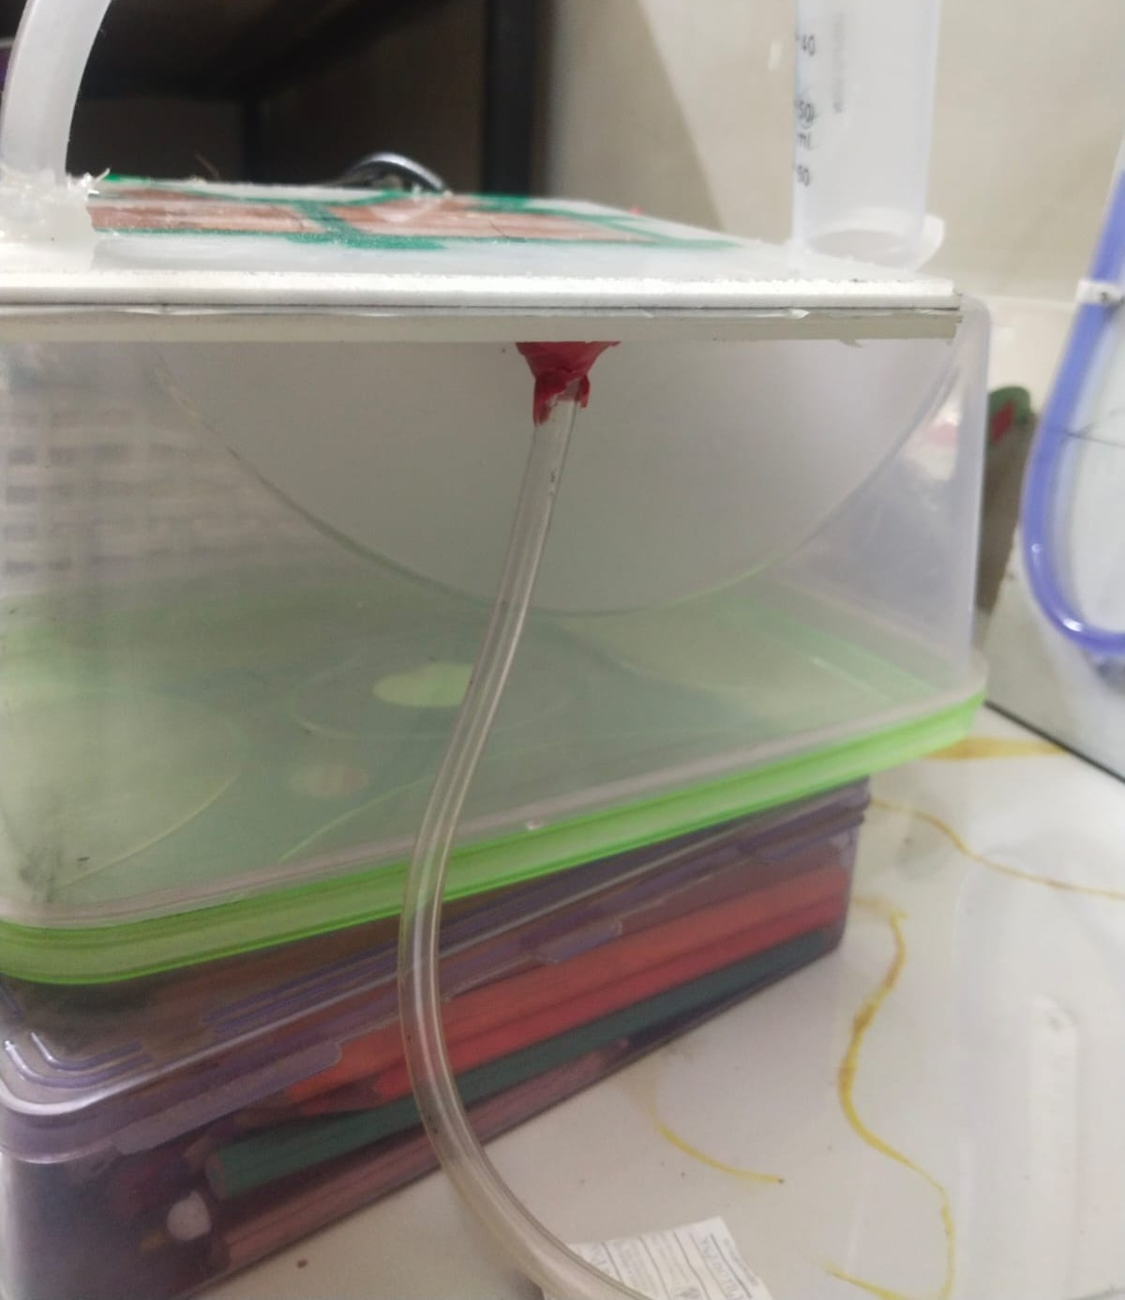
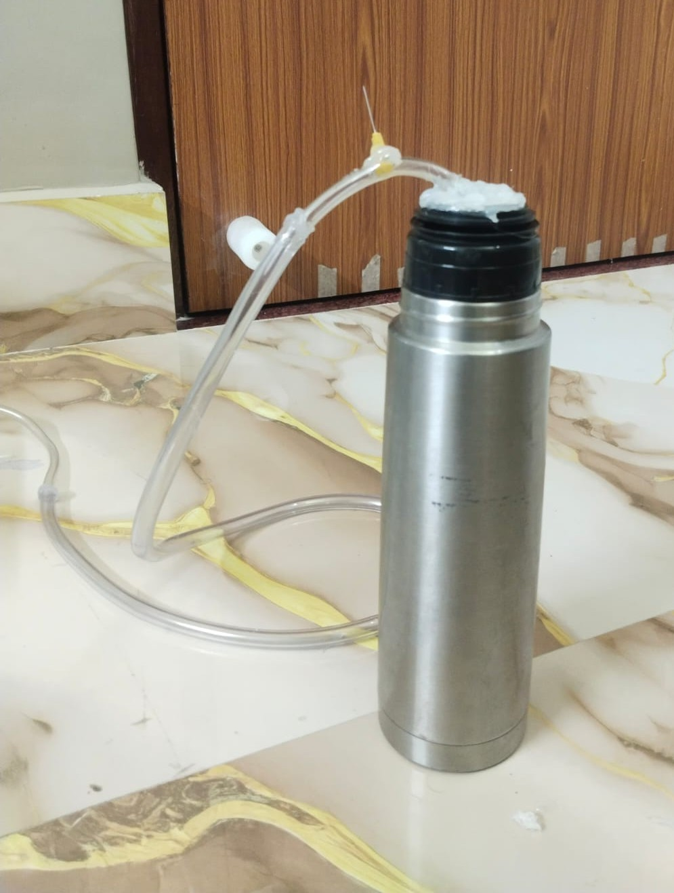
- AIM:
To calibrate the low-cost differential-capacitive micro-barometer by relating applied pressure difference to measured differential capacitance.
- PRINCIPLE:
The calibration determines the sensor’s response to known pressure variations. A known pressure difference was applied to the upper chamber, with the manometer’s water-level difference used to estimate pressure. Simultaneously, the
differential capacitance was recorded using the AD7746. These measurements

established the pressure–capacitance relationship for converting sensor output into pressure.
- EXPERIMENTAL SETUP:

The upper chamber of the mechanical sensor was connected to a custom-built water manometer using clear flexible tubing, with a transverse inlet sealed using a glue gun to prevent leakage. The lower chamber was connected to a reference pressure through similar tubing fitted with a 25-gauge needle for pneumatic filtering. The connections were leak-tested using colored water.
The manometer had millimeter markings for measuring water-level differences. The sensor was connected to an AD7746 capacitance-to-digital converter (CDC) interfaced with a laptop to record differential capacitance.
For calibration, air was introduced through the inlet by controlled blowing. Each pressure level was maintained for approximately 5 seconds, while the manometer water-level difference and corresponding differential capacitance were recorded simultaneously.
- CALIBRATION PROCEDURE and RESULTS:
Initially, both the upper and lower chambers of the mechanical sensor were exposed to atmospheric pressure,
corresponding to a pressure difference of ΔP=0. The differential capacitance measured under this condition was recorded as the zero-pressure reference (offset/error).
Subsequently, pressure was applied to the upper chamber by controlled introduction of air through the pneumatic inlet. The resulting difference in water levels in the two arms of the manometer was used to determine the applied pressure difference using the hydrostatic pressure relation ΔP=ρgh (where ρ is the density of water, g is the acceleration due to gravity, and h is the total difference in
water levels between the two arms of the manometer). Differential capacitance was recorded for water-level differences ranging from 0.1 cm to 1.0 cm, in increments of
0.1 cm. This experimental setup was repeated 3 times. The corresponding differential capacitance values obtained at each pressure level are presented in the table below.

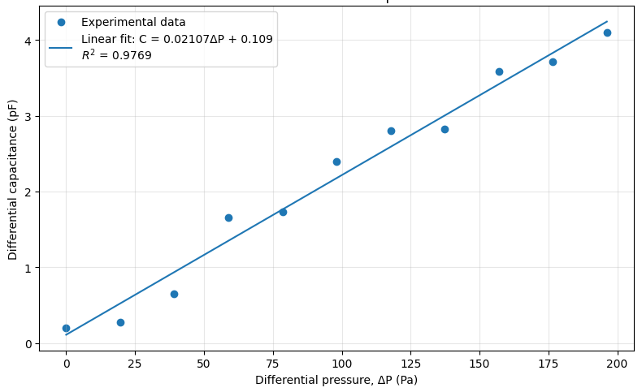
FIRST EXPERIMENT:
DATE: 27th September 2026
TIME: 12:10pm -12:30pm
TEMPERATURE &HUMIDITY: Regional (Kolkata)

OBSERVATIONAL DATA:
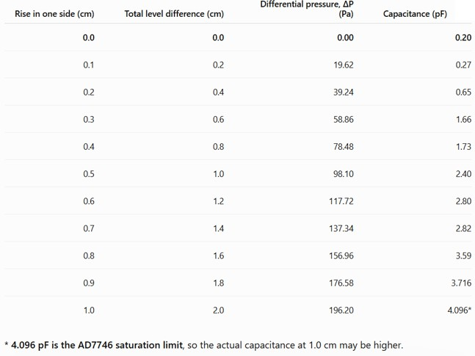

CALIBRATION CURVE:

SECOND EXPERIMENT:
DATE: 27th September 2026
TIME: 3:10pm -3:30pm
TEMPERATURE &HUMIDITY: Regional (Kolkata)

OBSERVATIONAL DATA:
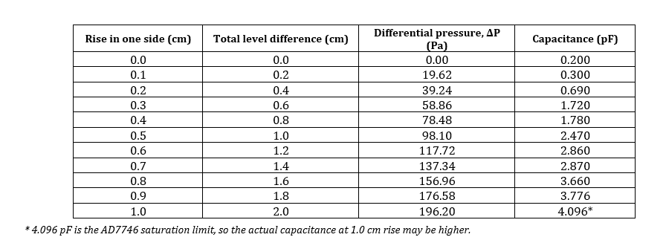

CALIBRATION CURVE:
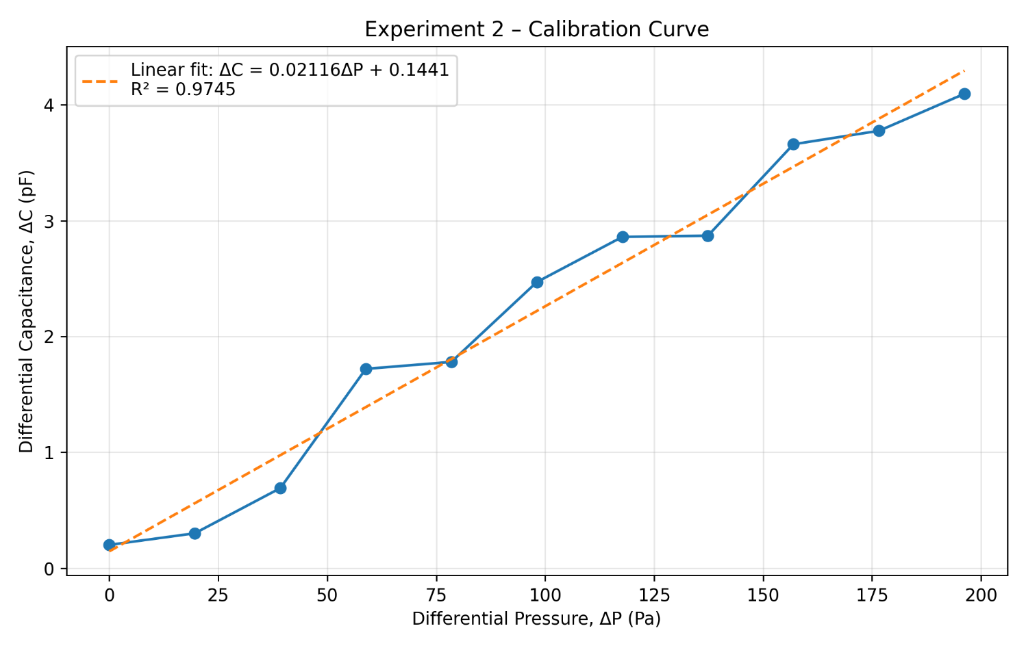

THIRD EXPERIMENT:
DATE: 27th September 2026
TIME: 6:10pm -6:30pm
TEMPERATURE &HUMIDITY: Regional (Kolkata)

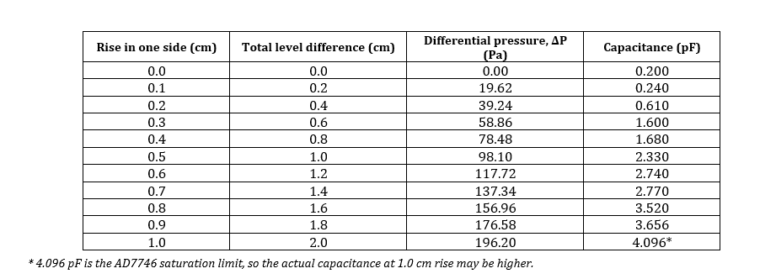

OBSERVATIONAL DATA:

CALIBRATION CURVE:
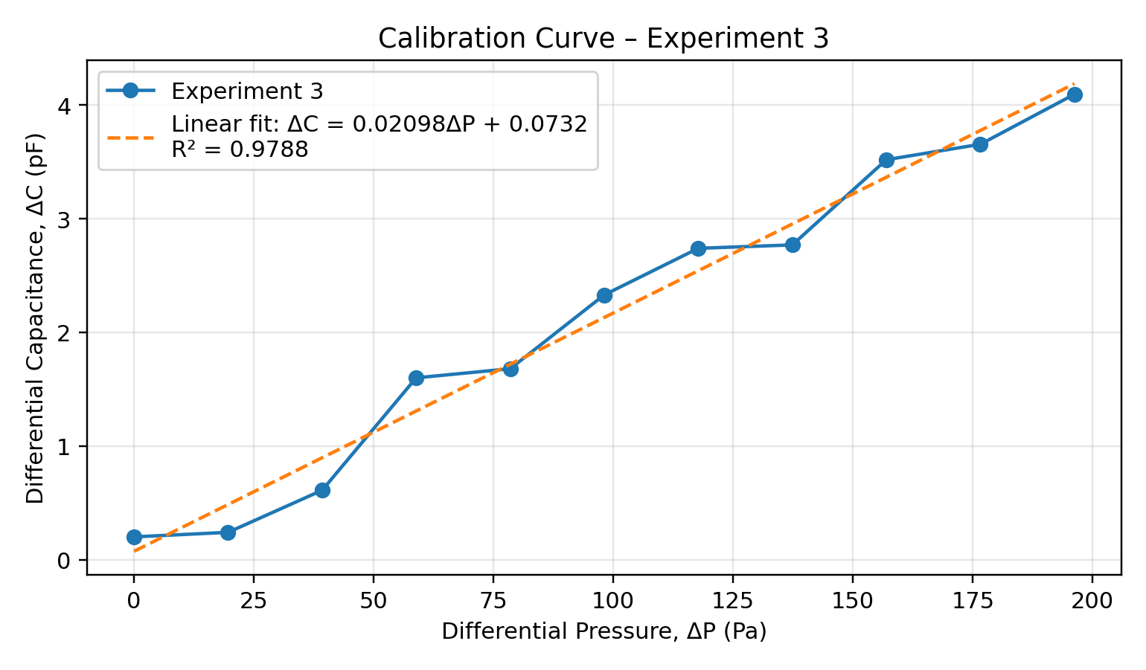
The three experimental data values were averaged and the calibration curve was obtained by plotting the mean of measured differential capacitance against the corresponding differential pressure. A linear regression was performed on the experimental mean data, yielding ΔC=0.02107ΔP+0.1086 with a coefficient of determination of R2=0.9769.

- SENSOR SENSITIVITY:
The slope of the calibration curve represents the sensitivity of the capacitive sensor to applied pressure. The experimentally obtained sensitivity was 0.02107 pF/Pa or approximately 21.07 fF/Pa
- INFERENCE:
The calibration experiment demonstrates that the differential capacitance of the mechanical sensor increases with increasing differential pressure. Over the experimentally investigated range of 0–196.2 Pa, the sensor exhibits an approximately linear response, with R2=0.9769. The obtained calibration equation can therefore be used to estimate the applied differential pressure from the measured capacitance output. The measured zero-pressure capacitance was 0.20 pF, representing the initial offset of the sensor.
- EFFECT OF HUMIDITY ON SENSOR RESPONSE:
An important observation was made during the calibration experiment regarding the effect of humidity on the sensor response. As the experiment progressed, repeated blowing of air into the pneumatic system resulted in an increase in the humidity of the air inside the tubing and sensing chamber. Since humid air has a higher effective dielectric constant than dry air, the increasing humidity introduced an additional change in the measured capacitance. Consequently, the differential capacitance approached its saturation value at a lower manometer level difference, approximately around 0.4–0.5 cm, than observed under the initial conditions.

