C Programming Assignment Pattern Menu Using Switch Statement

Nested loops | Separate parameterless functions | No arrays

Aim
To write a C program that displays a menu and uses a switch statement to print four basic square/rectangular patterns selected by the user. The patterns are generated using nested loops without arrays, and each pattern is implemented in a separate parameterless function with no return value.

Algorithm
- Start the program.
- Display a menu with four pattern choices: solid square, solid rectangle, row-number pattern, and columnnumber pattern.
- Read the user’s choice.
- Use a switch statement to call the corresponding parameterless function.
- Inside the selected function, read the required number of rows and/or columns.
- Use nested loops to generate and print the required pattern.
- If the choice is not 1 to 4, display an invalid-choice message.
- Stop the program.

C Program
#include <stdio.h>

void solidSquare(void); void solidRectangle(void); void rowNumberPattern(void); void columnNumberPattern(void);
int main(void)
{ int choice;
printf("PATTERN MENU\n"); printf("1. Solid square pattern\n"); printf("2. Solid rectangular pattern\n"); printf("3. Row-number pattern\n"); printf("4. Column-number pattern\n"); printf("Enter your choice: "); scanf("%d", &choice);
switch (choice) { case 1: solidSquare(); break; case 2: solidRectangle(); break; case 3: rowNumberPattern(); break; case 4: columnNumberPattern(); break; default:
printf("Invalid choice!\n");
} return 0;
}
void solidSquare(void)
{ int n, i, j; printf("Enter number of rows: "); scanf("%d", &n); for (i = 1; i <= n; i++)
{ for (j = 1; j <= n; j++) printf("* "); printf("\n");
}
}
void solidRectangle(void)
{ int m, n, i, j; printf("Enter number of rows and columns: "); scanf("%d %d", &m, &n);

for (i = 1; i <= m; i++)
{ for (j = 1; j <= n; j++) printf("* "); printf("\n");
}
}
void rowNumberPattern(void)
{ int m, n, i, j;
printf("Enter number of rows and columns: "); scanf("%d %d", &m, &n);

for (i = 1; i <= m; i++)
{ for (j = 1; j <= n; j++) printf("%d ", i); printf("\n");
}
}
void columnNumberPattern(void)
{ int m, n, i, j; printf("Enter number of rows and columns: "); scanf("%d %d", &m, &n);
for (i = 1; i <= m; i++)
{ for (j = 1; j <= n; j++) printf("%d ", j); printf("\n");
} }

Prepared Test Cases
Test Case | Choice | Input | Expected Output
1 | 1 | n = 4 | 4 x 4 solid square of *
2 | 2 | m = 3, n = 5 | 3 x 5 solid rectangle of *
3 | 3 | m = 4, n = 4 | Rows: 1 1 1 1 through 4 4 4 4
4 | 4 | m = 4, n = 4 | Each row: 1 2 3 4
5 | 7 | - | Invalid choice!

Expected Outputs

1. Solid Square Pattern (n = 4)
- * * *
- * * *
- * * *
- * * *

2. Solid Rectangular Pattern (m = 3, n = 5)
- * * * *
- * * * *
- * * * *

3. Row-Number Pattern (m = 4, n = 4)
- 1 1 1
- 2 2 2
- 3 3 3
- 4 4 4

4. Column-Number Pattern (m = 4, n = 4)
1 2 3 4
1 2 3 4
1 2 3 4
1 2 3 4

Result
The C program was designed to display a menu and generate the selected square/rectangular pattern using a switch statement, nested loops, and separate parameterless functions without arrays. The prepared test cases cover all four valid menu options and an invalid choice.

Execution Screenshots

Compilation of the C program

Actual Output: Matches the expected output shown for this test case.
Result: PASS

Test Case 1 - Solid square pattern (choice 1, n = 4)
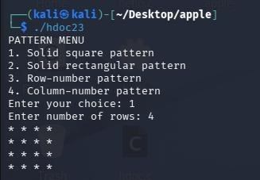
Actual Output: Matches the expected output shown for this test case.
Result: PASS

Test Case 2 - Solid rectangular pattern (choice 2, rows = 3, columns = 5)
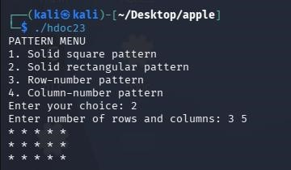
Actual Output: Matches the expected output shown for this test case.
Result: PASS

Test Case 3 - Row-number pattern (choice 3, rows = 4, columns = 4)
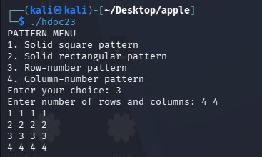
Actual Output: Matches the expected output shown for this test case.
Result: PASS

Test Case 4 - Column-number pattern (choice 4, rows = 4, columns = 4)
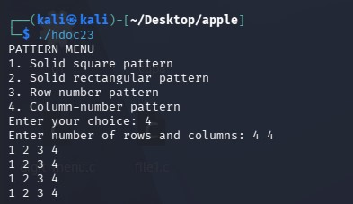
Actual Output: Matches the expected output shown for this test case. Result: PASS

Invalid choice test (choice 7)
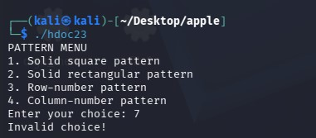
Actual Output: Matches the expected output shown for this test case.
Result: PASS

