LAB 1
1.
counter = 100 # An integer assignment
miles = 1000.0 # A floating point
name = "John" # A string
print (counter)
print (miles)
print (name)

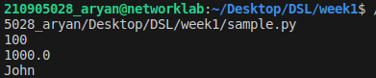

2.
a=b=c=1
a, b, c = 1, 2, "john"

3.
str = 'Hello World!'
print (str) # Prints complete string
print (str[0]) # Prints first character of the string
print (str[2:5]) # Prints characters starting from 3rd to 5th
print (str[2:]) # Prints string starting from 3rd character
print (str * 2) # Prints string two times
print (str + "TEST") # Prints concatenated string

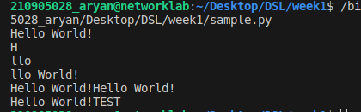
4.
var1 = 'Hello World!'
print ("Updated String :", var1[:6] + 'Python')

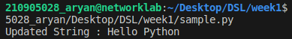
5.
print( "My name is %s and weight is %d kg!" % ('Abay', 55))
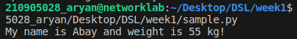
6.
str = "this is string example wow!!!";
print (str.capitalize())
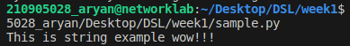
7.
str = "this is string example ... wow!!!"
print(str.count('s'))
print(str.find('example'))

str = "THIS IS STRING EXAMPLE ... WOW!!!";
print (str.lower())

str = "this is string example ... wow!!! this is really string";
print (str.replace("is", "was"))

str = "this is string example ... wow!!!";
print (str.swapcase())

str = "this is string example ... wow!!!";
print (str.title())

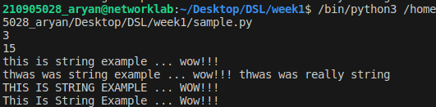
8.
list = [ 'abcd', 786 , 2.23, 'john', 70.2 ]
tinylist = [123, 'john']
print (list) # Prints complete list
print (list[0]) # Prints first element of the list
print (list[1:3]) # Prints elements starting from 2nd till 3rd
print (list[2:]) # Prints elements starting from 3rd element
print (tinylist * 2) # Prints list two times
print (list + tinylist) # Prints concatenated lists
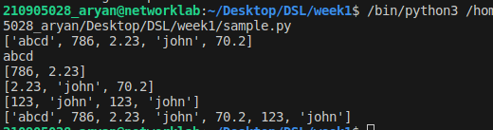
9.
list = ['physics', 'chemistry', 1997, 2000];
print(list)
list.append('maths')
print(list)

del list[2]
print(list)

'physics' in list
'english' in list
len(list)

print(list.count('physics'))

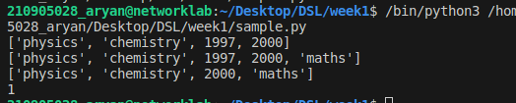
10.
tuple = ( 'abcd', 786 , 2.23, 'john', 70.2 )
list = [ 'abcd', 786 , 2.23, 'john', 70.2 ]
tuple[2] = 1000 # Invalid syntax with tuple
list[2] = 1000 # Valid syntax with list

11.
num=float(input('Enter a number:'))
if num>0:
print('pos number')
elif num==0:
print('zero')
else:
print('Neg number')
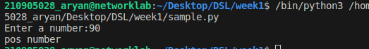
12.
x=float(input('Enter a number:'))
if x<10:
print('smaller')
if x>20:
print('bigger')
print('Finished')
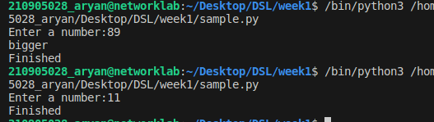
13.
x=5
print('Before 5')
if x==5:
print ('this is 5')
print('still 5')
print('After 5')
print('Before 6')
if x==6:
print('this is 6')
print ('After 6')
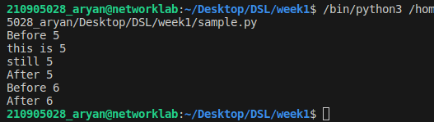
14.
x=float(input('Enter a number:'))
if x<20:
print('Below 20')
elif x<10:
print('Below 10')
else:
print('something else')

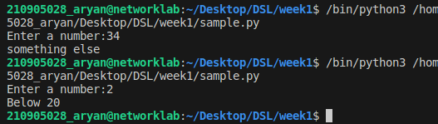
15.
x=42
if x>1:
print('above one')
if x<100:
print('less than 100')
print('All done')

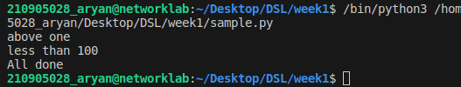
16.
age=23
b=('kid' if age<18 else 'adult')
print(b)
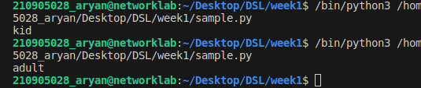
17.
for val in [5,4,3,2,1]:
print(val)
print ('Done')
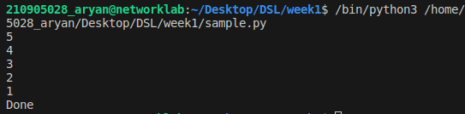
18.

stud=['Ram','Vijay','Nithya','Anu','Ramesh','suja']
for k in stud:
print('Hello:', k)
print('done')

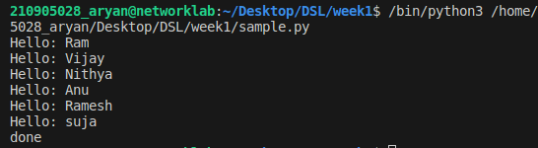
19.
for i in range(5):
print(i)
if i>2:
print('Bigger than 2')
print('Done with i',i)

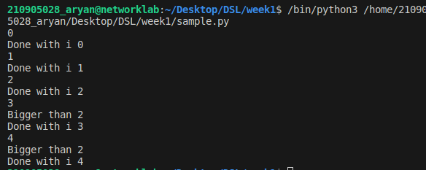
20.
x=int(input('Enter a number:'))
for i in range(1,x+1):
if x%i ==0:
print(i)
x=10
1,2,5,10
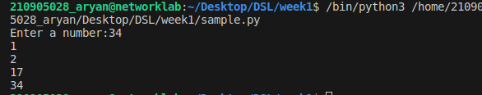

21.
from math import *
x = [9, 41, 12, 3, 74, 15]
Largest=-inf
for i in x:
if i>Largest:
Largest=i
print(Largest)
22.
from math import *
x= [9, 41, 12, 3, 74, 15]
smallest=inf
for i in x:
if i<smallest:
smallest=i
print(smallest)
23.

x= [9, 41, 12, 3, 74, 15]
count=sum=avg=0
for i in x:
count=count+1
sum=sum+1
avg=sum/count
print(count)
print(sum)
print(avg)
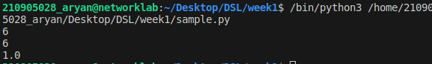
24.
x= [9, 41, 12, 3, 74, 15]
for i in x:
if i>20:
print (i)
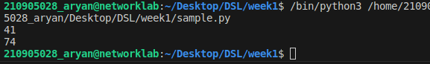
25.
x= [9, 41, 12, 3, 74, 15]
res=[]
for i in x:
if i>20:
res.append(i)

import numpy as np
y=np.zeros(len(x))
for i in range(len(x)):
if x[i]>20:
y[i]=x[i]
print(y)
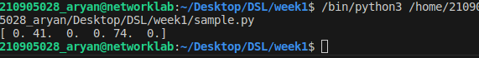
26.
price = 10
if price > 100:
print("price is greater than 100")
elif price == 100:
print("price is 100")
elif price < 100:
print("price is less than 100")
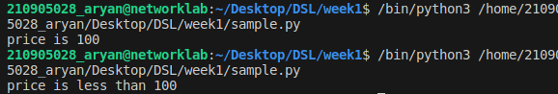
27.
# initialize the variable
i=1
n=5
# while loop from i = 1 to 5
while i <= n:
print(i)
i=i+1
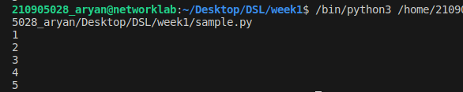
28.
total = 0
number = int(input('Enter a number: '))
# add numbers until number is zero
while number != 0:
total += number # total = total + number
# take integer input again
number = int(input('Enter a number: '))
print('total =', total)
