LAB 2
1.
import numpy as np
# data type checking
A = np.array ([2,5,10])
print(A.dtype)

2.
import numpy as np

# data type checking
A = np.array ([2,5,10])
print(A.dtype)

#Creating sequence of sequence will create 2-dimensional array.
A=np.array([(3,4,5),(12,6,1)])
Z=np.zeros((2,4)) # will create zero matrix of dimension 2x4
B=np.ones((3,3)) # will create one’s matrix of dimension 3x3

print(A,"\n\n",Z,"\n\n",B,"\n")

#To create a sequence of data,
S=np.arange(10,30,5)
print(S) #will give (10,15,20,25,30), with step size of 5
P=np.arange( 0, 2, 0.3 ) # it accepts float arguments
print("\n\n",P)

#Instead of step-size, we can specify total number of elements in the array using
S1=np.linspace(0,2,9) # produce 9 numbers starting 0 & ends with 2array([ 0. , 0.25, 0.5 , 0.75, 1. , 1.25, 1.5 , 1.75, 2. ])
print("\n\n",S1)

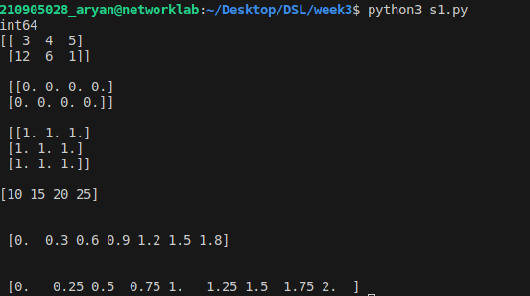
3.
import random
a = random.choice([1,2,3,4,5]) #this will pick one number from the list randomly
b= random.choice('python') #will pick one character from the string randomly
c = random.randrange(25,50) #will pick one integer between 25 to 50
d = random.randrange(25,50,2) #will pick one integer between 25 to 50 with step size of 2
e= random.random() #will pick a random number between 0 to 1
f = random.uniform(5,10) #will pick a floating point number between 5 to 10
g = random.shuffle([1,2,3,4,5]) #will shuffle the list elements
h =random.seed(10) #to get same random value during every execution

print(a,"\n",b,"\n",c,"\n",d,"\n",e,"\n",f,"\n",g,"\n",h,"\n\n")

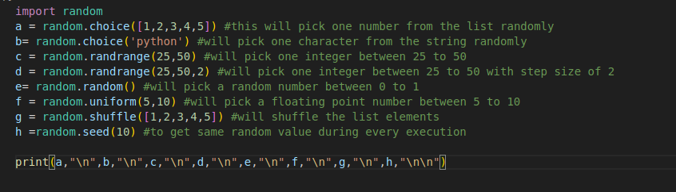
4.
import numpy as np

#2- Dimensional array (Matrix)
a = np.arange(15).reshape(3, 5)
# array([[ 0, 1, 2, 3, 4],
# [ 5, 6, 7, 8, 9],
# [10, 11, 12, 13, 14]])
#to check the dimension
dim = a.shape
# (3,5)
# will return total elements in matrix (here 15)
si = a.size

# to transpose a matrix
ww=a.T # transposed to 5x3 matrix

print(a,"\n\n",dim,"\n\n",si,"\n\n",ww,"\n")
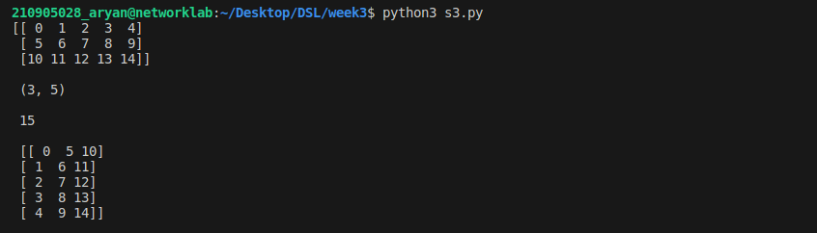
5.
import numpy as np

# 3- Dimensional array
c = np.arange(24).reshape(2,3,4) # 1st value indicates (no of planes) (3,4) is the dimension
# [[[ 0 1 2 3]
# [ 4 5 6 7]
# [ 8 9 10 11]]
# [[12 13 14 15]
# [16 17 18 19]
# [20 21 22 23]]]
b=c.shape #will return (2,3,4)
d=c[1,...] #is equal to c[1,:,:] # will fetch all elements of 2nd plane
e=c[...,2] #is equal to c[:,:,2] [[3,7,11],[15,19,23]]

print(c,"\n\n",b,"\n\n",d,"\n\n",e,"\n")

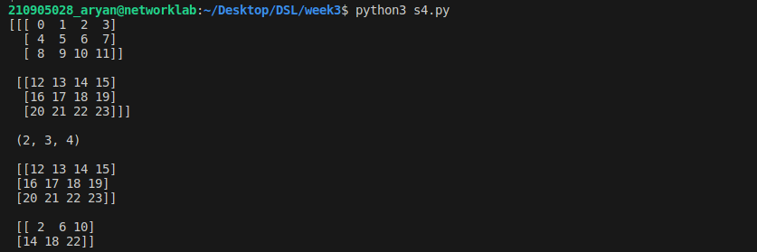
6.
import numpy as np
#Array operations
a = np.array( [20,30,40,50] )
b = np.arange( 4 )

#array([0, 1, 2, 3])

c = a-b
# array([20, 29, 38, 47])

d = b**2
# array([0, 1, 4, 9])

e= 10*np.sin(a)
#array([ 9.12945251, −9.88031624, 7.4511316 , −2.62374854])
f=a<35
# array([ True, True, False, False], dtype=bool)

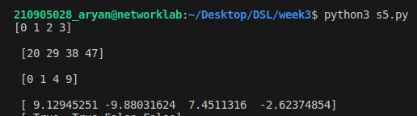
7.
import numpy as np
# Matrix operations
A = np.array( [[1,1],[0,1]] )
B = np.array( [[2,0],[3,4]] )
b =A*B # elementwise product
# array([[2, 0],
# [0, 4]])
c= A.dot(B) # matrix product
# array([[5, 4],
# [3, 4]])
# (OR)

d = np.dot(A, B)
# array([[5, 4],
# [3, 4]])

e = np.arange(12).reshape(3,4)
# array([[ 0, 1, 2, 3],
# [ 4, 5, 6, 7],
# [ 8, 9, 10, 11]])
f= e.sum(axis=0)
# array([12, 15, 18, 21])# sum of each column
g= e.sum(axis=1)
# array([6, 22, 38])

print(b,"\n\n",c,"\n\n",d,"\n\n",e,"\n\n",f,"\n\n",g)

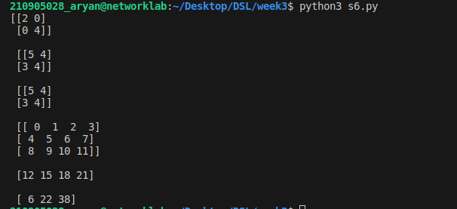
8.
import numpy as np
# Indexing, Slicing & Iterating Array
a = np.arange(10)**3

# array([ 0, 1, 8, 27, 64, 125, 216, 343, 512, 729])
c= a[2:5]
#array([ 8, 27, 64])
d = a[0:6:2]
# array([0,8,64,216])
# Let ‘b’, is an input matrix of size 5x4
b=np.array ([[ 0, 1, 2, 3],
[10, 11, 12, 13],
[20, 21, 22, 23],
[30, 31, 32, 33],
[40, 41, 42, 43]])

e =b[2,3] #will fetch 23
f =b[0:5,1] #or b[:5,1] or b[:,1] #will fetch [1,11,21,31,41]
g =b[-1,:] # will fetch last row
h = b[:,-1] # will fetch last col

for row in b:
print(row) # will print every row
for element in b.flat:
print (element) # will show all elements of b in 1−D array

print(a,"\n\n",c,"\n\n",d,"\n\n",e,"\n\n",f,"\n\n",g,"\n\n",h,"\n\n")
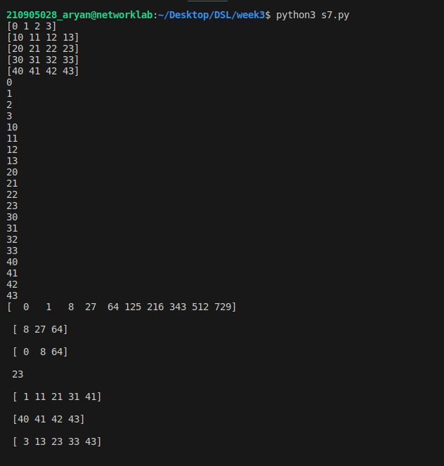
9.
#Usage of for-loop (Mapping by Value)
# Calculate sum of all the elements in a 2D Numpy Array (iterate over elements)
import numpy as np
a=np.array([(3,2,9),(1,6,7)])
s1=0
for row in a:
for col in row:
s1+=col
print(s1)
# Usage of for-loop (Mapping by Index)
# Calculate sum of all the elements in a 2D Numpy Array (iterate over range)
import numpy as np
a=np.array([(3,2,9),(1,6,7)])
s=0
for i in range(a.shape[0]):
for j in range(a.shape[1]):
s+=a[i,j]
print(s)
