**SOFTWARE REQUIREMENTS**

**SPECIFICATION**

**For Image Based Food Classifier (Calorie Click)**

**Version 1.0**

## Prepared by:

|  |  |  |  |
| --- | --- | --- | --- |
| **1. Aryan Garg** | | **(102103768)** | |
| **2. Samarth Paliwal** | | **(102103775)** | |
|  |  | |

**Submitted to: Dr. Nitigya Sambyal**

**Contents**

1.1 Purpose 3

1.2 Product Scope 3

1.3 Definitions, abbreviations, and acronyms 3

1.4 References 4

1.5 Overview 4

2 Overall Description 5

2.1 Product Perspective 5

2.2 Product Functions 5

2.3 User Characteristics 6

2.4 General Constraints, Assumptions and Dependencies 6

2.5 Apportioning of requirements 7

3 Specific Functional Requirements 7

3.1 External Interface Requirements 7

3.2 Detailed Description of Functional Requirements 8

3.3 Performance Requirements 9

4 Document Approvers 9

1. **Introduction**

## Purpose

This SRS document aims to provide a detailed overview of our software product: Tuberculosis Detection web application. It grabs the purpose and various features of the app, its aim, and the constraints for the functioning of the app. This document is intended for end users and web app developers.

## Product Scope

## Authenticate User: It must be able to authenticate the user using a combination of username and password. This will be compared to securely stored data in the database.

## Maintain User Records: As new users sign up for the web-app, it is important to retain their data to serve the next time they wish to login.

## Scan Image and predict class of food: The program must be able to scan the entire image using a machine learning model specifically trained on food, and be able to find a food product in the image.

## Track User History: The program must be able to track all the previous items scanned by the individual and show statistics for the previous data.

## Initially, we aim to develop a web application with the primary function of analyzing food photos to estimate their calorie content. This application will be piloted in four Software Development and Testing (SDET) unit labs, targeting an audience of 10 individuals. If the pilot phase proves successful, we intend to expand the use of this calorie prediction web app on a greater scale.

## Definitions, abbreviations, and acronyms

|  |  |  |
| --- | --- | --- |
| S. No | Term | Description |
| 1 | Authenticate | Provides access control for systems by checking to see if a user's credentials match the credentials in a database |
| 2 | CNN | Convolutional Neural Network |
| 3 | API | Application Programming Interface |

## References

[1] Google Images (For Dataset): <https://www.google.com/imghp?hl=en>

[2] Kaggle: <https://www.kaggle.com/datasets/aryan401/indian-food-16>

[3] TensorFlow Playground: <https://playground.tensorflow.org/>

## Overview

## The remaining sections of this document provide a general description, including characteristics of the users of this project, the product's hardware, and the functional and data requirements of the product. General description of the project is discussed in section 2 of this document. Section 2 gives the functional requirements, data requirements and constraints and assumptions made while designing the multi-utility system. It also gives the user viewpoint of product use. Section 3 gives the specific requirements of the product. Section 3.0 also discusses the external interface requirements and gives detailed description of functional requirements

# Overall Description

## Product Perspective

## The “Calorie Click” application is a user-friendly web application that helps to detect various meals that the user consumes, whenever they upload an image of it. The web-application provides the following categories of services:

#### Scan Image and Predict Class of Food: The web application allows users to upload a picture of their Meal. The model processes these uploaded images and determines which of the pre-trained meals the user is having

#### Track users’ progress: The web app allows users to track their progress and Nutritional History.

#### Maintain user profile records: The web app maintains a database storing a patient’s profile containing their meal history as well as the calorie, and macro/micro-nutrient intake per meal.

## Product Functions

The major features of Calorie Click are:

* It allows user to register, complete their profile and later, log in. During log in, the user and password are authenticated.
* It scans images and gives result on the class of item being consumed.
* It tracks the progress of the user.
* Gives information about different types of nutrients that the body requires.
* It maintains a database storing a user’s profile containing their nutritional history.

## User Characteristics

The goal of Calorie Click is to enable healthy eating habits within its users. These include:

* Admins/Developers
* General Users

The admins have the following privileges:

* Add/Delete a record
* Update a record
* Terminate Spammy User Accounts

General Users will have the following privileges:

* Add images to their personal profile

## General Constraints, Assumptions and Dependencies

## The following list presents the constraints, assumptions, dependencies, or guidelines that are imposed upon implementation of the CSC based Multi-Utility System including Access Control and Attendance Monitoring software:

* The website operates in any Operating Environment - Windows98 and upper Versions (EX: Win98, windows 2000 prof, XP Vista and win NT Server, Windows 2000 server, 2003 server, and Windows 2008 server), Unix and all Unix flavors like LINUX, Solaris, etc.
* Using browsers such as - Google Chrome, Microsoft Edge, Brave Browser, Mozilla Fire- fox, AOL, and Netscape Navigator etc.
* The user has a system which can support the latest version of React.js used.
* The server can support the latest version of Node.js and is powerful enough to run a large CNN.
* The user has an Internet connection with a minimum speed of 0.5 Mbps and recommended speed of 1.5 Mbps.
* The central database server and backup database servers should be updated regularly. This updating and replication of data from central database server to the backup database server can introduce additional latency in the working of the system

## Apportioning of requirements

The Calorie Click is to be implemented in three phases:

1. **Pilot Phase**: This application will be piloted in four SDET unit labs, we will initially be beta testing with a target audience of 10 individuals. If the pilot phase proves to be successful, we intend to expand the use of this calorie prediction web app on a greater scale.
2. **Extended Beta Phase**: Following successful nature of the initial pilot phase, we will further expand the roll out of the webapp to new testers and users. We may also add new food types and retrain our model.
3. Full Rollout: In the future we will add more food items, and eventually be able to differentiate many different food items. We will also be able to show more complex graphs based on user feedback.

# Specific Functional Requirements

## External Interface Requirements

## The following list presents the external interface requirements:

* User Interface: The app should have a user-friendly interface to capture food photos. It should also display the predicted calorie count and any additional relevant information to users
* Camera Integration: The app should have access to the device's camera to capture food images. Integration with the camera API on both mobile and desktop z platforms is essential
* Calorie Database: Access to an external calorie database or API to retrieve nutritional information for various food items. This database should be regularly updated and accurate.

The functional requirements for the project are explained below in the form of tables with their respective purpose, inputs, processing, and output.

## Detailed Description of Functional Requirements



### Functional Requirement for Sign-Up Screen

Figure 3.1: Functional Requirement for Sign-Up Screen

### Functional Requirements for Login Screen

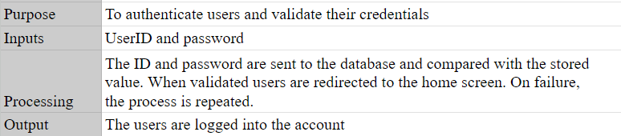

Figure 3.2: Functional Requirements for Login Screen

### Functional Requirements for Food Upload Page

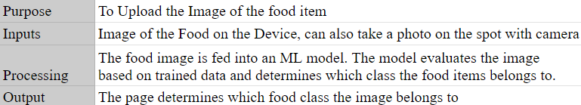

Figure 3.3: Functional Requirements for Food Upload page

### Functional Requirements for Statistics Page

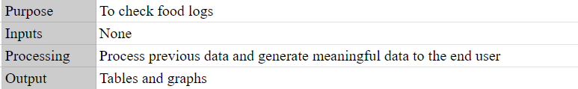

Figure 3.5: Functional Requirements for Statistics Page

## Performance Requirements

The requirements associated with performance are:

* The application requires an Internet connection with a minimum speed of 0.5 Mbps and recommended speed of 1.5 Mbps
* The application supports up to 100 concurrent users.
* The application takes 0.5-3s to load, depending on the users’ connection speeds.
* The application must be hosted on a reliable server like AWS servers.

# Document Approvers

# SRS for Calorie Click: Image Based food recognition and nutrient information web-app approved by: ___________________

# Designation:

# Date: