Pizza Sales

**1.** SELECT SUM(total_price) AS Total_Revenue

FROM pizza_sales;

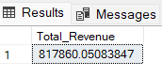

**2.** SELECT SUM(total_price) / COUNT(DISTINCT order_id) AS Average_Revenue

FROM pizza_sales

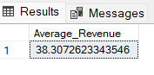

**3.** SELECT SUM(quantity) AS Total_Pizza_Sold

FROM pizza_sales

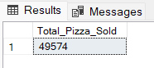

**4.** SELECT COUNT(DISTINCT order_id) AS Total_Orders

FROM pizza_sales

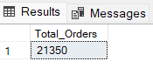

**5.** SELECT CAST(SUM(quantity) AS DECIMAL(10,2)) /

CAST(COUNT(DISTINCT order_id) AS DECIMAL(10,2)) AS Average_Pizzas_Per_Order

FROM pizza_sales

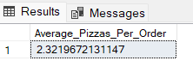

OR

SELECT CAST(

CAST(SUM(quantity) AS DECIMAL(10,2))/ CAST(COUNT(DISTINCT order_id) AS DECIMAL(10,2))

AS DECIMAL(10,2)

) AS Average_Pizzas_Per_Order

FROM pizza_sales

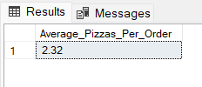

**6.** SELECT DATENAME(DW, order_date) AS order_day, COUNT(DISTINCT order_id) AS Total_Orders

FROM pizza_sales

GROUP BY DATENAME(DW, order_date)

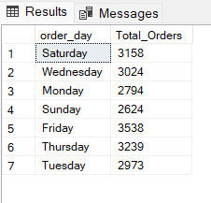

**7.** SELECT DATEPART(HOUR, order_time) AS order_hours, COUNT(DISTINCT order_id) AS Total_Orders

FROM pizza_sales

GROUP BY DATEPART(HOUR, order_time)

ORDER BY DATEPART(HOUR, order_time)

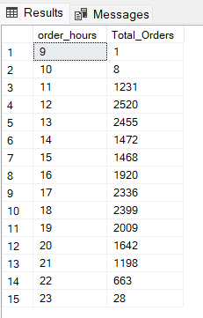

**8.** SELECT pizza_category, SUM(total_price) * 100 / (SELECT SUM(total_price) FROM pizza_sales) AS Total_Sales_Percentage

FROM pizza_sales

GROUP BY pizza_category

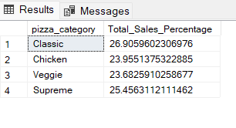

**9.** SELECT pizza_category, SUM(total_price) * 100 / (SELECT SUM(total_price) FROM pizza_sales WHERE MONTH(order_date) = 1) AS Total_Sales_Percentage

FROM pizza_sales

WHERE MONTH(order_date) = 1 --For Month January

GROUP BY pizza_category

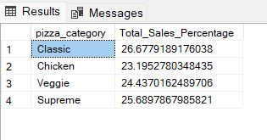

**10.** SELECT pizza_size,

CAST(SUM(total_price) AS DECIMAL(10,2)) AS Total_Sales,

CAST(

SUM(total_price)*100 / (SELECT SUM(total_price) FROM pizza_sales) AS DECIMAL(10,2)

) AS PCT

FROM pizza_sales

GROUP BY pizza_size

ORDER BY PCT DESC

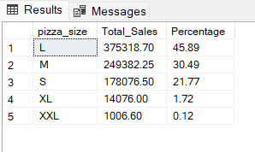

**11.** SELECT pizza_size,

CAST(SUM(total_price) AS DECIMAL(10,2)) AS Total_Sales,

CAST(

SUM(total_price)*100 / (SELECT SUM(total_price) FROM pizza_sales WHERE DATEPART(QUARTER, order_date) = 1 ) AS DECIMAL(10,2)

) AS Percentage

FROM pizza_sales

WHERE DATEPART(QUARTER, order_date) = 1 --For First Quarter

GROUP BY pizza_size

ORDER BY Percentage DESC

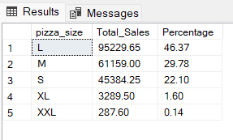

**12.** SELECT pizza_category, SUM(quantity) AS Total_Pizzas_Sold

FROM pizza_sales

GROUP BY pizza_category

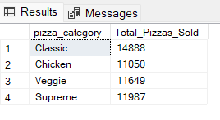

**13.** SELECT TOP 5 pizza_name, SUM(quantity) AS Total_Pizzas_Sold

FROM pizza_sales

GROUP BY pizza_name

ORDER BY Total_Pizzas_Sold DESC

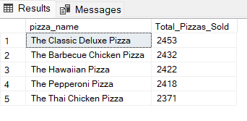

**14.** SELECT TOP 5 pizza_name, SUM(quantity) AS Total_Pizzas_Sold

FROM pizza_sales

WHERE MONTH(order_date) = 8 --For August Month

GROUP BY pizza_name

ORDER BY Total_Pizzas_Sold DESC

