Software Requirements Specification

for

Retail showroom website
Version 1.0 approved
Prepared by 20CS045, 20CS046, 20CS050, 20CS051
CSPIT-CSE
01-09-21
Table of Contents
Table of Contents ii
Revision History ii
1. Introduction 1
1.1 Objective 1
1.2 Document Conventions 1
1.3 Intended Audience and Reading Suggestions 1
1.4 Project Scope 1
1.5 References 2
2. Overall Description 2
2.1 Product Perspective 2
2.2 Product Features 2
2.3 User Classes and Characteristics 2
2.4 Operating Environment 2
2.5 Design and Implementation Constraints 3
2.6 User Documentation 3
2.7 Assumptions and Dependencies 3
3. System Features 3
3.1 System Feature 1 3
4. External Interface Requirements 4
4.1 User Interfaces 4
4.2 Hardware Interfaces 5
4.3 Software Interfaces 5
4.4 Communications Interfaces 5
5. Other Nonfunctional Requirements 5
5.1 Performance Requirements 5
5.2 Safety Requirements 6
5.3 Security Requirements 6
5.4 Software Quality Attributes 6
6. Other Requirements 6
Appendix A: Glossary 6
Appendix B: Analysis Models 7
Appendix C: Issues List 7

Revision History
Name | Date | Reason For Changes | Version

1) Introduction

1.1 Introduction
We are designing a website for a retail showroom that deals with sanitary items and bathroom accessories.
The basic motto of this project is to give customers a brief idea about the brands and the products The showroom is dealing with.
This website helps the customer to surf for the products according to the requirements
by sitting at home.

1.2 Document Conventions

We have chosen fonts and highlighted certain information which will be reader friendly.

1.3 Intended Audience and Reading Suggestions
The people who have requirements of sanitaryware items like ceramic products, faucets, sinks, bathtubs, showers and saunas etc. For the hotels, new residential projects, sites, visit this website to get the idea of the product.

1.4 Project Scope
The basic motto of this project is to give customers a brief idea about the brands and the products the showroom is dealing with.
The purpose of this website is to give the customers the glimpse of our showroom and variety of the sanitaryware and lightning products.
Our website provides all the necessary details needed by the customer and help them selecting the right products from the comfort of their homes

1.5 References

Reference has been taken from the official website of the brands like Duravit, Jaquar, Groha etc..

Reference has also been taken from web designing and development tutorials.

2 Overall Description

2.1 Product Perspective
A retailed base showroom website contains the following information
- Product details:
It displays the various bathroom lighting and sanitaryware products and displays its dimensions and different colours and various brands.
- Product quotation : Provides estimated quotation of the products which the customer wishes to buy. This provides the estimated amount of the money the customer has to spend.

2.2 Product features

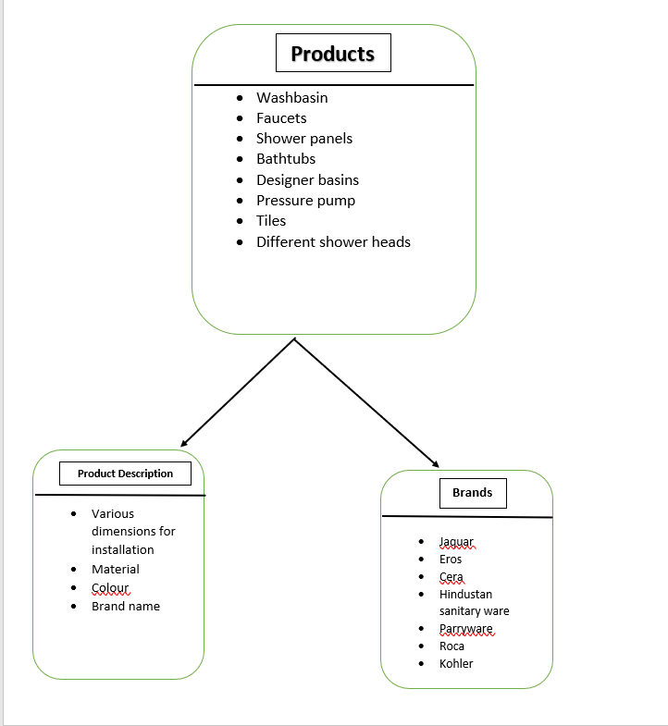

2.3 User Classes and Characteristics
User of the system will be able to retrieve vital information regarding sanitary ware products and lighting. Customers will also be able to compare prices for a certain product from the prices given by different brands The system will support two types of user privileges, Customer, and Employee. Customers will have access to customer functions, and the employees will have access to both customer and product management function .’
The customer should be able to do the following functions:
- Explore variety of different products
• Sanitary ware
• Ceramic ware
• Lightning products
- Generate quotation

2.4 Operating Environment
Operating environment for our retailed website is as listed below.

client/server system
Operating system: Windows,MacOs.

platform: HTML/Javascript/CSS

2.5 Design and Implementation Constraints

<Describe any items or issues that will limit the options available to the developers. These might include: corporate or regulatory policies; hardware limitations (timing requirements, memory requirements); interfaces to other applications; specific technologies, tools, and databases to be used; parallel operations; language requirements; communications protocols; security considerations; design conventions or programming standards (for example, if the customer’s organization will be responsible for maintaining the delivered software).>
3rd Sem | 4th Sem | 5th Sem | 6th Sem | 7th Sem
Not required | Not Required | Not Required | Mandatory | Mandatory

2.6 User Documentation
In the About Us section of the project there will be a brief description of the Showroom and the list of brands we are dealing with. The section will also consist of the showroom directions and a few glimpses of our showroom.

2.7 Assumptions and Dependencies
The main assumption of this project is that the user will be provided with ample information regarding sanitaryware products which will help the customer review our products and select the products they wish to purchase and the customer will be provided with a rough estimated expenditure(Quotation).

3 System Features

3.1 System Feature 1
3.1.1 Description and Priority

3.1.2 Stimulus/Response Sequences
  - Search for varieties of different sanitaryware products lightning products
  - Displays a detailed list of products along with images , dimensions,colour,estimated price,list of brands.
  - Clients can generate quotation for the products they wish to buy.
3.1.3 Functional Requirements
- The website should be able to display the products the user to see
- The website should be able to generate and estimate expenditure(quotation) for the products the customer has added.

4 External Interface Requirements

4.1User Interfaces
Front-end Software: Visual studio code,Bootstrap.

4.2 Hardware Interfaces

Windows
Browser which supports CSS,HTML,javascript

4.3 Software Interfaces
Following are the software used for the our online showroom website.
Software used | Description
Operating system | We have chosen Windows operating system for its best support and user-friendliness.
Database | To save the flight records, passengers records we have chosen SQL+ database.
Visual studio code | To implement the project we have chosen HTML,CSS,javascript language for its more interactive support.

4.4 Communications Interfaces
This project supports all types of web browsers.
5 Other Nonfunctional Requirements

5.1 Performance Requirements
As the project is web based so there are no specifications for performance but in further updates of the project the user will be able to select the products they wish to buy and will also be able to generate a rough expenditure(Quotation) for the products.

5.2 Safety Requirements
<Specify those requirements that are concerned with possible loss, damage, or harm that could result from the use of the product. Define any safeguards or actions that must be taken, as well as actions that must be prevented. Refer to any external policies or regulations that state safety issues that affect the product’s design or use. Define any safety certifications that must be satisfied.>
3rd Sem | 4th Sem | 5th Sem | 6th Sem | 7th Sem
Not Required | Not Required | Required, if requirement needs | Required, if requirement needs | Required, if requirement needs

5.3 Security Requirements
<Specify any requirements regarding security or privacy issues surrounding use of the product or protection of the data used or created by the product. Define any user identity authentication requirements. Refer to any external policies or regulations containing security issues that affect the product. Define any security or privacy certifications that must be satisfied.>
3rd Sem | 4th Sem | 5th Sem | 6th Sem | 7th Sem
Not Required | Not Required | Required, if requirement needs | Required, if requirement needs | Required, if requirement needs

5.4 Software Quality Attributes
- AVAILABILITY: Our retailed website is available 24*7.
- CORRECTNESS: The flight should reach start from correct start terminal and should reach the correct destination.
- MAINTAINABILITY: The administrators and flight in chargers should maintain correct schedules of flights.
- USABILITY: The flight schedules should satisfy a maximum number of customers needs.

Other Requirements
<Define any other requirements not covered elsewhere in the SRS. This might include database requirements, internationalization requirements, legal requirements, reuse objectives for the project, and so on. Add any new sections that are pertinent to the project.>

Appendix A: Glossary
<Define all the terms necessary to properly interpret the SRS, including acronyms and abbreviations. You may wish to build a separate glossary that spans multiple projects or the entire organization, and just include terms specific to a single project in each SRS.>
3rd Sem | 4th Sem | 5th Sem | 6th Sem | 7th Sem
If applicable | If applicable | If applicable | If applicable | If applicable

Appendix B: Analysis Models
<Optionally, include any pertinent analysis models, such as data flow diagrams, class diagrams, state-transition diagrams, or entity-relationship diagrams.>
3rd Sem | 4th Sem | 5th Sem | 6th Sem | 7th Sem
If applicable | If applicable | If applicable | If applicable | If applicable

Appendix C: Issues List
< This is a dynamic list of the open requirements issues that remain to be resolved, including TBDs, pending decisions, information that is needed, conflicts awaiting resolution, and the like.>
3rd Sem | 4th Sem | 5th Sem | 6th Sem | 7th Sem
If applicable | If applicable | If applicable | If applicable | If applicable

References
https://krazytech.com/projects/sample-software-requirements-specificationsrs-report-airline-database

