CSE307 NETWORKING LAB REPORT

On

Multi-floor Office Network Setup and Configuration

Submitted by: Aryan Submitted to:

Registration No: 12304657 Mr. Simarjit Singh Malhi

Section:K23UP

Roll No: 48



GitHub Repository Link: <https://github.com/Aryan-Dangi/Multi-Floor-Office-Network-Design>

Physical Scenario Creation:

Based on the provided network simulation, the five-floor building of Alpha Infotech has been designed with a clear hierarchical structure ensuring efficient communication. Each floor is equipped with a dedicated Cisco 2960 switch connecting seven PCs using Fast Ethernet links. Floors 1 to 3 follow a Ring topology while Floors 4 and 5 use a Bus topology. Servers are properly placed: the Email server is on Floor 1, the DNS server on Floor 2, the HTTP server on Floor 3, and both FTP and DHCP servers are placed on Floor 5. Inter-floor connectivity is established using Gigabit Ethernet links between routers, ensuring high-speed communication across floors. Each router has been assigned a subnet based on VLSM (Variable Length Subnet Masking) with Class A IP addressing, and static routing is implemented for controlled and efficient packet delivery between floors.

The IP addressing scheme carefully separates private and public addressing: Floors 1 and 2 use the private IP range (10.x.x.x), while Floors 3, 4, and 5 simulate the use of a public IP range (8.x.x.x). Static routes have been manually configured on each router to enable communication between the different subnets without relying on dynamic protocols. Each floor’s router acts as the default gateway for its connected devices, with gateway IPs clearly labelled in the design. Switches on Floors 4 and 5 are interconnected to form a bus layout, ensuring a cost-effective setup. Overall, the network setup aligns with Alpha Infotech’s goals of scalability, reliability, and efficient data flow across the building.

Following are the snapshots of the physical layout of the entire network :

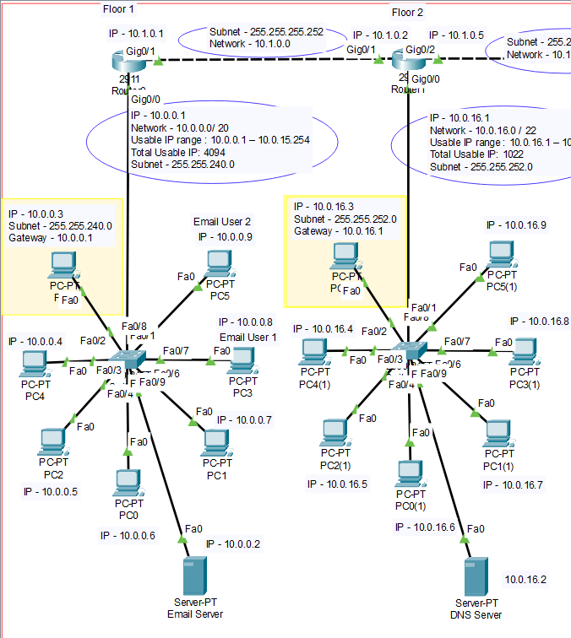

Fig 1. Floors 1-2

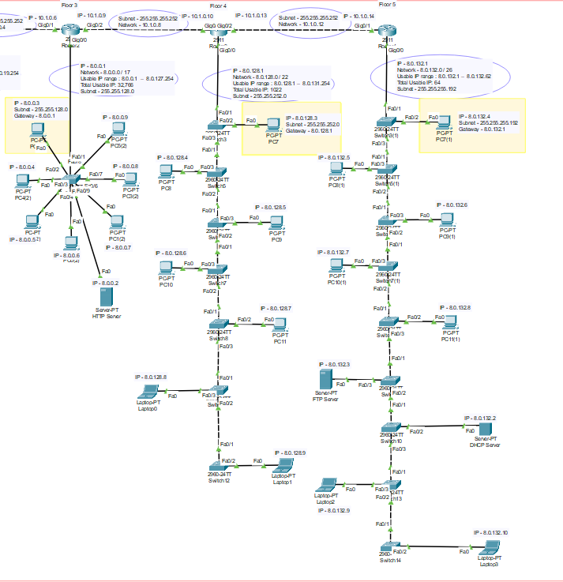

Fig 2. Floors 3-5

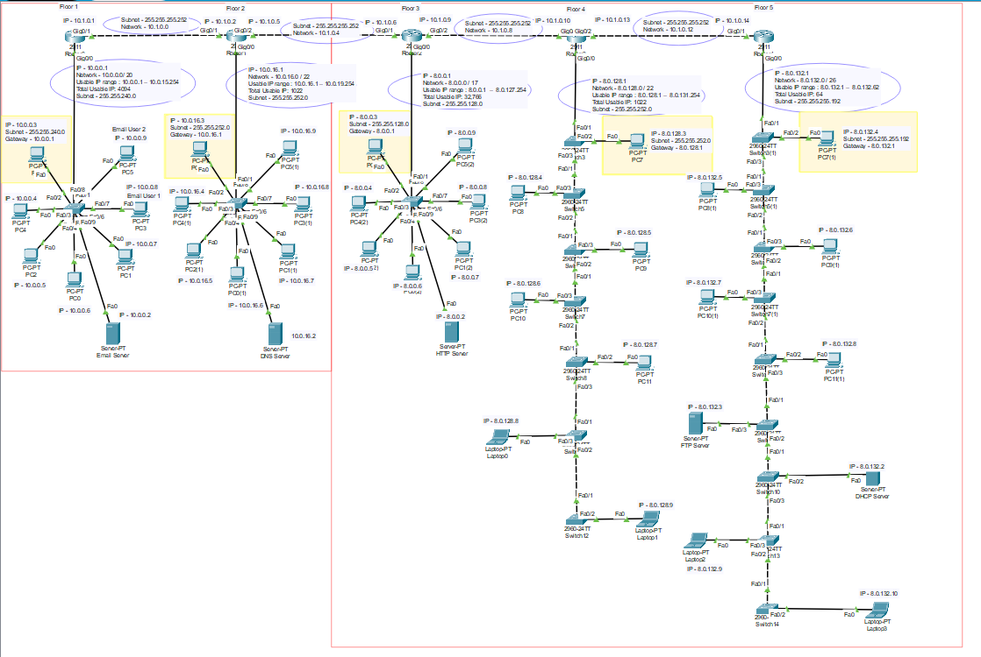

Fig 3. Entire network Floors 1-5

Servers used – DHCP, FTP, EMAIL, DNS and HTTP

Total networks - 9

Switch used - 2960

Router used – 2811

Floor 1 ,2 and Floor 2 – Star Topology

Floor 4 and Floor 5 – Bus Topology

Total Routers – 5

VLSM Calculation

Unlike traditional fixed-size subnetting, where every subnet has the same number of hosts, VLSM enables a more efficient use of IP addresses by allocating just the right amount of addresses to each subnet. This approach significantly reduces wastage of IP space, especially in complex networks where different departments or floors may have vastly different numbers of devices, like in Alpha Infotech’s network where the number of computers varied from 49 to 29,748 across floors.

In the Alpha Infotech design, VLSM helped assign larger address blocks to floors with more devices (such as a /17 for nearly 30,000 devices) and smaller blocks to those with fewer devices (such as a /26 for 49 devices). This smart allocation not only ensures that each floor has enough IP addresses but also maintains room for future expansion without unnecessary overhead. Additionally, using VLSM improves network performance and organization, making routing tables smaller and more efficient, which is critical in maintaining a scalable and manageable enterprise network.

| **Floor** | **Required Hosts** | **Host Bits** | **Network Bits** | **Subnet Mask** | **CIDR** | **Subnet Address** | **IP Range** | **Broadcast Address** |
| --- | --- | --- | --- | --- | --- | --- | --- | --- |
| 3 (Floor 3) | 29748 | 15 bits (≥32768) | 17 | 255.255.128.0 | /17 | 8.0.0.0 | 8.0.0.1 – 8.0.127.254 | 8.0.127.255 |
| 1 (Floor 1) | 3283 | 12 bits (≥4096) | 20 | 255.255.240.0 | /20 | 10.0.0.0 | 10.0.0.1 – 10.0.15.254 | 10.0.15.255 |
| 2 (Floor 2) | 987 | 10 bits (≥1024) | 22 | 255.255.252.0 | /22 | 10.0.16.0 | 10.0.16.1 – 10.0.19.254 | 10.0.19.255 |
| 4 (Floor 4) | 678 | 10 bits (≥1024) | 22 | 255.255.252.0 | /22 | 8.0.128.0 | 8.0.128.1 – 8.0.131.254 | 8.0.131.255 |
| 5 (Floor 5) | 49 | 6 bits (≥64) | 26 | 255.255.255.192 | /26 | 8.0.132.0 | 8.0.132.1 – 8.0.132.62 | 8.0.132.63 |

IP Addressing

To ensure proper segmentation and clear identification of devices, we assigned IP addresses floor-wise.

* Floors 1, 2 use **Private IPv4 Class A** addresses.
* Floors 3,4 and 5 use **Public IPv4 Class A** addresses.

|  |  |  |
| --- | --- | --- |
| Floor No. | Gateway | Ip’s for PC’s |
| 1 | 10.0.0.1 | 10.0.0.3 – 0.9 |
| 2 | 10.0.16.1 | 10.0.16.3 – 16.9 |
| 3 | 8.0.0.1 | 8.0.0.3 – 0.9 |
| 4 | 8.0.128.1 | 8.0.128.3 – 128.9 |
| 5 | 8.0.132.1 | 8.0.132.4 – 132.10 |

Table 1. Floor-wise Gateway and IP configuration

|  |  |
| --- | --- |
| Floor 1 | Floor 2 |
| Floor 3 | Floor 4 |
| Floor 5 |  |

Table 2. Snaps of IP configuration window from a pc of each floor

Router IP Configuration:

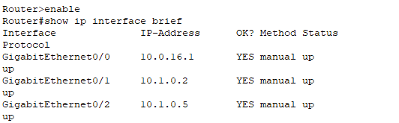

Fig 4. Ex.IP addressing of Floor 2’s router in CLI

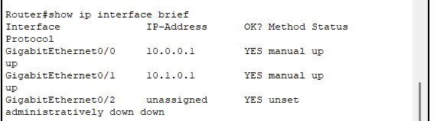

Fig 5. Ex. IP addressing of Floor 1’s router in CLI

Routing

In our project, we used Static Routing for inter-floor communication between the floor routers. Static routes were manually configured on each floor’s router, specifying the exact path to reach networks located on other floors. This approach ensures that devices on one floor can communicate with devices on any other floor by following predefined routes without relying on dynamic routing protocols. While static routing requires careful planning and manual updates if the network changes, it provides better control, security, and predictability in a network like ours, where the structure is relatively stable.

|  |
| --- |
| Floor 1 |
| Floor 2 |
| Floor 3 |
| Floor 4 |
| Floor 5 |

Table 3. Snaps of static routing between routers on CLI

Communication between PC’s

To check communication between pc’s we used the ping command in the command prompt and to see the paths we used tracert command also to see flow of packets.

|  |
| --- |
| Floor 1 to 1 |
| Floor 1 to 2 |
| Floor 1 to 3 |
| Floor 1 to 4 |
| Floor 1 to 5 |

Table 4. Snaps of inter-communication between pc’s of all floors

Using the ping command.

Usage of Tracert command :

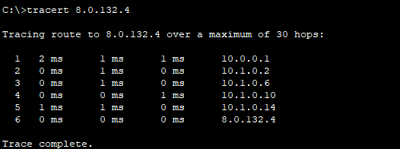

Fig 6. Use of Tracert command on floor 1’s pc to floor 5’s pc to see flow of data to trace the route.

Floor-Wise Server Setup:

|  |  |  |
| --- | --- | --- |
| Server | Floor | IP |
| Email | 1 | 10.0.0.2 |
| DNS | 2 | 10.0.16.2 |
| HTTP | 3 | 8.0.0.2 |
| FTP | 5 | 8.0.132.3 |
| DHCP | 5 | 8.0.132.2 |

Table 5. Floor-Wise Server Ip and Floor number

Email Server Setup:

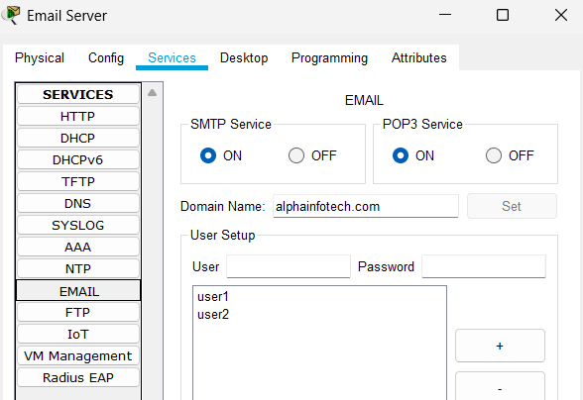

Fig. 7 Email Server setup on floor 1

|  |  |
| --- | --- |
|  |  |

Fig. 8 User Mail setup on PC

|  |
| --- |
|  |
|  |

Fig 9. Mail Sending and Receiving from 2 pc’s on floor 1

DNS Server Setup:

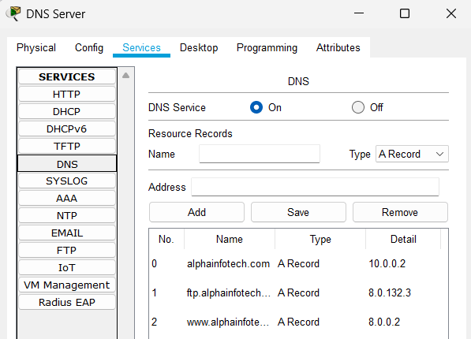

Fig 10. DNS Server Setup on Floor 2.

The Email server (alphainfotech.com) was assigned the IP address 10.0.0.2, the FTP server (ftp.alphainfotech.com) was assigned 8.0.132.3, and the HTTP server (www.alphainfotech.com) was mapped to 8.0.0.2. This DNS configuration ensures that all users can easily connect to services using domain names

DNS Testing:

We Tested its working by opening browser on a pc and directly searching the url/domain names.

|  |
| --- |
| For Email Server |
| For HTTP Server |
| For FTP Server |

HTTP Server Setup:

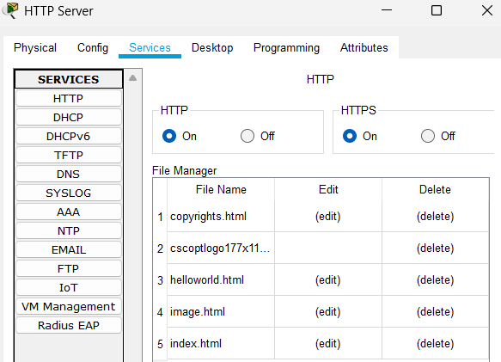

HTTP and HTTPS are by-default always on in a server. So, we didn’t needed to do anything else. We just added the domain in the DNS server of this server.

DHCP Server:

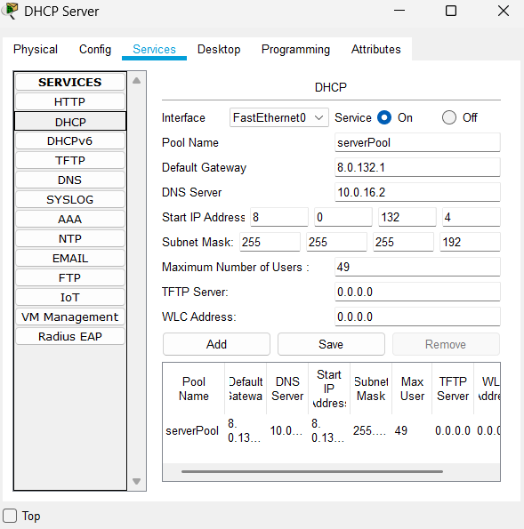

We automatically configured all the pc’s in floor 5 using dhcp server by giving it various informations.

FTP Server:

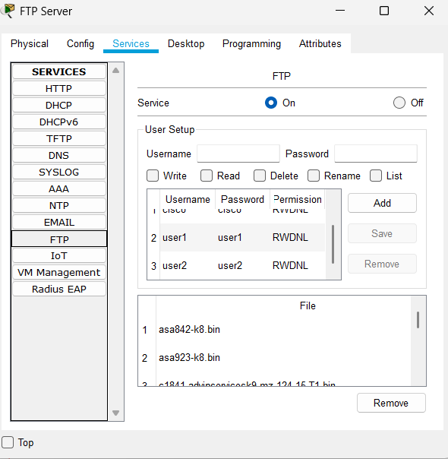

We created two users, namely user1 and user2 with all permissions.

Testing of FTP:

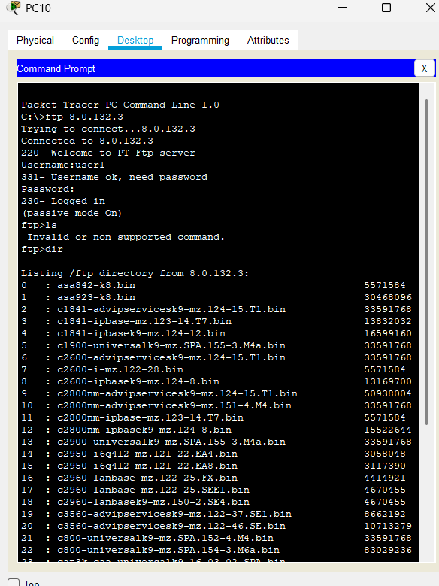

THANK YOU!!