**“*Analysis of Top Universities in United States of America*”**

By

**Aryan Jain**

**Table of Contents**

Introduction- 3

Introduction to Datasets- 4

Sources of Datasets- 4

Key Audiences- 4

Story Telling by Data Visualization- 5

Descriptive - 5

Predictive- 5

Prescriptive- 5

Question Story- 1 6

Descriptive - 6

Predictive- 7

Prescriptive- 8

Question Story- 2 9

Descriptive 9

Predictive 10

Prescriptive 11

Question Story- 3 12

Descriptive 12

Predictive 13

Prescriptive 14

Conclusion- 15

What have we learnt from Data Visualisation Concepts? 15

How has the Data Visualization process helped you find answers to the questions you developed? 16

References 17

# Introduction-

In the United States, higher education is vital to furthering individuals' social and economic growth. A master's degree is one of the most efficient methods to get the information and skills required to survive in an increasingly competitive and fast-changing environment. Nonetheless, with so many good institutions and universities to pick from, deciding on the best one might be difficult.

The goal of this visualization project is to evaluate and provide information on the best master's programs at colleges in the United States. The goal is to help prospective students make educated judgments by offering a complete visual picture of the country's top colleges, including insights into key factors like beginning wages, student-to-faculty ratios, and admission rates.

To achieve this purpose, we gathered information from a variety of sources, including renowned organizations and important performance metrics. The information was then presented in a visually appealing and user-friendly style using data visualization techniques.

The major goal of our project is to give prospective students an overview of the country's leading colleges and institutions, as well as critical criteria for making educated selections about where to continue their master's degree. We think that by doing so, we may make the process of picking a university less intimidating and clearer.

In the next sections of our study, we give our results and visualizations of the top master's programs in the United States, including their rankings and numerous metrics such as admission rates, beginning salaries, and student-to-faculty ratios.

# Introduction to Datasets-

The datasets utilized for this research come from Kaggle, which gives information on the best American universities. The files provide critical information about each university, such as financial assistance, student population, university phone number, website, and more. This data will be the major source of information for our analysis.

In addition, for additional research, we are combining university data with information on average salary in the United States on a state-by-state basis. This information was taken from the USDA's county-level dataset, which contains information on numerous economic and social variables across the United States.

We want to give more complete insights into the link between university choice and earning potential by merging these datasets. This technique, we hope, will enable prospective students to make more informed selections about where to pursue their master's degree.

## Sources of Datasets-

* [Top American Colleges 2022 | Kaggle](https://www.kaggle.com/datasets/kabhishm/top-american-colleges-2022)
* [World University Rankings | Kaggle](https://www.kaggle.com/datasets/mylesoneill/world-university-rankings?select=timesData.csv)

## Key Audiences-

Using data visualization tools such as charts, graphs, and maps, our project provides an interactive approach for parents and their children to research top colleges in the United States for master's degrees. We also hope to help institutions improve their academic programs and attract more students by offering our data analysis. Our project includes interactive capabilities such as data filtering and sorting, hovering over data points for more information, and interactive maps to display university dispersion. The major target for our initiative is current and prospective students, but institutions may also benefit from our research in order to enhance their rankings and recruit more students.

# Story Telling by Data Visualization-

**The main questions:-**

Q1. How do students make decisions for choosing the university?

## Descriptive - What is the student distribution in terms of choosing universities based on location versus academic programs?

## Predictive- How will changes in government funding for higher education impact the number of students attending universities in the future?

## Prescriptive- How can universities improve their financial aid packages to better support students with financial need?

Q2. What value do the universities provide to the students?

**Descriptive-** What is the distribution of students among top universities in terms of their socio-economic background, gender, and location, and what is their starting salary once they graduate?

**Predictive-** Based on the current data, what is the impact of universities' investment in career development, programs, starting salary, and other factors on graduates’ career success in the future?

**Prescriptive-** What are the areas of investment that the universities should focus on for providing better value to the students? For example, courses they offer, resources, or opportunities for career development.

Q3. What factors play an important role which might help universities attract students?

**Descriptive-** What are the key factors that influence students' decisions to choose a particular university for their master's degree? This question seeks to describe the factors that are currently important to students when they are considering their options for pursuing a master's degree.

**Predictive-** How will changes in the student-to-faculty ratio, faculty ratings, and tuition fees impact the competitiveness and attractiveness of universities for potential master's students.

**Prescriptive-** What steps can universities take to improve their attractiveness to potential master’s.

students? This question seeks to provide recommendations for universities on how to improve their standing among prospective students based on the factors identified in the descriptive question.

# Question Story- 1

**How do students make decisions for choosing the university?**

## Descriptive - What is the student distribution in terms of choosing universities based on location versus academic programs?

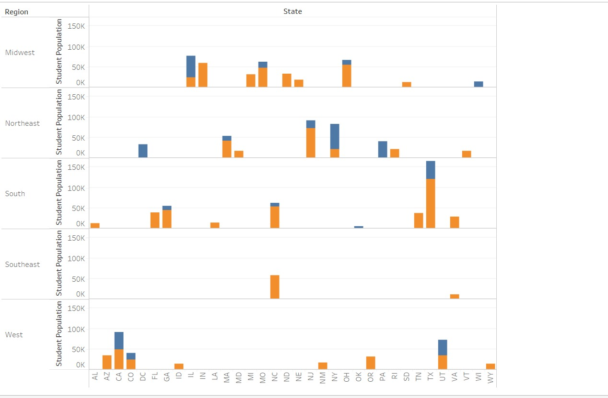

The visualization for this question is a bar chart that shows how region is affecting the student population as well as how public universities dominate the situation over private universities.

On the X-axis we can see different States in USA . The filters used here are “College type” which shows us whether the university is Public or a Private Institution, “Carnegie Classification” which is a framework used to classify colleges and universities according to the degrees offered.

The Y axis shows student population region wise. The output shows that in each region, students select public universities irrespective of course. As the population is higher in public universities in each region, we can interpret that students are preferring the public universities.

Furthermore, the students are choosing the universities in the urban areas. They do so for various reasons, such as facilities or amenities provided in the urban areas. Also, infrastructure, safety reasons along with the connectivity which is higher in the urban cities.

Predictive- How will changes in funding for higher education impact the number of

students attending universities in the future?

The above graph predicts the relationship between the student population and total grant.

On X-axis, we have shown the population of students through the Universities in United States.

Now on Y-axis, total grant aid offered by the universities. In the filters we have used rank and region. While in the detail, we have used research rank and organisation name.

The visualisation tells that the student population is increasing where more total grant there is aid is offered. Furthermore, the trend suggests that higher the impact of research rank, higher is the grant provided to the students and they are more attracted to such universities. After applying the filter, we can observe that there is more dominance in the North-eastern region, this correlation is more significant depending on the R square value which is 0.563. The reason for this significant relation is due the fact that all the top ranked universities like the Ivy League’s - Harvard, MIT are in that region with higher research impact.

## Prescriptive-How can universities improve their financial aid packages to better support students with financial need?

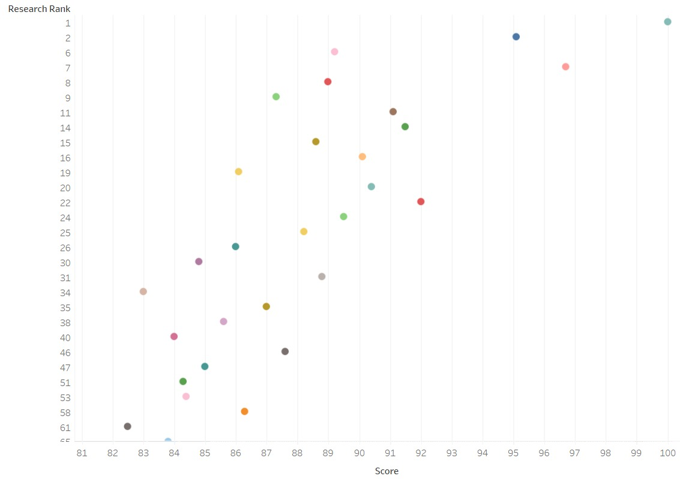

The above graph shows the prescriptive analysis based on the research rank and score. Here on the X-axis, we have represented score whereas on the Y-axis we have represented score. The score implies an overall university score which was calculated using parameters such as student-faculty ratio, employability rank, education quality, student-intake ratio, etc. This graph suggests that research rank is impacted by the score, which means as the score is increased research rank is also increased. So, based on the predictive analysis, which suggested that research rank is preferred factor for the grant offered and eventually to attract a greater number of students, we can suggest that universities can increase their research rank by increasing their overall score. Thus, it is suggested that universities should work on improving the score by working on employability, increasing infrastructure for research etc. if they want to increase the research rank and the students would prefer such universities.

# Question Story- 2

**What value do the universities provide to the students?**

Descriptive**-** What is the distribution of students among top universities in terms of their gender, and location, and what is their starting salary once they graduate?

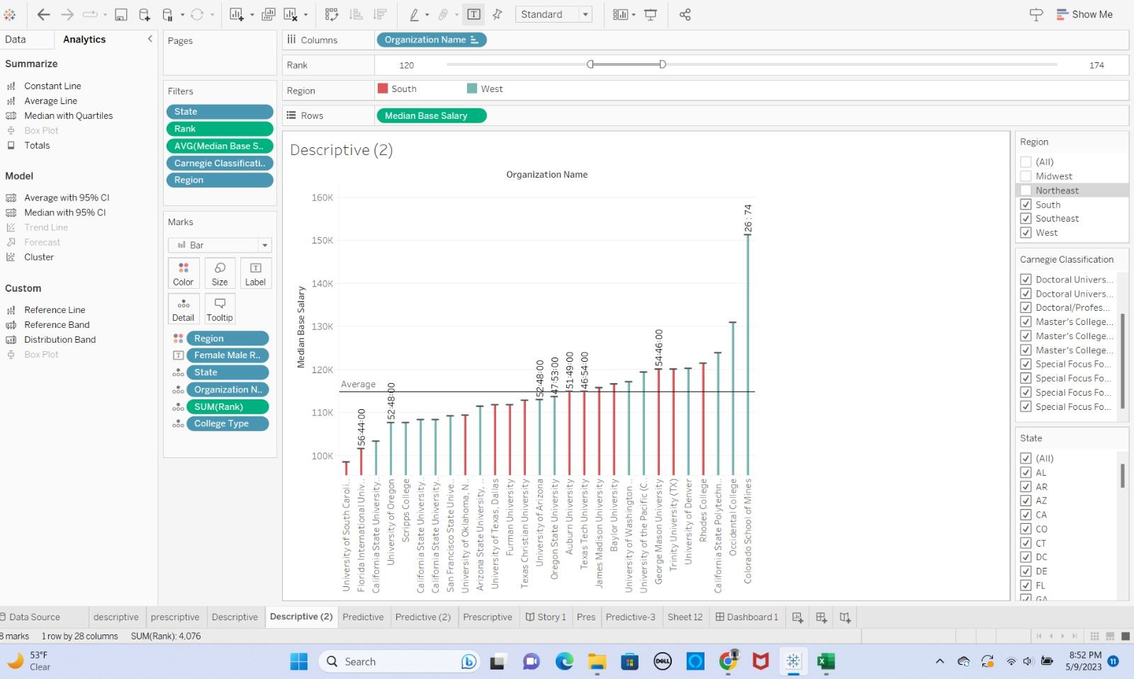

Here in the above given bar graph, we are showing the distribution of the students based on the various factors in the filters such as gender, and location, and what is their starting salary once they graduate. The X- axis shows the universities name and Y- axis shows the median base salary. The graph suggests that the university popularity is increasing with the median salary. Also, this distribution helps to understand for the further analysis in the prediction for providing the better value to the students based on the distribution like the research rank, scores, and citation.

Predictive**-** Based on the current data, what is the impact of universities' investment in career-

development, programs, and other factors on graduates’ career success in the future?

The above graph is forecasting the research rank, citation, and total score. The total score is dependent on the various factors like research facilities, faculty ratio, infrastructure etc. In this line graph, over the years, how the research rank is being conducted in the universities, citations, and total scores. Over the years the years research rank has been reduced while, citations have increased, and total scores is consistent. The forecasting tells all the three parameters will remain the same in the coming two years. This means it will affect the career development of students because as the research score will increase, the popularity of university will increase which can provide more value in terms of their career with better alumni recognition. Moreover, the score will impact the quality of education, quality of faculty and program offered that can provide value to the students.

Prescriptive**-** What are the areas of investment that the universities should focus on for providing better value to the students? For example, courses they offer, resources, or opportunities for career development.

The above dot graph shows the prescriptive analysis. As in the predictive analysis we came to know that total score is dependent on the citation and quality of education with other factors. We can suggest to the universities that for the providing more value to the students in future, they must improve the total score which eventually means improving the research rank, teaching (quality of education, and citation). In other words, Universities may enhance their overall score by boosting their research output, teaching quality, citation impact, internationalization, and infrastructure. This may be accomplished through encouraging academic members to publish significant research, investing in teacher professional development, supporting multidisciplinary partnerships, recruiting foreign students and faculty, and improving infrastructure.

# Question Story- 3

**What factors play an important role which might help universities attract students?**

Descriptive**-** What are the key factors that influence students' decisions to choose a particular university for their master's degree? This question seeks to describe the factors that are currently important to students when they are considering their options for pursuing a master's degree.

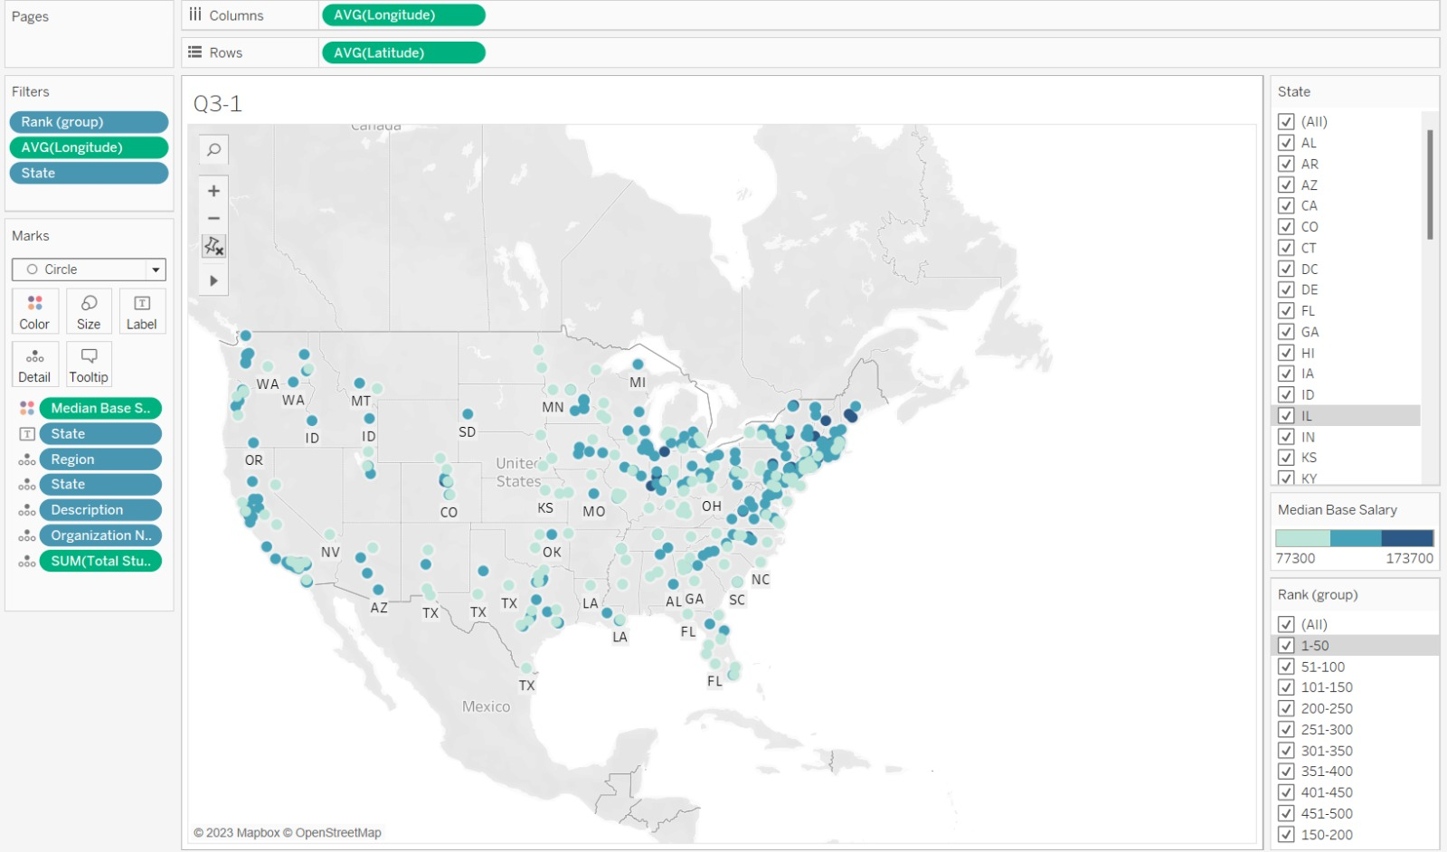

The above map is showing the visualisation of median base salary distribution in different region throughout the country according to the rank. Further, the focus has been shifted to the top-ranking universities by forming the groups. This has helped in comparing the factors in the top universities and lowered rank universities. The output shows that median base salary is going up with higher university rank. Moreover, this map visualisation helps us to easily navigate the median base salary, so that it becomes easy to focus on region and the universities located there.

Predictive**-** How will changes in the student-to-faculty ratio, faculty ratings, and tuition fees impact the competitiveness and attractiveness of universities for potential master's students?

The above graph shows the predictive analysis for the top 18 universities. It shows that the university rank is correlated with the overall score and faculty rank. This shows that if the other universities want to attract more students that is the lowered rank universities, they need to focus on the faculty rank and overall score. Thus, we can predict that popularity of any university is based on the score which is proportional to the institute/faculty rank.

Prescriptive**-** What steps can universities take to improve their attractiveness to potential master's students? This question seeks to provide recommendations for universities on how to improve their standing among prospective students based on the factors identified in the descriptive question.

Based on the factors identified in the predictive analysis, we can suggest to the universities that for improving their popularity or rank, they need to increase their student staff ratio and average teaching score which means the overall teaching quality. So, Universities could increase faculty numbers to reduce the student-staff ratio, invest in teacher training to improve teaching quality, use technology to enhance the student learning experience and reduce the workload on faculty members, and offer smaller class sizes for more personalized attention to boost their popularity or rank. These efforts can raise the average teaching score and attract more students who value high-quality education, as well as expand course offerings and research programs and improve overall educational quality to boost the university's reputation and attract more students and faculty.

# Conclusion-

From the entire Data Visualization in our project, we noticed a certain pattern and parameters responsible for the decisions taken by the students. In the first half, we noticed that most of the student population chose the Urban areas for their studies and academic career. This proves how the location dominates the decision since it all comes down to the several factors like the safety concerns, infrastructure, connectivity, job opportunities with exposure to work culture as well as diversity. From this we also noticed that although students preferred the urban areas, they chose public universities over private since the reason can be regarding the tuition fees and government facilities. Moving to the second half, we observed that- the more the research facilities, citations, and quality of education with respect to the faculty rank, more the Grant offered to the Universities which results into better ranking and excellent career opportunities and thus providing more value to the students. This shows how several factors, parameters are related to each other and how the connections help in determining the decision of students and how Universities can excel with their ranking.

## What have we learnt from Data Visualisation Concepts?

From the data visualisation concepts we have learnt valuable insights from the data that we had on university ranking and several factors that a student would prefer while selecting a university.

Firstly, we have learned the concept of data collection, integration, and cleaning of the data. We have collected it from the various resources, then integrating and cleaning the null values which have filtered the data and made relevant to the project.

Secondly, knowing the target audience, we have applied the concepts by understanding the needs of the main audience, which are students and the purpose which was selection of universities.

Thirdly, we have learned the concept of correct data visualisation techniques, for instance, different types of graphs such as line graph, bar chart, scatter plot, forecasting technique, grouping of the data, along with using the right colour techniques for using the proper visualization. For instance, we have grouped the ranking for more critical insights, used line graph to understand the patterns and colour to show the region.

In this project, we have applied the concept of storytelling. There are various kind of story telling and we have decided to choose first starting with expanded view and drilling down to the focused view through analysing the location like considering the wider view to drilling down to the factors among the grouping of the universities.

## How has the Data Visualization process helped you find answers to the questions you developed?

The visualisation process helped us finding the answers to major questions developed in the project. It has helped us to solve the purpose for the target audience. We have recognised the patterns and factors which affects the popularity of the universities. We have recognised how student choose the university based on location or region or if there are any more parameter affecting their decision. Furthermore, we have solved the question how the universities can improve the value for the students through recognising the patterns of research rank, total score making this visualization helpful for the Universities as well to develop themselves on a wide scale. Moreover, we solved the factors that are important among the top universities and the universities with lowered rank by comparing them.

# References

Gomes, M. M. (2018). Data Visualization: Best Practices and Foundations. Toptal Design Blog. <https://www.toptal.com/designers/data-visualization/data-visualization-best-practices>

What is Interactive Data Visualization? | HEAVY.AI. (n.d.). <https://www.heavy.ai/technical-glossary/interactive-data-visualization>

Hooper, L. (2023, April 25). Data Storytelling: How to Tell a Story With Data - Venngage. Venngage. <https://venngage.com/blog/data-storytelling/>

**Thank You!**