DEPARTMENT OF COMPUTER SCIENCE & ENGINEERING
ABES ENGINEERING COLLEGE, GHAZIABAD
SOFTWARE REQUIREMENTS
SPECIFICATION (SRS)
Project Title: DataLens AI: Conversational Data Analysis Assistant, Natural-Language Q&A over CSV Datasets
Project ID: P_123 (HCL Industry Project)
Standard Academic Compliance: IEEE Std 830-1998
SUBMITTED BY:  1. Aryan Kumar Yadav (Roll No: 2400320100292)  Degree: Bachelor of Technology (B.Tech)  Academic Year: 2026 - 2027 | UNDER THE GUIDANCE OF:  Ashwani Kumar  Project Guide  Department of Computer Science & Engg.  Status: 3rd Year Project Specification  Date of Submission: 01-10-2026

Document Revision & Approval History
Version | Date | Description / Major Changes | Prepared By | Reviewed By
0.1 | 28-09-2026 | Initial Draft & Scope Definition | Aryan Kumar Yadav | Project Guide
1.0 | 30-09-2026 | Final 3rd Year Mid-Term SRS Baseline | Aryan Kumar Yadav | HOD / Committee

Guidance Note: This Software Requirements Specification document conforms to the IEEE 830-1998 standard recommended practice. All sections are strictly designed for 3rd-year university lab evaluation, project reviews, and system design baselines.

1. Introduction

1.1 Purpose
The purpose of this Software Requirements Specification (SRS) is to provide a complete, clear, and unambiguous definition of the functionality, external interfaces, performance targets, and constraints of the proposed system: ‘DataLens AI: Conversational Data Analysis Assistant’. It serves as a reference agreement between the student developer, project evaluators, the academic supervisor, and prospective end users during the 3rd-year engineering curriculum.

1.2 Scope of the System
The application is designed to solve the problem that non-technical users cannot query CSV data without Pandas, SQL or formulas, and that general chatbots invent numbers. A user loads a CSV and asks questions in plain English; a language model turns the question into a Pandas expression, the backend validates it, and Pandas computes the real answer. Key boundaries:
- In-Scope: CSV ingestion (upload or local folder), profiling and schema review, conversational Q&A, secure query validation and local Pandas execution, Show Calculation, chart builder, data-quality score, insights, history and HTML reports.
- Out-of-Scope: User authentication (single-user local app), RAG and vector databases, custom ML training, Docker and microservices, cloud databases, Excel and multi-CSV joins.
- Expected Benefits: Answers without technical skill, numerically verified results (the LLM never calculates), transparent calculations, and privacy by design because raw rows stay local.

1.3 Definitions, Acronyms, and Abbreviations
Category | Term / Acronym | Definition / Standard Context
Standard | SRS | Software Requirements Specification (IEEE Std 830-1998 format).
Architecture | API / REST | Application Programming Interface; stateless architectural style exchanging JSON over HTTP.
Data | CSV / DataFrame | Comma-separated file; in-memory Pandas table (df) holding the loaded dataset.
Database | SQLite | Serverless file-based database for metadata, history and pins.
AI | LLM | Large Language Model; Groq-hosted openai/gpt-oss-120b.
Project Specific | Schema / AST validator | Column names, types and descriptions (no row values); check that parses a generated expression and rejects unsafe constructs.

1.4 References
- IEEE Std 830-1998: IEEE Recommended Practice for Software Requirements Specifications.
- Software Engineering (10th Edition): Ian Sommerville, Pearson Education.
- APIs and Manuals: Pandas, NumPy, FastAPI, Groq API, React, Vite, Tailwind CSS and Recharts documentation; HCL problem statement P_123.

1.5 Document Overview
Section 2 outlines the product perspective, user personas, operating context and constraints. Section 3 itemizes functional requirements by module. Section 4 specifies external interfaces. Section 5 defines non-functional attributes. Section 6 provides standard analysis models and Section 7 the academic sign-off.

2. Overall Description

2.1 Product Perspective
The project is a self-contained multi-tier system: a presentation layer (React), an application/API tier (FastAPI with the Pandas analysis engine) and a lightweight persistence layer (in-memory DataFrame plus SQLite). It interfaces with one external service, the Groq LLM API, over HTTPS; only the approved schema and the user’s question are transmitted.
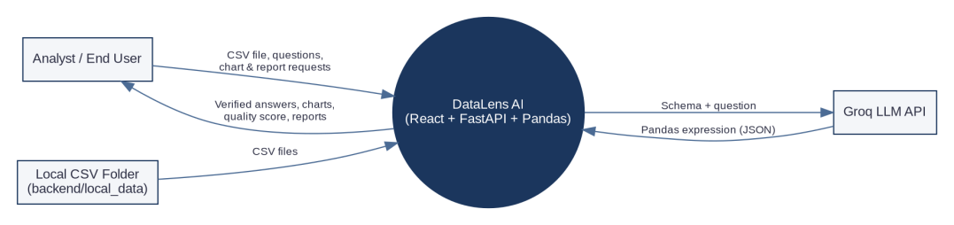
Figure 2.1: System Context Diagram (DFD Level 0)

2.2 User Classes and Characteristics
User Role / Persona | Technical Proficiency | Core Responsibilities & Rights
Analyst / End User | Basic to Intermediate | Loads CSVs, reviews schema, asks questions, builds charts, checks quality, pins analyses, generates reports.
Technical User / Student | High (knows Pandas) | Uses Show Calculation to verify generated queries, timings and execution location.
Evaluator / Reviewer | Intermediate | Verifies correctness, privacy behaviour and rejection of unsafe queries.

2.3 Operating Environment
- Client: Modern browser (Chrome >= v110, Firefox >= v108, Edge, Safari); 1366x768 desktop, responsive down to 360x640.
- Server Runtime: Windows, Linux (Ubuntu 22.04 LTS) or macOS; Python 3.10+ (backend) and Node.js 18 LTS+ (frontend build).
- Storage Tier: SQLite 3, in-memory Pandas DataFrame, and the local folder backend/local_data/.

2.4 Design and Implementation Constraints
- Academic Budget: Local deployment and Groq free tier; no paid cloud infrastructure.
- Security and Privacy: LLM output is untrusted and must pass the AST validator; the API key stays in the backend .env; the full CSV and result tables are not sent to the LLM.
- Modularity: Separate api, services and schemas on the backend; pages, components, context and services on the frontend.

2.5 Assumptions and Dependencies
- Assumptions: Input CSVs are well-formed and fit in memory; the user has a Groq API key and Internet access for LLM features.
- Dependencies: Availability of the Groq API; Python packages FastAPI, Pandas, NumPy, Pydantic; JavaScript packages React, Vite, Tailwind CSS, Recharts.

3. System Features and Functional Requirements
Requirements are grouped by module with unique identifiers (FR-x.x). Priority: High, Medium, Low.

3.1 Module 1: Dataset Loading, Profiling and Schema
Req ID | Feature Description | Input / Validation Rule | Priority
FR-1.1 | CSV upload and local-folder load | Only .csv; empty, headerless or oversized files rejected; local files only inside backend/local_data/ (path traversal such as ../ blocked); encodings UTF-8, UTF-8-SIG, CP1252, Latin-1 tried | High
FR-1.2 | Dataset session management | Unique dataset_id per load; DataFrame held in memory; unknown ID returns 404; DELETE removes the session | High
FR-1.3 | Profiling and type detection | Rows, columns, missing, duplicates, numeric/categorical/date counts, statistics, paginated preview; semantic types without altering the DataFrame | High
FR-1.4 | Schema review and AI-safe schema | Editable column descriptions; schema sent to the LLM holds only names, types, descriptions; sample values excluded unless enabled | High

3.2 Module 2: Conversational Ask Data and Secure Execution
Req ID | Feature Description | Input / Validation Rule | Priority
FR-2.1 | Intent routing | Dataset analysis, dataset information, data concept, app help, general chat or clarification; information questions answered locally without the LLM; no-dataset message offers Upload / Browse actions | High
FR-2.2 | LLM query generation | Approved schema + question to Groq; strict JSON with one Pandas expression, explanation and chart suggestion | High
FR-2.3 | Supported operations | mean, sum, median, min, max, count, distinct, filter, group-by, sort, top/bottom N, correlation, percentage, time-series grouping | High
FR-2.4 | AST validation | Every expression parsed with ast; imports, open/eval/exec/compile, os/sys/subprocess/requests, file read/write methods, dunder access and non-whitelisted methods rejected | High
FR-2.5 | Repair and local execution | One automatic LLM repair retry; if still unsafe, nothing runs and a safe-failure message is shown; valid query executed by execute_pandas_query(df, query) | High
FR-2.6 | Follow-ups and clarification | Minimal structured context only (never result tables); ambiguity such as several sales columns triggers a question | Medium

3.3 Module 3: Explainability, Visualization and Quality
Req ID | Feature Description | Input / Validation Rule | Priority
FR-3.1 | Show Calculation | Question, Pandas query, columns, filters, grouping, aggregation, rows analysed, dataset, execution location, whether the CSV was sent to the LLM, per-stage timings | Medium
FR-3.2 | Chart builder | Bar, Line, Pie, Scatter, Histogram; X, Y, aggregation, Top N; data computed by Pandas via POST /visualize; natural-language chart requests | Medium
FR-3.3 | Data quality and health score | Missing %, duplicates, invalid types, constant columns, IQR outliers; 0-100 heuristic score; fixes only with user confirmation | Medium
FR-3.4 | Insights and suggestions | Insights and suggested questions derived from Pandas and the schema; the LLM may not invent numbers | Low

3.4 Module 4: Dashboard, History, Reports and Settings
Req ID | Feature Description | Input / Validation Rule | Priority
FR-4.1 | Dashboard and status | Real metrics, health score, Quick Ask; Backend / AI / Dataset indicators; local features work if the LLM is down | Low
FR-4.2 | History and pins | Session history with Open, Pin, Add-to-Report; follow-up question suggestions after every answer | Medium
FR-4.3 | Reports | Select sections (overview, schema, quality, pinned insights, history, charts, privacy, methodology); downloadable HTML with real figures | Low
FR-4.4 | Privacy Centre and Settings | Data-flow explanation; theme; toggles: send schema (ON), descriptions (ON), sample values (OFF) | Low

4. External Interface Requirements

4.1 User Interfaces (UI)
The interface follows standard UX best practices: dark-first minimal design (background #09090B, card #111113, border #27272A, one blue/violet accent), persistent sidebar, active-dataset indicator, and empty, loading and error states on every page, with inline feedback on forms and a responsive layout. Planned screens: (1) Dashboard with dataset loader, (2) Ask Data chat with answer cards, (3) Visualize chart workspace, (4) Data Quality, (5) Schema, Privacy, Reports and Settings. Screen captures will be added to the final submission.

4.2 Hardware Interfaces
Standard keyboard, mouse and display (>= 720p) on a computer with enough memory for the loaded DataFrame. No embedded or IoT hardware is used.

4.3 Software Interfaces
- Database Connector: Python sqlite3 for metadata and history; Pandas for in-memory data.
- External LLM Service: Groq OpenAI-compatible endpoint (GROQ_BASE_URL, GROQ_MODEL), called only from the FastAPI backend.

4.4 Communication Interfaces
- Protocol: HTTP on localhost (frontend 5173, backend 8000); HTTPS for Groq. REST routes under /api/datasets/{id}/ (summary, schema, ask, visualize, quality, reports) and /health.
- Serialization: UTF-8 application/json; CSV upload as multipart/form-data.

5. Non-Functional Requirements (NFRs)
Attribute | Target Metric / Standard | Verification & Testing Method
5.1 Performance | Local operations complete within a few seconds on a 12,000 x 33 dataset; analysis time dominated by LLM latency; per-stage timings displayed (targets confirmed by measurement). | Timings in Show Calculation; Python timers and browser DevTools.
5.2 Security | AST validation before execution; path traversal blocked; API key only in backend; no raw stack traces shown. | Tests: import, eval, exec, file, network, dunder and ../../secret.csv rejected.
5.3 Privacy | Raw CSV, full rows and results stay local; only schema and question reach the LLM; sample sharing OFF by default. | Test that the AI schema contains no cell values.
5.4 Correctness | Every displayed number comes from Pandas execution, never from the LLM. | Verified answers on employee.csv and e-commerce data.
5.5 Reliability | Friendly handling of invalid CSV, empty file, large file, encoding problems, unsupported question, missing column, backend offline, LLM outage and rate limits. | Fault-injection tests; error-state review.
5.6 Portability | Chrome, Edge, Firefox, Safari; mobile to desktop; Windows, macOS and Linux. | Responsive inspection in DevTools.

6. System Design and Analysis Models
The following standard models illustrate the static and dynamic behaviour of the application: Use Case (Figure 6.1), Data Flow Diagram Level 0 (Figure 2.1) and Level 1 (Figure 6.2), Entity-Relationship Diagram (Figure 6.3) and Sequence Diagram (Figure 6.4).
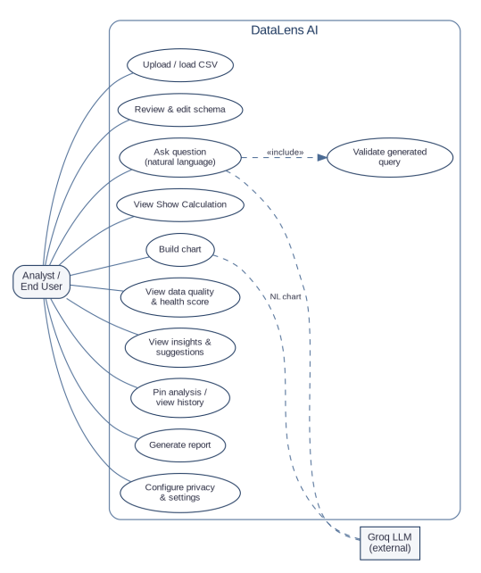  Figure 6.1: Use Case Diagram | 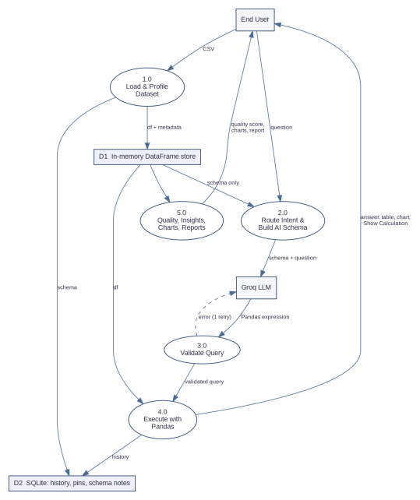  Figure 6.2: DFD Level 1

6.3 Entity-Relationship Diagram
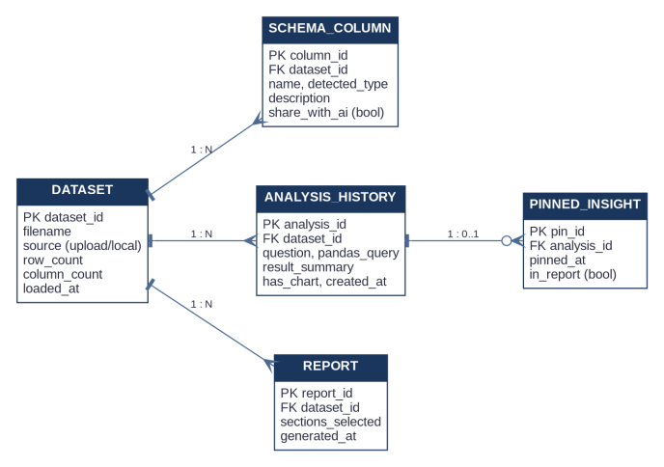
Figure 6.3: ERD of the SQLite metadata store (the active DataFrame stays in memory)

6.4 Sequence Diagram (Ask Data)
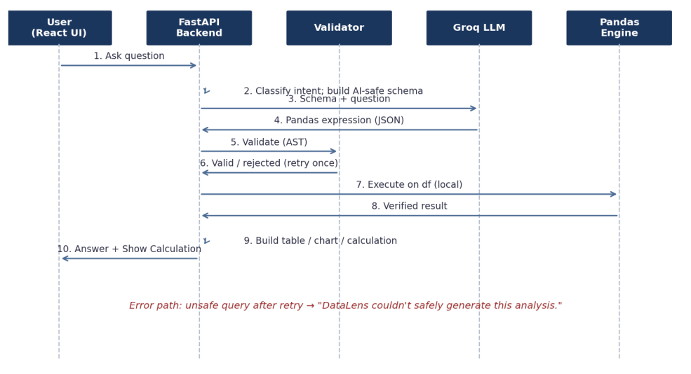
Figure 6.4: Question to Verified Answer, including the error path

7. Academic Review & Sign-Off
This Software Requirements Specification document has been submitted and reviewed by the academic supervisory panel:
Project Coordinator / Guide | Internal Examiner | Head of Department (HOD)
Signature: ____________________  Date: ____________________ | Signature: ____________________  Date: ____________________ | Signature: ____________________  Date: ____________________

Submitted by: Aryan Kumar Yadav (Roll No: 2400320100292) | Guide: Ashwani Kumar

