Synthetic GBM Data Preview
This document shows a simulated Geometric Brownian Motion price path used for training the reinforcement learning hedging model.

GBM Price Chart
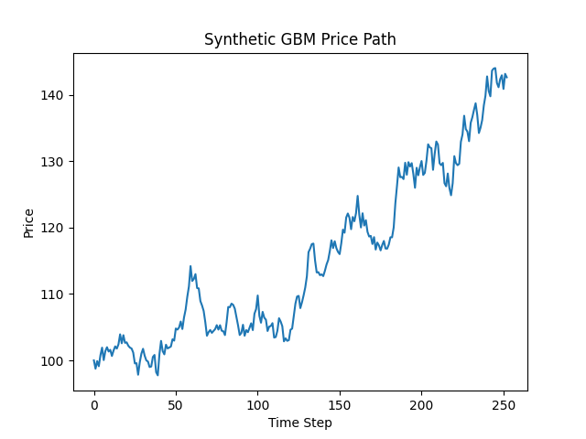

GBM Price Table
Time Step | Price
0 | 100.0000
1 | 98.7443
2 | 99.8923
3 | 99.1179
4 | 100.7861
5 | 101.9221
6 | 100.0428
7 | 101.4067
8 | 101.9828
9 | 101.3338
10 | 101.5856
11 | 100.6602
12 | 101.4754
13 | 102.1080
14 | 101.7765
15 | 102.4173
16 | 103.9268
17 | 102.5713
18 | 103.7961
19 | 102.6396
20 | 102.7150
21 | 102.2062
22 | 101.9202
23 | 101.7896
24 | 101.1754
25 | 99.5391
26 | 99.5833
27 | 97.8400
28 | 99.7134
29 | 101.0169
30 | 101.7445
31 | 100.7003
32 | 100.0001
33 | 99.8231
34 | 98.9950
35 | 99.0738
36 | 100.5085
37 | 100.8179
38 | 98.2196
39 | 97.7447
40 | 100.9271
41 | 102.9318
42 | 101.3863
43 | 100.9036
44 | 102.3561
45 | 101.7974
46 | 101.9493
47 | 102.0839
48 | 103.1785
49 | 102.9722
50 | 104.7984
51 | 104.6312
52 | 104.9607
53 | 105.8484
54 | 104.7182
55 | 106.4497
56 | 107.6590
57 | 109.5624
58 | 111.1251
59 | 114.1948
60 | 111.9497
61 | 112.2585
62 | 112.9927
63 | 110.8914
64 | 110.8371
65 | 108.9335
66 | 108.2684
67 | 107.4443
68 | 105.7567
69 | 103.7077
70 | 104.2462
71 | 104.5732
72 | 104.1429
73 | 104.4212
74 | 104.7087
75 | 105.3050
76 | 104.6320
77 | 105.2958
78 | 104.4652
79 | 104.3887
80 | 103.8069
81 | 105.7210
82 | 108.0413
83 | 108.0095
84 | 108.5462
85 | 108.3614
86 | 107.7948
87 | 106.5210
88 | 105.2592
89 | 103.8166
90 | 104.1323
91 | 105.3644
92 | 103.7053
93 | 104.5584
94 | 104.2393
95 | 104.9337
96 | 105.5837
97 | 104.5576
98 | 107.0229
99 | 107.7134
100 | 109.7700
101 | 106.7166
102 | 105.6659
103 | 107.3064
104 | 106.4262
105 | 106.1249
106 | 104.4190
107 | 105.0835
108 | 105.1787
109 | 105.6071
110 | 103.4312
111 | 103.5158
112 | 104.4543
113 | 106.3496
114 | 105.8493
115 | 105.1423
116 | 102.8635
117 | 103.3192
118 | 102.9388
119 | 103.0525
120 | 104.6149
121 | 104.7801
122 | 106.6690
123 | 108.5350
124 | 109.6090
125 | 109.7129
126 | 107.8658
127 | 108.7369
128 | 109.7871
129 | 110.9695
130 | 112.6629
131 | 116.2948
132 | 116.8244
133 | 117.5110
134 | 117.5868
135 | 115.0284
136 | 113.2410
137 | 113.2858
138 | 112.8276
139 | 112.9502
140 | 112.6903
141 | 113.4901
142 | 114.4354
143 | 115.1117
144 | 116.4496
145 | 118.0848
146 | 116.9084
147 | 117.9373
148 | 116.9074
149 | 116.3322
150 | 116.0013
151 | 117.6342
152 | 119.6845
153 | 119.2190
154 | 121.5120
155 | 122.1196
156 | 121.4762
157 | 119.7557
158 | 121.5975
159 | 120.9482
160 | 122.1744
161 | 124.7713
162 | 121.9078
163 | 120.0151
164 | 122.1493
165 | 120.3008
166 | 121.1159
167 | 119.3548
168 | 118.6502
169 | 118.7475
170 | 117.5226
171 | 118.5635
172 | 116.6879
173 | 117.7405
174 | 117.3050
175 | 116.5624
176 | 117.3788
177 | 117.9812
178 | 116.8440
179 | 116.8234
180 | 117.4422
181 | 118.5383
182 | 118.5329
183 | 120.0361
184 | 123.6487
185 | 126.2586
186 | 129.0471
187 | 127.5844
188 | 127.6320
189 | 127.2995
190 | 129.7571
191 | 127.9558
192 | 129.8483
193 | 129.1979
194 | 129.7030
195 | 128.0450
196 | 125.9888
197 | 129.0008
198 | 127.8758
199 | 129.1033
200 | 130.0220
201 | 127.9197
202 | 128.2382
203 | 130.0748
204 | 132.5366
205 | 132.0791
206 | 131.9495
207 | 128.6930
208 | 131.0712
209 | 132.9601
210 | 132.4966
211 | 129.6795
212 | 129.3921
213 | 129.7419
214 | 126.6855
215 | 126.2154
216 | 128.1366
217 | 125.9406
218 | 124.8617
219 | 126.6824
220 | 130.7544
221 | 129.7052
222 | 129.3902
223 | 129.6067
224 | 132.9145
225 | 134.0191
226 | 136.8378
227 | 134.8377
228 | 134.4398
229 | 133.0089
230 | 135.7750
231 | 136.6144
232 | 137.7299
233 | 138.7162
234 | 136.9315
235 | 134.2322
236 | 135.0421
237 | 136.1855
238 | 138.3816
239 | 139.8487
240 | 142.7627
241 | 140.5621
242 | 139.7644
243 | 143.6257
244 | 143.9376
245 | 144.0207
246 | 141.7748
247 | 141.1354
248 | 142.3562
249 | 142.9330
250 | 140.8713
251 | 143.1480
252 | 142.6240

