Task 1: Create a Storage Account
- Create an Azure Storage Account
- Configuration:
  - Performance: Standard
  - Redundancy: LRS (Locally Redundant Storage)
- Note the following:
  - Storage account name: waterlevel
  - Region: usEast
- Replication type: Cross Tanent Replication(Allow object replication to copy blobs to a destination account on a different Microsoft Entra tenant. Not enabling cross-tenant replication will limit object replication within the same Microsoft Entra tenant.)
Task 2: Blob Storage
- Create a Blob container named:
training-content
- Upload:
  - One video or large file
  - One PDF or text file
- Set the container access level to Private
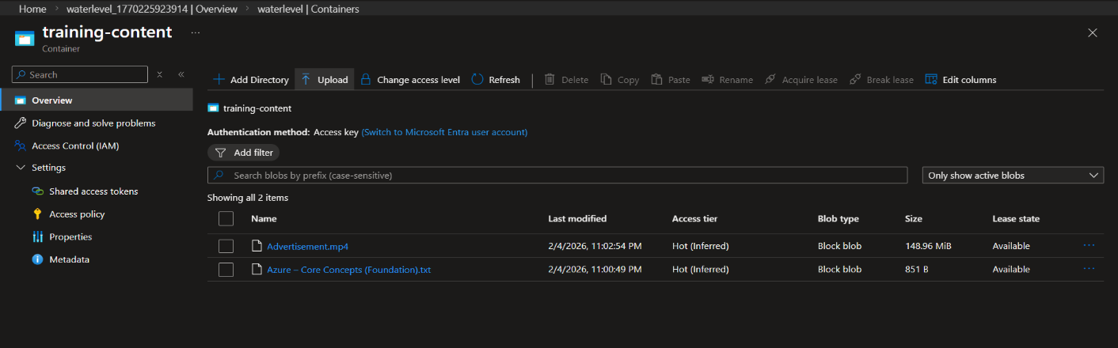
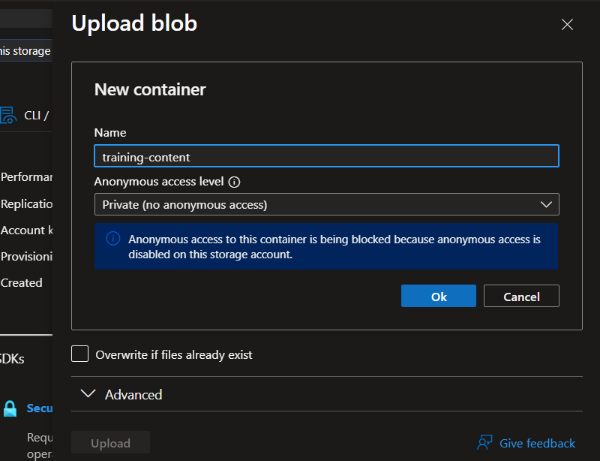
Task 3: File Share
- Create an Azure File Share named:
team-docs
- Upload any document (txt, pdf, or docx)

- 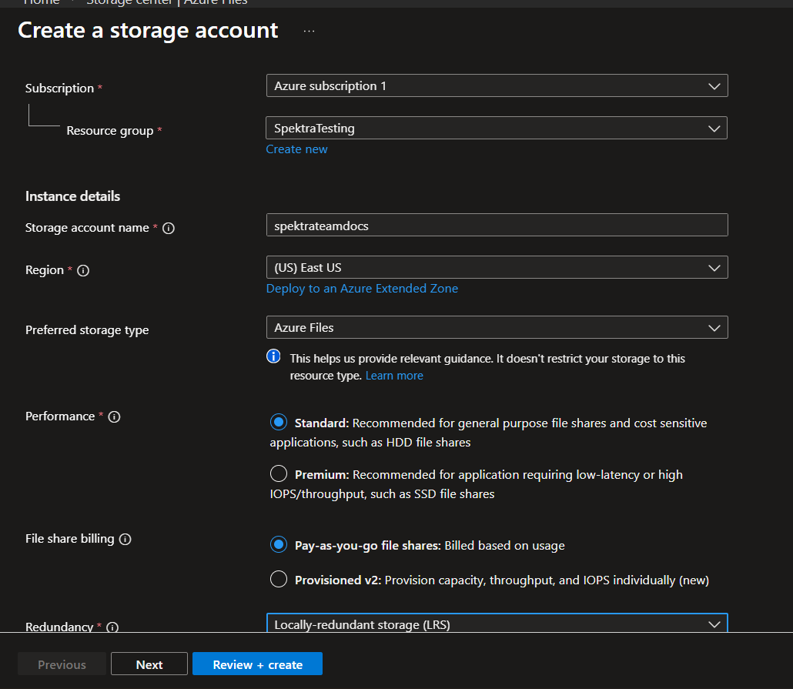
- 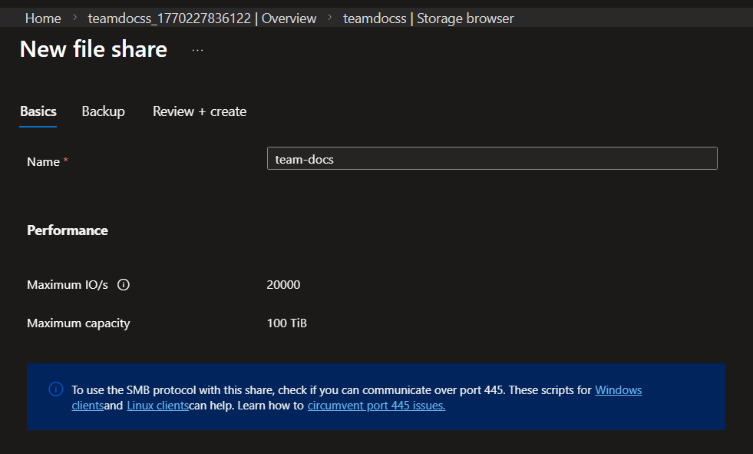
- 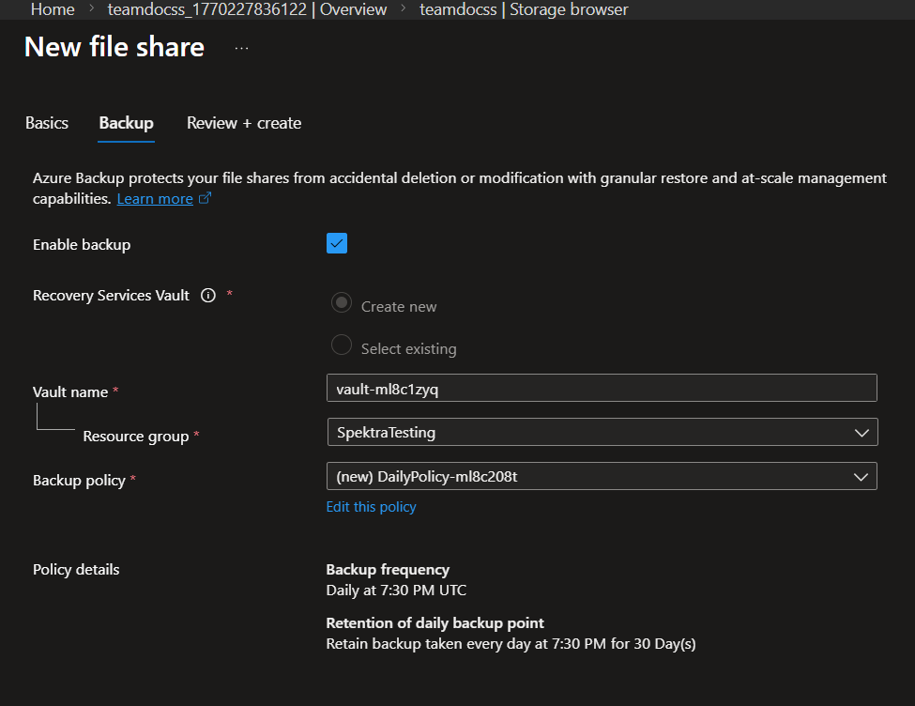
Task 4: Queue Storage
- Create a Queue named:
user-registration
- Add at least 3 messages
- View and delete one message
- 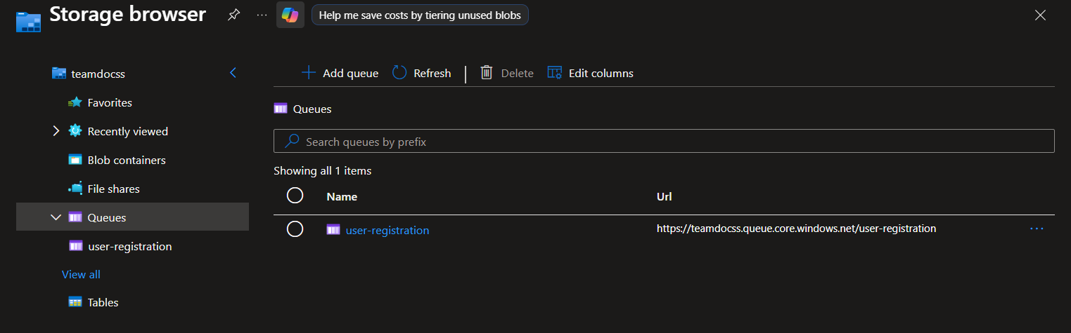
- 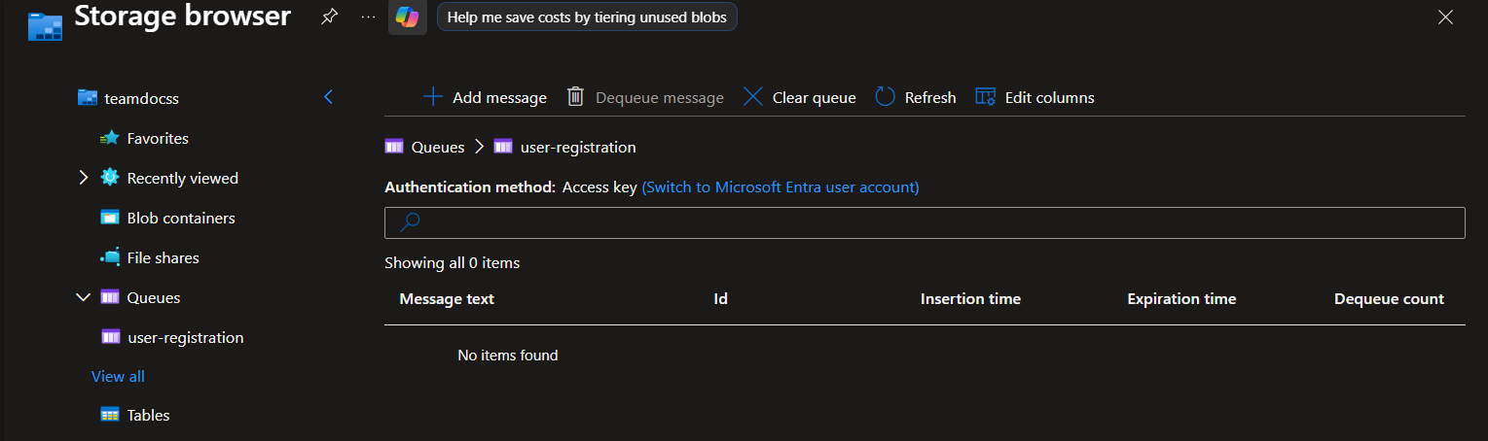
- 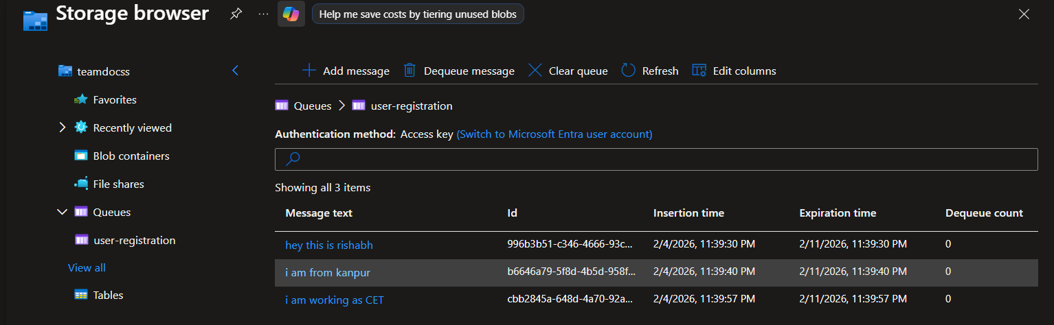
- 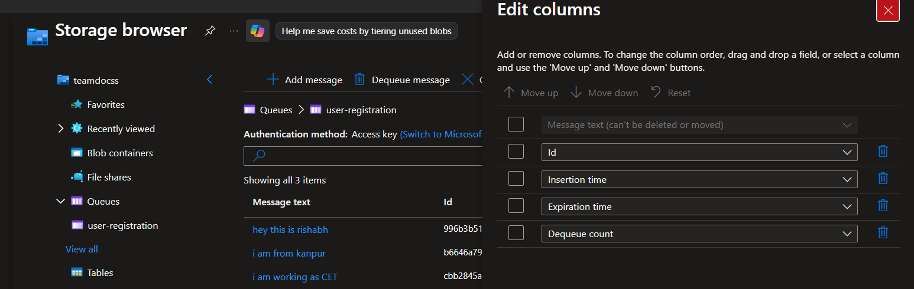
- 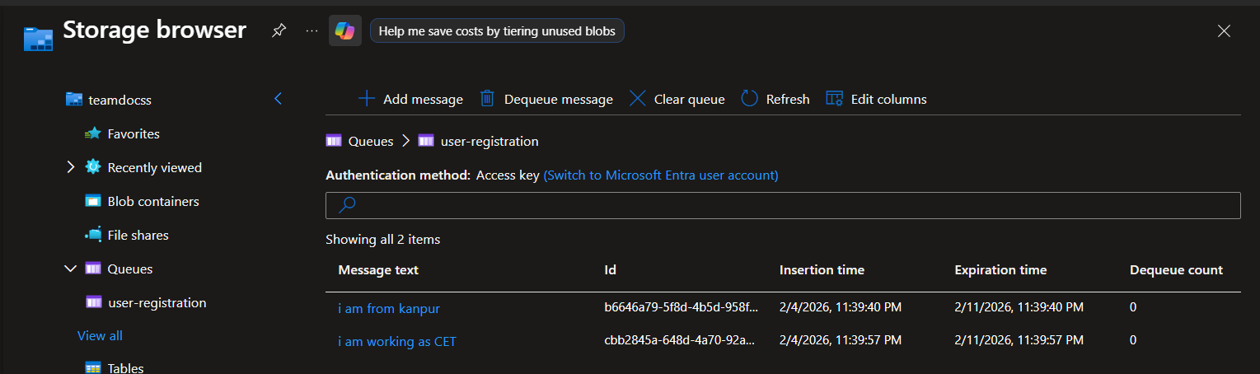
Task 5: Table Storage
- Create a Table named:
students
- Add at least 3 entities with the following fields:
  - PartitionKey
  - RowKey
  - Name
  - Course
- 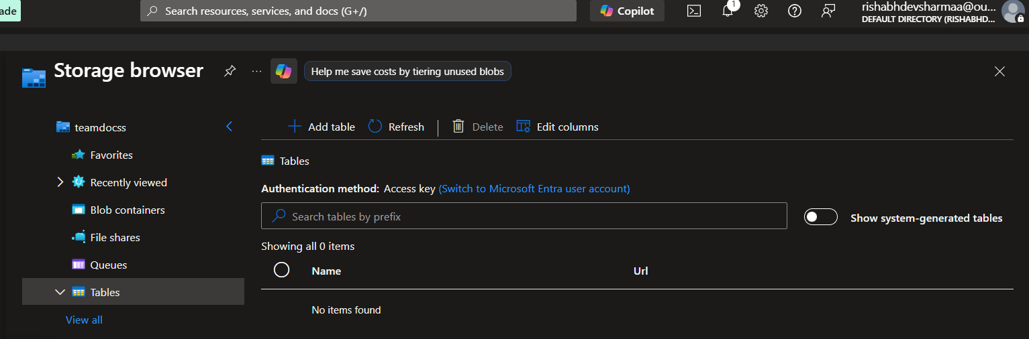
- 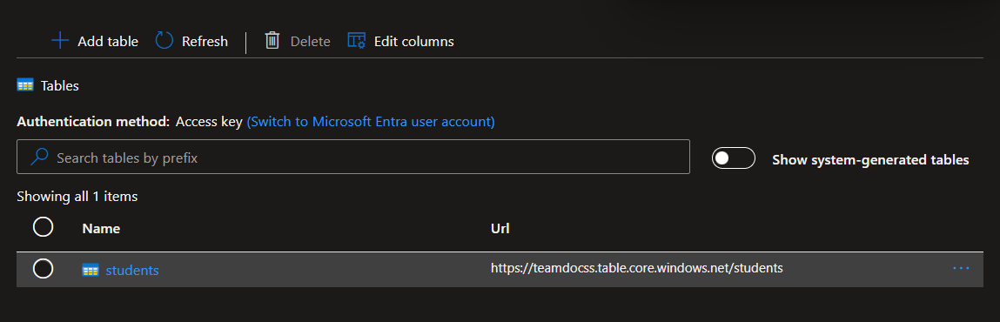
- 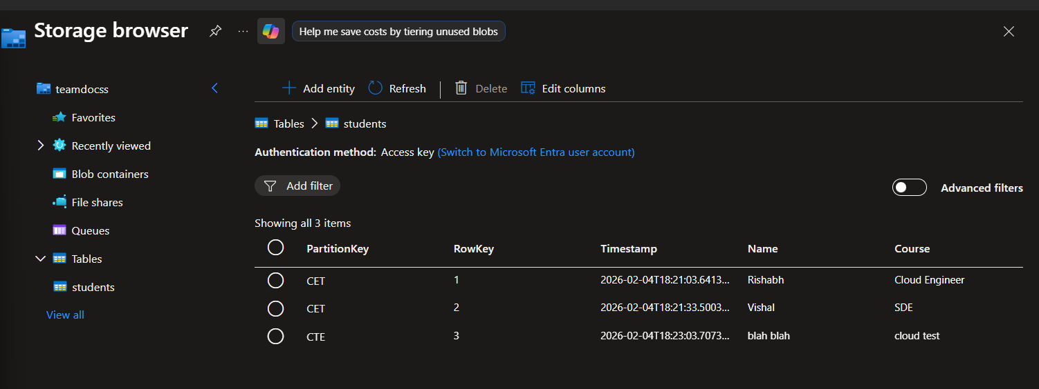
Task 6: Blob Soft Delete & Recovery
- Enable Soft Delete for Blob Storage
- Delete one blob from the training-content container
- Restore the deleted blob

Task 7: Access Control using SAS
- Generate a Shared Access Signature (SAS) for one blob
- Configure it as read-only
- Verify that the file can be accessed using the SAS URL
Task 8: Blob Storage Access Tiers
- Change the access tier of one blob from Hot to Cool
- Observe the available access tier options
- Note when each tier should be used (Hot vs Cool vs Archive)
Transition Type | What Happens? | Minimum Storage Period
Hot → Cool | You pay a Write charge for the move. | Must stay for 30 days.
Cool → Cold | You pay a higher Write charge than Hot-to-Cool. | Must stay for 90 days.
Cool/Cold → Archive | You pay a Write charge. | Must stay for 180 days.
Any Tier → Hot | You pay a Read charge (Rehydration). | N/A

Tier | Best Use Case | Retention / Cost Logic
Hot | Data accessed frequently (daily). | High storage cost but lowest access cost. No minimum retention period.
Cool | Data accessed infrequently (once a month). | Lower storage cost but higher access cost. Minimum retention: 30 days.
Archive | Data rarely accessed (once a year). | Lowest storage cost but highest access cost. Minimum retention: 180 days. Data is "offline" and takes hours to retrieve.

