Day 5 – Assessment: The Infrastructure Challenge
Task 1: Networking Setup
- Create a Virtual Network (VNet)
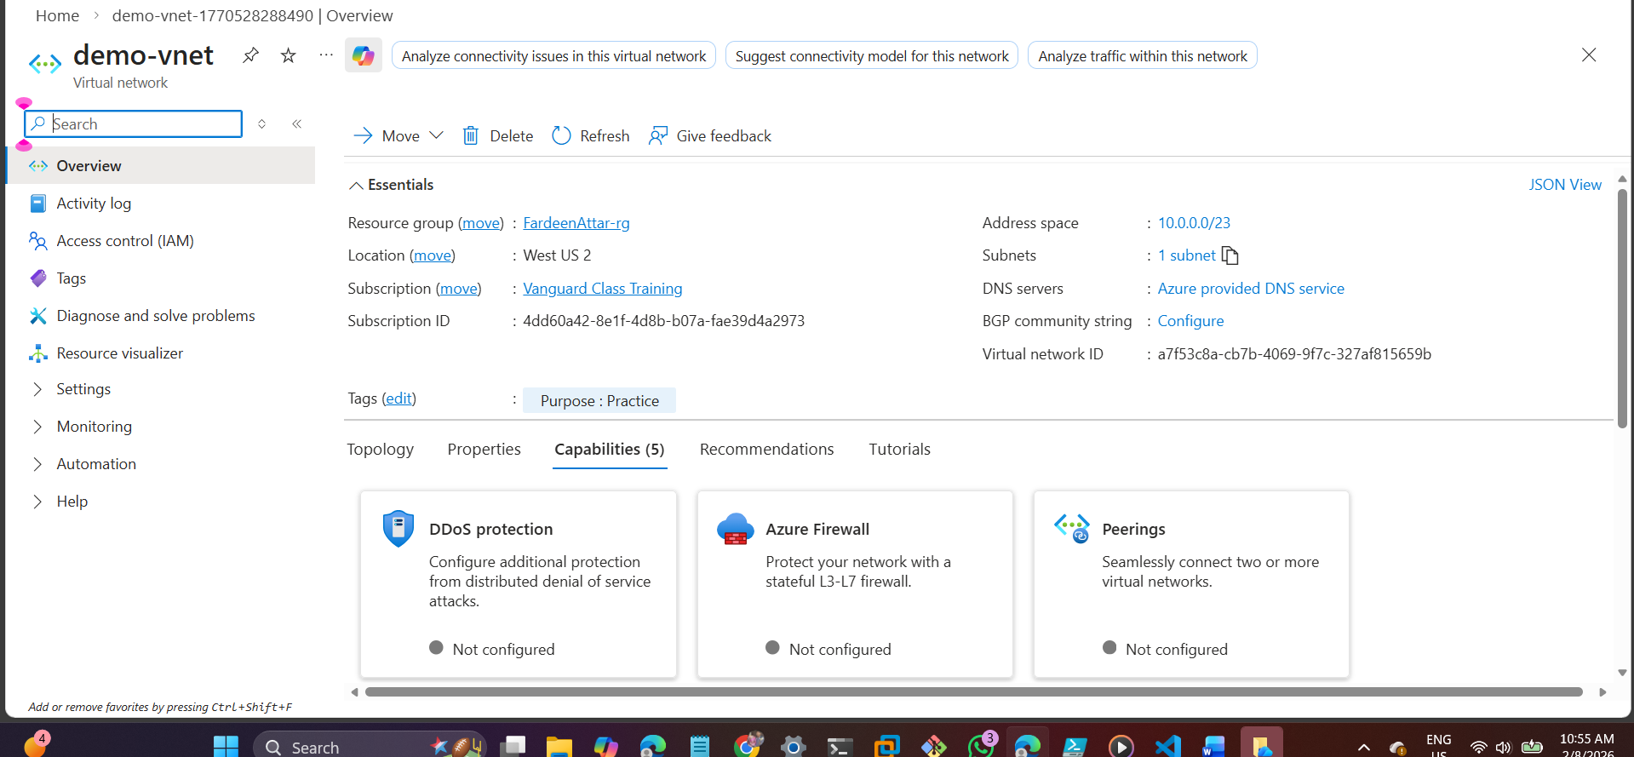

- Define a Subnet within that VNet.
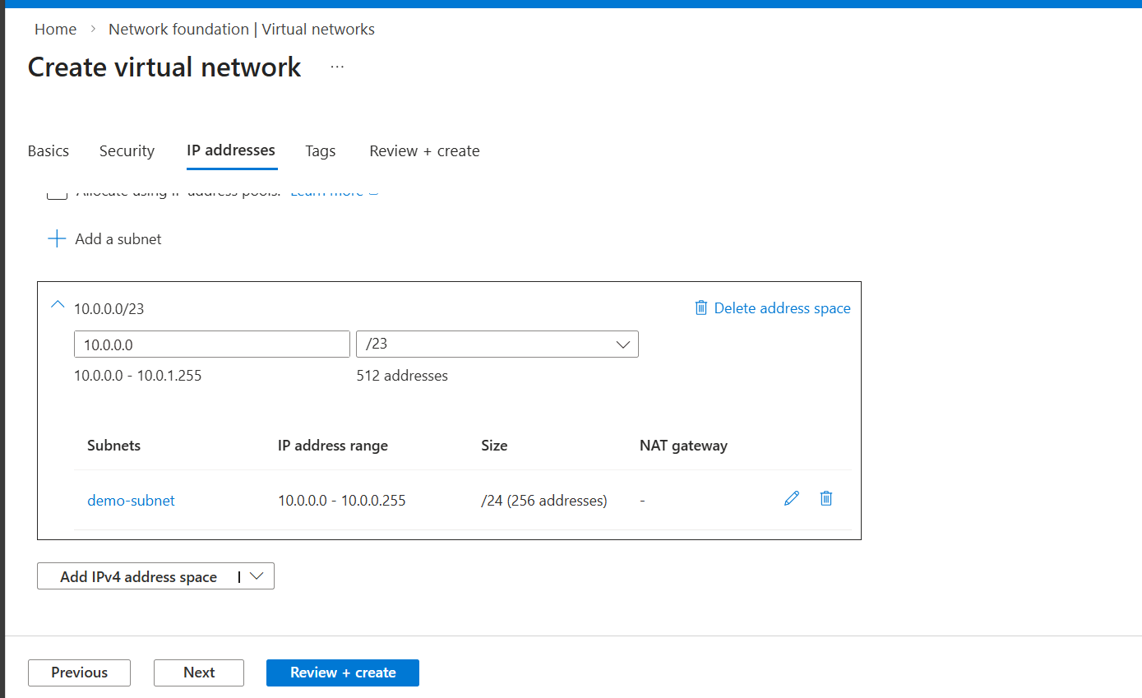
- Goal: Ensure the address space is sufficient for future scaling.

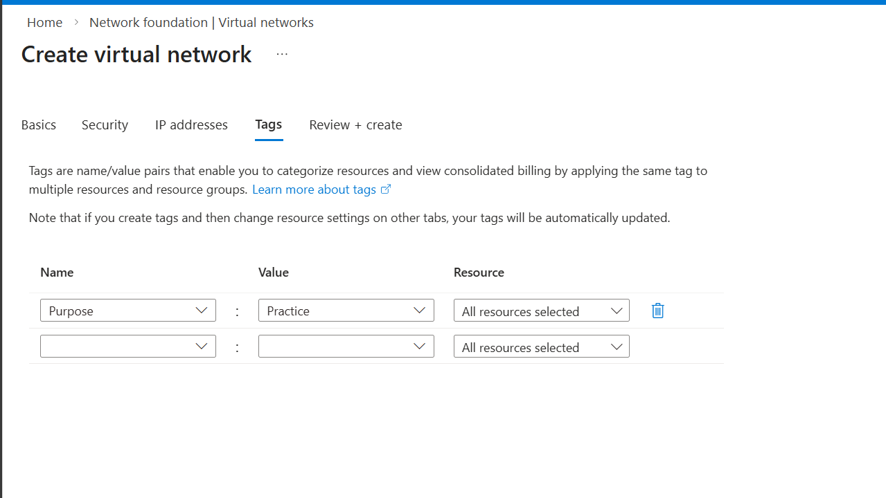

vnet is ready

Task 2: Security & Entry Points
- Create a Network Security Group (NSG).
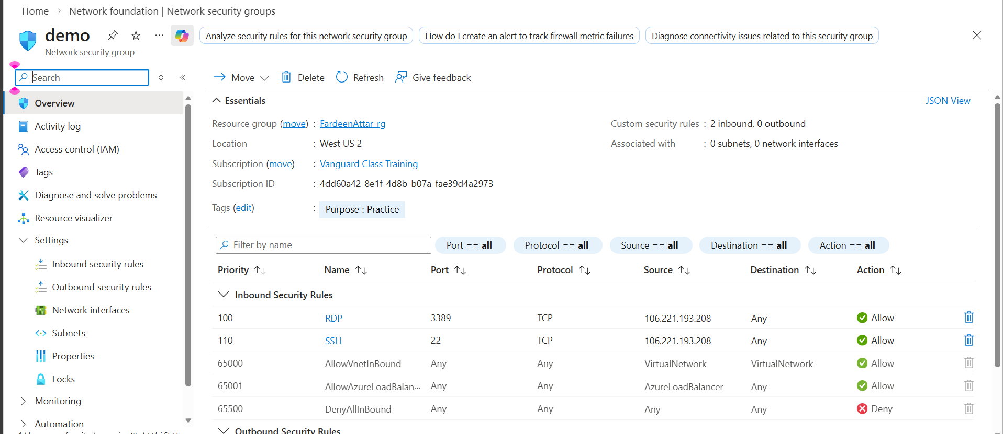

- Configure a rule that allows you to remotely manage the VM.
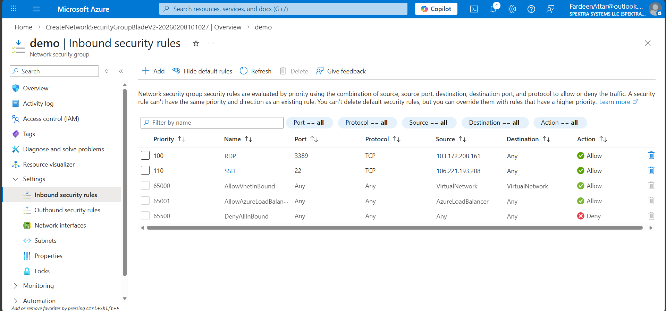

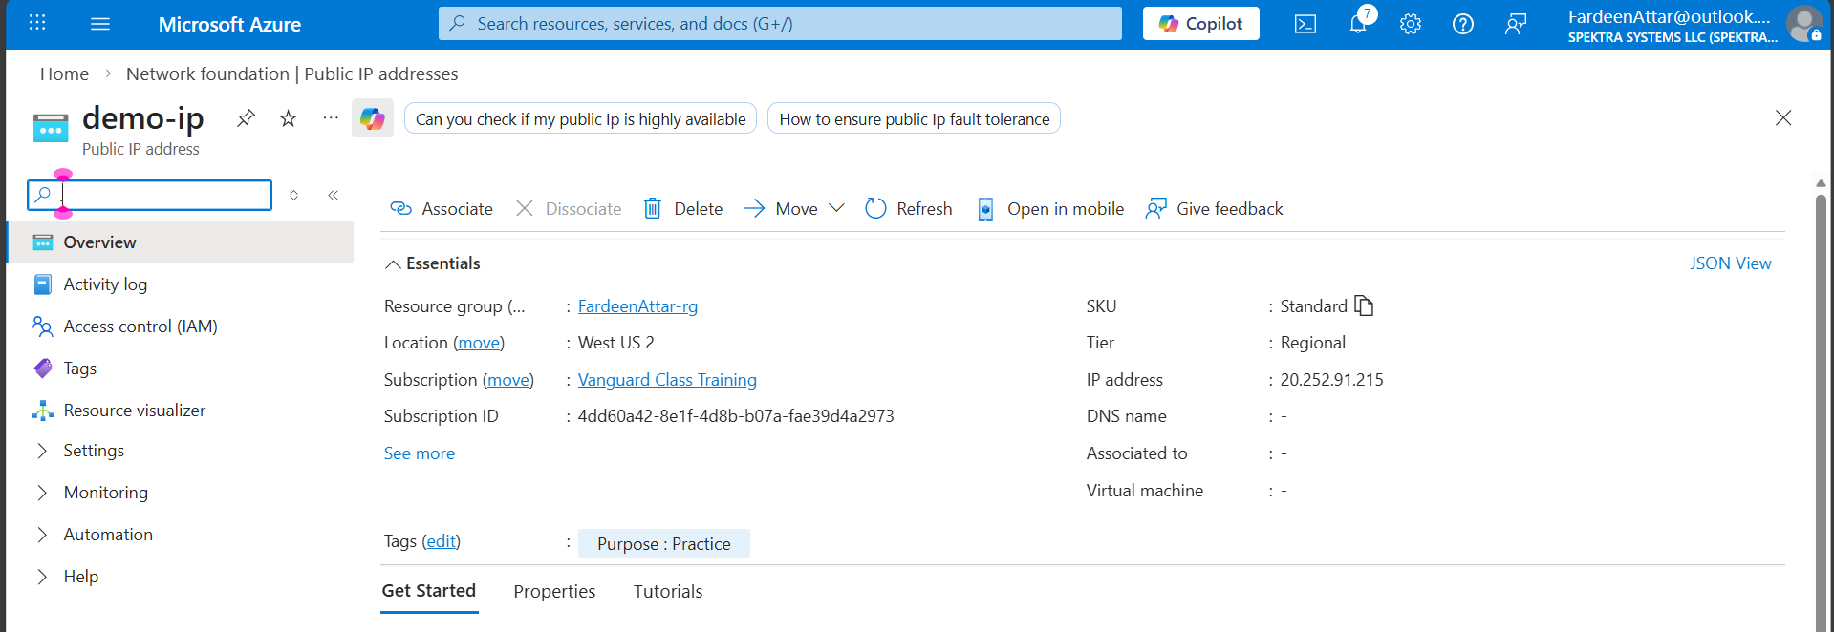
- Create a Public IP Address to allow external connectivity.
Public IP Address Created
Task 3: The Connection Layer
- Create a Network Interface (NIC).
- Manually associate the VNet, Subnet, NSG, and Public IP you created in the previous
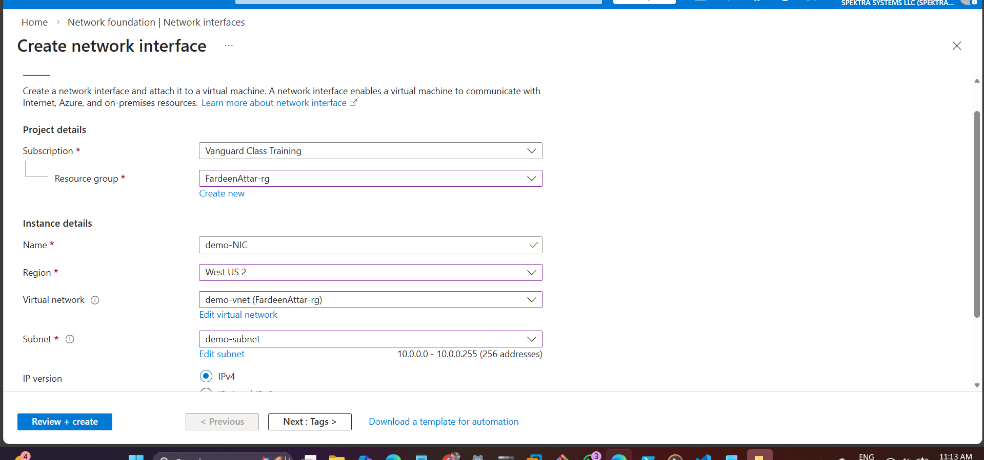
steps.

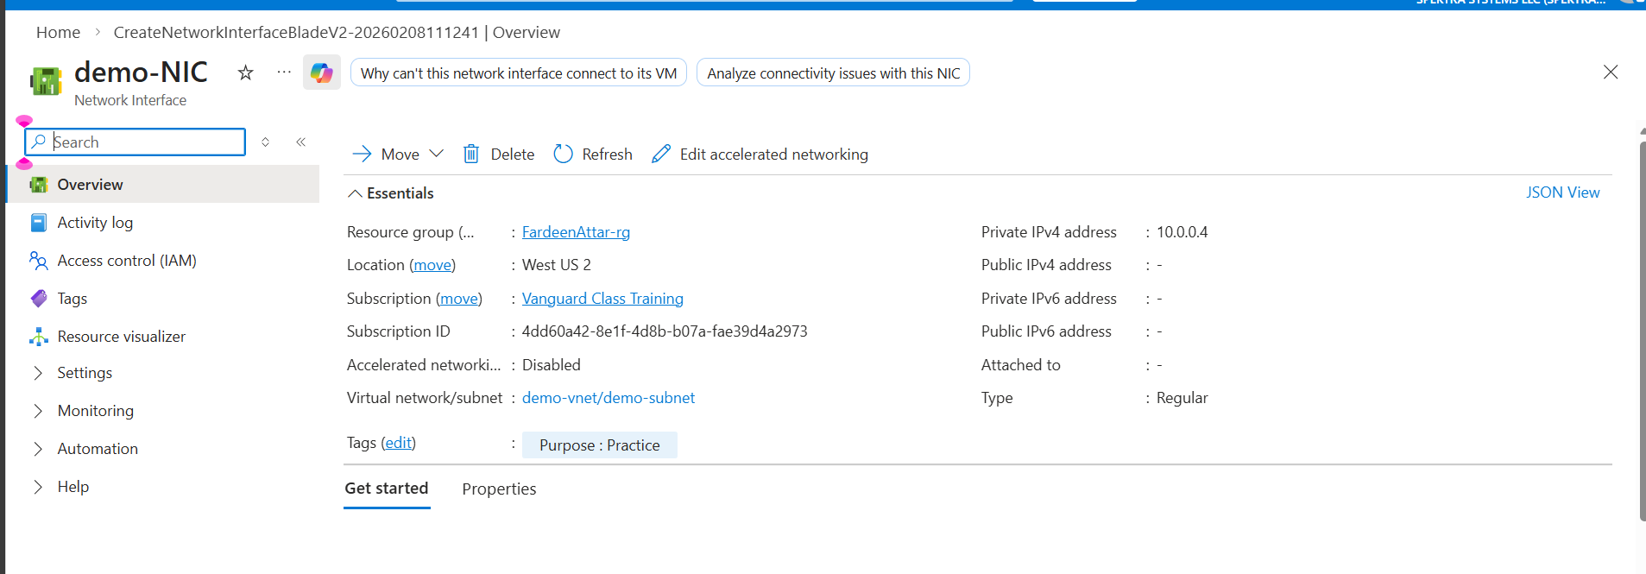
Created NIC
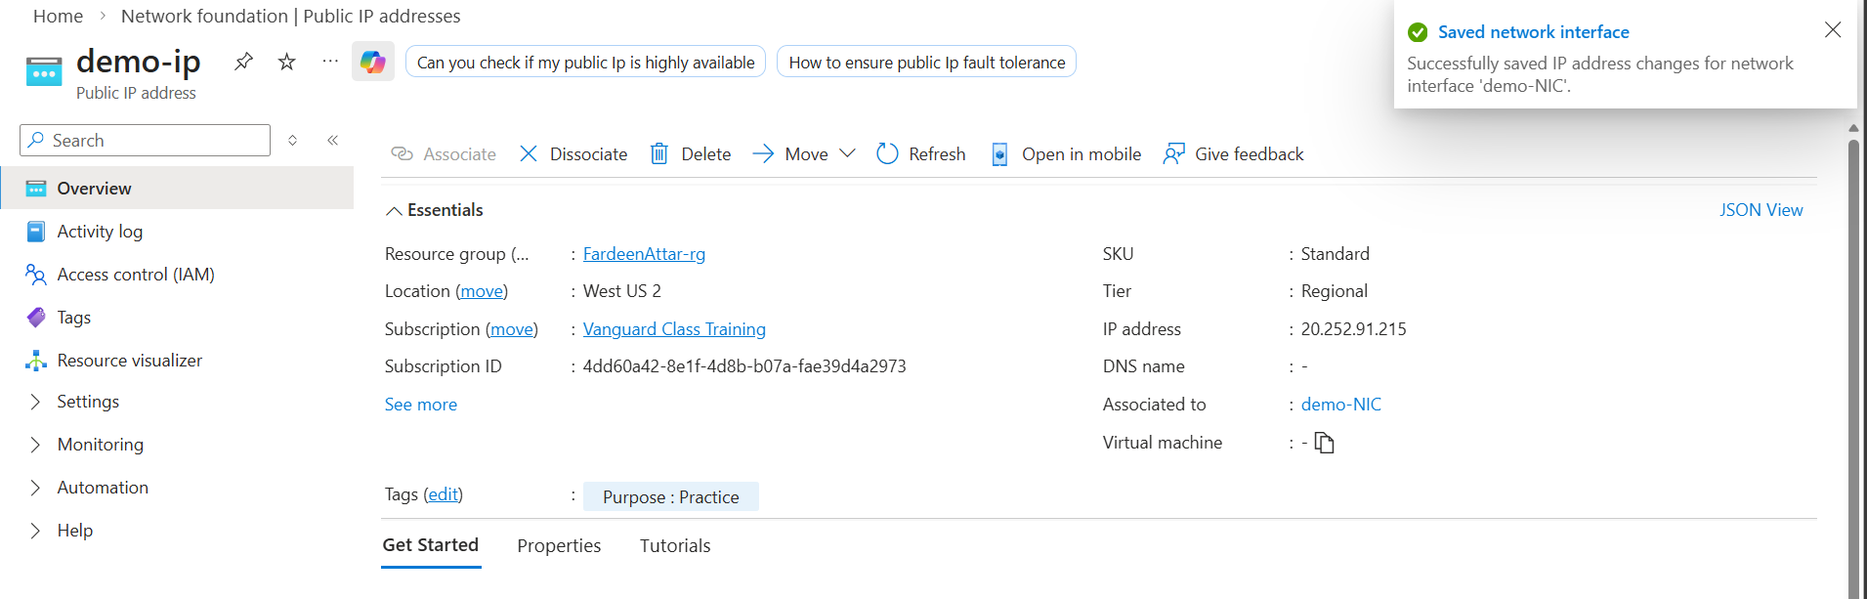
Associated Public IP Address to NIC
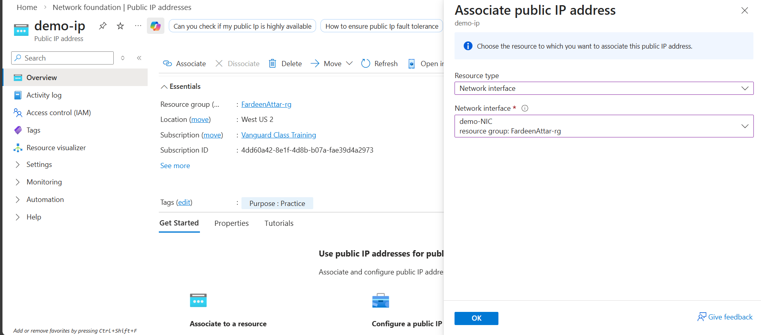
Task 4: Storage Allocation
- Create a Managed Data Disk.
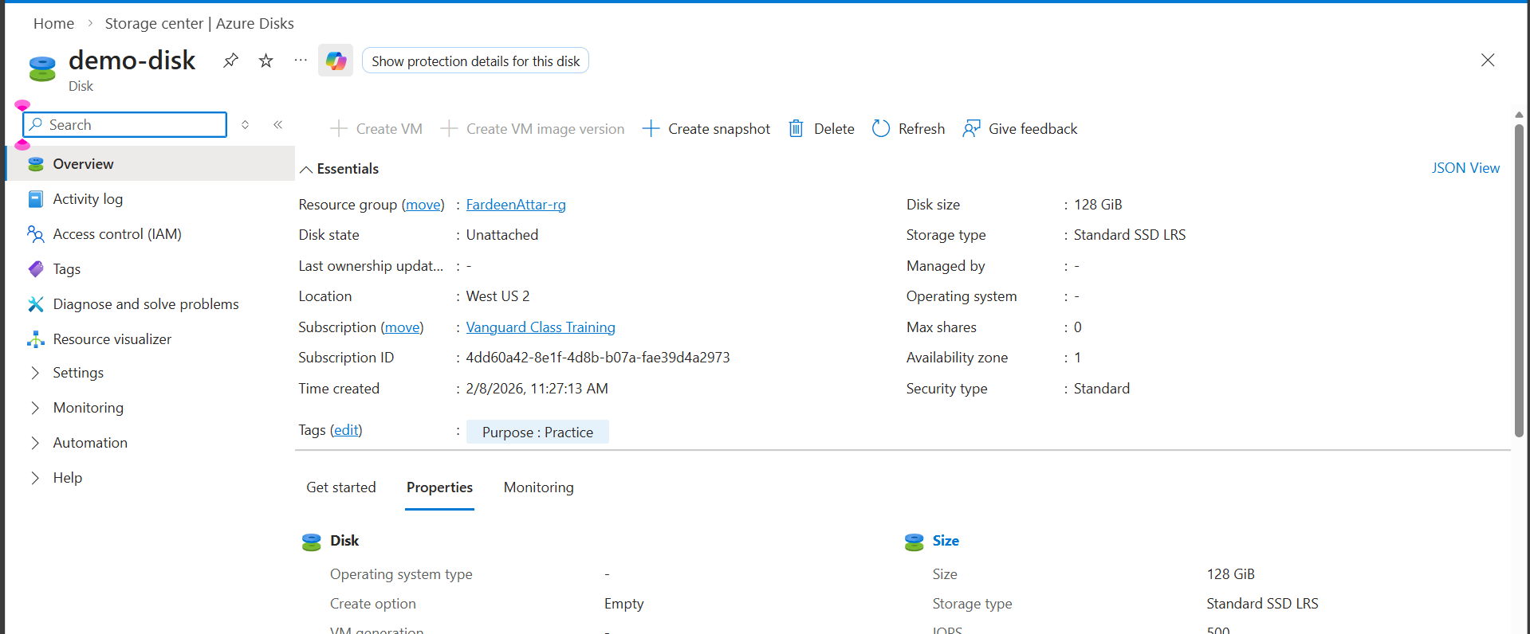
- Constraint: This disk must be physically located to ensure zero-latency attachment to your compute resource.
Created data disk in the same AZ where vm is going to create to ensure low latency .

Task 5: Final Assembly (Compute)
- Deploy a Virtual Machine.
- Requirement: Do not create new networking or storage during this step. You must attach the NIC and the Data Disk you prepared in Tasks 3 and 4.
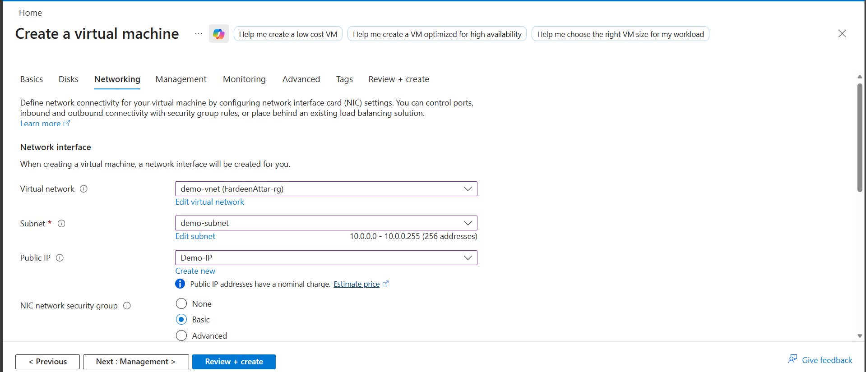
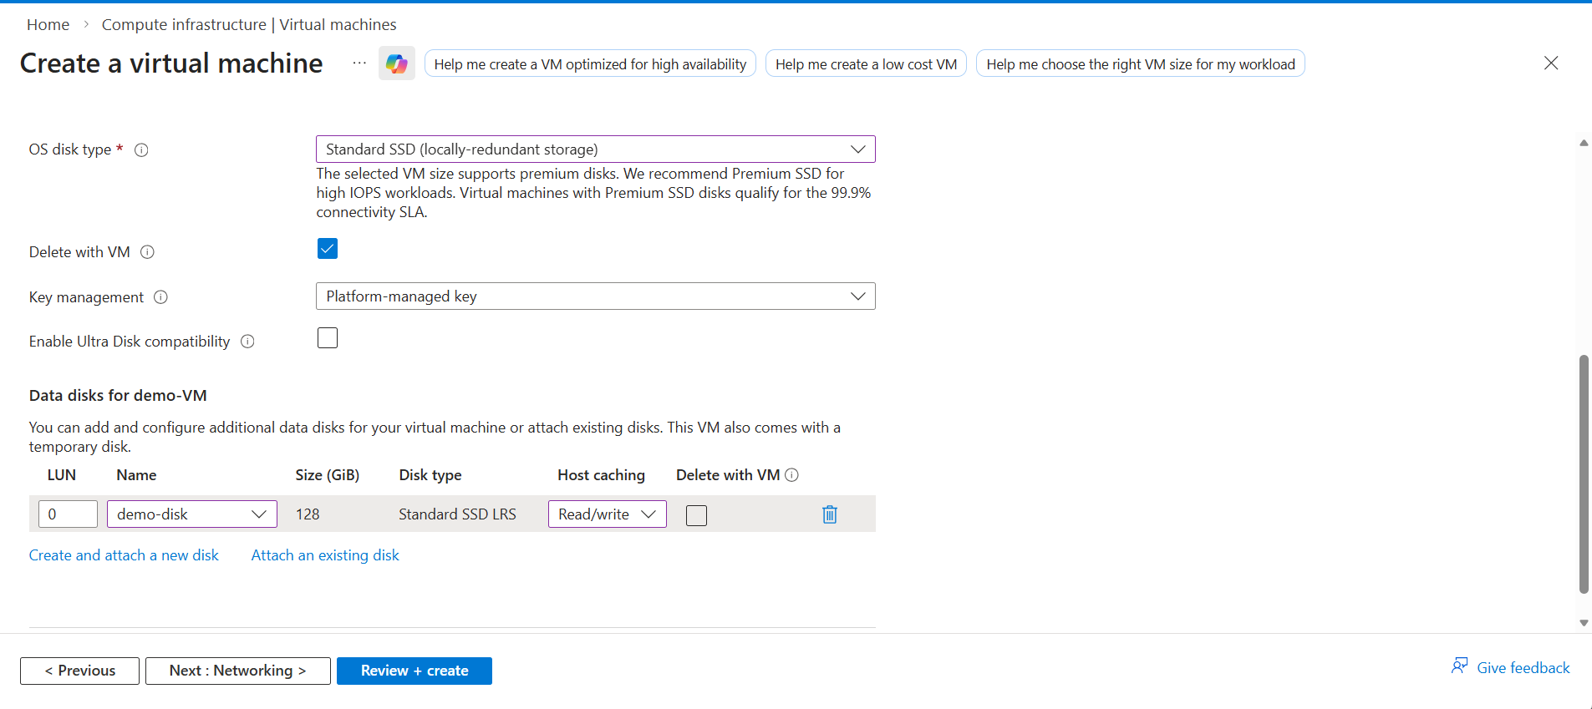
- Attached the existing vnet and Subnet to my demo-VM
- Attached data disk to vm in same Region in same Zone to ensure low latency

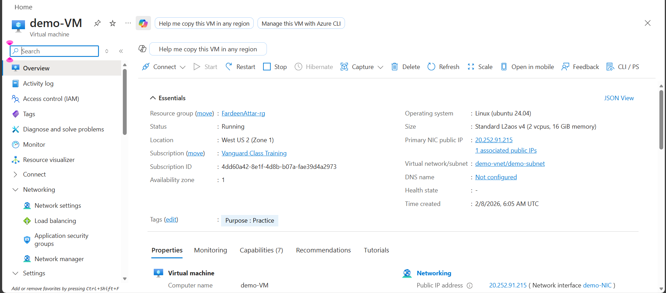
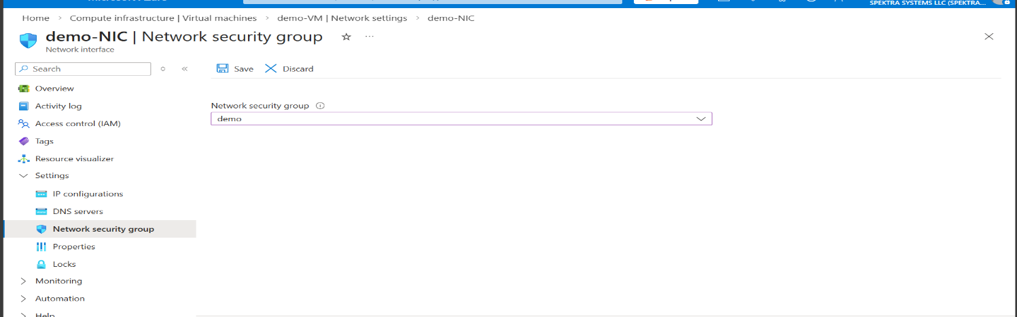
VM IS READY
- Attached NSG to existing NIC
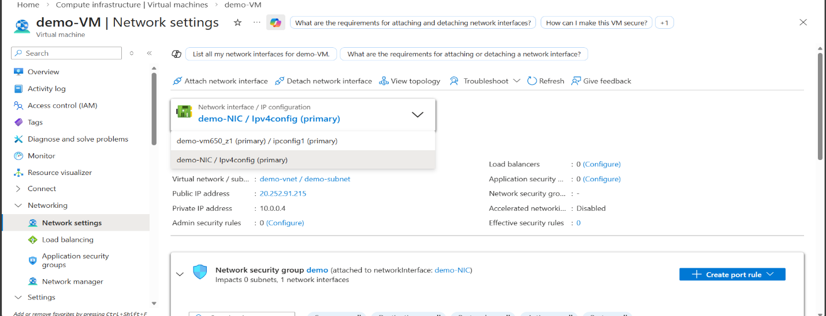
- Stopped VM and Attached existing Network Interface (NIC)

Task 6: Validation
- Log in to the machine and verify that the extra data disk is visible and ready for use
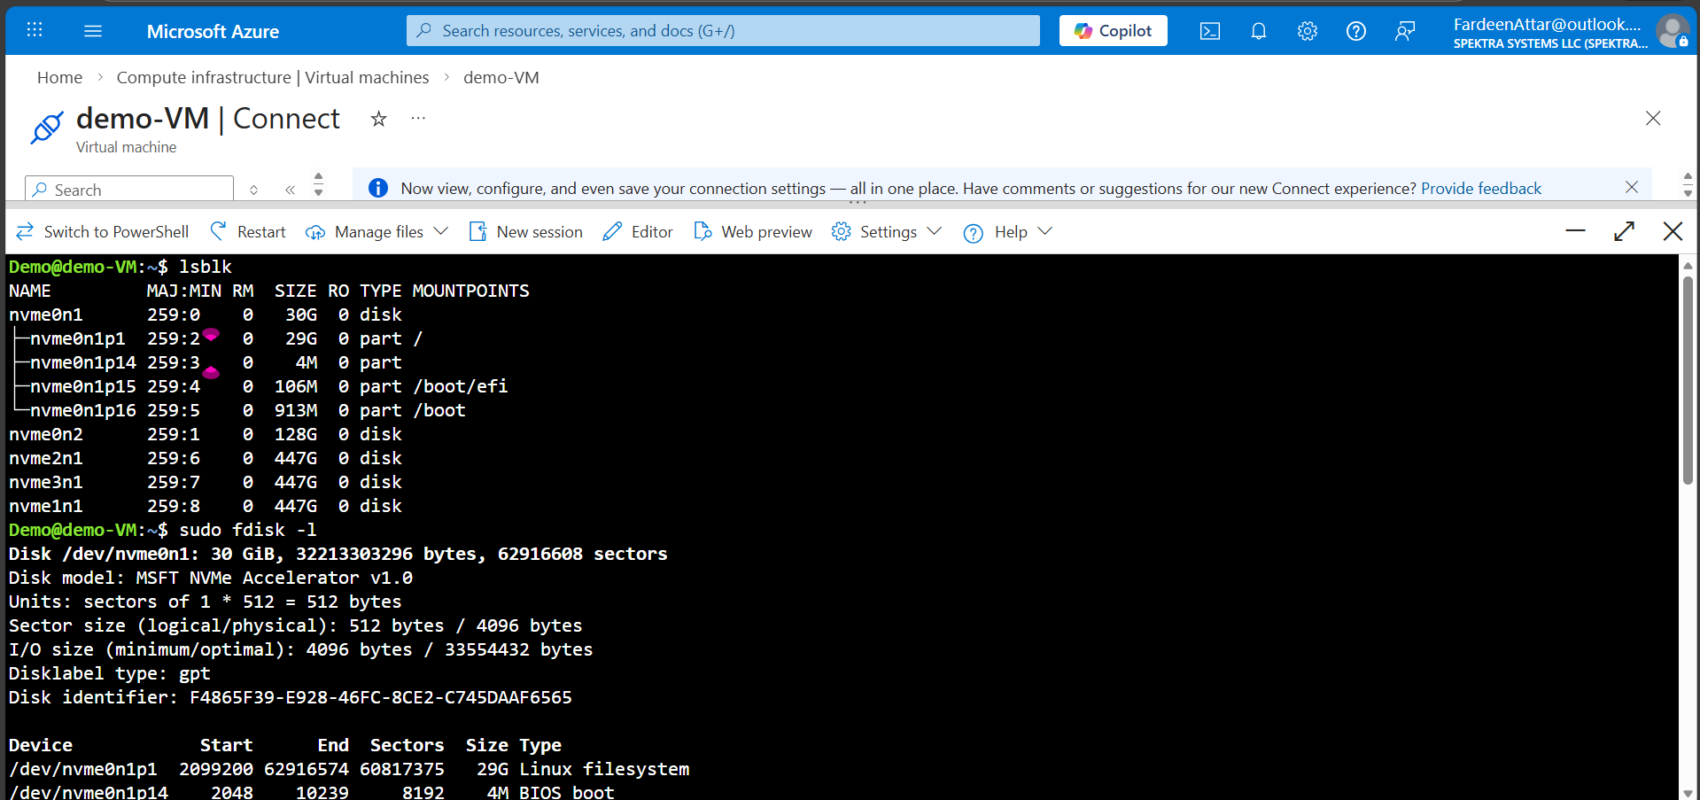
Topology
