20/06/2024

**To Whom It May Concern**

I am writing to recommend Aryan Parashar, Final-year student in the BTech program in Computer Science Engineering with IoT, Cyber Security, and Blockchain Technology i.e. CSE(ICB), having Enrollment Number 0108IC211011 for training opportunities in the field of Cyber Security at your reputed organization.

During his on-going tenure at Samrat Ashok Technological Institute, he has consistently demonstrated technical proficiency in the domain of Application Security and a strong dedication towards problem solving. I have mentored him upon significant projects focused on enhancing Web Application security incorporating VAPT methodologies.

In addition to his technical skills, Aryan possesses excellent work ethics and a keen analytical mind. His collaborative nature and strong soft skills have made him an asset in team projects and presentations.

His commitment to continuous learning and his passion for cyber security make him an ideal candidate for technical roles in this field. I am confident that he will contribute significantly to any organization that values innovation, security, and technical excellence.

Please feel free to contact me if you need any further information regarding Aryan's qualifications.

Truly

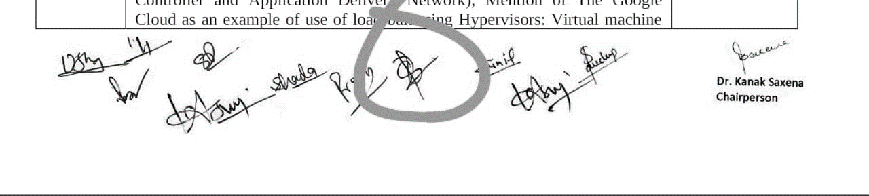

Dr. Divya Rishi Sahu

Professor, Department of Computer Science Engineering  
Samrat Ashok Technological Institute, Vidisha, M.P.  
[drsahu.cse@satiengg.in](mailto:drsahu.cse@satiengg.in)

+91 88271 33880